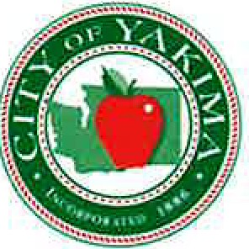***HUMAN RESOURCES DEPARTMENT***

***129 North Second Street Yakima, Washington 98901***

***Phone (509) 575-6090*** I ***Fax (509) 576-6358***

Open Enrollment Memo

# To: From: Date: Subject:

All City of Yakima Health Plan Participants Abbi Rhoads, Human Resources Specialist November 1, 2024

2025 Open Enrollment

# November is Open Enrollment Month

During O.E. you can enroll, make changes, or cancel insurance that is not required for employment. The City follows the CDC’s, “Total Worker Health Model”, for *Safety-Protection from harm*. *Social Support - Connection & Community. Work-Life Harmony. Mattering at Work & Work that matters. Opportunity for Growth - Learning.*

# Workplace Mental Health and Well-Being

*You matter,* our workplace plays a significant role in our lives. Work affects both our physical and mental well-being - in good and bad ways. COY workplace resources and support can help you flourish.

# 2025 Improved health plan benefits:

* Prudent Rx – Specialty drug co-pay assistance
* *No Changes to YPPA Plan pending negotiations*

**Learn your Benefits** (Pick up your 2024 benefits guide at the Wellness Fair or go online to CityICE)

**COY Benefits Guide**

|  |  |
| --- | --- |
| * Traditional Benefits | * Supplemental Benefits |
| * Flexible Spending | * Recuro Telehealth |
| * Wellness Incentive | * Employee Assistance |
| * Employee Primary Care Clinic | * Health Advocate |

**Important items to remember:**

# Stay in network, out of network providers don’t negotiate a good deal for you. Aetna does, and they can save you and the plan a lot of money. Always ask your provider if they are in-network and it they are not persuade them to join.

* 2024 O.E. checklist to check off your O.E. task.
* If you do not wish to change your benefit elections, you do not need to take any action. Benefit elections will roll over into the next plan year.