The City of Yakima

Office of Neighborhood Development Services

Consolidated Annual Performance Evaluation Report

For Year of 2018

For further information, contact:

The Office of Neighborhood Development Services
112 S. Eighth Street
Yakima, WA 98901

509-575-6101

CR-05 - Goals and Outcomes
Progress the jurisdiction has made in carrying out its strategic plan and its action plan. 91.520(a)
This could be an overview that includes major initiatives and highlights that were proposed and executed throughout the program year.

The City of Yakima continues to receive both Community Development Block Group (CDBG) funds and HOME Investment funds from HUD.
The City continues to use the bulk of its CDBG funding to address "Single Family Rehabilitation" in the form of a "Senior/Disabled Emergency Repair Program" that assists qualified low to moderate income Senior and/or Disabled homeowners with emergency type repairs. These repairs include no heat, no power, no hot water, leaking pipes, leaking roof or other such emergency repairs. The Single Family Rehabilitation program also includes an Exterior Paint Program and a Wheel Chair Ramp program as funding and demand allow.
CDBG funds also assist other eligible activities in the Public Service category of National Objectives. The first is a funding of Public Service programs administered through the Henry Beauchamp Community Center for low to moderate income citizens. Another Public Service that was funded through 2018 was the Paint Out Graffiti program in addressing graffiti which directly affected lower income residential areas in Yakima.
CDBG funds were also used to support eligible activity of Code Compliance in order to enable the Yakima Code Department to further assist low to moderate income areas with the continued clean up efforts associated with Code Compliance through assisting the payroll of staff.
The HOME program continues to support local Community Housing Development Organizations (CHDO) such as Yakima Valley Habitat for Humanity in purchasing vacant lots or lots that have vacant/abandoned buildings that are substandard and in need of abatement. The qualified CHDO in partnership with the City of Yakima constructs a new single family dwelling which is then sold to a qualified low to moderate income first time homebuyer.
Comparison of the proposed versus actual outcomes for each outcome measure submitted with the consolidated plan and explain, if applicable, why progress was not made toward meeting goals and objectives. 91.520(g)
Categories, priority levels, funding sources and amounts, outcomes/objectives, goal outcome indicators, units of measure, targets, actual outcomes/outputs, and percentage completed for each of the grantee’s program year goals.

Goal | Category | Source / Amount | Indicator | Unit of Measure | Expected – Strategic Plan | Actual – Strategic Plan | Percent Complete | Expected – Program Year | Actual – Program Year | Percent Complete
Table 1 - Accomplishments – Program Year & Strategic Plan to Date

Assess how the jurisdiction’s use of funds, particularly CDBG, addresses the priorities and specific objectives identified in the plan, giving special attention to the highest priority activities identified.
The City of Yakima assisted 82 low to moderate income Senior/Disabled homeowners with Emergency Repairs to their homes. This program aims at assisting this high risk group of elderly to remain in their home as long as possible by making emergency repairs that might otherwise displace these citizens from their homes and into assisted living facilities. The Wheel Chair ramp program as part of the Single Family Rehabilitation program also provides much needed "Accesibility" for Senior/Disabled homeowners through the use of CDBG funds.

CR-10 - Racial and Ethnic composition of families assisted
Describe the families assisted (including the racial and ethnic status of families assisted). 91.520(a)

Table 2 – Table of assistance to racial and ethnic populations by source of funds

Narrative
The Single Family Rehabilitation program is the only program that tracks racial and ethnic status of families within the Senior/Disabled Emergency Home Repair program. This is a city wide program that assists low to moderate income homeowners with emergency home repairs.
12 African American
83 Caucasian
31 Hispanic
0 Russian
0 Native American

CR-15 - Resources and Investments 91.520(a)
Identify the resources made available
Source of Funds | Source | Resources Made Available | Amount Expended During Program Year
CDBG | public - federal | 1,509,749 | 881,430
HOME | public - federal | 1,916,949 | 110,659
Table 3 - Resources Made Available

Narrative

Identify the geographic distribution and location of investments
Target Area | Planned Percentage of Allocation | Actual Percentage of Allocation | Narrative Description
CITY OF YAKIMA | 100 | 100 | 100% of the allocation was spent within the geographic location (Yakima City Limits)
Table 4 – Identify the geographic distribution and location of investments

Narrative
The City of Yakima does not limit either CDBG or HOME investment funds to any limited target area, but uses these funds to the best of it's ability to assist any and all low to moderate income applicants that qualify within the programs funded within the entire city limits of Yakima.
Leveraging
Explain how federal funds leveraged additional resources (private, state and local funds), including a description of how matching requirements were satisfied, as well as how any publicly owned land or property located within the jurisdiction that were used to address the needs identified in the plan.
CDBG funds are leveraged with partnerships with non-profits such as OIC of Washington in the continued operation of the Henry Beauchamp Center ( formerly known as the South East Community Center) to provide community service programs to low and moderate income citizens.
HOME Investment funds are used in partnership with local Community Housing Development Organizations (CHDO)such as Habitat for Humanity, Next Step Housing and Catholic Charities Housing to construct affordable housing units for low to moderate income qualified renters and/or qualified first time homebuyers.

Fiscal Year Summary – HOME Match
1. Excess match from prior Federal fiscal year | 15,739,158
2. Match contributed during current Federal fiscal year | 71,120
3. Total match available for current Federal fiscal year (Line 1 plus Line 2) | 15,810,278
4. Match liability for current Federal fiscal year | 0
5. Excess match carried over to next Federal fiscal year (Line 3 minus Line 4) | 15,810,278
Table 5 – Fiscal Year Summary - HOME Match Report

Match Contribution for the Federal Fiscal Year
Project No. or Other ID | Date of Contribution | Cash  (non-Federal sources) | Foregone Taxes, Fees, Charges | Appraised Land/Real Property | Required Infrastructure | Site Preparation, Construction Materials, Donated labor | Bond Financing | Total Match
Volunteer Hours | 12/31/2018 | 0 | 0 | 0 | 0 | 71,120 | 0 | 71,120
Table 6 – Match Contribution for the Federal Fiscal Year

HOME MBE/WBE report
Program Income – Enter the program amounts for the reporting period
Balance on hand at begin-ning of reporting period  $ | Amount received during reporting period  $ | Total amount expended during reporting period  $ | Amount expended for TBRA  $ | Balance on hand at end of reporting period  $
549,444 | 145,340 | 63,103 | 0 | 631,681
Table 7 – Program Income

Minority Business Enterprises and Women Business Enterprises – Indicate the number and dollar value of contracts for HOME projects completed during the reporting period

 | Total | Minority Business Enterprises |  |  |  | White Non-Hispanic
 |  | Alaskan Native or American Indian | Asian or Pacific Islander | Black Non-Hispanic | Hispanic

Contracts
Dollar Amount | 0 | 0 | 0 | 0 | 0 | 0
Number | 0 | 0 | 0 | 0 | 0 | 0

Sub-Contracts
Number | 0 | 0 | 0 | 0 | 0 | 0
Dollar Amount | 0 | 0 | 0 | 0 | 0 | 0

 | Total | Women Business Enterprises | Male

Contracts
Dollar Amount | 0 | 0 | 0
Number | 0 | 0 | 0

Sub-Contracts
Number | 0 | 0 | 0
Dollar Amount | 0 | 0 | 0
Table 8 - Minority Business and Women Business Enterprises

Minority Owners of Rental Property – Indicate the number of HOME assisted rental property owners and the total amount of HOME funds in these rental properties assisted

 | Total | Minority Property Owners |  |  |  | White Non-Hispanic
 |  | Alaskan Native or American Indian | Asian or Pacific Islander | Black Non-Hispanic | Hispanic
Number | 0 | 0 | 0 | 0 | 0 | 0
Dollar Amount | 0 | 0 | 0 | 0 | 0 | 0
Table 9 – Minority Owners of Rental Property

Relocation and Real Property Acquisition – Indicate the number of persons displaced, the cost of relocation payments, the number of parcels acquired, and the cost of acquisition

Parcels Acquired | 0 | 0
Businesses Displaced | 0 | 0
Nonprofit Organizations Displaced | 0 | 0
Households Temporarily Relocated, not Displaced | 0 | 0

Households Displaced | Total | Minority Property Enterprises |  |  |  | White Non-Hispanic
 |  | Alaskan Native or American Indian | Asian or Pacific Islander | Black Non-Hispanic | Hispanic
Number | 0 | 0 | 0 | 0 | 0 | 0
Cost | 0 | 0 | 0 | 0 | 0 | 0
Table 10 – Relocation and Real Property Acquisition

CR-20 - Affordable Housing 91.520(b)
Evaluation of the jurisdiction's progress in providing affordable housing, including the number and types of families served, the number of extremely low-income, low-income, moderate-income, and middle-income persons served.

 | One-Year Goal | Actual
Number of Homeless households to be provided affordable housing units | 0 | 0
Number of Non-Homeless households to be provided affordable housing units | 90 | 82
Number of Special-Needs households to be provided affordable housing units | 25 | 8
Total | 115 | 90
Table 11 – Number of Households

 | One-Year Goal | Actual
Number of households supported through Rental Assistance | 0 | 0
Number of households supported through The Production of New Units | 4 | 3
Number of households supported through Rehab of Existing Units | 90 | 82
Number of households supported through Acquisition of Existing Units | 0 | 0
Total | 94 | 85
Table 12 – Number of Households Supported

Discuss the difference between goals and outcomes and problems encountered in meeting these goals.
Due to the rising cost of material and construction costs associated with Rehabilitation, fewer dwellings could be addressed than anticipated.
The difference between the estimated production of new units resulting in one fewer new single family dwelling units was attributed to the limited capacity of the CHDO within the City limits in order to meet their prior building commitment in outlying areas.
Discuss how these outcomes will impact future annual action plans.
The limited amount of CDBG and dwindling amount of HOME Investment funds does not keep up with the escalating need associated with keeping a growing population of Senior/Disabled homeowners that continue to seek much needed emergency home repairs. Thus not only is the need growing for such services but the increasing cost of labor and material continues to out pace the allocations of both CDBG and HOME funds.
Include the number of extremely low-income, low-income, and moderate-income persons served by each activity where information on income by family size is required to determine the eligibility of the activity.

Table 13 – Number of Households Served

Narrative Information

CR-25 - Homeless and Other Special Needs 91.220(d, e); 91.320(d, e); 91.520(c)
Evaluate the jurisdiction’s progress in meeting its specific objectives for reducing and ending homelessness through:
Reaching out to homeless persons (especially unsheltered persons) and assessing their individual needs
As in the past, the City of Yakima continues to struggle with increasing costs of living, construction and labor costs while our entitlement funds fail to keep pace. The city continues to us the majority of it's limited CDBG funds in assisting low to moderate income Senior/Disabled homeowners with emergency repairs in order to keep them in their homes and thus keeping this fragile populace from becoming displaced and adding to the Homeless situation. The City of Yakima continues to work with the local Continuem of Care in assessing the mumbers and needs of the unsheltered homeless.
Addressing the emergency shelter and transitional housing needs of homeless persons
The City of Yakima continues to work with the local Continuem of Care, Neighborhood Health and Transform Yakima in providing temporary emergency shelters to assist the homeless through severe weather conditions as well as transitional and more permanent housing.
Helping low-income individuals and families avoid becoming homeless, especially extremely low-income individuals and families and those who are: likely to become homeless after being discharged from publicly funded institutions and systems of care (such as health care facilities, mental health facilities, foster care and other youth facilities, and corrections programs and institutions); and, receiving assistance from public or private agencies that address housing, health, social services, employment, education, or youth needs
The City continues to work with local Community Housing Development Organizations (CHDO) in Multi-Family unit projects, such as the new partnership with Next Step Housing to develop and construct the 88 unit complex that will assist with housing and services to homeless families.
Helping homeless persons (especially chronically homeless individuals and families, families with children, veterans and their families, and unaccompanied youth) make the transition to permanent housing and independent living, including shortening the period of time that individuals and families experience homelessness, facilitating access for homeless individuals and families to affordable housing units, and preventing individuals and families who were recently homeless from becoming homeless again
The City is working with local Community Housing Development Organizations, such as Next Step housing and the Yakima Housing Authority to develop permanent housing that assists Homeless and Homeless veterans and their families.
The City is also working with Neighborhood Health Services with transitional housing to serve homeless.

CR-30 - Public Housing 91.220(h); 91.320(j)
Actions taken to address the needs of public housing
The Yakima Housing Authority (YHA) offers affordable housing through a variety of programs. Each program is designed to meet the need of our community.
- Housing for families; YHA offers two housing programs for low income families. The first is the family Housing/Low Rent Program which has a 150 units at scattered sites across Yakima. Rent is determined based on family income.
- The Housing Choice Vouchers-Section 8 program; Eligible families will receive rental assistance and can rent from any landlord that accepts Section 8 vouchers. Unit size and maximum rent limits apply.
- Housing for the Homeless; YHA offers a Section 8 voucher program specifically for Veterans who also qualify as homeless under the Veterans Affairs Supportaive Housing Program (VASH).
- Housing for Farmworkers; YHA owns and manages 173 units throughout Yakima County which are set aside for Farmworkers and their families. Reduced rents and rental assistance may be available.
- Housing for the Elderly; YHA owns and manages a 38 unit apartment building in Yakima for the elderly. In order to qualify for the one-bedroom units, the individual and his or her spouse must be 62 or older.
- Housing for the Disabled; YHA offers a Section 8 Voucher Program specifically for Non-Elderly Disabled Individuals through the NED Voucher Program.
Actions taken to encourage public housing residents to become more involved in management and participate in homeownership
The Yakima Housing Authority encourages resident involvement with programs like the Resident Advisory Board (RAB). The (RAB) provides the YHA and residents with a forum for sharing information about the Agency's Annual Plan. RAB membership is comprised of individuals who reflect and represent the residents assisted by the PHA. The role of the RAB is to assist the PHA in developing the PHA Plan and making any significant amendment or modification to the Plan. In addition, Yakima Housing Authority is an active participant in crime free rental housin which allows our residents to be a part of the local block watch and we participate every year, inviting residents and local organizations in the National Night Out.
The YHA also participates in the Yakima County Asset Building coalition and they are establishing a partnership with YV-CAN for the Union Gap and Yakima area. YHA also works with Americorps VISTA Educational Project with the goal of every eligible resident signing up for the college bound scholarship.
YHA also administers the Family Self-Sufficiency (FFS) Program. This program enables families assisted through the HCV program to increase their earned income and reduce their dependency on welfare assistance and rental subsidies.
Actions taken to provide assistance to troubled PHAs
The Yakima Housing Authority is not desinated as "Troubled".

CR-35 - Other Actions 91.220(j)-(k); 91.320(i)-(j)
Actions taken to remove or ameliorate the negative effects of public policies that serve as barriers to affordable housing such as land use controls, tax policies affecting land, zoning ordinances, building codes, fees and charges, growth limitations, and policies affecting the return on residential investment. 91.220 (j); 91.320 (i)
The Yakima City Council is an elected body chosen by the citizens of Yakima and as a governing body is able to direct the Yakima City Manager as to manging changes, negative or otherwise concerning public policies that serve as barriers to affordable housing within the cities control concerning land use controls, tax policies affecting land, zoning ordinances, building codes, fees and charges, growth limitations and policies affecting the return on residential investment.
Actions taken to address obstacles to meeting underserved needs. 91.220(k); 91.320(j)
Due to the continued limitations of federal entitlements, the ability to take action to address ever growing obstacles to meet the need of underserved citizens continues to grow. The City of Yakima assists its citizens to the best of it's ability as directed by the Yakima City Council as the elected and governing boyd representing the citizens of Yakima through the programs described throughout this document. The Cities Annual Action Plan and Five Year Consolidated Plan as approved by HUD.
Actions taken to reduce lead-based paint hazards. 91.220(k); 91.320(j)
The Office of Neighborhood Development Services addresses Lead-Based paint hazards as required and oulined by HUD within it's individual programs.
Actions taken to reduce the number of poverty-level families. 91.220(k); 91.320(j)
The City continues to strive to increase i's Economic Development avenues to increase avoilable local jobs that pay reasonable living wages. The City continues to seek to establish new businesses as well as commercial manufacturing and agricultural opportunities to broaden the employment avenues available to its poverty-level families.
Actions taken to develop institutional structure. 91.220(k); 91.320(j)
Institutional structure is expanded as needed and as funding allows.
Actions taken to enhance coordination between public and private housing and social service agencies. 91.220(k); 91.320(j)
The city continues to partner with both public and private housing agencies, such as Yakima Valley Habitat for Humanity, The Yakima Catholic Diocese Housing Services, Next Step Housing and the local Yakima Housing Authority to address affordable housing issues within the city limits of Ykaima. The city also communicates with a large variety of social sercie agencies through seval committes in which both the City Council member and/or staff attend.
Identify actions taken to overcome the effects of any impediments identified in the jurisdictions analysis of impediments to fair housing choice. 91.520(a)
Any impediments identified by the City of Yakima are addressed on an idividual basis and then addressed by either the individual city department with the expertise to do so, or assigned by the Yakima City Manager as directed by the elected governing body, the Yakima City Council.

CR-40 - Monitoring 91.220 and 91.230
Describe the standards and procedures used to monitor activities carried out in furtherance of the plan and used to ensure long-term compliance with requirements of the programs involved, including minority business outreach and the comprehensive planning requirements

The City of Yakima's Office of Neighborhood Development Services is regularly monitored by both Region 10 HUD monitors and the Washington State Auditors Office as to program compliance and comprehensive planning requirements per mandated Federal HUD regulations. Both of these monitoring reports are available through HUD and the Washington State Auditors office through the "Public Disclosure Act".

Citizen Participation Plan 91.105(d); 91.115(d)
Describe the efforts to provide citizens with reasonable notice and an opportunity to comment on performance reports.
As outlined in the City of Yakima's adopted "Citizen Participation Plan", a Fifteen day written comment period is conducted as advertised in both the Yakima Herald newspaper and the El Sol newspaper, along with two public meetings which are advertised at least 15 days prior to the scheduled meetings. Those meetings are held before the Yakima City Council and held in order to provide the public the opportunity to comment on the Consolidated Annual Performance Evaluation Report, as mandated by HUD. The City also posts the CAPER on the city's website so that it can be easily downloaded and reviewed.

CR-45 - CDBG 91.520(c)
Specify the nature of, and reasons for, any changes in the jurisdiction’s program objectives and indications of how the jurisdiction would change its programs as a result of its experiences.
The City of Yakima discontinued to fund the "Landlord Tenant Hotline" with CDBG and instead funds it through the general fund. Also the "Paint out Graffiti" program was removed from the "Public Service" national objective and is now being funded through general funds so that the Yakima Police Activity League youth activities programs could be funded through the Eligible National Objective catagory within the Public Service limit cap of 15%.
Does this Jurisdiction have any open Brownfields Economic Development Initiative (BEDI) grants?
No
[BEDI grantees] Describe accomplishments and program outcomes during the last year.

CR-50 - HOME 91.520(d)
Include the results of on-site inspections of affordable rental housing assisted under the program to determine compliance with housing codes and other applicable regulations
Please list those projects that should have been inspected on-site this program year based upon the schedule in §92.504(d). Indicate which of these were inspected and a summary of issues that were detected during the inspection. For those that were not inspected, please indicate the reason and how you will remedy the situation.
YWCA located at 818 W. Yakima Ave. consisting of 16 total housing units, 2 units that are monitored. The affordability period is 15 years, starting April of 2008 with a monitoring schedule of every two years and was monitored in 2018. Both monitored units were inspected on 9/27/2018 and passed inspection with no listed deficiencies.
Pear Tree Place (Next Step Housing) located at 2900 Powerhouse Road, consisting of 26 total housing units, 5 units that are monitored. The affordability period is 20 years, starting October 2007 with a monitoring schedule of every two years and was monitored in 2018. Five floating units were inspected on 9/2/2018 with all five passing inspection with no listed deficiencies.
Catholic Charities Housing Services located at 1423 Karr Ave. One housing unit (group home) which has an affordability period of 20 years, starting November of 2016 with a monitoring schedule of every two years and was monitored in 2018. The unit was inspected on 9/26/2018 and passed inspection with no deficiencies.
Provide an assessment of the jurisdiction's affirmative marketing actions for HOME units. 92.351(b)
The following actions are taken by the City of Yakima Office of Neighborhood Development Services to evaluate the success of its Affirmative Fair Housing Marketing Policy and that of it's Grantees:
- ONDS assesses the results of it's affirmative Fair Housing Marketing Plan annually with a summary of "Good Faith Efforts" taken by its Grantees in the CAPER.
- ONDS assesses the information compiled in the manner described under Section V and SEction VII above and evaluates the degree to which statutory and policy objectives were met. If the required steps were taken, the office of Neighborhood Development Services will determine
Refer to IDIS reports to describe the amount and use of program income for projects, including the number of projects and owner and tenant characteristics

Describe other actions taken to foster and maintain affordable housing. 91.220(k) (STATES ONLY: Including the coordination of LIHTC with the development of affordable housing). 91.320(j)

Attachment
2018 MBE Reports
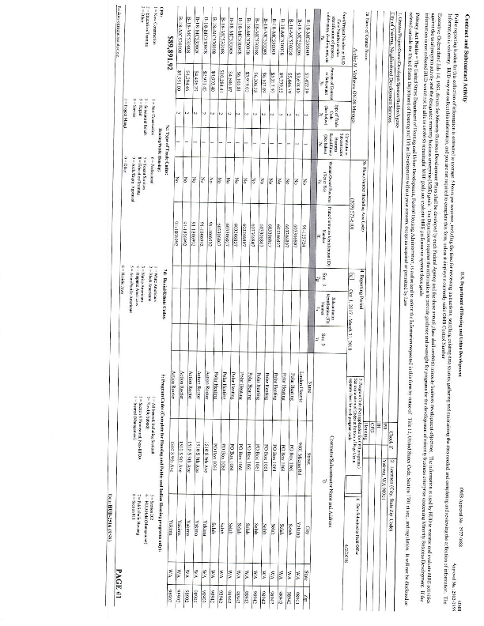
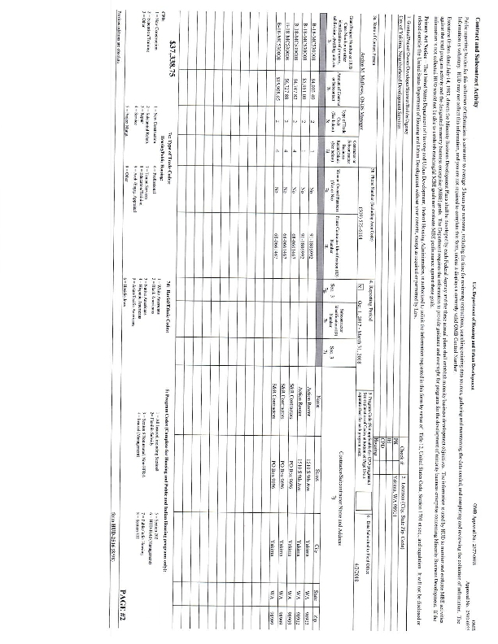
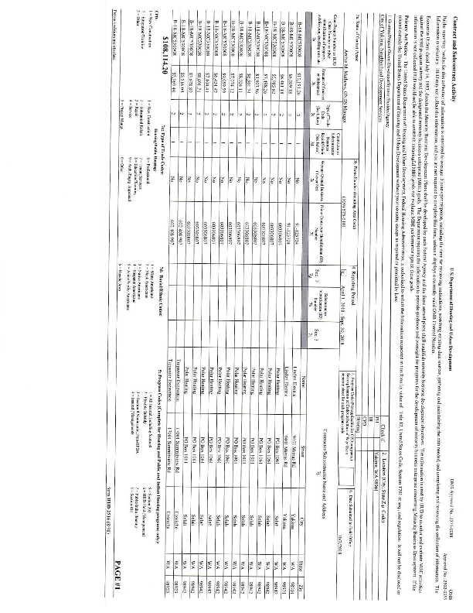
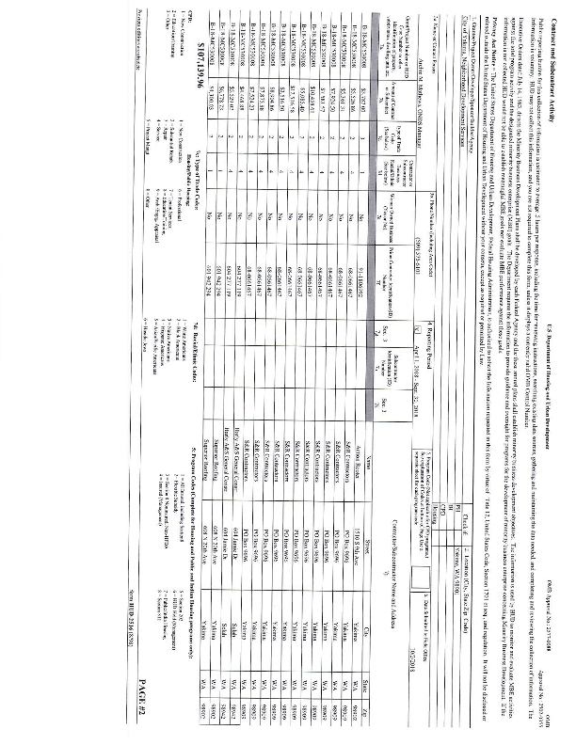

2018 HOME Inspection Reports
