City of Yakima Comprehensive Plan
Technical Analysis
DRAFT December 2025

Prepared by BERK Consulting

Contents
1. Introduction 1-1
1.1. Planning Framework 1-1
1.2. Context 1-3
2. Land Use 2-1
2.1. Overview 2-1
2.2. Land Use Patterns and Growth 2-1
2.3. Future Land Use 2-17
2.4. Planning and Regulatory Context 2-27
3. Housing Analysis 3-1
3.1. Overview 3-1
3.2. Summary of Key Findings 3-1
3.3. Community Profile 3-3
3.4. Housing Inventory 3-22
3.5. Housing Programs 3-30
3.6. Displacement & Displacement Risk 3-31
3.7. Racially Disparate Impacts 3-34
3.8. Projected Housing Needs 3-45
3.9. Adequate Provisions 3-50
4. Historic Preservation 4-1
4.1. Overview 4-1
5. Economic Development 5-1
5.1. Overview 5-1
5.2. Downtown Revitalizations 5-1
6. Transportation 6-1
6.1. Overview 6-1
6.2. Transportation Network 6-1
6.3. Transportation Performance 6-1
6.4. Vehicular Operations 6-1
6.5. Transit Operations 6-1
6.6. Bike and Trail Operations 6-1
7. Capital Facilities 7-1
7.1. Overview 7-1
7.2. Analysis 7-1
8. Utilities 8-2
8.1. Overview 8-2
8.2. Analysis 8-2
9. Natural Environment 9-1
9.1. Overview 9-1
9.2. Analysis 9-1
10. Glossary 10-1
Exhibits
Exhibit 1-1. 4th Street from a 1940s Postcard 1-3
Exhibit 1-2. East Yakima Avenue from a 1900s Postcard 1-3
Exhibit 2-1. Existing Land Use Map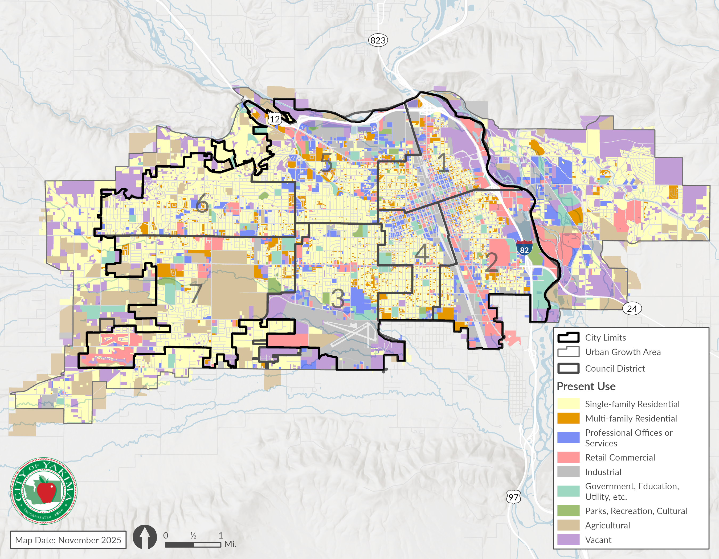 2-2
Exhibit 2-2.Existing Land Use within the City Limits and Unincorporated UGA 2-3
Exhibit 2-3. Size of Council Districts in the City Limits (Acres), 2025 2-3
Exhibit 2-4. Current Land Use– District 1 2-4
Exhibit 2-5. Land Use Acres – District 1 2-4
Exhibit 2-6. Current Land Use– District 2 2-5
Exhibit 2-7. Land Use Acres – District 2 2-6
Exhibit 2-8. Current Land Use– District 3 2-7
Exhibit 2-9. Land Use Acres – District 3 2-8
Exhibit 2-10. Current Land Use– District 4 2-9
Exhibit 2-11. Land Use Acres – District 4 2-10
Exhibit 2-12. Current Land Use– District 5 2-11
Exhibit 2-13. Land Use Acres – District 5 2-12
Exhibit 2-14. Current Land Use– District 6 2-13
Exhibit 2-15. Land Use Acres – District 6 2-14
Exhibit 2-16. Current Land Use– District 7 2-15
Exhibit 2-17. Land Use Acres – District 7 2-16
Exhibit 2-18. Future Land Use Map 2-18
Exhibit 2-19. Future Land Use in Acres 2-19
Exhibit 2-20. Future Land Use Areas by Council District 2-19
Exhibit 2-21. Critical Area & Other Deductions 2-20
Exhibit 2-22. Parcel Development Status Definitions 2-21
Exhibit 2-23. Developable Land Area in the Yakima UGA by Zone 2-23
Exhibit 2-24. Density and Mixed-Use Split Assumptions by Zone in the Yakima UGA 2-23
Exhibit 2-25. New ADU Capacity by Zone 2-25
Exhibit 2-26. Net New Housing Units by Zone 2-26
Exhibit 2-27. Square Feet per Job Assumptions 2-26
Exhibit 2-28 Job Capacity by Zone 2-27
Exhibit 2-29 Use Classes for Permitting 2-29
Exhibit 3-1. Population Growth in City of Yakima and Peer Cities, 2014-2024 3-3
Exhibit 3-2. Age Distribution in City of Yakima and Yakima County, 2022 3-3
Exhibit 3-3. Areas with Large Percentages of Senior or Minor Residents, City of Yakima, 2022 3-4
Exhibit 3-4. Percentage of Population by Race and Ethnicity in City of Yakima and Comparison Geographies, 2017 and 2022 3-5
Exhibit 3-5. Languages Spoken at Home in City of Yakima and Washington State, 2017 and 2022 3-6
Exhibit 3-6. Percent of Residents that Identify as Hispanic or Latino, City of Yakima, 2022 3-7
Exhibit 3-7. Household Size by Tenure in City of Yakima, 2018-2022 3-8
Exhibit 3-8. Percentage of Households by Income Level in City of Yakima, 2021 3-9
Exhibit 3-9. Median Household Income by Ethnicity in City of Yakima and Washington State, 2022 3-9
Exhibit 3-10. Median Household Income by Census Tract in City of Yakima, 2022 3-9
Exhibit 3-11. Cost Burden Status by Income Level of Households, City of Yakima, 2017-2021 3-11
Exhibit 3-12. Total Cost-Burdened Households by Income Level, City of Yakima, 2017-2021 3-11
Exhibit 3-13. Household Tenure by Cost Burden in City of Yakima, 2017-2021 3-12
Exhibit 3-14. Cost-Burdened Renter Households by Household Type and Income Level, City of Yakima, 2017-2021 3-12
Exhibit 3-15. Homeless System Project Entries by Project Type, Yakima County, SFY 2024 3-14
Exhibit 3-16. Top Reasons Cited as Cause of Homelessness, Yakima County, 2024 3-15
Exhibit 3-17. Renter Households by Disability Status and Income Level in City of Yakima, 2021 3-16
Exhibit 3-18. Elderly, Cost-Burdened Households by Household Type and Income Level, City of Yakima, 2017-2021 3-16
Exhibit 3-19. Projected Population by Age Range, Yakima County 3-17
Exhibit 3-20. Farmworker Employment Counts, Yakima County, 2023 3-18
Exhibit 3-21. Housing Affordability in Yakima for a Full-Time Minimum-Wage Worker, 2024 3-19
Exhibit 3-22. Employment Density in the City of Yakima, 2022 3-20
Exhibit 3-23. Total Jobs in the City of Yakima, 2012-2022 3-21
Exhibit 3-24. Commute Distance for Workers, City of Yakima, 2022 3-21
Exhibit 3-25. Housing Inventory by Type in City of Yakima, 2024 3-22
Exhibit 3-26. Percentage of Housing Unit Sizes Compared to Household Sizes, City of Yakima, 2022 3-23
Exhibit 3-27. Residential Properties by Year Built, City of Yakima, 2025 3-24
Exhibit 3-28. Household Tenure, City of Yakima, 2022 3-25
Exhibit 3-29. Housing Tenure by Race and Ethnicity, City of Yakima, 2021 3-25
Exhibit 3-30. Percent Change since 2014 in Typical Home Value and Median Family Income (MFI) 3-26
Exhibit 3-31. Home Ownership Affordability in City of Yakima, 2025 3-27
Exhibit 3-32. Yakima County* Rental Rates and Affordability, 2024 3-27
Exhibit 3-33. Yakima County Apartment Rents and Vacancy, 2014-2024 3-28
Exhibit 3-34. Count of Permitted Dwelling Units by Project Type in City of Yakima, 2010-2014 3-29
Exhibit 3-35. Subsidized Rental Housing Units by Number of Bedrooms, City of Yakima, 2023 3-30
Exhibit 3-36. City of Yakima Housing Program 3-30
Exhibit 3-37. Race & Ethnicity in the City of Yakima, Yakima County, and Statewide, 2017 & 2022 3-32
Exhibit 3-38. Displacement Risk in the City of Yakima, 2020 3-33
Exhibit 3-39. Social Vulnerability in the City of Yakima, 2020 3-34
Exhibit 3-40. Demographic Change in the City of Yakima, 2020 3-34
Exhibit 3-41. Dissimilarity Index for the City of Yakima and Comparison Geographies 3-36
Exhibit 3-42. Location Quotient for Residents Identifying as White Alone, City of Yakima, 2020 3-38
Exhibit 3-43. Location Quotient for Residents Identifying as Hispanic or Latino, City of Yakima, 2020 3-38
Exhibit 3-44. Location Quotient for Residents Identifying as Black, Indigenous, or a Person of Color, City of Yakima, 2020 3-39
Exhibit 3-45. PM2.5 Concentration, City of Yakima, 2014-2017 Average 3-40
Exhibit 3-46. Environmental Health Disparities Map Score, City of Yakima, 2022 3-41
Exhibit 3-47. Transportation Noise Levels, City of Yakima, 2020 3-42
Exhibit 3-48. Urban Heat Island Severity, City of Yakima, 2023 3-44
Exhibit 3-49. Tree Canopy Coverage, City of Yakima, 2021 3-44
Exhibit 3-50 Racially Disparate Impacts – Housing Policy Analysis and Audit Summary 3-46
Exhibit 3-51. Project Housing Needs, Yakima County (2020-2046) 3-49
Exhibit 3-52. Allocation of Projected Housing Needs to Jurisdictions and UGAs, 2020-2046 3-50
Exhibit 3-53. City of Yakima and UGA Combined Allocation of Projected Housing Needs, 2020-2046 3-51
Exhibit 3-54. Housing Types and Potential Income Levels Served 3-51
Exhibit 3-55. Capacity for Housing Compared to Projected Housing Need, City of Yakima 3-52
Exhibit 3-56. Capacity for Housing Compared to Projected Housing Need, City of Yakima and Unincorporated UGA Combined 3-52
Exhibit 3-57: Proposed Changes to Development Standards by Zone 3-1
Exhibit 3-58. Minimum Required Parking Spaces Per Unit by Housing Type in City of Yakima, Current Zoning and New State Requirements 3-1
Exhibit 10-1. HUD Income Limits by Household Size (Number of Persons in Household), 2025 10-2

Introduction

Planning Framework
The Comprehensive Plan (Plan) guides Yakima’s long term physical development for 20 or more years, addresses community values, activities or functions, and provides policies guiding how Yakima’s desires for growth and character are to be achieved. The City of Yakima needs to update its 2017 Plan consistent with the updated Growth Management Act (GMA) requirements. GMA requires each Washington city and county planning under GMA periodically review and, if needed, revise its Plan and development regulations as part of a periodic review cycle (RCW 36.70A.130). Less extensive revisions and updates are incorporated into the Plan on an annual basis. The Plan Update addresses the following elements: land use, housing, economic development, historic preservation, transportation, parks and recreation, natural environment and shorelines, capital facilities, utilities, and energy. A new climate resilience element, as required by the GMA, is integrated in multiple elements and in the goals and policies. The focus of the Plan and development regulations is the Yakima incorporated city limits. Yakima County is planning for the Yakima unincorporated urban growth areas (UGA) in consultation with the City of Yakima.

Growth Management Act (GMA)
The GMA contains 15 planning goals (RCW 36.70A.020) that guide local jurisdictions as they determine their vision for the future, develop plans, write or amend regulations, and implement programs and budgets that help realize the community’s vision. The 15 goals are summarized below:

- Guide growth in urban areas  - Reduce sprawl  - Encourage an efficient multi-modal transportation system  - Encourage a variety of housing types including affordable housing  - Promote economic development  - Recognize property rights  - Ensure timely and fair permit procedures  - Protect agricultural, forest and mineral lands | - Retain and enhance open space, protect habitat, and develop parks and recreation facilities  - Protect the environment  - Foster citizen participation  - Ensure adequate public facilities and services  - Encourage historic preservation  - Adapt to and mitigate the effects of a changing climate  - Integrate shoreline master program (SMP) goals and policies

Countywide Planning Policies
The City of Yakima’s Plan, along with other jurisdictions’ plans in the County are to be guided by the Yakima County-wide Planning Policy (CWPP) established in accordance with the GMA. The revised CWPP creates a framework that provides an overall direction for development of jurisdictional comprehensive plans. The updated CWPP will be included with this Comprehensive Plan as Appendix B.

Context
Located in central Washington, on the banks of the Yakima River, the City of Yakima is the largest city in Yakima County and the county seat. The cities of Selah and Union Gap lie immediately to the north and south respectively of Yakima. In addition, the unincorporated suburban areas of West Valley and Terrace Heights are considered part of greater Yakima.
Yakima is comprised of numerous neighborhoods. Older neighborhoods cover the east side of the city, from the Yakima River to approximately 16th Avenue. This area includes the original city and the growth occurring prior to World War II. This area also contains some of the more architecturally-significant, historical neighborhoods in the city, including portions of northeast and southeast Yakima. Growth in Yakima has been largely westward from Downtown, despite a limited east-west street network and pedestrian-oriented infrastructure. Newer housing in the west provides residents with fewer opportunities to walk to destinations or amenities. Coupled with the long distance from employment centers in the east, this creates greater dependence on cars to access jobs, services, and amenities.
Exhibit 1-1. 4th Street from a 1940s Postcard
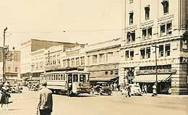
Source: HistoryLink, 2020.
Exhibit 1-2. East Yakima Avenue from a 1900s Postcard
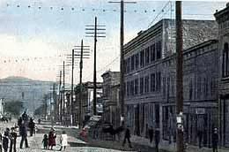
Source: HistoryLink, 2020.

Land Use

Overview
This Land Use analysis provides information on the current land use planning framework in the study area that consists of the city limits and the unincorporated urban growth area (UGA), including adopted land use plans, existing land uses, and future land use designations and zoning applied by the City Yakima and Yakima County. This chapter also characterizes neighborhood features.
This inventory relies primarily on information from the City of Yakima, Yakima County, and the Yakima Valley Conference of Governments. Additional data sources include population and housing estimates from the Washington State Office of Financial Management (OFM), data from the United States (US) Census Bureau and the American Community Survey (ACS).

Land Use Patterns and Growth

Existing Land Use
Yakima’s current land use pattern is dominated by single family residential uses, both in the city limits and the UGA. Exhibit 2-1 provides a map of existing land use in the City of Yakima. Exhibit 2-3 shows the total acreage in each of the seven Council Districts. Sections followed by these exhibits include detailed breakdown of land uses and maps by each Council District.
Exhibit 2-1. Existing Land Use Map
Source: City of Yakima, Yakima County Assessor, BERK, 2025.

Exhibit 2-2.Existing Land Use within the City Limits and Unincorporated UGA
Existing Land Use | Incorporated City (acres) | Share (%) | City + Unincorporated UGA (acres) | Share (%)
Single-family Residential | 5,547 | 38% | 9,787 | 38.5%
Multi-family Residential | 1,009 | 7% | 1,144 | 4.5%
Professional Offices or Services | 1,133 | 8% | 1,487 | 5.9%
Retail Commercial | 1,370 | 9% | 1,760 | 6.9%
Industrial | 1,675 | 11% | 2,024 | 8.0%
Government, Education, Utility, etc. | 766 | 5% | 1,071 | 4.2%
Parks, Recreation, Cultural | 263 | 2% | 265 | 1.0%
Agricultural | 1,298 | 9% | 3,570 | 14.1%
Vacant | 1,629 | 11% | 4,298 | 16.9%
Total | 14,692 |  | 25,408
Note: Acreages listed here are derived from parcel-level data and do not include right-of-way space. Total existing land use acreage shown here is slightly lower than the total land area of Yakima and its UGA.
Source: City of Yakima, 2025; Yakima County Assessor’s Office, 2025; BERK, 2025
Exhibit 2-3. Size of Council Districts in the City Limits (Acres), 2025
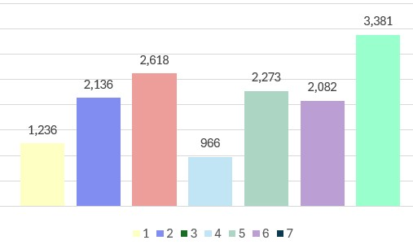
Source: City of Yakima, 2025; Yakima County Assessor’s Office, 2025; BERK, 2025

District 1
District 1 is primarily comprised of single family residential and vacant/undeveloped/open space lands. Exhibit 2-4 shows District 1 map with various existing land uses. Exhibit 2-5 provides the existing acres and shares for each existing land use group.
Exhibit 2-4. Current Land Use– District 1
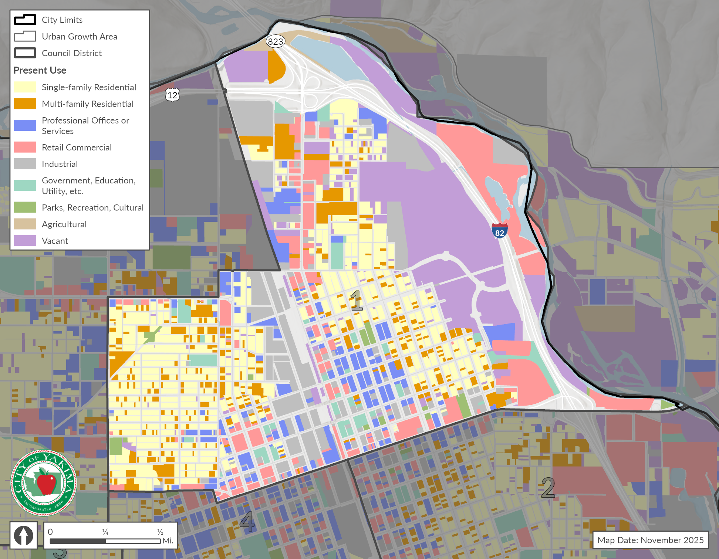
Source: City of Yakima, 2025; Yakima County Assessor’s Office, 2025; BERK, 2025

Exhibit 2-5. Land Use Acres – District 1
Existing Land Use Groups | Acres | Percent
Single-family Residential | 300.0 | 24.3%
Multi-family Residential | 127.0 | 10.3%
Professional Offices or Services | 100.0 | 8.1%
Retail Commercial | 187.0 | 15.1%
Industrial | 177.0 | 14.3%
Government, Education, Utility, etc. | 43.0 | 3.5%
Parks, Recreation, Cultural | 14.5 | 1.2%
Agricultural | 9.1 | 0.7%
Vacant | 278.0 | 22.5%
Total | 1,235.6 | 100%
Source: City of Yakima, 2025; Yakima County Assessor’s Office, 2025; BERK, 2025

District 2
District 2 predominantly includes single family residential and retail commercial. Exhibit 2-6 shows District 2 map with various existing land uses. Exhibit 2-7 provides the existing acres and shares for each existing land use group.
Exhibit 2-6. Current Land Use– District 2
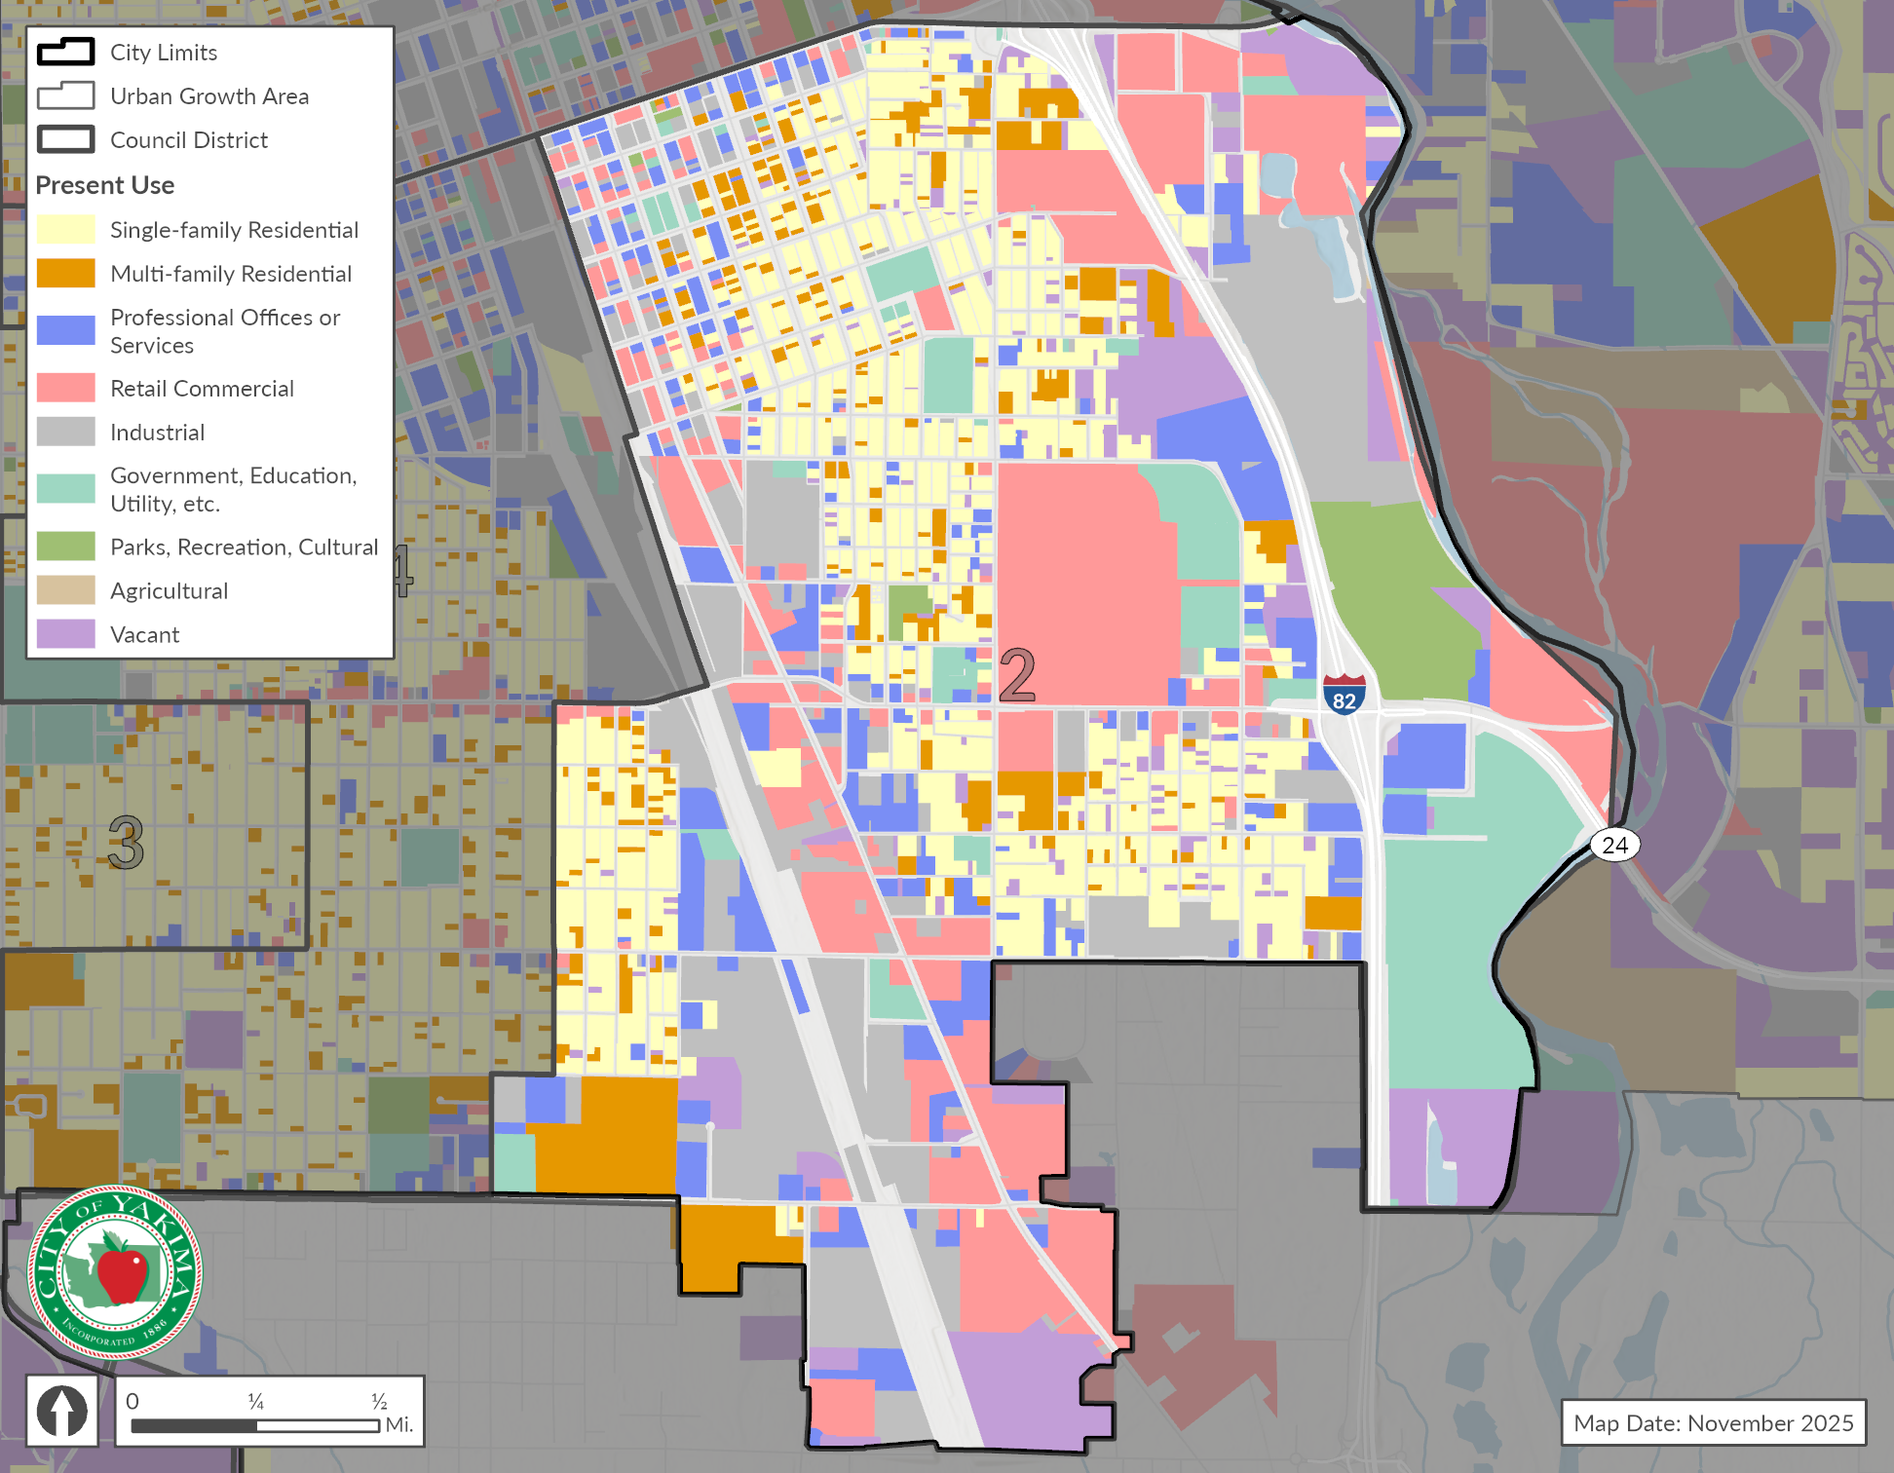
Source: City of Yakima, 2025; Yakima County Assessor’s Office, 2025; BERK, 2025

Exhibit 2-7. Land Use Acres – District 2
Existing Land Use Groups | Acres | Percent
Single-family Residential | 433.0 | 20.3%
Multi-family Residential | 171.0 | 8.0%
Professional Offices or Services | 216.0 | 10.1%
Retail Commercial | 472.0 | 22.1%
Industrial | 372.0 | 17.4%
Government, Education, Utility, etc. | 200.0 | 9.4%
Parks, Recreation, Cultural | 65.0 | 3.0%
Agricultural | 0.1 | 0.0%
Vacant | 207.0 | 9.7%
Total | 2,136.1 | 100%
Source: City of Yakima, 2025; Yakima County Assessor’s Office, 2025; BERK, 2025

District 3
District 3 is primarily comprised of single family residential. It also comprises of a major share of industrial land with the airport use. Exhibit 2-8 shows a District 3 map with various existing land uses. Exhibit 2-9 provides the existing acres and shares for each existing land use group.
Exhibit 2-8. Current Land Use– District 3
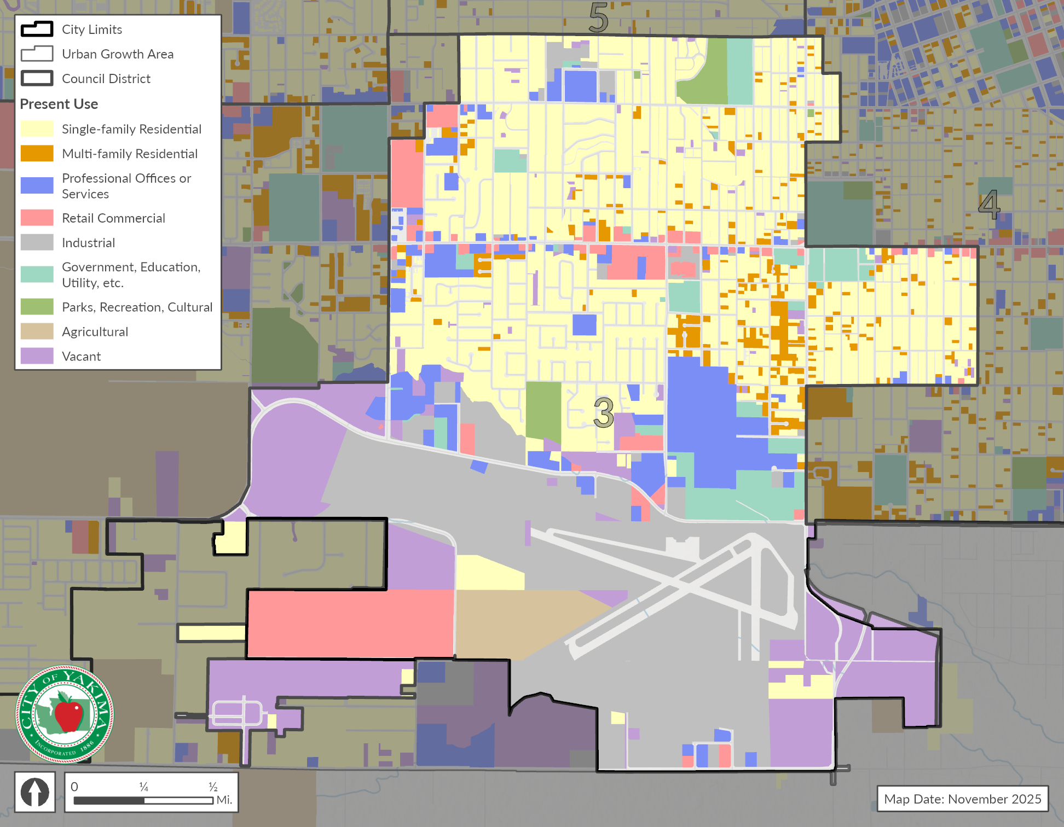
Source: City of Yakima, 2025; Yakima County Assessor’s Office, 2025; BERK, 2025

Exhibit 2-9. Land Use Acres – District 3
Existing Land Use Groups | Acres | Percent
Single-family Residential | 897.0 | 34.3%
Multi-family Residential | 85.0 | 3.2%
Professional Offices or Services | 202.0 | 7.7%
Retail Commercial | 198.0 | 7.6%
Industrial | 620.0 | 23.7%
Government, Education, Utility, etc. | 109.0 | 4.2%
Parks, Recreation, Cultural | 36.0 | 1.4%
Agricultural | 69.0 | 2.6%
Vacant | 402.0 | 15.4%
Total | 2,618.0 | 100%
Source: City of Yakima, 2025; Yakima County Assessor’s Office, 2025; BERK, 2025

District 4
Almost half of District 4 is comprised of single family residential (48.8%). Other uses such as multifamily residential, professional office, industrial, and government, education & utility have almost equal shares of land. Exhibit 2-10 shows the District 4 map with various existing land uses. Exhibit 2-11 provides the existing acres and shares for each existing land use group.

Exhibit 2-10. Current Land Use– District 4
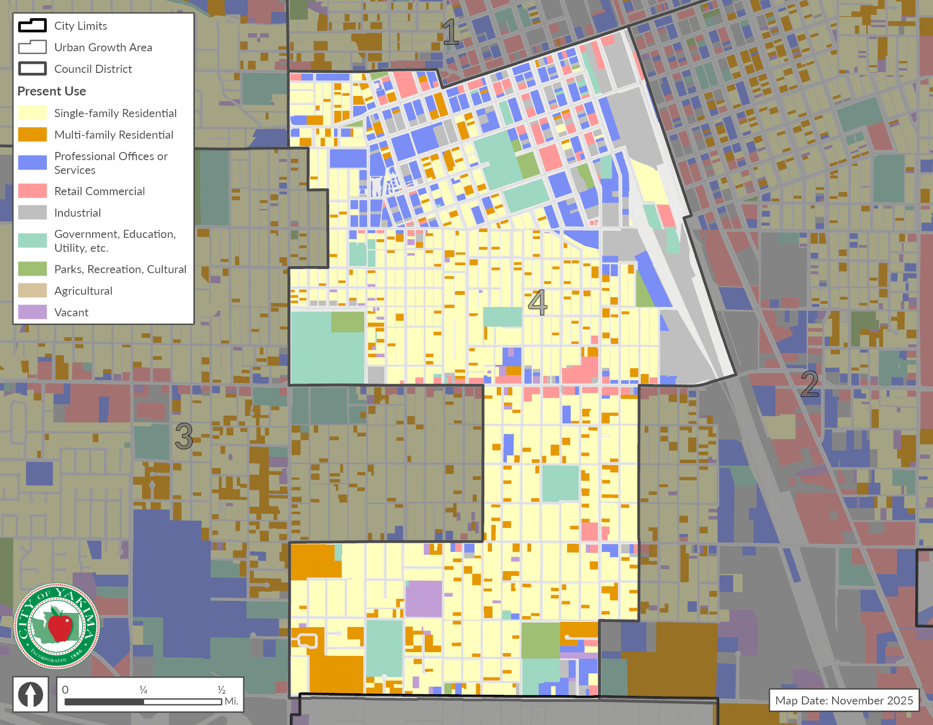
Source: City of Yakima, 2025; Yakima County Assessor’s Office, 2025; BERK, 2025

Exhibit 2-11. Land Use Acres – District 4
Existing Land Use Groups | Acres | Percent
Single-family Residential | 472.0 | 48.8%
Multi-family Residential | 103.0 | 10.7%
Professional Offices or Services | 110.0 | 11.4%
Retail Commercial | 43.0 | 4.4%
Industrial | 101.0 | 10.5%
Government, Education, Utility, etc. | 98.0 | 10.1%
Parks, Recreation, Cultural | 23.0 | 2.4%
Agricultural | 0.0 | 0.0%
Vacant | 16.4 | 1.7%
Total | 966.4 | 100%
Source: City of Yakima, 2025; Yakima County Assessor’s Office, 2025; BERK, 2025

District 5
District 5 is primarily single family residential (34.9%) and industrial (15.5%). Exhibit 2-12 shows District 5 map with various existing land uses. Exhibit 2-13 provides the existing acres and shares for each existing land use group.
Exhibit 2-12. Current Land Use– District 5
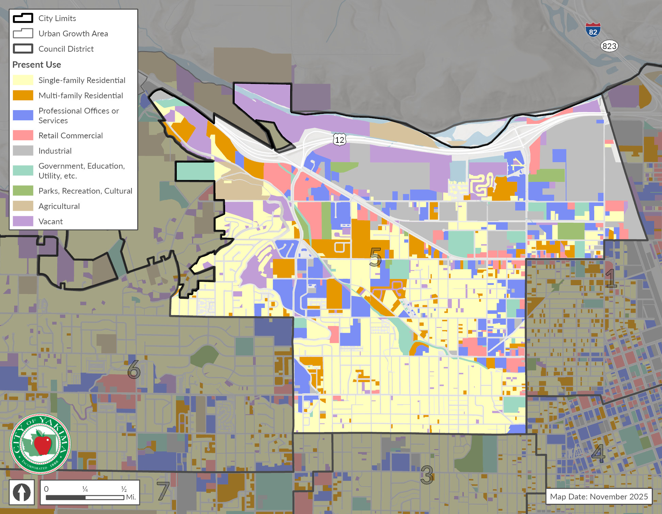
Source: City of Yakima, 2025; Yakima County Assessor’s Office, 2025; BERK, 2025

Exhibit 2-13. Land Use Acres – District 5
Existing Land Use Groups | Acres | Percent
Single-family Residential | 794.0 | 34.9%
Multi-family Residential | 206.0 | 9.1%
Professional Offices or Services | 289.0 | 12.7%
Retail Commercial | 126.0 | 5.5%
Industrial | 353.0 | 15.5%
Government, Education, Utility, etc. | 117.0 | 5.1%
Parks, Recreation, Cultural | 45.0 | 2.0%
Agricultural | 62.0 | 2.7%
Vacant | 281.0 | 12.4%
Total | 2,273.0 | 100%
Source: City of Yakima, 2025; Yakima County Assessor’s Office, 2025; BERK, 2025

District 6
District 6 is mostly single family residential (68.9%). Exhibit 2-14 shows District 6 map with various existing land uses. Exhibit 2-15 provides the existing acres and shares for each existing land use group.
Exhibit 2-14. Current Land Use– District 6
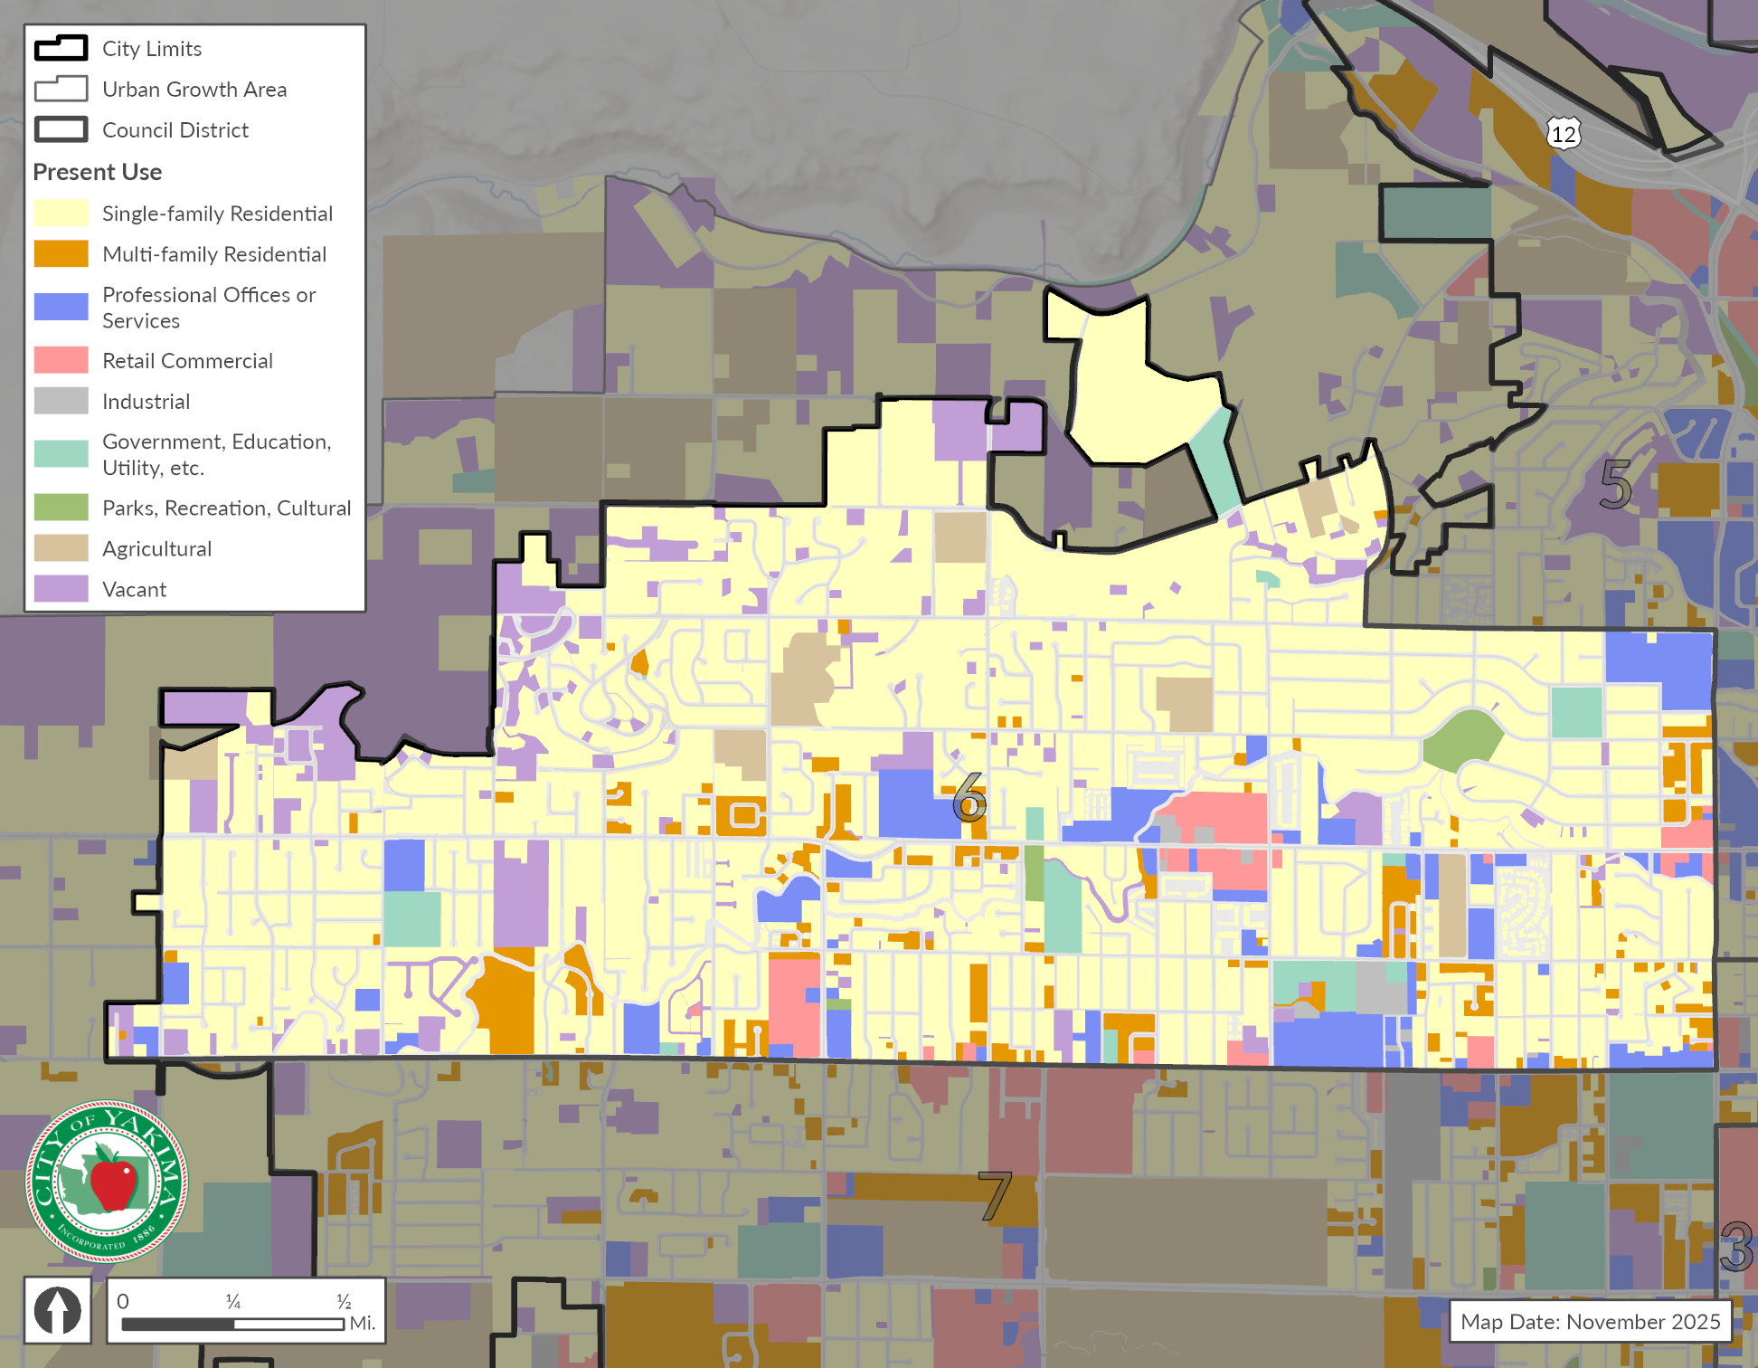
Source: City of Yakima, 2025; Yakima County Assessor’s Office, 2025; BERK, 2025

Exhibit 2-15. Land Use Acres – District 6
Existing Land Use Groups | Acres | Percent
Single-family Residential | 1,435.0 | 68.9%
Multi-family Residential | 113.0 | 5.4%
Professional Offices or Services | 149.0 | 7.2%
Retail Commercial | 55.0 | 2.6%
Industrial | 13.7 | 0.7%
Government, Education, Utility, etc. | 58.0 | 2.8%
Parks, Recreation, Cultural | 15.3 | 0.7%
Agricultural | 62.0 | 3.0%
Vacant | 181.0 | 8.7%
Total | 2,082.0 | 100%
Source: City of Yakima, 2025; Yakima County Assessor’s Office, 2025; BERK, 2025

District 7
Single family residential (36%) and agricultural (32.4%) are two predominant uses in District 7. Exhibit 2-16 shows District 6 map with various existing land uses. Exhibit 2-17 provides the existing acres and shares for each existing land use group.
Exhibit 2-16. Current Land Use– District 7
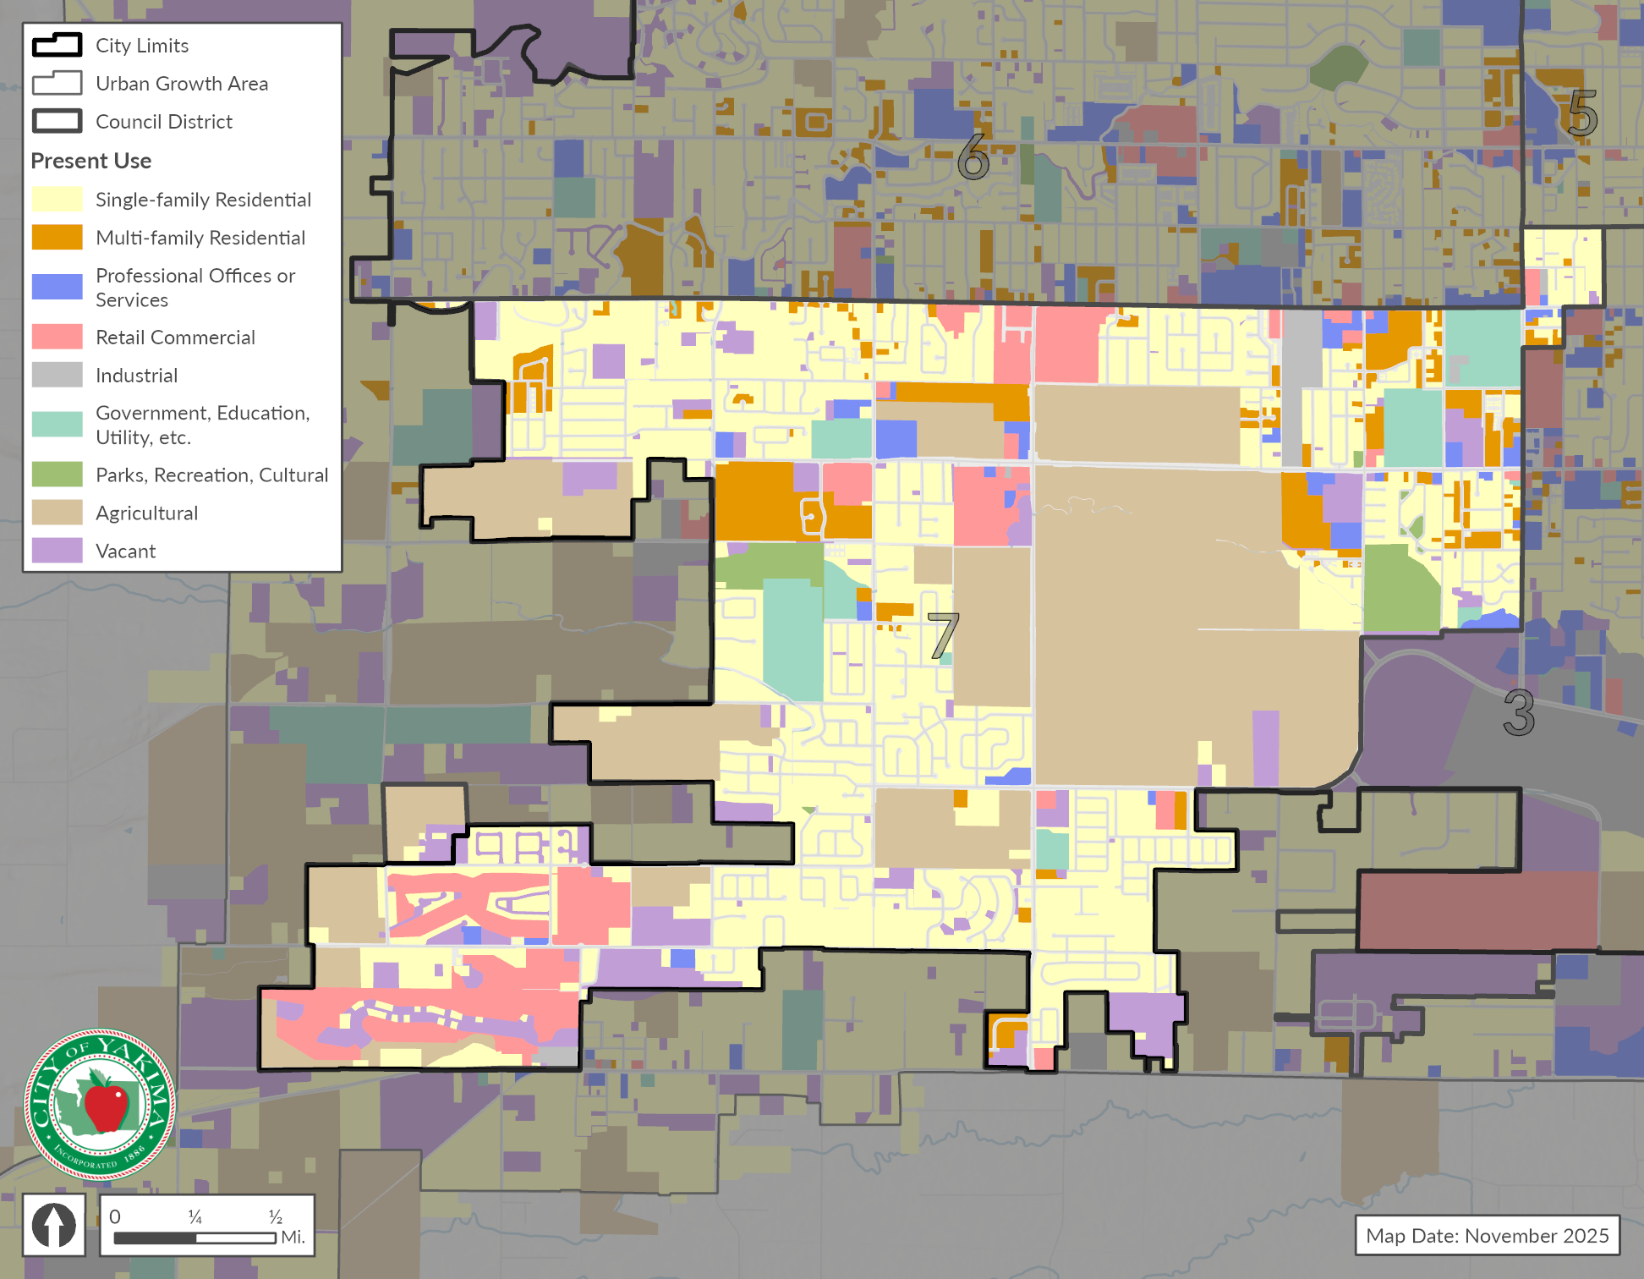
Source: City of Yakima, 2025; Yakima County Assessor’s Office, 2025; BERK, 2025

Exhibit 2-17. Land Use Acres – District 7
Existing Land Use Groups | Acres | Percent
Single-family Residential | 1,216.0 | 36.0%
Multi-family Residential | 204.0 | 6.0%
Professional Offices or Services | 67.0 | 2.0%
Retail Commercial | 289.0 | 8.5%
Industrial | 39.0 | 1.2%
Government, Education, Utility, etc. | 141.0 | 4.2%
Parks, Recreation, Cultural | 65.0 | 1.9%
Agricultural | 1,096.0 | 32.4%
Vacant | 264.0 | 7.8%
Total | 3,381.0 | 100%
Source: City of Yakima, 2025; Yakima County Assessor’s Office, 2025; BERK, 2025

Future Land Use
Yakima’s land use map designates Low Density Residential as a predominant land use constituting about 53% of the total. Exhibit 2-18 shows the future land use map with Council Districts. See land within the City and UGA. See Exhibit 2-19 for the acreages within the city limits and the UGA .

Exhibit 2-18. Future Land Use Map
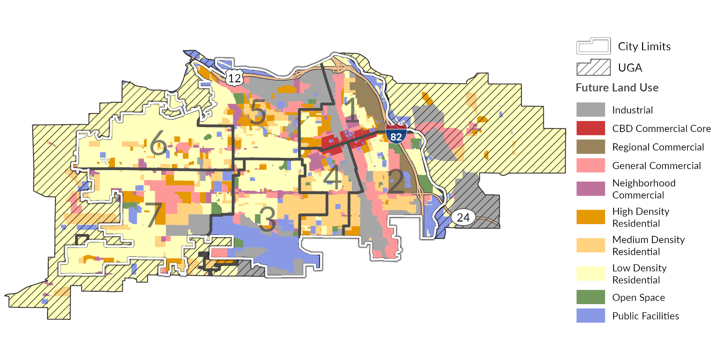
Source: City of Yakima, 2025; Yakima County Assessor’s Office, 2025; BERK, 2025

Exhibit 2-19. Future Land Use in Acres
Future Land Use | Incorporated City (acres) | Unincorporated UGA (acres) | Total (acres) | Share (%)
Industrial | 2,104 | 1,199 | 3,303 | 11.6%
CBD Commercial Core | 254 | 0 | 254 | 0.9%
Regional Commercial | 516 | 0 | 516 | 1.8%
General Commercial | 1,792 | 273 | 2,066 | 7.3%
Neighborhood Commercial | 598 | 52 | 650 | 2.3%
High Density Residential | 1,255 | 115 | 1,369 | 4.8%
Medium Density Residential | 2,194 | 553 | 2,747 | 9.7%
Low Density Residential | 6,910 | 8,022 | 14,932 | 52.5%
Open Space | 403 | 0 | 403 | 1.4%
Public Facilities | 1,797 | 422 | 2,219 | 7.8%

Exhibit 2-20. Future Land Use Areas by Council District
Future Land Use | Council District #1 | Council District #2 | Council District #3 | Council District #4 | Council District #5 | Council District #6 | Council District #7
Industrial | 190 | 461 | 331 | 184 | 665 | 17 | 257
CBD Commercial Core | 140 | 63 | 0 | 51 | 0 | 0 | 0
Regional Commercial | 294 | 222 | 0 | 0 | 0 | 0 | 0
General Commercial | 212 | 674 | 155 | 92 | 247 | 53 | 361
Neighborhood Commercial | 59 | 4 | 113 | 100 | 109 | 82 | 129
High Density Residential | 176 | 92 | 85 | 78 | 342 | 133 | 391
Medium Density Residential | 71 | 374 | 438 | 459 | 257 | 184 | 455
Low Density Residential | 474 | 383 | 878 | 261 | 898 | 2,053 | 2,039
Open Space | 14 | 142 | 92 | 20 | 54 | 15 | 67
Public Facilities | 148 | 247 | 952 | 72 | 208 | 48 | 137

Land Capacity Analysis
As part of the Yakima Comprehensive Plan process, BERK Consulting, Inc. (BERK) conducted a Land Capacity Analysis (LCA) to determine the capacity for housing units and jobs within the City and surrounding unincorporated Urban Growth Area (UGA). This analysis estimated the total amount of new development that could occur on vacant or underutilized residential, commercial, and industrial lands over the planning period (2026-2046). Capacity is determined by several factors, including available land area, zoning regulations, critical areas identified by the city code, and market factors.
BERK’s analysis examined individual parcels and deducted mapped critical areas in accordance with the existing Yakima Municipal Code (Chapter 15.27). The base point-in-time in which capacity was measured is May 2025, and the study area includes the entire city limits and UGA, both incorporated and unincorporated areas. Parcel data was retrieved from the Yakima County Assessor’s publicly available records. Critical area data was obtained as listed in Exhibit 2-21. For each critical area type, BERK applied a spatial buffer according to the City of Yakima development regulation requirements.
Exhibit 2-21. Critical Area & Other Deductions
Category | Definition | Method/Assumption | Data Source(s)
Wetlands | All as determined by the National Wetland Inventory. | Category IV: 40’  All other categories: 150’ | National Wetland Inventory  Washington Department of Ecology  City of Yakima
Streams, lakes, and ponds | All, with attributes for fish-bearing streams. | Streams and lakes:  - Type 1:  - Streams: 100’  - Lakes: 50’  - Type 2: 100’  - Type 3: 50’  - Type 4: 25’ | Washington Department of Natural Resources
Flood zones | 100-yr flood zones. | No buffer | FEMA
Geologic hazards & steep slopes | High risk geologic hazards and slopes >40% across at least 10 feet. | No buffer | City & University of Washington Digital Elevation Models
Sources: City of Yakima Municipal Code Chapter 15.27; BERK, 2025.
Once critical areas and their respective buffers were removed from the parcel land area, certain parcels were selected to be excluded from subsequent analysis based on the assumption that they are unlikely to see new development over the planning period. These parcels were selected based on present use information from the Yakima County Assessor’s Office. The specific use types considered not developable during the planning period, include:
- Schools
- Police & fire stations
- Utilities
- Open spaces & preserves
- State or federally owned land
- Churches & places of worship
- Community centers
After flagging those parcels for removal, the remaining parcels were assigned a current developable status. Exhibit 2-22 defines each parcel development status. Vacant, Agricultural, Partially-used, and Redevelopable parcels are assumed to have capacity for future development. Developed parcels are assumed to not have capacity for additional growth during the planning period.
Exhibit 2-22. Parcel Development Status Definitions
Status Type | Definition | Method/Assumption | Data Source(s)
Vacant | Residential-zoned parcels on which no significant development has occurred. | Improvement value <$10,000 | County Assessor’s Office, City zoning
Agricultural | Residential-zoned parcels with agriculture as current use. | Privately-owned land with agricultural current use | County Assessor’s Office, City zoning
Partially-used | Residential-zoned parcels with existing housing units but capacity to add additional units. | Single-family parcels in SR and R1 zones with single-family current use and greater than 0.5 acres. | County Assessor’s Office, City zoning
Redevelopable | Parcels with existing structures (residential, commercial, or industrial) and a likelihood of redevelopment. | (Not SR or R1 zones) Commercial, multi-family residential, or industrial zoned parcels with single-family current use and/or the ratio of improvement value to land value is <1 | County Assessor’s Office, City zoning
Developed | Already developed and not expected to see new development during the planning period. | All parcels not included in any of the above categories.
Sources: City of Yakima, Yakima County Assessor, BERK, 2025.
Next, BERK summed the buildable areas of developable parcels by zone. Additional deductions were then applied to this aggregated developable area to account for future right of way and market factors – the assumption that not all properties would change in the planning period such as due to property owner preferences. The amount deducted was dependent on the parcel status. For example, space needed for future rights-of-way to serve new development was deducted from all parcels, but Vacant and Agricultural parcels had higher deductions for future rights-of-way as they are less likely to already be served by that infrastructure than Partially-used or Redevelopable parcels. The deductions applied were:
- 2.5% deduction for future public or semi-public uses
- Vacant or Agricultural parcels:
  - 15% deduction for future rights-of-way
  - 15% deduction for market factors
- Partially-used or Redevelopable parcels:
  - 10% deduction for future rights-of-way
  - 25% deduction for market factors
The output is the total developable area for the entire UGA within the planning period. Tagging parcels by their zoning designation and whether they are within the incorporated city illustrates developable area by zone and jurisdiction. Exhibit 2-23 presents the total developable area by zone in acres as determined by this LCA model.
Exhibit 2-23. Developable Land Area in the Yakima UGA by Zone
Zone | Incorporated City (acres) | Unincorporated UGA (acres) | Full UGA (acres)
SR | 128 | 790 | 918
R-1 | 933 | 2,368 | 3,302
R-2 | 948 | 283 | 1,231
R-3 | 264 | 39 | 303
B-1 | 35 | 0 | 36
B-2 | 68 | 17 | 85
HB | 0 | 0 | 0
SCC | 71 | 53 | 124
LCC | 10 | 0 | 10
CBD | 33 | 0 | 33
GC | 330 | 30 | 360
M-1 | 437 | 282 | 720
M-2 | 17 | 0 | 17
RD | 94 | 0 | 94
AS | 40 | 0 | 40
Total | 3,409 | 3,863 | 7,272
Sources: City of Yakima, Yakima County Assessor, BERK, 2025.
Zone-specific density assumptions were then applied to the developable area outputs to determine the capacity for new housing units and jobs within the planning period. Assumptions were largely carried over from analysis completed during the previous City of Yakima Housing Needs Assessment in 2017. These values were the result of the analysis of achieved and potential densities per zone within Yakima. For mixed-use zones, the total developable acreage of that zone was split between commercial and residential uses. Exhibit 2-25 shows density and mixed use split assumptions.
Exhibit 2-24. Density and Mixed-Use Split Assumptions by Zone in the Yakima UGA
Zone | Units per Acre | Floor Area Ratio | Square Feet per Job | Split  (Residential/ Non-Residential)
Residential: SR (single-family) | 4 | N/A | N/A | 100% / 0%
Residential: R-1 (single-family) | 7 | N/A | N/A | 100% / 0%
Residential: R-2 (two-family) | 12 | N/A | N/A | 100% / 0%
Residential: R-3 (multi-family) | 18 | N/A | N/A | 100% / 0%
Mixed-use: B-1 | 15 | 0.26 | 500 | 50% / 50%
Mixed-use: B-2 | 15 | 0.26 | 500 | 50% / 50%
Mixed-use: SCC | 15 | 0.26 | 500 | 50% / 50%
Mixed-use: LCC | 15 | 0.26 | 500 | 50% / 50%
Mixed-use: CBD | 15 | 2.0 | 500 | 50% / 50%
Mixed-use: GC | 15 | 0.26 | 500 | 33% / 67%
Mixed-use: HB | N/A | 1.0 | 500 | 50% / 50%
Industrial: M-1 | N/A | 0.45 | 1,000 | 0% / 100%
Industrial: M-2 | N/A | 0.45 | 1,000 | 0% / 100%
Mixed-use: RD | 15 | 0.35 | 500 | 50% / 50%
Airport: AS | N/A | N/A | 1,000 | 0% / 100%
To calculate capacity for net new housing units, a zoning designation’s total developable acreage (after deductions) was first multiplied by its residential split (e.g. if in a mixed use zone a share would be residential and a share would be commercial) then by its assumed units per acre. For partially-used and redevelopable parcels, existing units were then deducted from the total capacity to achieve a net new unit capacity.
Next, we estimated capacity for accessory dwelling units (ADUs). Our analysis estimates the number of net new housing units that could be built in the form of ADUs on parcels that are already developed with a detached single unit home. To identify parcels that could add an ADU, we used the following criteria:
- Residential parcels that have only one unit as of 2025
- Zoning allows for ADUs
- Lot size beyond the minimum required to support the existing single-family structure but no larger than half an acre, as those parcels would be candidates for subdivision.
Following guidance from the Washington State Department of Commerce, we assumed that 10% of parcels identified as having potential to add an ADU would choose add a single new ADU within the planning horizon.
Presents the capacity of new ADUs for the city of Yakima. The majority of ADU capacity exists in areas zoned R-1.
Exhibit 2-25. New ADU Capacity by Zone
Zone | ADU Capacity (Incorporated City) | ADU Capacity (Unincorporated UGA) | ADU Capacity (Full UGA)
SR | 10 | 6 | 15
R-1 | 1,213 | 198 | 1,412
R-2 | 449 | 2 | 451
R-3 | 104 | 4 | 109
B-1 | 9 | 0 | 9
B-2 | 8 | 1 | 9
HB | 0 | 0 | 0
SCC | 2 | 0 | 2
LCC | 0 | 0 | 0
CBD | 0 | 0 | 0
GC | 36 | 0 | 36
M-1 | 0 | 0 | 0
M-2 | 0 | 0 | 0
RD | 2 | 0 | 2
AS | 0 | 0 | 0
Total | 1,832 | 211 | 2,043
Exhibit 2-25 shows the net new housing unit capacity per zone, including ADUs, as determined by this Land Capacity Analysis.
Exhibit 2-26. Net New Housing Units by Zone
Zone | Unit Capacity (Incorporated City) | Unit Capacity (Unincorporated UGA) | Unit Capacity (Full UGA)
SR | 665 | 3,710 | 4,375
R-1 | 7,095 | 15,776 | 22,871
R-2 | 6,944 | 3,327 | 10,271
R-3 | 3,273 | 617 | 3,890
B-1 | 186 | 1 | 187
B-2 | 426 | 116 | 541
HB | 0 | 0 | 0
SCC | 516 | 396 | 912
LCC | 74 | 0 | 74
CBD | 187 | 0 | 187
GC | 1,301 | 145 | 1,445
M-1 | 0 | 0 | 0
M-2 | 0 | 0 | 0
RD | 1,062 | 0 | 1,062
AS | 0 | 0 | 0
Total | 21,728 | 24,087 | 45,815
Finally, to arrive at total job capacity, buildable square footage capacity was calculated as the developable acreage multiplied by an assumed Floor Area Ratio (FAR) and converted into square feet. The product was then multiplied by the assumed Square Feet per Job value respective of zoning (shown in Exhibit 2-26). The final job capacity outputs from the model are shown in Exhibit 2-27.
Exhibit 2-27. Square Feet per Job Assumptions
Zone | Square Feet per Job
SR | N/A
R-1 | N/A
R-2 | N/A
R-3 | N/A
B-1 | 500
B-2 | 500
HB | 500
SCC | 500
LCC | 500
CBD | 500
GC | 500
M-1 | 1,000
M-2 | 1,000
RD | 500
AS | 1,000
Exhibit 2-28 Job Capacity by Zone
Zone | New Jobs Capacity (Incorporated City) | New Jobs Capacity (Unincorporated UGA) | New Jobs Capacity (Full UGA)
SR | 0 | 0 | 0
R-1 | 0 | 0 | 0
R-2 | 0 | 0 | 0
R-3 | 0 | 0 | 0
B-1 | 374 | 3 | 377
B-2 | 648 | 173 | 821
HB | 11 | 0 | 11
SCC | 600 | 592 | 1,192
LCC | 56 | 0 | 56
CBD | 2,558 | 0 | 2,558
GC | 4,224 | 406 | 4,631
M-1 | 8,337 | 6,313 | 14,650
M-2 | 334 | 0 | 334
RD | 1,997 | 0 | 1,997
AS | 0 | 0 | 0
Total | 19,140 | 7,487 | 26,627

Planning and Regulatory Context
Beyond the Comprehensive Plan Land Use Element, Regulations and Plans shaping the design of the built environment include the City’s zoning ordinance and a series of functional plans guiding infrastructure. Each is addressed below.

Title 15 – Yakima Urban Area Zoning Ordinance
Title 15 of the Yakima Municipal Code provides standards for the various zoning districts and permitted uses throughout the City. Key provisions affecting the design of development include:
Permitted uses (Chapter 15.04) and associated land use classification system. While nearly all cities contain lists of permitted outright, conditional, and permitted uses, Yakima has a system of review approvals from Class 1 to 3. Exhibit 2-28 shows difference use classifications.
Exhibit 2-29 Use Classes for Permitting
Class Type | Description | Example of uses in zones
Class 1 | Permitted subject to administrative approval | Attached or residential uses in R-1 or R-2 zones
Class 2 | Permitted uses also subject to administrative approval, but allows the administrative official to add conditions to mitigate impacts or require Class 2 uses to undergo a Class 3 review if certain conditions are present. Since there are very little design related standards in Title 15, this system adds a level of uncertainty and unpredictability to the review of uses that can be challenging both to applicants and the administrative official. | Parts and Accessories (tires, batteries, etc.) uses in B2 zone.
Class 3 | Uses are generally not permitted in a district, but may be approved by the hearing examiner after Type III review and a public hearing. The hearing examiner may impose conditions to an approval. As with Class 2 approvals, without the benefit of design standards within Title 15, this procedure can add a level of uncertainty and unpredictability to the review of such uses. | Office Contractor Building and Trade (Plumbing, Heating, Electrical, and Painting) in R-3 zone.
Site design and improvement standards (Chapter 15.05) address the following aspects. These standards implement various land use policies of the Plan:
- Maximum lot coverage (percentage of land area covered by structure and other impervious areas)
- Minimum front, side, and rear setbacks (which vary depending on adjacent street classification)
- Maximum height
- Fence and wall height standards
- Access requirement (frontage by a public road or acceptable access easement)
- Sidewalks are required on one side of the street (except for single family structures). If no sidewalks existing within 200 feet of the use, no sidewalks are required.
- Maximum density calculations (dwelling unit/acre)
- Minimum lot size and width (which varies depending on housing type and zone)
- Other development standards in Title 15 of the Yakima Municipal Code. This includes:
- Off-street parking and loading (Chapter 15.06), which addresses minimum parking requirements, driveway locations, parking lot landscaping and lighting, and off street loading requirements.
- Site screening standards (Chapter 15.07), which requires 3-10-feet of landscape screening or fencing for uses along edges of zoning districts.
- Sign standards (Chapter 15.08)
- Special development standards (Chapter 15.09) for specific uses
- Critical areas provisions (Chapter 15.27)
- Master planned development overlay provisions (Chapter 15.28)
- Wireless communication facilities provisions (Chapter 15.29)
- Overlay zone provisions (Chapters 15.28, 15.30, and 15.31 regarding master planned development, airport safety, and institutional overlays)

Adopted Plans and Projects

Yakima Housing Action Plan 2021
The Housing Action Plan developed objectives and strategies for Yakima to promote affordable housing. Objectives were set to increase housing supply and affordability, increase home ownership, and prevent displacement. It set priorities for various strategies for implementation to be led by the City or its partners.

Yakima Parks and Recreation Comprehensive Plan 2022-2027
The Parks and Recreation Comprehensive Plan, adopted in 2022, is the required six-year park plan update, which includes an inventory of park and recreational facilities, needs inventory, opportunities, goals and objectives, industry standards, demands, and needs, and a capital improvement program.

Historic Preservation Element (July 15, 2016)
The Yakima Historic Preservation Commission completed this Element consistent with the GMA. It was incorporated with the 2040 Comprehensive Plan in 2017. YMC 11.62, Historic Preservation Ordinance for Special Evaluation provides implementation code for this element.

2040 Transportation System Plan (adopted in 2017)
The Transportation System Plan is intended to serve as a guide for making transportation decisions to address both short and long term needs. To meet Growth Management Act (GMA) requirements, the Transportation Systems Plan must identify existing transportation system characteristics, establish standards for levels of service, and identify existing and future deficiencies based on land use growth projections.

Six Year Transportation Improvement Plan (From 2025 to 2030)
The Transportation Improvement Plan identifies major projects and funding sources for a six-year time frame. Yakima’s Transportation Element will be updated as part of the Comprehensive Plan, in coordination with Yakima Valley Regional Council’s (YVCOG) data.

Downtown Master Plan
In November of 2013, the City Council approved an Action Plan of steps to be taken to accomplish this priority. The Action Plan was a summary of the Yakima Downtown Master Plan Report prepared in 2013 by Crandall Arambula for the City Council. The Plan provided several action recommendations. Some of the actions have been completed such as a parking plan, and Chestnut Avenue improvement. The City is considering a new strategic plan in 2026 to identify goals and actions for Yakima’s downtown.

Wastewater Collection System Master Plan
This master plan was prepared in 2023 and describes the City’s wastewater collection system, the planning area characteristics, hydraulic criteria, and the hydraulic model development. The prioritized capital improvement program accounts for growth through the Yakima Urban Growth Area and includes suggested construction triggers for the orderly expansion of the wastewater collection system.

Yakima Waste Water Treatment Plant Facility Master Plan, 2022
The purpose of this Plan is to review the overall condition of the treatment plan facility and its capability to meet capacity needs and regulatory requirements through the planning period. The primary factors that will drive WWTP improvements are generally conditions, capacity, and/or regulatory based. This plan identifies existing and future needs or deficiencies of the WWTP and recommends improvements to remedy these items. The Treatment Plan is projected to serve 147,090 people by 2040, identify gaps and includes recommendations.

Yakima 2017 Water System Plan
The City’s water system plan was developed in 2017 to analyze the service area, water system and forecast water demand. This plan identifies policies for providing services such as annexation requirements, performance standards etc. The City aims to connect underserved areas to northeast and south-central areas in the City where utility services currently do not exist.

Housing Analysis

Overview
The City of Yakima’s Housing Element provides a framework for the City to support and encourage housing supply that meets local housing needs. The Housing Element will plan to increase housing choice and affordability for Yakima residents and workers of all income levels.
This Housing Existing Conditions Report will serve as an appendix to the Housing Element. The purpose of this report is to provide an understanding of the Yakima community and its housing conditions. Overall, this report answers the following questions:
- Who lives and works in Yakima and what are their socioeconomic characteristics?
- What types of housing are available in Yakima?
This report includes a Community Profile and Housing Inventory. The Community Profile analyzes Yakima’s population trends and projections, and includes data on age, race and ethnicity, household size, residents with special housing needs such as homelessness, disability status, farm workers, and employment. The Housing Inventory summarizes characteristics of Yakima’s housing stock, including housing types, location, tenure, unit sizes, conditions, and affordability for both rental and owned housing.
Based on this understanding, we conduct analysis to assess future housing needs.

Summary of Key Findings
- There is a housing shortage in Yakima. Only 2.4% of rental housing units in Yakima are vacant, which is lower than what is considered a healthy rate of 5% to 6%. The supply of ownership housing is also constrained. When vacancy rates and supply are low, people looking for homes have fewer options, increasing competition for the limited units available. This drives up both rents and housing prices.
- Housing prices are rising faster than incomes. The typical home value in Yakima has risen by 99%, nearly doubling, between 2014 to 2022. Over the same period, the median family income only increased by 43%. This indicates homeownership is getting further out of reach for many prospective buyers.
- Many households in Yakima are cost-burdened. Between 2017 and 2021, 32% of all households in Yakima were cost burdened. Nearly half (44%) of renter households, and just under a quarter (23%) of owner households, were cost-burdened. Cost-burdened households spend a large portion (over 30%) of their available income on housing costs. This leaves less money available for other vital needs like food, transportation, healthcare, and education.
- Needs are greatest among low-income households. About 75% of all households with incomes below 50% of the Area Median Income (AMI) are cost-burdened. Over half of these households are severely cost-burdened, meaning they spend over 50% of their income on housing costs. While there are low-income households living in neighborhoods across the city, the greatest concentration of low-income households is in eastern Yakima, and many of these households are of Hispanic/Latino ethnicity.
- There is considerable need among elderly residents. There are 3,405 cost-burdened elderly households in Yakima. About a third of these households are elderly persons (age 62+) living alone, and nearly all have incomes well below the county median. These residents are spending more than 30% of their income on housing costs and often have fixed incomes that don’t keep pace with rising housing costs over time.
- Yakima needs more housing diversity. Over 60% of all housing in the City of Yakima are single-family homes. Not all households require, or can afford, that much space. For example, 30% of all households in Yakima are individuals living alone. Yet only 6% of housing units in Yakima are studios and only 11% have just one bedroom. Increasing the diversity of housing options available will increase housing supply and provide more choices for residents seeking more affordable housing that meets their current needs.

Community Profile

Population
During the last ten years, Yakima County had an annual average population growth rate of about 0.6%, which was less than half Washington’s statewide growth rate of 1.4%. Yakima County’s population was estimated to be 263,200 in 2024, up from the 248,229 county residents in 2014. As the county’s largest population center, the City of Yakima has also grown steadily in recent years. In 2024, the city had an estimated population of 99,370 residents.
While Yakima has grown at a steady rate, the city slower growth than most peer cities in eastern and central Washington, as shown in Exhibit 3-1. Population Growth in City of Yakima and Peer Cities, 2016-2024.
Exhibit 3-1. Population Growth in City of Yakima and Peer Cities, 2014-2024
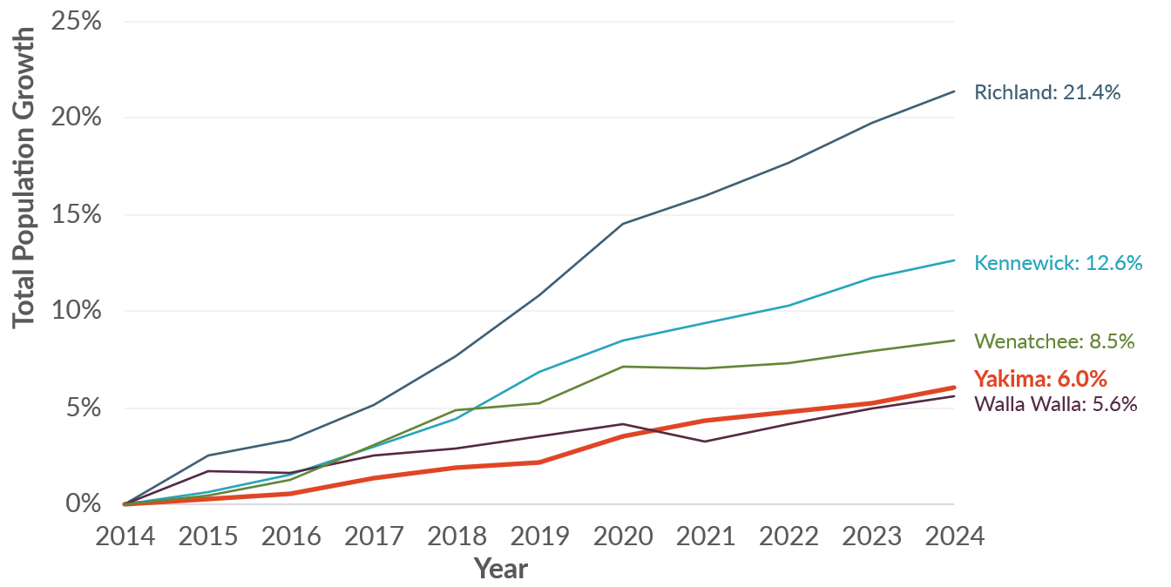
Sources: Washington Office of Financial Management, 2024; BERK, 2025.

Age of Population
The City of Yakima’s age distribution aligns closely with Yakima County, with a slightly smaller proportion of younger residents (0 – 24 years old) and a slightly larger proportion of older residents (70+ years old) than the county, as shown in Exhibit 3-2. Age Distribution in City of Yakima and Yakima County, 2022. The City of Yakima has a large population of children, with 29,558 aged 19 years old or younger (31% of the total population).
Exhibit 3-2. Age Distribution in City of Yakima and Yakima County, 2022
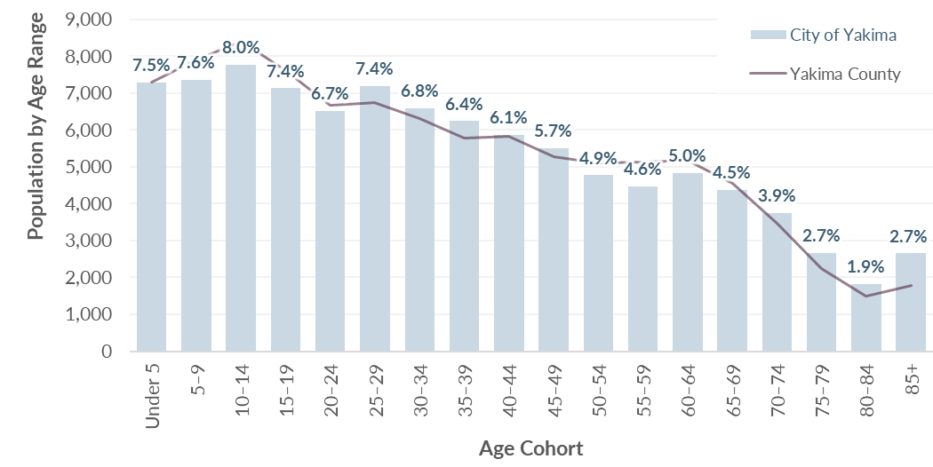
Sources: US Census Bureau, American Community Survey 5-Yr Estimates, 2018-2022; BERK, 2025.
Demographic patterns across Yakima vary by geography. As shown in Exhibit 3-3, residents aged 65 or older are more typically located in the north central and western parts of the city. This aligns with the locations of local retirement communities and assisted living facilities such as The Terraces at Summitview and Fieldstone. Residents under 18 are more typically located in the south central and eastern parts of the city. Many of the areas with larger youth populations have larger proportions of Hispanic or Latino residents, as shown later in Exhibit 3-6.
Exhibit 3-3. Areas with Large Percentages of Senior or Minor Residents, City of Yakima, 2022
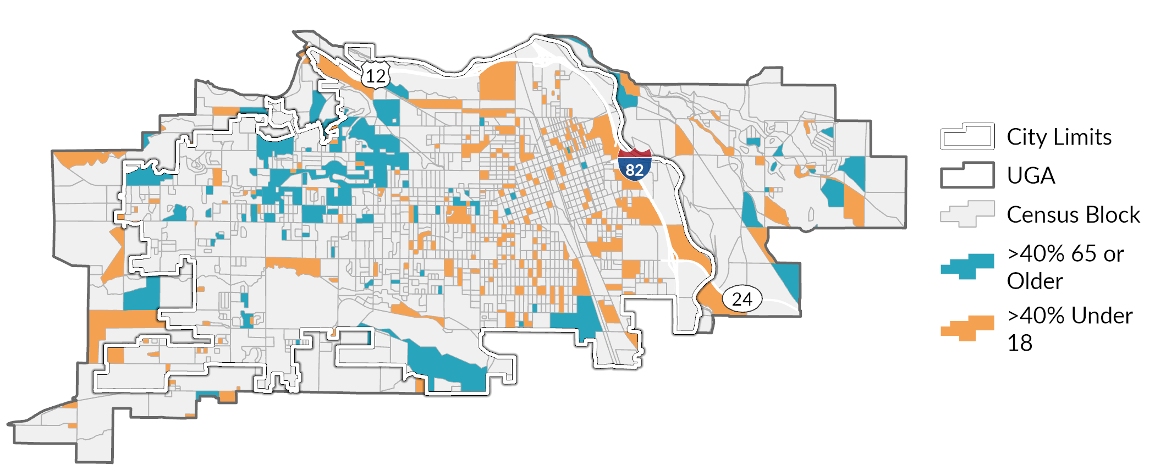
Sources: US Census Bureau, American Community Survey 5-Yr Estimates, 2018-2022; BERK, 2025.

Race and Ethnicity
Yakima is ethnically diverse. The City of Yakima’s Hispanic or Latino population comprises 47% of the total population, the largest of any reported comparison geographies besides Yakima County. The share of people who identify as Non-Hispanic People of Color grew from 5% in 2017 to 8% in 2022. A comparison of Yakima’s Hispanic or Latino population to comparable communities is shown in Exhibit 3-4. Percentage of Population by Race and Ethnicity in City of Yakima and Comparison Geographies, 2017 and 2022.
The Non-Hispanic People of Color group includes those who identify as American Indian or Alaska Native, which makes up 1% of the city’s population, as well as other races. This percentage likely reflects the nearby presence of the Yakama Nation in Yakima County.
Exhibit 3-4. Percentage of Population by Race and Ethnicity in City of Yakima and Comparison Geographies, 2017 and 2022
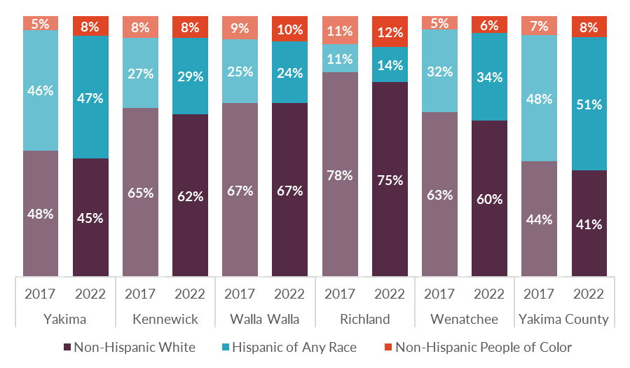
Sources: US Census Bureau, American Community Survey 5-Yr Estimates, 2018-2022; BERK, 2025.
Reflecting its ethnic diversity, Yakima has a high proportion of residents (38%) who speak a language other than English at home compared to 21% statewide, shown in Exhibit 3-5. Spanish is the most common language among non-English speakers, with 36% of the city’s total population speaking it at home.
History of The Latino community in yakima County
The large number of Latino and Hispanic residents in the city reflects historical patterns of migration and employment, tied mostly to the local agricultural industry. While the city has been a destination for migrant Hispanic farmworkers over the years, growing numbers of Hispanic farmworkers began permanently settling in the area from the 1930s to 1980s due to changes in the agricultural industry and immigration reforms.
Yakima’s population grew from roughly 3,200 residents in 1900, steadily increasing decade after decade, to 45,500 in 1960. These population increases were in part due to the arrival of Mexican American farmworkers from Texas in the early 1930s. During World War II, the U.S. government established the Bracero program, which allowed Mexican citizens to come to the Yakima Valley to work. While these workers did not settle in the Valley, this established the Yakima Valley as a destination for Latinx farmworkers. By the 1980s many former seasonal workers settled permanently in the Yakima Valley due to changes in immigration policies. By the 1980s, Yakima County's Hispanic population was 14.8%, and by the 2000 census, 33% of the residents of Yakima County were of Hispanic or Latino origin, compared to 7.5% in the state. In 2022, 51% of Yakima County’s population identified as Hispanic, nearly four times the statewide percentage of 13.1%
Source: HistoryLink.org Essay 9187 by Jim Kershner

Exhibit 3-5. Languages Spoken at Home in City of Yakima and Washington State, 2017 and 2022
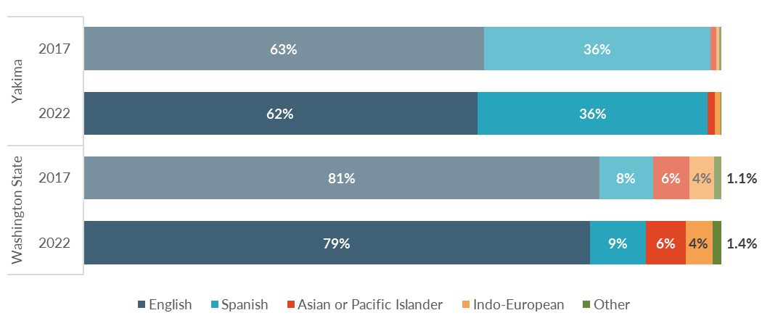
Sources: US Census Bureau, American Community Survey 5-Yr Estimates, 2018-2022; BERK, 2025.
Areas on the east half of the city and near downtown have larger proportions of residents of Hispanic or Latino origin than areas on the west half of the city, as shown in Exhibit 3-6. Comparing to the age distribution map shown in Exhibit 3-3 reveals that there are larger populations of residents under 18 in areas that have large proportions of Hispanic or Latino residents.
Exhibit 3-6. Percent of Residents that Identify as Hispanic or Latino, City of Yakima, 2022
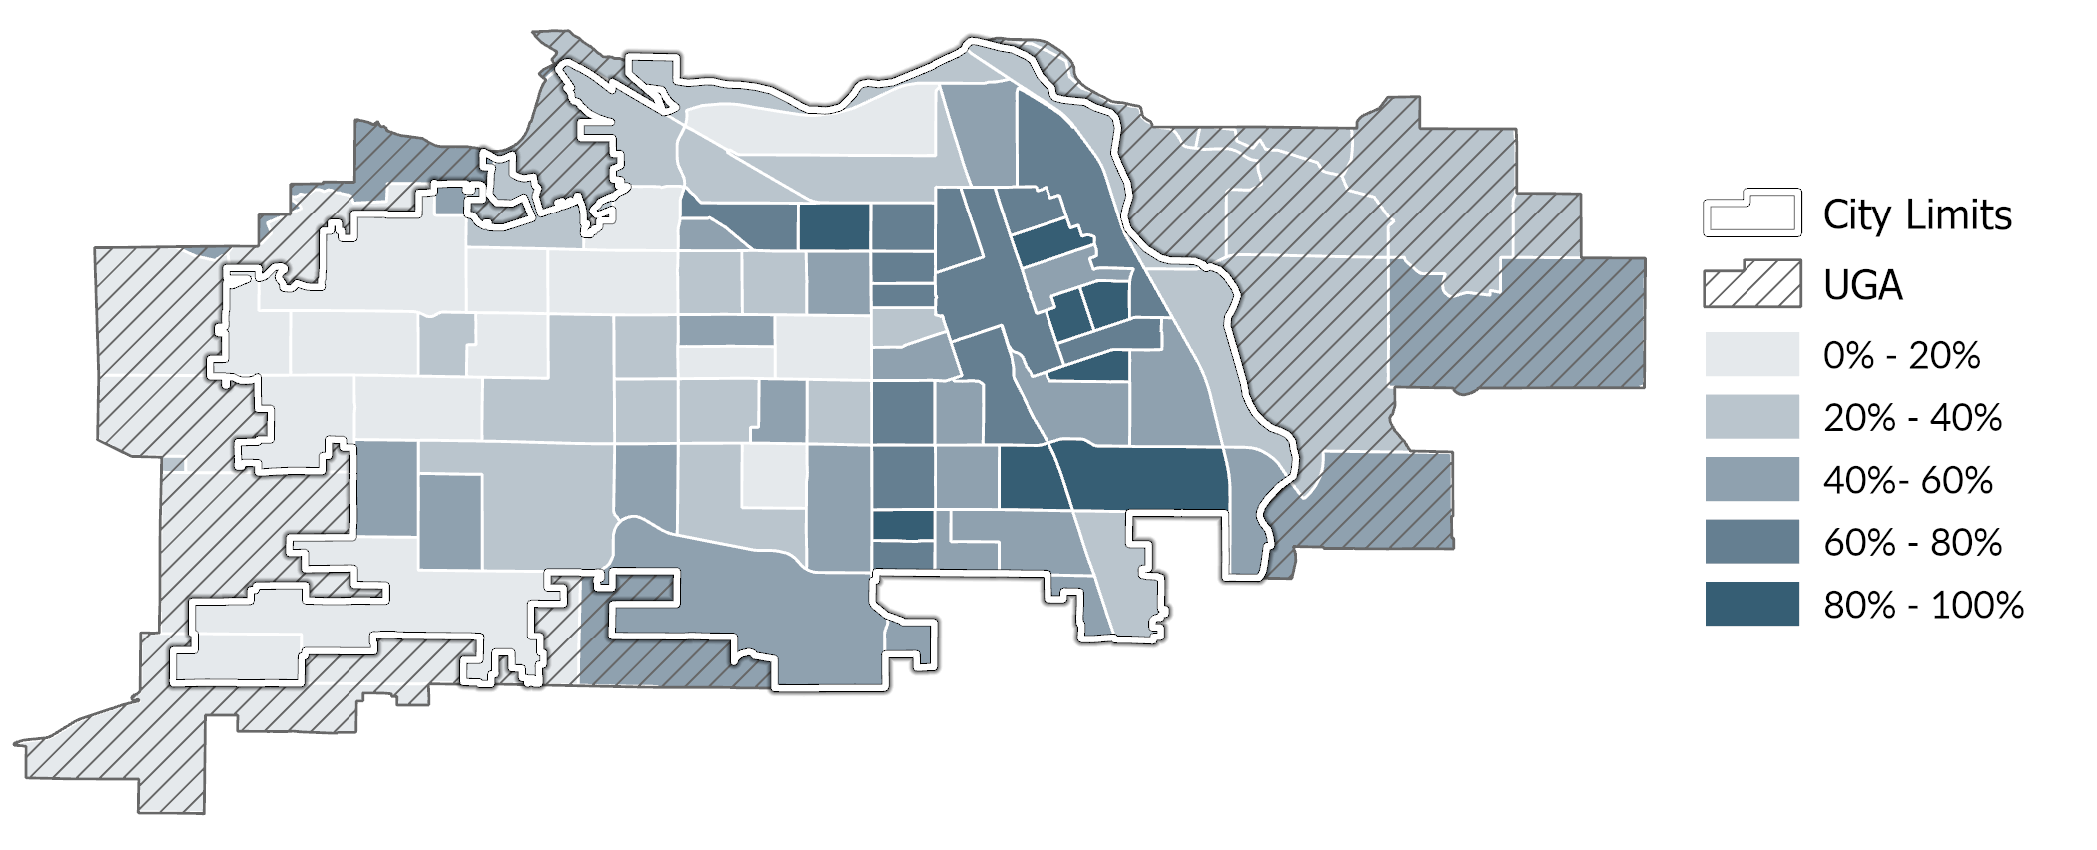
Source: US Census Bureau, American Community Survey, 2018-2022; BERK Consulting, 2025.

Households
A household is a group of people who live in a single dwelling unit, such as a house or apartment. Households can have one member or many members. They can be families or unrelated people living together. As of 2022, there are an estimated 34,830 total households in the City of Yakima. Understanding the makeup of the households in the city across age, race, and family sizes helps us to better understand the diversity of household types and sizes which can help support affordable housing strategies.

Household Size
The average household size in Yakima is 2.61 people, down slightly from 2017’s average size of 2.71. More than half (59%) of the city’s residents live in single or two-member households. Exhibit 3-7 shows the breakdown of households by size by tenure.
Exhibit 3-7. Household Size by Tenure in City of Yakima, 2018-2022
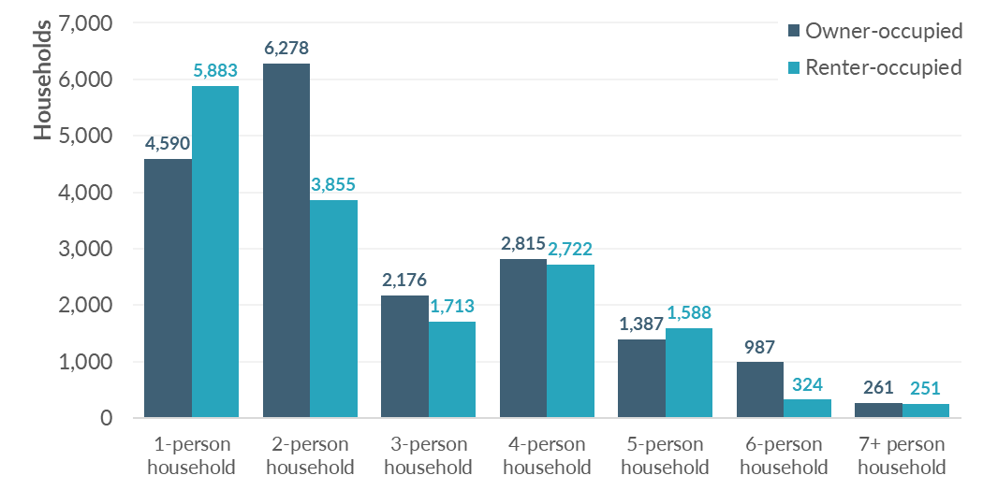
Sources: US Census Bureau, American Community Survey 5-Yr Estimates, 2018-2022; BERK, 2025.

Household Income
When summarizing housing affordability by income level, households are typically grouped relative to the U.S. Department of Housing and Urban Development (HUD) Area Median Family Income (also known as “AMI”). The 2025 AMI for Yakima County is $82,300. However much of the data in this section reflects conditions as of 2021, when AMI was $60,294. HUD also applies adjustments for household size when determining the income level of a household. This is to reflect the fact that it requires more income to affordably support a larger family compared to just one or two household members. Exhibit 3-8 breaks down renter- and owner-occupied households in the City of Yakima by income level relative to AMI. It shows a significant difference between owner-occupied and renter-occupied households, with owner households much more likely to have incomes above 100% AMI. Only 20% of renter households had income at or above AMI, compared to 54% of owner households. Close to a fifth of renter households have extremely low incomes, compared to 8% of owner households.
Exhibit 3-8. Percentage of Households by Income Level in City of Yakima, 2021
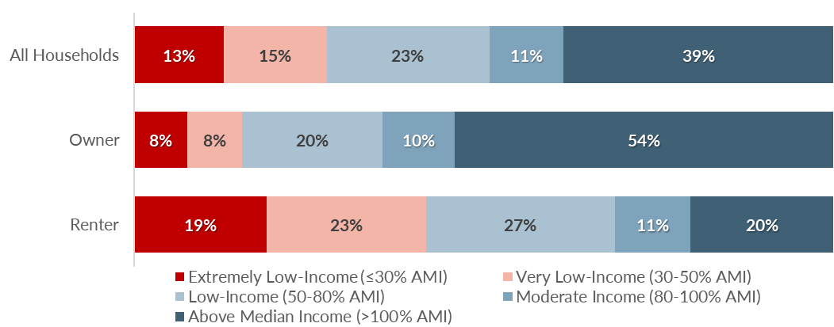
Sources: US HUD Comprehensive Housing Affordability Strategy, 2017-2021; BERK, 2025.
Median household incomes vary by ethnicity as well, as shown in Exhibit 3-9. The median Hispanic or Latino household has an income about 9% lower than median Non-Hispanic White households.
Exhibit 3-9. Median Household Income by Ethnicity in City of Yakima and Washington State, 2022
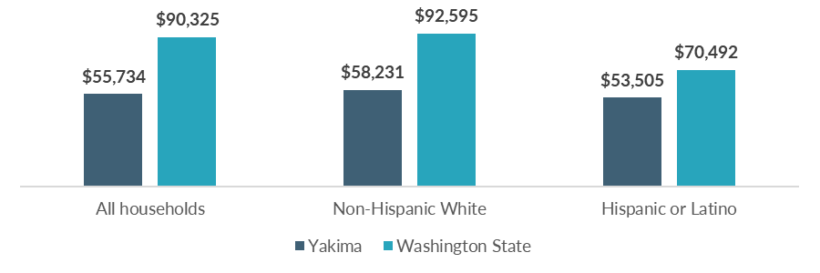
Sources: US Census Bureau, American Community Survey 5-Yr Estimates, 2018-2022; BERK, 2025.
A map showing disparities in income by neighborhood is provided in Exhibit 3-10. Areas with lower incomes are concentrated near the urban core of Yakima, while areas with higher incomes above AMI are typically found on the outskirts of the city, or in the west half.
Exhibit 3-10. Median Household Income by Census Tract in City of Yakima, 2022
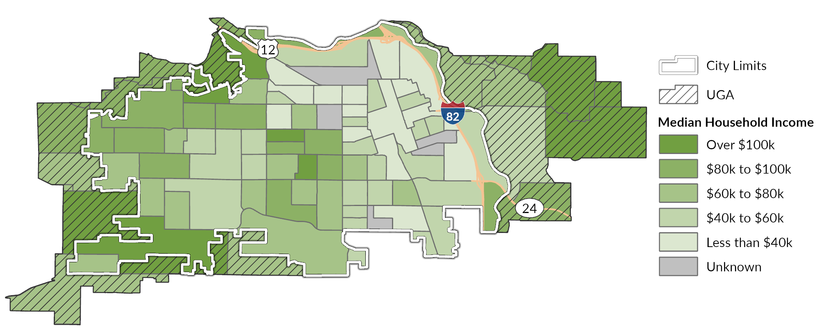
Source: US Census Bureau, American Community Survey 5-Yr Estimates, 2018-2022; BERK, 2025.

Cost-Burdened Households
One of the most common indicators of affordable housing needs is the number of households that are "cost-burdened" or spending a large share of their income on housing. These households have limited resources left over to pay for other life necessities such as food, medical care, transportation, and education. They are also at higher risk of displacement when housing costs rise, or life circumstances change.
HUD considers housing to be affordable if it costs no more than 30% of a household’s income. Households paying more than 30% of their income for housing are considered cost-burdened, and households paying more than 50% are considered severely cost-burdened.
In 2021, at least 32% of all households in Yakima were cost-burdened, as shown in Exhibit 3-11. Households with lower incomes are more likely to be cost-burdened.
Exhibit 3-11 and Exhibit 3-12 present estimates of total households by income level and cost-burdened status. It differentiates households that are moderately cost-burdened (spending 30-50% of their income on housing) from those that are severely cost-burdened (spending more than 50% of their income on housing). While there are cost-burdened households across the income spectrum, severe cost-burden is most prevalent among the lowest income groups. This includes slightly under 3,000 households with extremely low incomes (less than 30% AMI), roughly 1,400 households with very low incomes (30 – 50% AMI), and 700 households with low incomes (50-80% AMI).
Exhibit 3-11. Cost Burden Status by Income Level of Households, City of Yakima, 2017-2021
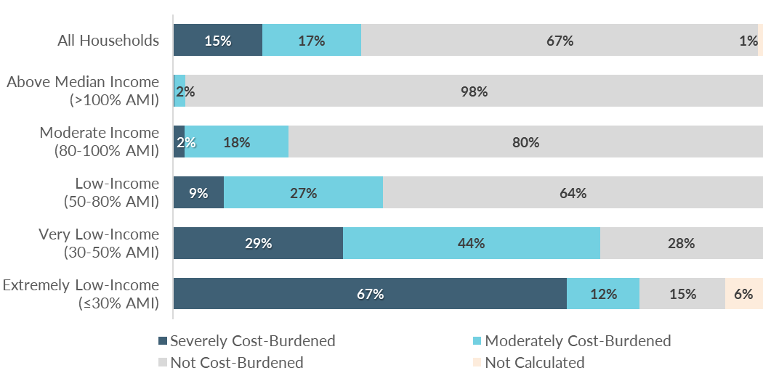
Sources: US HUD Comprehensive Housing Affordability Strategy, 2017-2021; BERK, 2025.
Exhibit 3-12. Total Cost-Burdened Households by Income Level, City of Yakima, 2017-2021
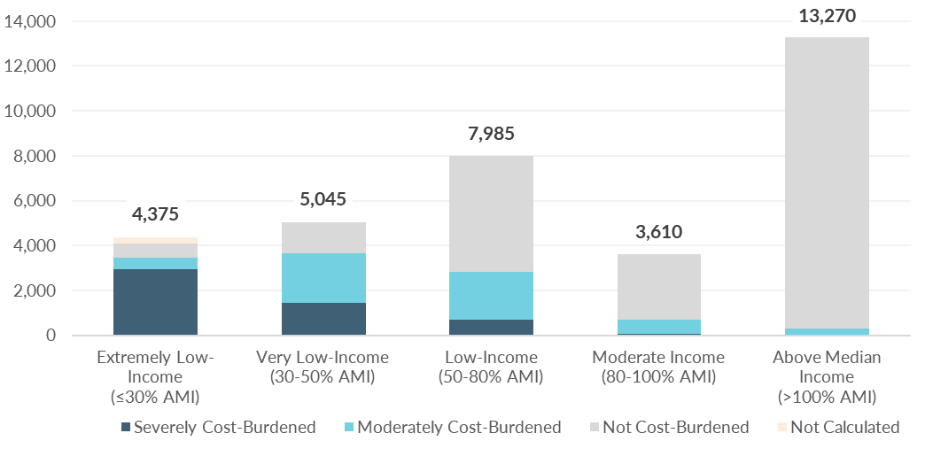
Sources: US HUD Comprehensive Housing Affordability Strategy, 2017-2021; BERK, 2025.
As shown in Exhibit 3-13, renters are more likely to be cost-burdened than owners, with nearly half (44%) of renter households cost-burdened, compared to just under a quarter (23%) of owner households. Renters are also more severely cost-burdened than owners, with 23% of renter households severely cost-burdened compared to 8% of owner households.
Exhibit 3-13. Household Tenure by Cost Burden in City of Yakima, 2017-2021
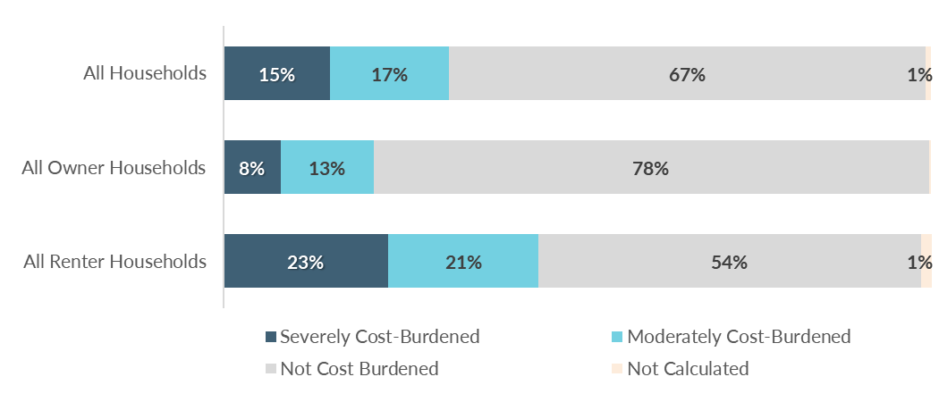
Sources: US HUD Comprehensive Housing Affordability Strategy, 2017-2021; BERK, 2025.
Renter households are most vulnerable to the impacts of rising housing costs. Exhibit 3-14 shows estimated counts of cost-burdened renter-occupied households by household type and income level. While there are households struggling with housing costs across the entire income spectrum, the greatest number are among household types with incomes below 50% of AMI. The greatest need is among Small Family, Elderly Non-Family, and Other (non-family) households, which are typically people living alone or with unrelated housemates.
Exhibit 3-14. Cost-Burdened Renter Households by Household Type and Income Level, City of Yakima, 2017-2021
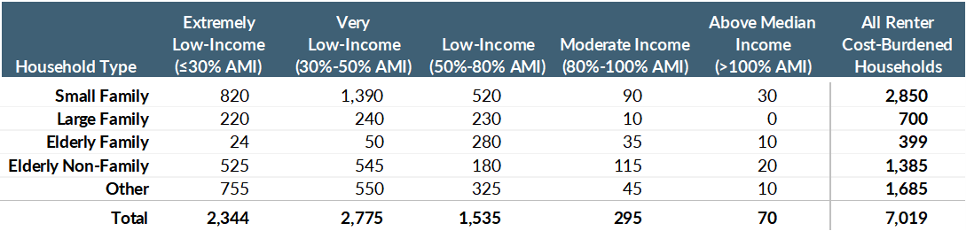
Household Type | Description
Family household | A household that includes two or more people related by birth marriage or adoption. (Definition applies to all household types that include “family.”)
Small Family | Two persons, neither aged 62 or older, or 3 or 4 persons
Large Family | Five or more persons
Elderly Family | Two persons, with either or both aged 62 or older
Elderly Non-Family | One or two unrelated people with either aged 62 or older
Other | Non-family, non-elderly households (includes those living alone or with housemates)
Note: AMI = HUD Area Median Family Income
Sources: US HUD Comprehensive Housing Affordability Strategy, 2017-2021; BERK, 2025.

Residents with Special Housing Needs
Several groups may have special housing needs or need supportive services, such as residents experiencing homelessness, residents with disabilities, and older residents. Given the city’s proximity to agricultural areas with significant seasonal workforce needs, farmworker housing needs also merit consideration.

Residents Experiencing Homelessness
According to the Department of Commerce’s Snapshot of Homelessness in Washington State for July 2024, there were 11,971 persons who were homeless or unstably housed in Yakima County. This was approximately 5% of the county population. Among these people, 9,906 were considered homeless. During the same year, 2,894 individuals countywide accessed homelessness services, according to the Commerce Homeless System Performance County Report Card. Entries are broken down by project type, with nearly half (49%) of entries occurring at Emergency Shelters. A summary of the results is shown in Exhibit 3-15.
Exhibit 3-15. Homeless System Project Entries by Project Type, Yakima County, SFY 2024
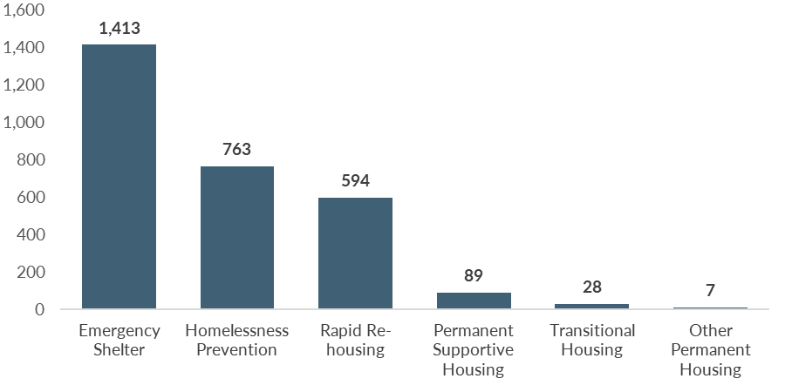
Sources: Department of Commerce, 2024; BERK, 2025.
The 2024 Yakima County Homeless Point-in-Time (PIT) Count surveyed individuals on causes of homelessness. The top reasons included eviction, alcohol/substance use, and family crisis. However, there are often a combination of factors that contribute to housing insecurity and homelessness. Exhibit 3-16 ranks the reasons cited by survey respondents. Research consistently indicates that the primary driver of homelessness is a lack of affordable housing supply. So while these individuals may have had life circumstances that made them more vulnerable to becoming homeless, the root challenge is housing affordability.
Exhibit 3-16. Top Reasons Cited as Cause of Homelessness, Yakima County, 2024
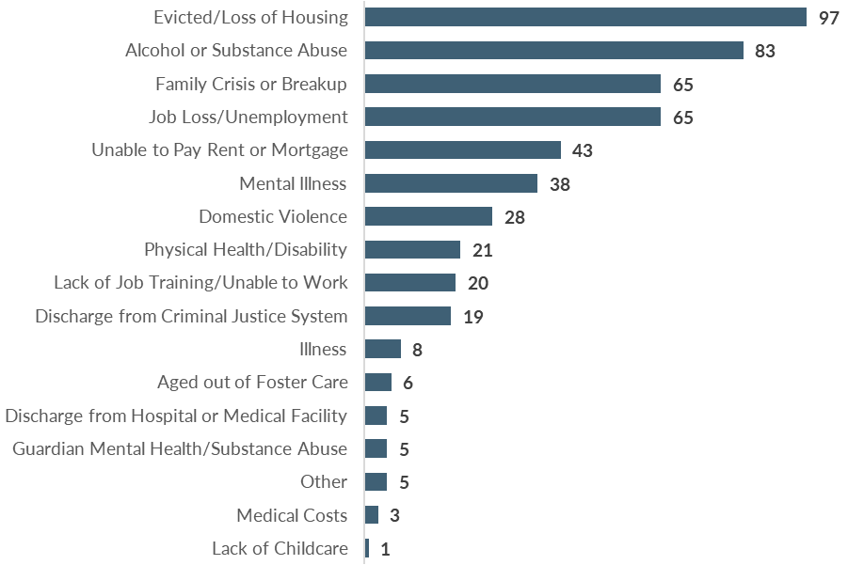
Note: Participants could select more than one cause.
Source: Yakima County Point-in-Time Community Report, 2024; BERK, 2025.
While conditions may have changed since its report, Yakima County’s Five-Year Plan to End Homelessness (2018) identified the following population as needing specific attention with regards to homelessness care:
- Individuals experiencing chronic homelessness,
- Unaccompanied youth,
- Veterans,
- Families with children (including victims of domestic violence), and
- Individuals over the age of 62.

Households with Disabilities
Exhibit 3-17 shows renter households in Yakima by disability status and income. While there are households with disabilities across the entire income spectrum, lower income households are more likely to have a disability than higher income households. Of the disabilities listed, the most common conditions include ambulatory limitations and hearing or vision impairments. People with disabilities often have special housing needs, and benefit from accessible layouts, supportive design, and proximity to healthcare services.
Exhibit 3-17. Renter Households by Disability Status and Income Level in City of Yakima, 2021
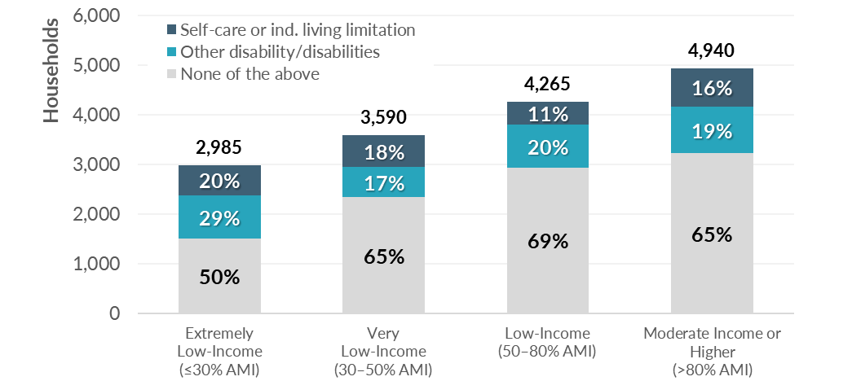
Note: AMI = HUD Area Median Family Income
Sources: US HUD Comprehensive Housing Affordability Strategy, 2017-2021; BERK, 2025.

Older Residents
15,250 residents in Yakima are aged 65 or older, or about 16% of the population. While older residents have a range of housing preferences, many need affordable, accessible housing in age-friendly neighborhoods with close links to healthcare and other supports. Some of these households in Yakima have the financial means to afford appropriate housing and services. Many others do not.
Exhibit 3-18 shows the prevalence of cost burden among elderly households across income ranges. The greatest need is among Non-Family elderly households (typically people living alone) with incomes below 30% AMI.
Exhibit 3-18. Elderly, Cost-Burdened Households by Household Type and Income Level, City of Yakima, 2017-2021
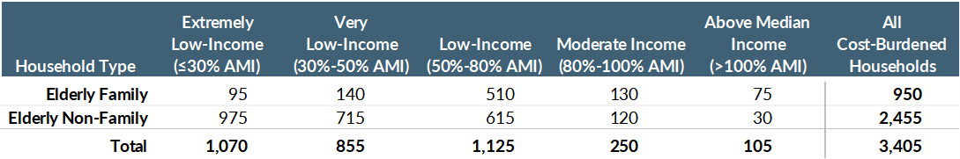
Note: AMI = HUD Area Median Family Income
Sources: US HUD Comprehensive Housing Affordability Strategy, 2017-2021; BERK, 2025.
Washington State Office of Financial Management (OFM) projects that the population of elderly households in Yakima County will increase faster than younger age groups. Exhibit 3-19 shows that by the year 2050, 20% of the population will be over age 65, up from 15% in 2022. This indicates the need for housing appropriate for elderly households will increase in the years ahead.
Exhibit 3-19. Projected Population by Age Range, Yakima County
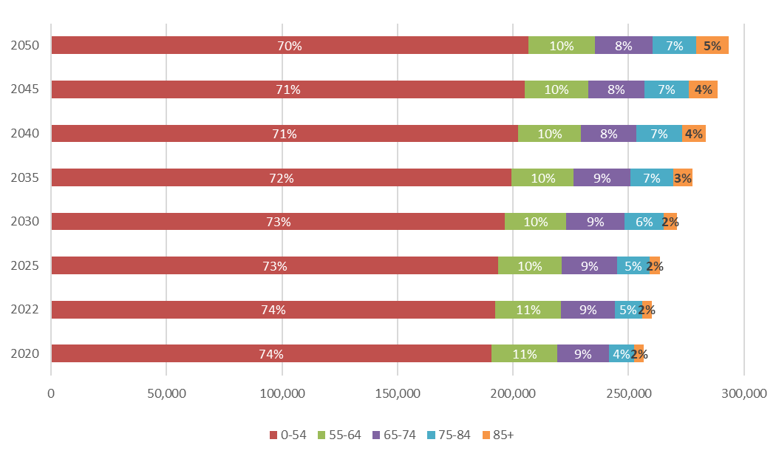
Source: OFM, 2022; BERK, 2025.

Farmworkers
Yakima County is the biggest county in Washington for agriculture, measured both by number of workers and by number of farms. In 2023, there were 28,603 farmworker jobs in Yakima County, seasonally adjusted. However, as shown in Exhibit 3-20 there are more workers in the summer months than in the remainder of the year. This is due to the demand for seasonal farmworkers during the harvest months. Many of these seasonal workers are migrants who need temporary housing. A 2022 study by the Department of Commerce found that the number of beds available in seasonal farmworker housing in Yakima does not nearly accommodate all the demand for seasonal housing, resulting in a gap of over 8,000 seasonal beds. The remainder of these seasonal workers must compete for housing with other renter households in Yakima.
The average year-round agricultural employee in this region is estimated to earn $39,750 annually in wages, significantly less than the median household income. While a household with this income can afford an average 1-bedroom apartment, it is far less than needed to afford a family sized rental or homeownership.
Exhibit 3-20. Farmworker Employment Counts, Yakima County, 2023
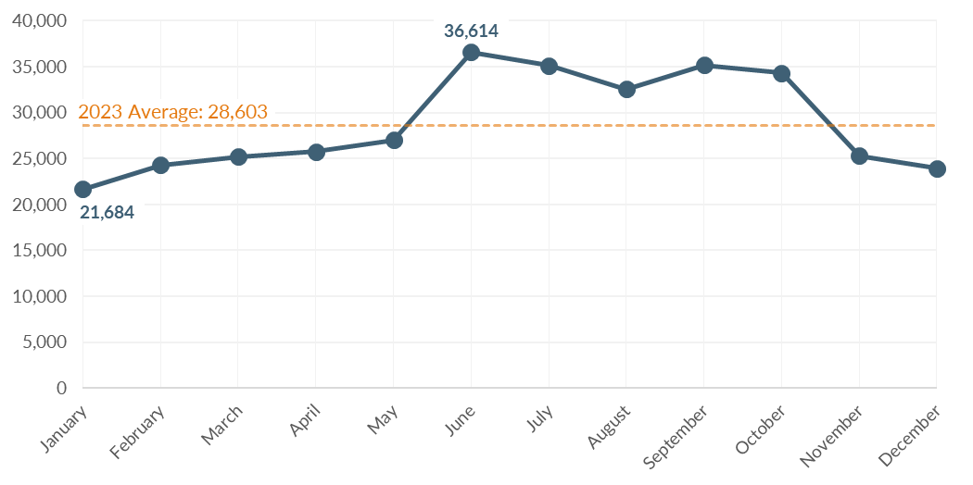
Source: Washington State Employment Security Department, 2023; BERK, 2025.

Employment

Countywide Employment
Yakima County had a total covered employment of 116,064 in 2023. The average annual wage was $49,831, or 57.2% of the state average of $87,091. The agricultural sector accounted for 25% of jobs (28,695 in total). The next largest employment sectors are Government with 16% (18,379 jobs), Health Care and Social Assistance at 15% (17,853 jobs), and Retail trade with 10% (11,509 jobs).

Citywide Employment
According to the Census, as of 2022 there were 50,087 jobs in the City of Yakima. Between 2017 and 2022, the city gained about 2,799 jobs, averaging ~1.2% growth (560 jobs) per year. Top sectors in the city include agriculture, health care, retail, and manufacturing. The City of Yakima's agricultural and manufacturing employers are diverse and include fruit packers, beef processors, and canneries. The jobs in the health sector reflect the city’s role as a regional medical center, with a hospital and the nearby Pacific Northwest University of Health Sciences (in Terrace Heights). The highest concentration of jobs in Yakima are Downtown and in the eastern part of the city.
About 1 in 7 (14%) primary jobs in Yakima paid less than $1,250 per month in 2022 (equivalent to $15,000 annually). However, not all these jobs are full-time. In 2022, a full-time minimum wage worker earned $2,511 a month. About a third (35%) of the jobs in Yakima paid between $1,250 and $3,333 per month. Many of those working these jobs would be cost-burdened by a one-bedroom rental without working multiple jobs, or rooming or cohabitating with others. The annual minimum wage increased annually to $16.28 per hour, or $2,821 per month for a full-time worker in 2024. Exhibit 3-21 shows that the average 1-bedroom rental in Yakima requires slightly more than 30% of monthly earnings for a full-time minimum wage worker.
Exhibit 3-21. Housing Affordability in Yakima for a Full-Time Minimum-Wage Worker, 2024
Monthly Earnings for Full-Time Minimum Wage Worker | Average 1-Bedroom Rental Cost | Share of Earnings Spent on Housing
$2,821 | $896 | 32%
Sources: Washington Department of Labor & Industries, 2024; Washington Center for Real Estate Research, 2024; BERK, 2025.
Exhibit 3-22 presents employment density within the City of Yakima in 2022. Employment is most dense around the downtown core near the east side of the city. A few other points of dense employment exist in Yakima, including one at the MultiCare Yakima medical campus in central Yakima. There is also a smaller concentration of industrial and commercial jobs along Fruitvale Blvd in northern Yakima. Job density is lowest in aeras predominated by residential development.
Exhibit 3-22. Employment Density in the City of Yakima, 2022
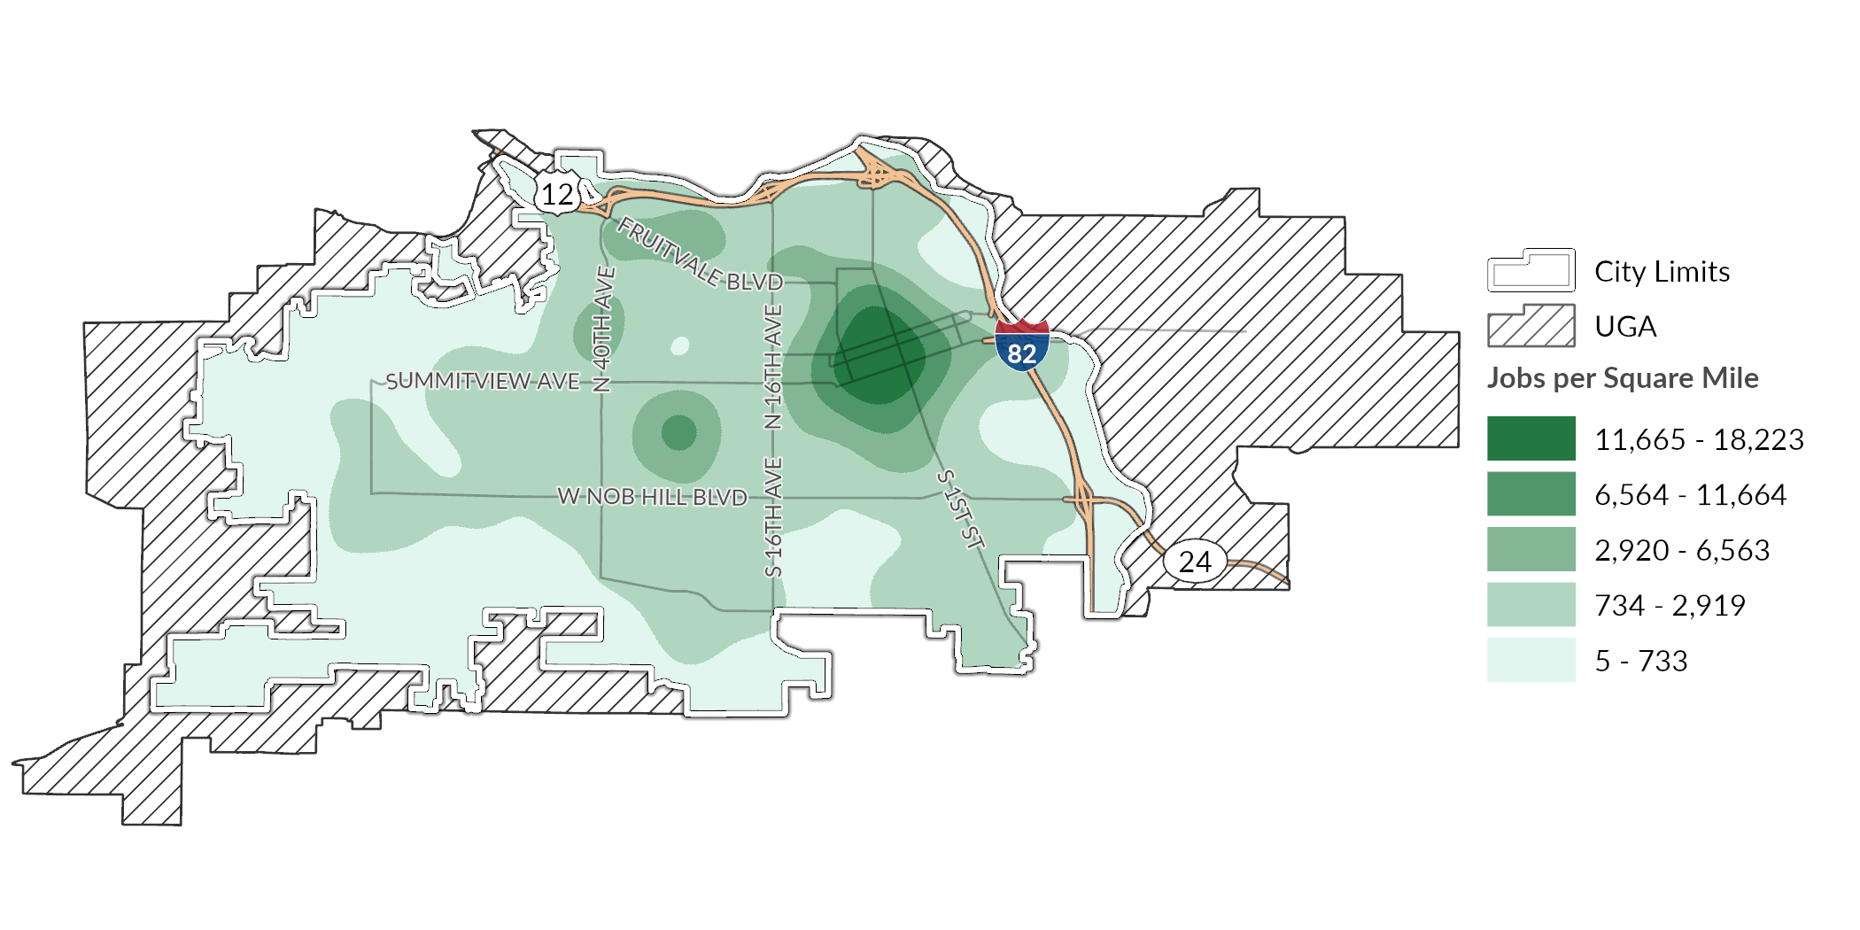
Source: US Census Bureau, Longitudinal Employer-Household Dynamics, 2022; BERK, 2025.

Employment Trends
Employment growth between 2012 and 2022 has been mostly healthy: an average of +2.1% growth per year during the period. This period includes the COVID-19 pandemic, which impacted employment and job growth. By 2022, employment recovered to levels seen before the pandemic, as shown in Exhibit 3-23. Many lower-paying employment sectors, such as healthcare support (nursing/medical assistants or home health aides), retail, and the food service industry, are currently in demand.
Exhibit 3-23. Total Jobs in the City of Yakima, 2012-2022
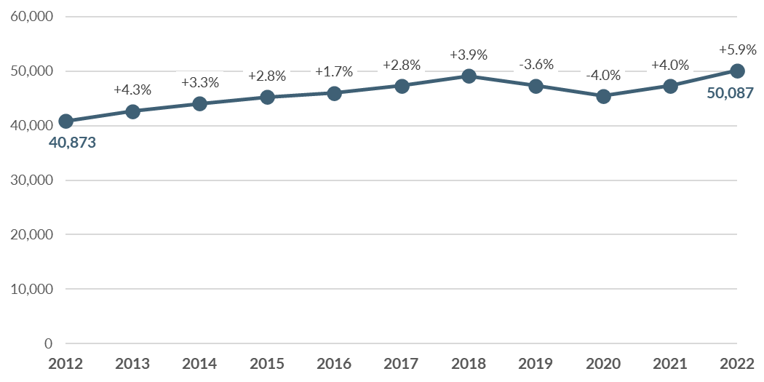
Sources: US Census Bureau, Center for Economic Studies, 2012-2022; BERK, 2025.

Worker Residential Locations
Many who work within the city of Yakima live elsewhere. Often, a lack of affordable housing in an economic center leads workers to search for living arrangements outside of their place of work. These workers have longer commutes, spend more of their income on gas and vehicle maintenance, and often live further from services.
Exhibit 3-24 shows the commute distances for people who work within the city of Yakima. While most workers live within 10 miles of the city, a large share (almost 40%, or nearly 20,000 jobs) commute more than 10 miles. More than 12,000 workers commute more than 50 miles, bringing in people from places such as the Tri-Cities to the east or Wenatchee to the north.
Exhibit 3-24. Commute Distance for Workers, City of Yakima, 2022
Commute Distance | Count | Share
Less than 10 miles | 30,370 | 61%
10 to 24 miles | 4,652 | 9%
25 to 50 miles | 2,907 | 6%
Greater than 50 miles | 12,158 | 24%
Source: US Census Bureau, Center for Economic Studies, 2022; BERK, 2025.

Housing Inventory

Housing Supply Characteristics

Housing Units by Type
There is a total of 38,584 housing units in Yakima, shown in Exhibit 3-25. Well over half (61%) of these units are single family homes and 18% are multi-family buildings of 5+ units. Another 7% of units are smaller multi-family structures such as triplex and quadplex buildings, while duplexes account for 9%. Mobile and manufactured homes make up 5% of the housing inventory.
Exhibit 3-25. Housing Inventory by Type in City of Yakima, 2024
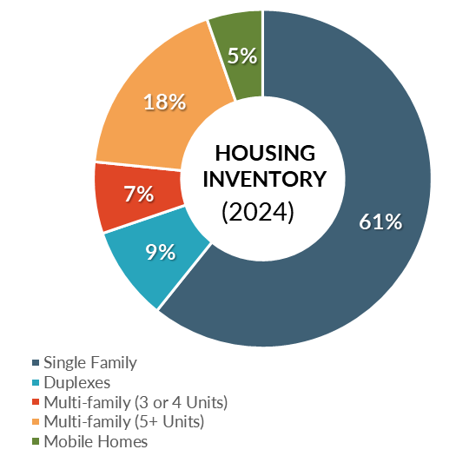
Source: Washington Office of Financial Management, 2024; BERK Consulting, 2025.

Unit Size
Exhibit 3-26 shows the Yakima housing supply by number of bedrooms and the share of households by household size. While roughly 17% of housing units are studios or 1-bedroom units 30% of households have one-person. This indicates a potential undersupply of smaller units compared to need.
Exhibit 3-26. Percentage of Housing Unit Sizes Compared to Household Sizes, City of Yakima, 2022
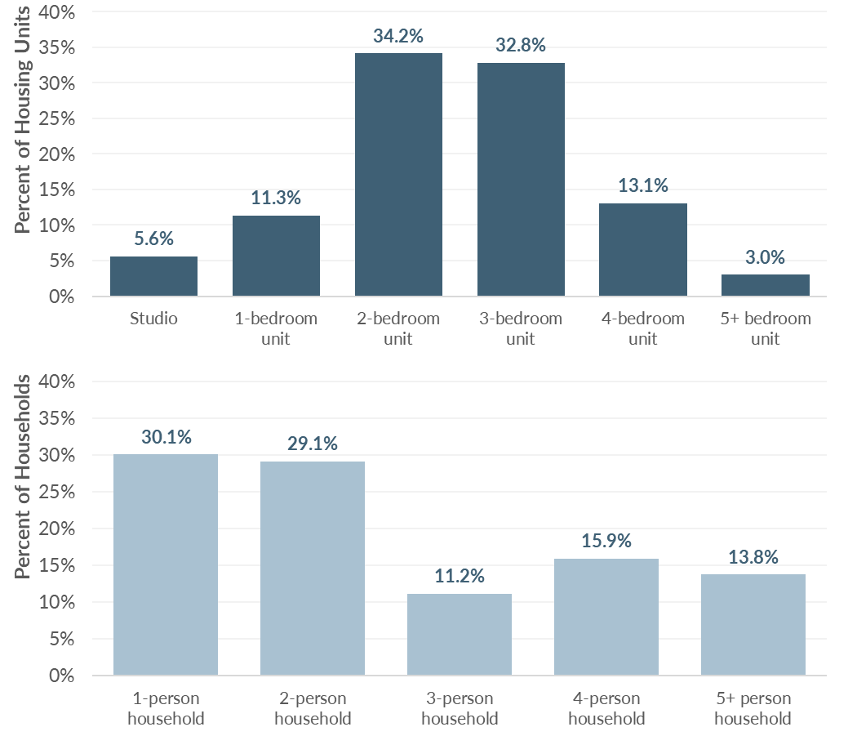
Source: US Census Bureau, American Community Survey 5-Yr Estimates, 2018-2022; BERK, 2025.

Housing Condition
According to the Yakima County Assessor’s Office as of April 2025, about 20% of the city’s residential parcels had primary structures that were built since 2000, and nearly two-thirds (63%) of units were built 40 or more years ago. These older units may represent lower quality housing stock that may require additional investments for upkeep. Older housing may also need modifications to ensure they are accessible for older residents, differently-abled residents, and families. While some older units may need maintenance or accessibility improvements, older housing stock may be the more affordable housing available in the city.
Exhibit 3-27 maps the geographical distribution of residential structure by year built. It shows that much of the older housing stock in the city is located in central and eastern Yakima, in areas that are typically close to amenities, services, and jobs. Preservation and support for home maintenance in these areas can contribute to sustaining this relatively affordable component of Yakima’s market housing supply.
Exhibit 3-27. Residential Properties by Year Built, City of Yakima, 2025
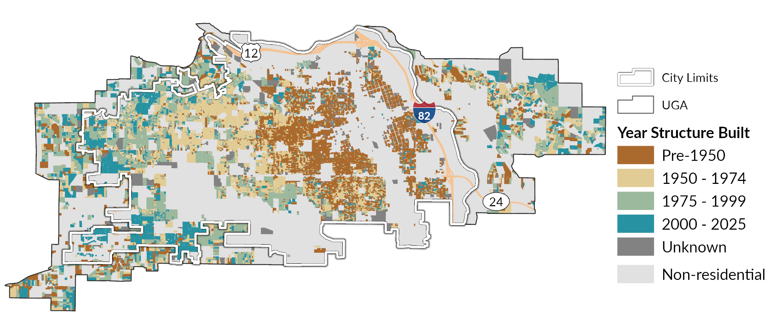
Source: Yakima County Assessor’s Office, 2025; BERK, 2025.

Housing Tenure
In Yakima, just over half (54%) of housing units are owner-occupied (32% with a mortgage and 22% without) while 46% are renter-occupied, as shown in Exhibit 3-28. There are major disparities in homeownership by race and ethnicity. Exhibit 3-29 shows that 62% of White, Non-Hispanic households own their homes, compared to only 42% of Hispanic or Latino households.
Exhibit 3-28. Household Tenure, City of Yakima, 2022
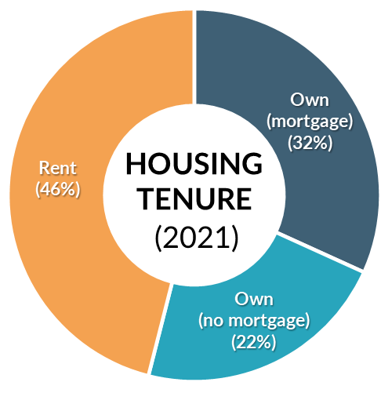
Source: US Census Bureau, American Community Survey 5-Yr Estimates, 2018-2022; BERK, 2025.
Exhibit 3-29. Housing Tenure by Race and Ethnicity, City of Yakima, 2021
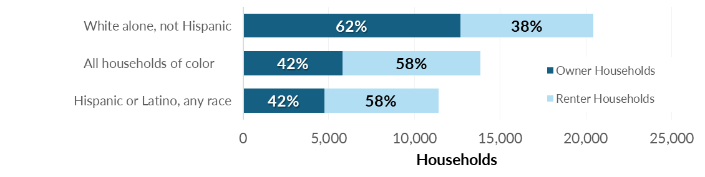
Note: Households of color includes Hispanic or Latino households as well as households of a race other than White alone.
Sources: US HUD Comprehensive Housing Affordability Strategy, 2017-2021; BERK, 2025.

Home Ownership
Homeownership is the primary way most American families accumulate wealth. Homeownership in advantaged neighborhoods also provides access to higher performing school districts, amenities, and social capital that can lead to better opportunities. In 2021, there was a total of 18,500 owner-occupied housing units in Yakima.
Exhibit 3-30 shows change in housing values over time in the city of Yakima compared to median family incomes in Yakima County. The separation between home value and income has grown between 2014 and 2022. In that period, the typical home value in Yakima rose by 99%, nearly doubling. Over the same period, the median family income only increased by 43%. This indicates homeownership is getting further out of reach for many prospective home buyers.
Exhibit 3-30. Percent Change since 2014 in Typical Home Value and Median Family Income (MFI)
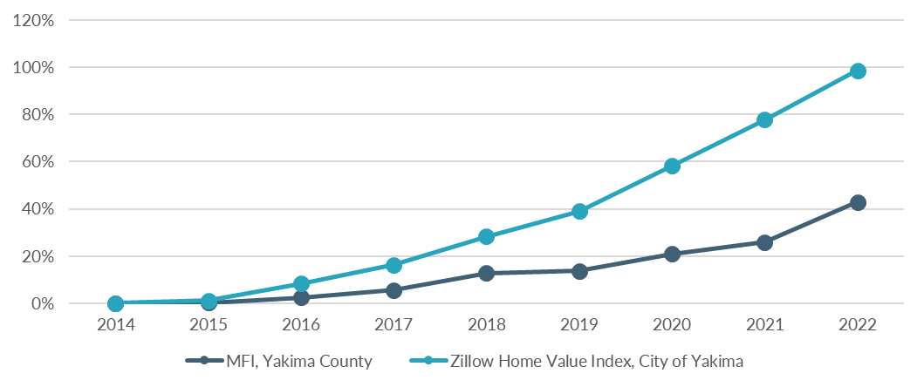
Note: Historic MFI and home value data are not adjusted for inflation.
Sources: Zillow, 2025; US Census Bureau, American Community Survey 5-Yr Estimates, 2018-2022; BERK, 2025.
One reason home values have increased so rapidly is the shortage of homes for sale. As of March 2025, there was just 2.3 months of supply. This supply measure compares the number of homes listed for sale to the rate at which homes are purchased. A healthy housing market has at least four months of supply available for home buyers. When the supply is limited, competition among homebuyers drives up sales prices.

Homeownership Affordability
Exhibit 3-31 estimates the income needed to afford purchasing home in the City of Yakima, assuming the household has 3.5% down payment in savings available. Unfortunately, data about household savings is not available, so it is impossible to estimate how many households have accumulated the savings necessary for the assumed downpayment.
The majority of home sales in Yakima are detached single family homes. In many areas, townhomes provide a slightly lower cost option for homeownership. However, available data about townhome sales in Yakima indicates the costs of these homes are on par with the average home shown in Exhibit 3-31.
Exhibit 3-31. Home Ownership Affordability in City of Yakima, 2025
 | Home price | 3.5% Down Payment | Annual income needed to afford (Assuming 3.5% down payment)
New home | $498,317 | $17,441 | $161,625  (196% of AMI for 3-person HH)
Average home | $345,114 | $12,079 | $111,935  (136% of AMI for 3-person HH)
“Bottom-tier” home | $246,581 | $8,630 | $79,976  (97% of AMI for 3-person HH)
Notes: New home price is estimated based on Zillow “top tier” home value, which is the weighted average of all homes in the top third of home values in the region. Average home price corresponds to Zillow’s weighted average of the middle third of all home values in the region. “Bottom-tier” home corresponds to Zillow’s weighted average of the bottom third of all home values in the region.
Source: Zillow, 2025; BERK, 2025.

Rental Housing
There are a total of 15,780 occupied rental housing units in Yakima. Nearly half (49%) of these units are rented by Non-Hispanic White residents, meaning 51% of rental units in Yakima are occupied by people of color. Of the residents in Yakima who identify as Hispanic or Latino, more than half (58%) are renters.

Rental Housing Costs and Vacancy
Exhibit 3-32 shows average apartment rents as of 2024 as well as the household income level needed to afford the unit as a percentage of AMI. Households with incomes at 50% of AMI can still afford average market rents for 1- and 2-bedroom apartments. Those with lower incomes cannot. This helps to explain the fact that so many lower-income households in Yakima are cost-burdened.
Exhibit 3-32. Yakima County* Rental Rates and Affordability, 2024
 | 1-bedroom | 2-bedroom
Average monthly rent | $896 | $1,094
Annual income needed to afford | $35,840 | $43,760
% AMI needed to afford (adjusted for assumed household size)** | 50% | 50%
Notes: *Most apartment buildings surveyed for these county-wide estimates are assumed to be in the City of Yakima.
** Percent AMI calculations reflect adjustments by HUD, including adjustments for assumed household size.
Source: Washington Center for Real Estate Research, 2024; WSHFC, 2025; BERK, 2025.
Rents in Yakima are also rising at a faster rate than incomes. Between 2014 and 2024, the average monthly rent for a 2-bedroom apartment has risen by nearly 60%. During the same period median family income increased by only 34%.
One likely reason for the continued increase in rent is extremely low vacancy rates, as shown in Exhibit 3-33. From 2014 to 2021, the vacancy rate in apartment buildings remained under 2%, while rents increased. In 2022, the county experienced a sharp increase in vacancy rate up to nearly 6%, likely due to impacts from the COVID-19 pandemic. The rate has decreased since then to just over 2%. A healthy housing market has a vacancy rate of around 5%. When vacancy rates sink much below 5%, there are fewer options on the market for households seeking to move. This increases competition for the limited supply of available units and results in upward pressure on market rents.
Exhibit 3-33. Yakima County Apartment Rents and Vacancy, 2014-2024
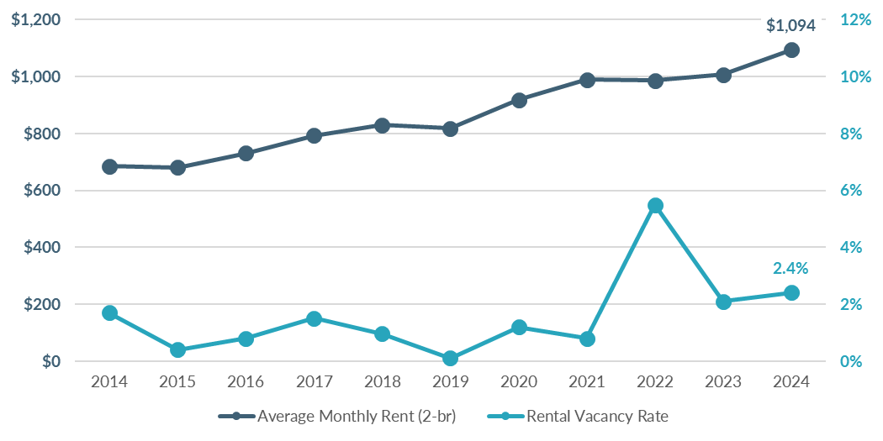
Note: Average rent does not adjust for inflation.
Source: Washington Center for Real Estate Research, 2014-2024; BERK, 2025.

Housing Production
Single family homes have been developed at a steady pace over the past several years in Yakima, as shown in Exhibit 3-34. Recent years have seen a decrease in permitting for duplexes with an increase in units in other multi-family structures. Housing production has increased considerably since 2019 compared to the preceding 10 years. Overall, 2,341 units of new housing units have been permitted in Yakima since 2019, with units in duplexes or multi-family buildings making up nearly 70%. These new units are adding diversity to the local housing stock, which provides more options at more affordability levels.
Exhibit 3-34. Count of Permitted Dwelling Units by Project Type in City of Yakima, 2010-2014
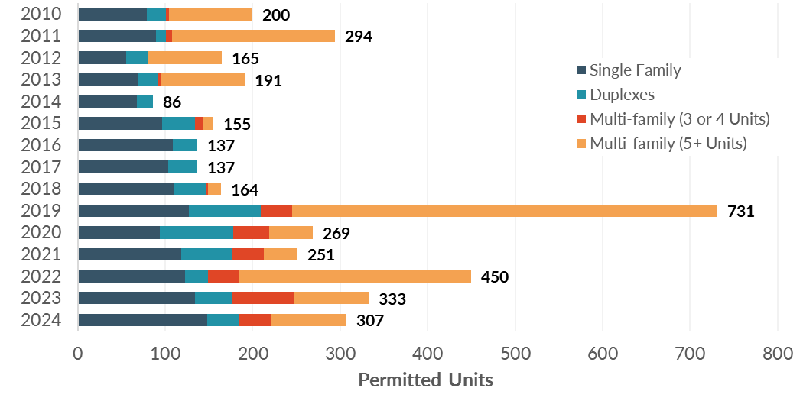
Sources: Washington Office of Financial Management, 2024; BERK, 2020.

Subsidized Affordable Housing
As of 2023, Yakima had 5,064 units of subsidized rental affordable housing, as summarized in Exhibit 3-35. These housing units are typically available at below market rents to households that meet income eligibility standards. Subsidies can come either from local, state, or federal agencies. Funding sources include the Washington State Housing Finance Commission (which manages federal Low Income Housing Tax Credits), Washington State Department of Commerce programs (including the Housing Trust Fund), US Department of Agriculture’s Rural Housing Service programs, and HUD’s project-based Section 8 and other multi-family programs.
Exhibit 3-35 shows the count of subsidized rental housing units in city of Yakima by unit size (number of bedrooms). Among units with known unit size, there is a relatively equal number of subsidized units that have between one to three bedrooms, with much less availability in studio units or units with four or more bedrooms.
Exhibit 3-35. Subsidized Rental Housing Units by Number of Bedrooms, City of Yakima, 2023
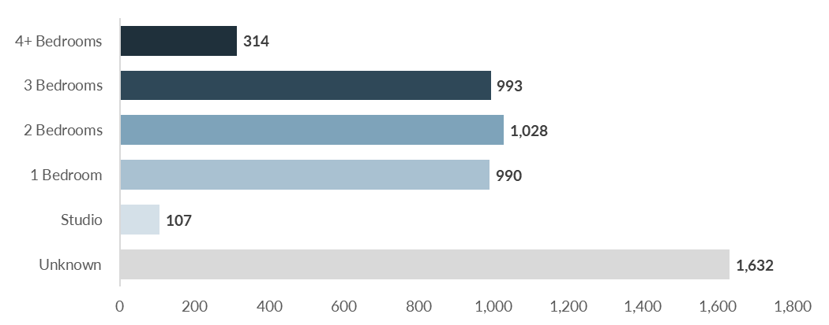
Source: Washington Center for Real Estate Research, 2023; BERK, 2025.

Housing Programs
The City of Yakima operates the following programs to support housing stability and affordability.
Exhibit 3-36. City of Yakima Housing Program
Program | Description | Desired Outcome
Senior/Disabled Persons Home Repair Program | City housing program to support home repairs for senior and disabled residents administered through the Office of Neighborhood Development to those who qualify (income and asset restrictions) | - Increased investment in neighborhoods  - Aesthetic improvements
Single-Family Emergency Repair Program | City housing program to support home repairs for low-income residents administered through the Office of Neighborhood Development to those who qualify (income and asset restrictions) | - Support housing and financial stability for low-income homeowners
Exterior Paint Program | City housing program administered through the Office of Neighborhood Development to those who qualify (age and disability restrictions) | - Increased investment in neighborhoods  - Aesthetic improvements
Homeownership Through New Construction | City housing program administered through the Office of Neighborhood Development to those who qualify (income restrictions) | - Increased homeownership
Tenant/Landlord Counseling | Office of Neighborhood Development Services program to assist either tenants or landlords with disputes and advice on reaching agreements or seeking legal support. | - Improved tenant/landlord relationships  - Education on legal support for those in need
Lot Acquisition Program | A City program within the Yakima Target Area that provides funds to purchase lots for residential development projects. Lots must be residentially zoned, have vacant or substandard buildings, and be developed within 12 months of purchase. | - New housing stock  - Neighborhood revitalization  - New infill development
Downtown Redevelopment Tax Incentive Program (YMC 11.63) | A City program that provides a tax incentive to stimulate new multi-family housing and the rehabilitation of vacant and underutilized buildings for multi-family housing. | - Increased housing options in residentially deficient urban centers.

Displacement & Displacement Risk
Policy guidance from Washington State Department of Commerce (Commerce) calls for comprehensive plans to study displacement and establish anti-displacement policies. Displacement refers to instances when a household is forced or pressured to move from their home against their will. Displacement can be physical, economic, or cultural. Direct, physical displacement occurs in cases of eviction, the termination of a tenant’s lease, or public land claims through eminent domain. Physical displacement can also occur when a property owner decides to renovate units to appeal to higher-income tenants or when buildings are sold for redevelopment. Another cause might be the expiration of an affordability covenant and resulting conversion of the unit to market rate housing. Economic displacement occurs when a household relocates due to the financial pressure of rising housing costs. Renters are more vulnerable to economic displacement, particularly those who are low-income, although some homeowners can experience this as well with significant increases to property tax bills. Cultural displacement is the result of fractured social fabrics. When physical and/or economic displacement affects community businesses, social institutions, and a concentration of racial or ethnic households, other households who affiliate with the affected cultural group may begin to feel increased pressure or desire to relocate.
While it is not possible to directly quantify the number of households displaced in a given year, we can analyze indicators of displacement to identify communities that may face displacement pressure. One indicator of potential displacement is a reduction in households of a particular racial or ethnic group over time. As presented below in Exhibit 3-37, the proportion of Yakima’s population that identifies as non-Hispanic White decreased from 2017 to 2022, while the proportion of those who identify as Hispanic or Latino or non-Hispanic persons who identify as two or more races increased. This reflects trends countywide and statewide and does not provide evidence of displacement of BIPOC communities overall in the city of Yakima. However, this finding does not tell us whether there is evidence of displacement at the neighborhood scale. Displacement risk and displacement that may have already occurred within Yakima are discussed in more detail below.
Exhibit 3-37. Race & Ethnicity in the City of Yakima, Yakima County, and Statewide, 2017 & 2022
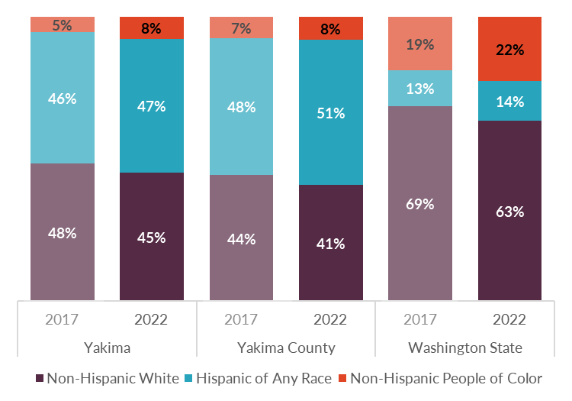
Source: US Census Bureau, American Community Survey 5-yr Estimates, 2017-2022; BERK, 2025.

Displacement Risk Mapping
Commerce provides a displacement risk mapping tool that identifies areas where residents are at greater risk of displacement. This tool evaluates relative displacement risk on a Census tract-level with a focus on three core categories: (1) social vulnerability; (2) demographic change; and (3) market trends:
- Social vulnerability: Calculates the share of BIPOC residents, the share of renter households, and median household income at a tract level. Each indicator is assigned a score (1-5) based on its level compared to the same measurement at the broader county level. Cumulative scores of 10 or more constitute higher social vulnerability.
- Demographic change: Calculates the change in the BIPOC population and lower income households between 2010 and 2020 (BIPOC) or 2021 (low-income households). Each characteristic is assigned a score based on its change relative to the countywide change, and the combination of these two indicators produces a demographic change score of “gentrification,” “disinvestment,” or “no change.”
- Market trends: Calculates 2015 rent levels for each tract, relative to the broader county, and also evaluates rental appreciation rates from 2010 to 2021 relative to the county. The combination of these two indicators produces a market trend of “Appreciated,” “Accelerating,” or “Stable.”
Exhibit 3-38 maps the displacement risk assessment for every Census tract overlapping the city. The tool shows variation in displacement risk throughout Yakima, with areas of high and moderate displacement risk concentrated on the eastern side of the city (including Downtown and areas toward Interstate 82). Downtown and the areas surrounding it are considered socially vulnerable (e.g., there is a higher share of BIPOC residents, renter households, and median household income is ≤80% of AMI). These mostly include areas within the city near Interstate 82 and along the industrial corridor created by the BNSF railway. The pattern follows for Demographic Change (Exhibit 3-40), with nearly all of Council District 1 at the northeast of the city having experienced gentrification.
Displacement risk is low in the western parts of the city. Some areas within Council District 3 and 5 are considered at moderate risk of displacement, with districts 6 and 7 having no areas at risk of displacement according to the Commerce tool. The entirety of Council District 4 is identified as socially vulnerable, with most of 1, 2, and 5 vulnerable as well. Again, districts 6 and 7 are not identified by the tool to be considerably vulnerable.
Note that Census tracts are often larger than neighborhoods experiencing gentrification and displacement. Yakima can use census tract data to monitor trends and review displacement risks in each Council district.
Exhibit 3-38. Displacement Risk in the City of Yakima, 2020
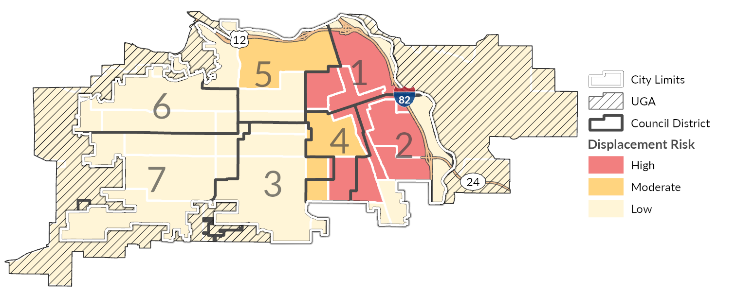
Source: WA State Department of Commerce, 2023; BERK, 2025.
Exhibit 3-39. Social Vulnerability in the City of Yakima, 2020
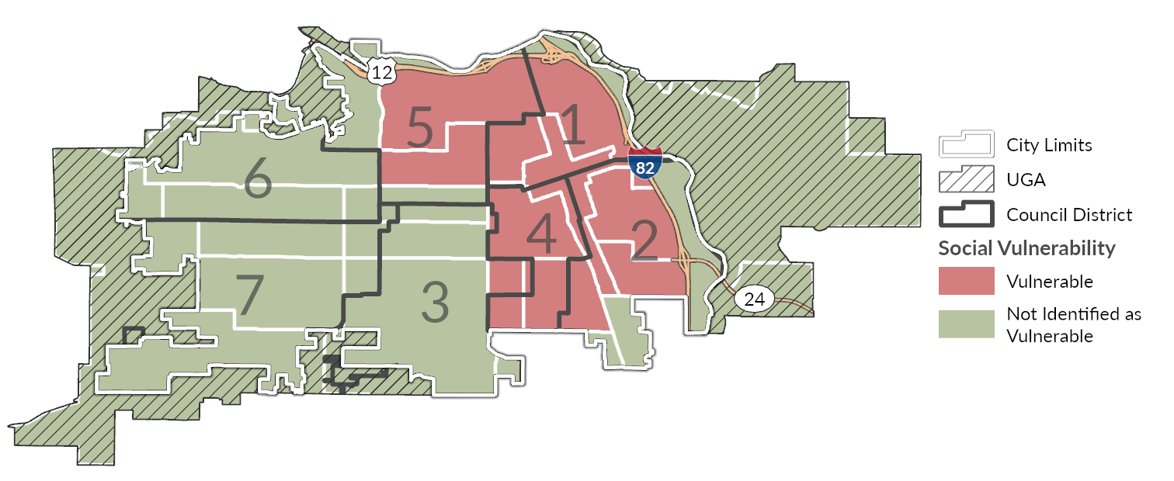
Source: WA State Department of Commerce, 2023; BERK, 2025.
Exhibit 3-40. Demographic Change in the City of Yakima, 2020
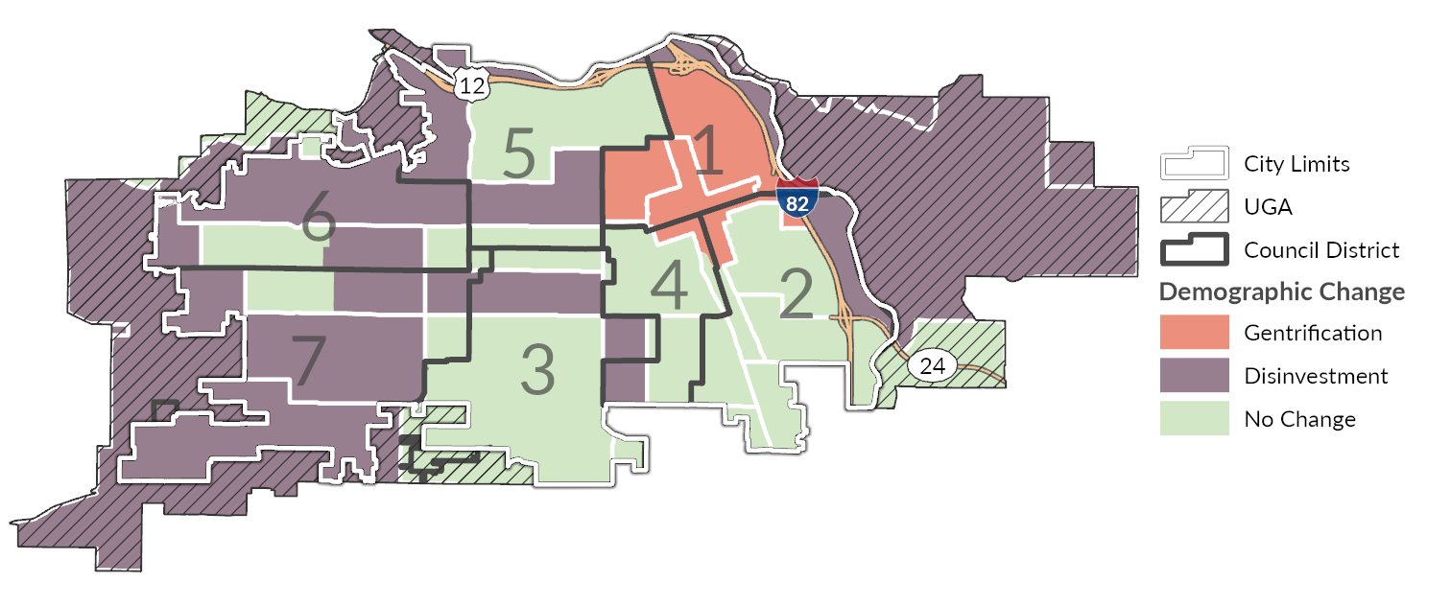
Source: WA State Department of Commerce, 2023; BERK, 2025.

Racially Disparate Impacts
New State and County requirements call for cities to assess whether racially disparate housing impacts are happening in their community, and to address them through policy and regulatory change. The requirements are not a charge against current communities in which there are racially disparate outcomes in housing, but an acknowledgement of the role land use policy has played in creating and institutionalizing race-based advantages and disadvantages. The statute uses the term “racially disparate” but does not identify protected groups based on race. Racially disparate impacts occur when policies, practices, rules, or other systems result in a disproportionate effect on one or more racial groups. Disparities in housing measures among different racial and ethnic groups are evidence of racially disparate impacts.
A community’s current housing situation is the product of many forces including historical factors, policy, regulations, macroeconomic changes, lending practices, cost of development, and individual preference. City governments cannot control all of these factors, but they can change local land use policies and regulations. Local land use policies and regulations have a significant impact on accessibility of housing for different households. As such, they are a key tool the City can use to address racially disparate impacts.
The City and consultant team used several measures to explore whether racially disparate impacts exist in Yakima. Some of these measures were covered earlier in this document, such as rates of homeownership, household income, and cost-burdened status by racial and ethnic groups. Those measures show evidence of racially disparate impacts. Homeownership rates are lower among Hispanic or Latino households (Exhibit 3-29). Median household income is also lower for Hispanic or Latino households than it is for non-Hispanic White households ($53,505 versus $58,231; Exhibit 3-9) and Census block groups with median household incomes below the citywide median correspond with greater concentrations of Hispanic or Latino populations (Exhibit 3-10 and Exhibit 3-6).
The team also explored displacement risk with the mapping tool provided by Commerce, as discussed in the prior section. The tool highlights areas of high and moderate displacement risk in and around Downtown and the eastern side of the city. It also indicates that displacement may already be occurring or have already occurred in primarily residential areas along Interstate 82. Additional measures the team used to explore exclusion and racially disparate impacts in Yakima are described in the following section, including a dissimilarity index and location quotient. These show evidence of segregation impacts the City should consider as it updates its housing policies.

Segregation Measures
The team used two measures to help understand whether racial and ethnic segregation is happening in the city of Yakima to assess possible exclusion in housing: a dissimilarity index and a location quotient. These measures explore whether certain populations are excluded from housing within a specified area, in a manner that may be intentional or unintentional, but which nevertheless leads to non-inclusive impacts. The dissimilarity index compares the city of Yakima to itself and considers segregation citywide for various populations. The location quotient compares each Census block group in the city of Yakima to Yakima County.

Dissimilarity Index
A dissimilarity index is a statistical method for measuring segregation based on the demographic composition of an area and smaller geographic units within that area. One way of understanding the index is that it indicates how evenly two demographic groups are distributed throughout an area: if the composition of both groups in each geographic unit (e.g., Census block group) is the same as in the area as a whole (e.g., countywide), then the dissimilarity index score for that count will be 0 (suggesting no segregation). By contrast, if one population is clustered entirely within one Census block group, the dissimilarity index score for the county will be 1 (complete segregation). The higher the dissimilarity index value, the higher the level of segregation in an area. Generally, areas with a dissimilarity index score above 0.4 are considered more highly segregated. Scores between 0.3 and 0.39 are associated with moderate segregation, and scores below 0.3 are considered to have a low level of segregation.
This methodology, as applied here, evaluates some of the largest non-White groups relative to the White population in Yakima. The scores therefore only represent the level of segregation between each group (Hispanic or Latino, Black, Asian, and all BIPOC) and the non-Hispanic White population. A similar analysis could be done to compare non-White groups to each other (e.g., Hispanic/Latino to American Indian or Alaska Native alone) to understand other dynamics; however, given the history of exclusionary housing practices in many places along with current residential trends, using the non-Hispanic White population as a point of comparison for understand relative segregation is often a useful starting point for evaluating disparate impacts related to housing.
Exhibit 3-41 shows dissimilarity indices for Yakima as well as the cities of Kennewick, Richland, West Richland, and Pasco along with Benton and Franklin counties for comparisons. Based on this data, the city of Yakima has a high level of segregation (0.44) within the city for Hispanic/Latino residents (who make up approximately 47% of the city population; Exhibit 3-37), and moderate segregation for the Black and All BIPOC populations. This suggests a moderate-to-high level of segregation within Yakima, which is consistent with mapping presented earlier in this report showing White, non-Hispanic populations are more prevalent in western areas of the city, while populations who identify as Hispanic or Latino (of any race) are more concentrated in and around Downtown and the areas surrounding it, especially to the southeast.
Exhibit 3-41. Dissimilarity Index for the City of Yakima and Comparison Geographies
 | Hispanic or Latino | Black | Asian | All BIPOC
Yakima | 0.44 | 0.37 | 0.27 | 0.39
Kennewick | 0.34 | 0.34 | 0.25 | 0.27
Richland | 0.22 | 0.24 | 0.28 | 0.13
West Richland | 0.21 | 0.17 | 0.24 | 0.14
Pasco | 0.48 | 0.29 | 0.24 | 0.44
Yakima County | 0.48 | 0.34 | 0.30 | 0.39
Source: US Census Bureau, Decennial Census, 2020; BERK, 2025.

Location Quotient
A location quotient is a helpful complement to other disparate impact measures and can reveal some trends that may otherwise be obscured. More specifically, it shows the concentration of communities in smaller areas within the city of Yakima (e.g., a Census block group) compared to Yakima County as a whole. Unlike the above application of the dissimilarity index, which compares the city to itself and considers segregation citywide for various populations, this use of the location quotient provides a more granular view, helping to show whether there are specific areas within Yakima that have disproportionately high or low populations of certain communities relative to countywide trends.
The methodology assigns a block-group level score for each community. For example, if 7% of the UGA population is Black, and 7% of a particular block group population is Black, then the location quotient for the Black community within that block group is 1. A block group where 14% of residents are Black would have a location quotient of 2. And a block group where only 3.5% of residents are Black would have a location quotient of 0.5. In other words, block groups with high location quotient scores have a greater share of that population compared to the rest of the urban growth area.
Exhibit 3-42, Exhibit 3-43Exhibit 3-44 show the location quotient for three race/ethnic groups in Yakima: White alone, Hispanic or Latino, and All BIPOC. They are based on block group population calculations. All areas with location quotients above 1.0 (green block groups) have a higher share of that particular group than the UGA as a whole. Areas with scores below 1.0 (purple block groups) have a lower share than the UGA. As shown, people identifying as White alone more consistently reside on the western half of the city, with very low quotient values within the Downtown area. There is a higher concentration of Hispanic or Latino populations in and around Downtown, especially to the southeast along Interstate 82. Examining the distribution of all BIPOC peoples (those identifying as any race other than White or a combination of two or more races) shows a point of concentration in the east near the edge of Downtown and around the Washington Park neighborhood, with most of the western half of the city and all of the unincorporated UGA having disproportionally less people identifying as BIPOC.
Exhibit 3-42. Location Quotient for Residents Identifying as White Alone, City of Yakima, 2020
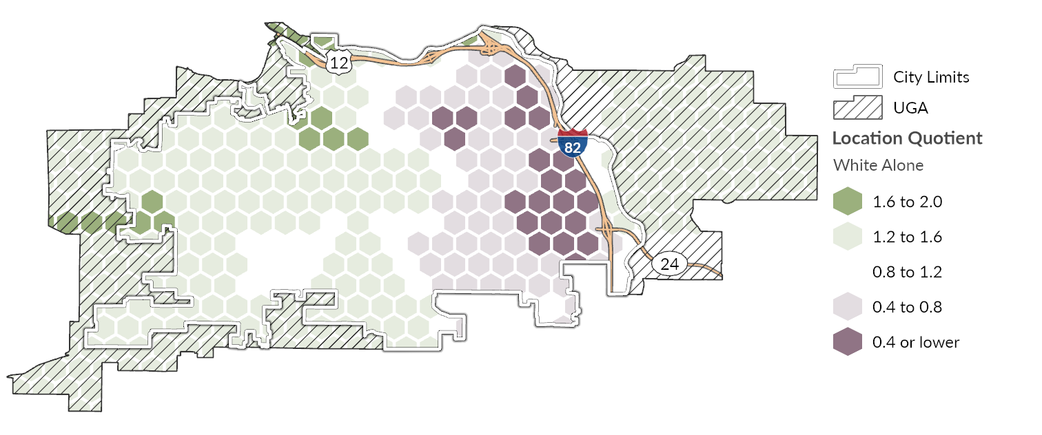
Source: US Census Bureau, Decennial Census, 2020; BERK, 2025.
Exhibit 3-43. Location Quotient for Residents Identifying as Hispanic or Latino, City of Yakima, 2020
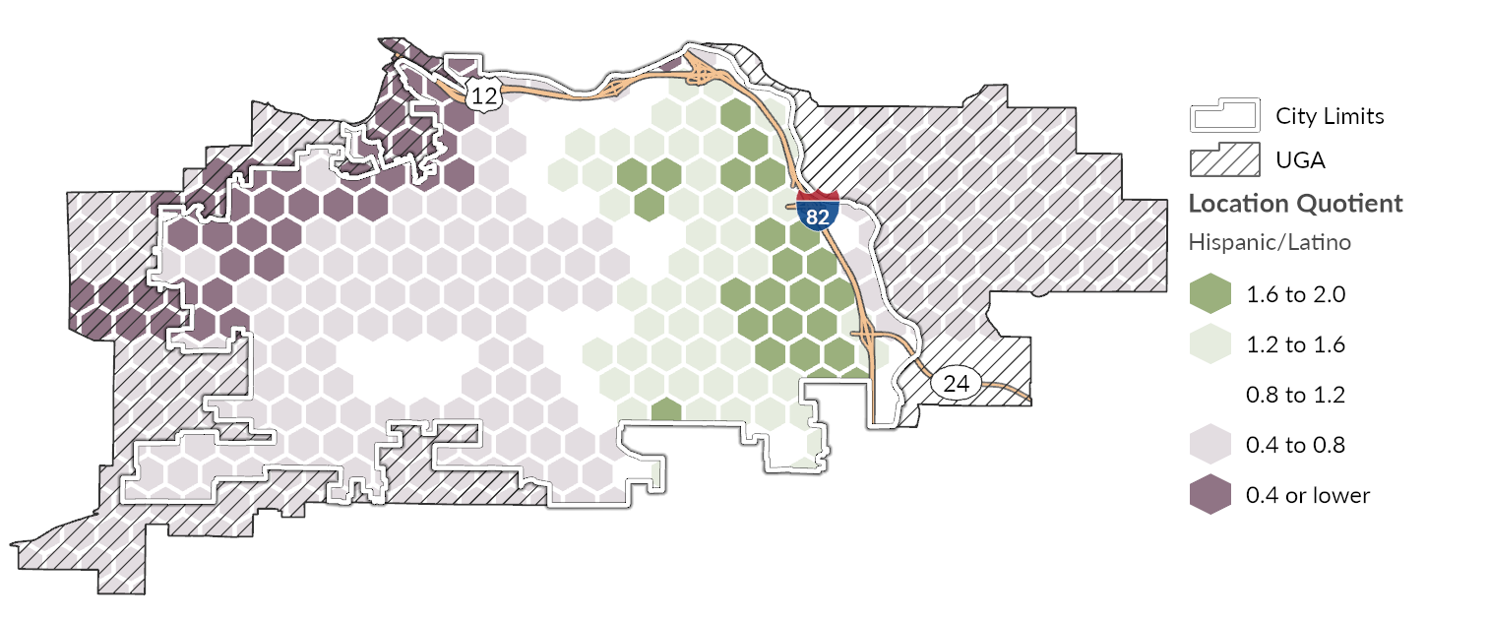
Source: US Census Bureau, Decennial Census, 2020; BERK, 2025.
Exhibit 3-44. Location Quotient for Residents Identifying as Black, Indigenous, or a Person of Color, City of Yakima, 2020
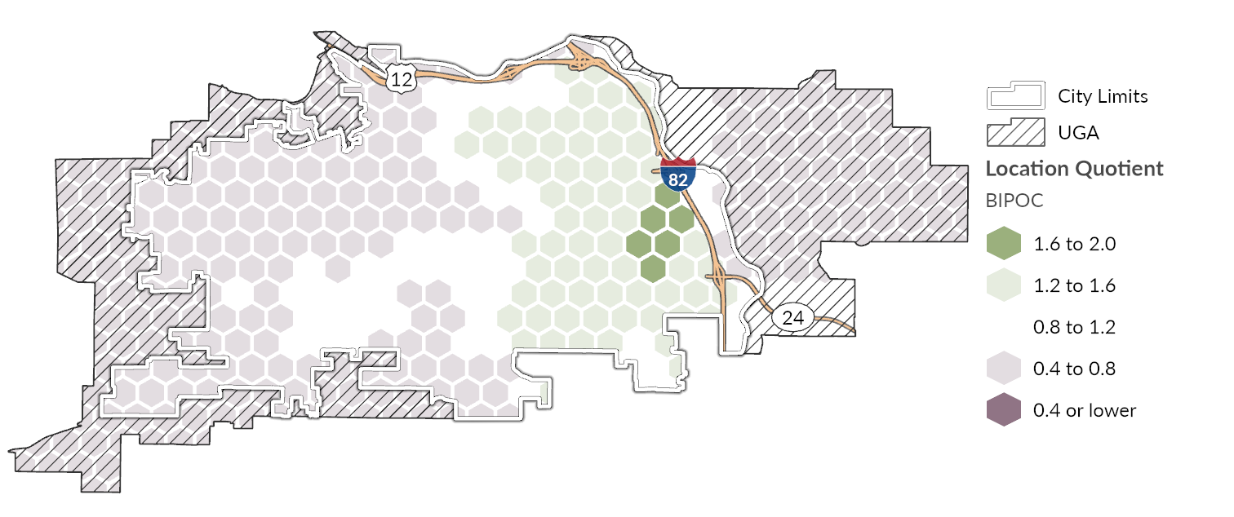
Source: US Census Bureau, Decennial Bureau, 2020; BERK, 2025.

Environmental Health Disparities
Environmental justice is concerned with the right of all people to enjoy a safe, clean, and healthy environment, and with fairness across racial, social, and economic groups in the siting and operation of infrastructure, facilities, or other large land uses. This section considers whether there are concentrations of racial groups in certain areas of the city with increased exposure to environmental health hazards or with limited access to transit, parks, or other services. Placing additional growth near high-volume roadways could expose future residents or workers to diminished air quality and heightened noise affecting quality of life and land use compatibility. It is particularly important to understand the health-related impacts of various land use patterns on spaces used by vulnerable populations, such as schools, daycares, elder care facilities, and medical centers.
Roadway users and adjacent neighborhoods experience air pollution from vehicle exhaust and brake/tire/road wear. Pollutant particle size, topography, and wind patterns affect the geographic extent of concern, with the greatest impacts immediately adjacent to and downwind of major freeways. Roadway traffic, especially larger vehicles (i.e., trucks and buses) also produce noise, and urban heat is generally of greatest concern where most of the ground area is covered by pavement, buildings, and other surfaces that absorb and retain heat.
Environmental exposure is affected by pollutants from both natural and manmade sources. Air quality and greenhouse gas (GHG) emissions are generally the greatest environmental exposure concerns in Yakima. These are areawide issues that are often discussed at a regional or even state level but there can be distinct differences between urbanized, populated areas and rural and undeveloped areas. Vehicles and equipment that burn fossil fuels are typically among the largest contributors to transportation-related emissions and can contribute to regional and localized concentrations of state and federally regulated pollutants. High concentrations of PM2.5 and other air pollutants contribute to respiratory problems, long-term health challenges, and increased healthcare costs. Exhibit 3-45 maps PM2.5 concentration levels in Yakima with an observed 2014-2017 average. Concentrations of PM2.5 are highest in the east and northeast portions of the city, including Downtown and industrial areas, where many Hispanic or Latino residents live.
Exhibit 3-45. PM2.5 Concentration, City of Yakima, 2014-2017 Average
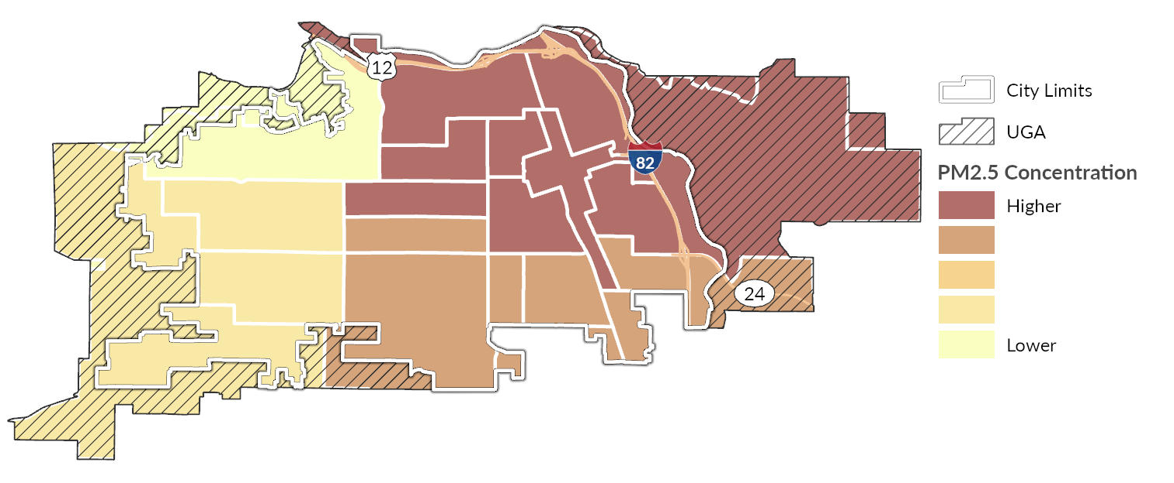
Source: WA Department of Health, Environmental Health Disparities Map, 2022; BERK, 2025.
The Washington State Department of Health (DOH) also produces an Environmental Health Disparities Map to evaluate environmental health risk factors in communities across Washington. The Environmental Health Disparities Map provides an index of environmental exposures (e.g., diesel emissions and proximity to traffic and hazardous waste sites) and socioeconomic and health factors (e.g., poverty and cardiovascular disease prevalence). Health disparities generally rank higher in the eastern portions of the city in and around Downtown where Hispanic or Latino populations are more concentrated.
A higher health disparity ranking represents an outsized burden of exposure and sensitivity to environmental harm. Prevailing socioeconomic characteristics and health factors—such as rates of poverty, chronic disease (like asthma) or low birthweight, limited English proficiency, race/ethnicity, or transportation expenses—can lead to worse health outcomes in some parts of the city than others despite varying levels of environmental exposures throughout the city. Environmental exposures include the levels of certain pollutants that residents and workers come into contact with, including airborne pollutants (e.g., diesel emissions, O3, and PM2.5) and proximity to traffic density or hazardous waste sites. Environmental exposure occurs when pollution sources get into the environment and affect individuals or populations. Prolonged exposure to pollutants may lead to poor health outcomes. Sensitive or vulnerable populations—including older adults, households living in poverty, disabled individuals, those without health insurance, households without access to a vehicle or other transportation options, and those experiencing homelessness—are at increased risk.
Exhibit 3-46. Environmental Health Disparities Map Score, City of Yakima, 2022
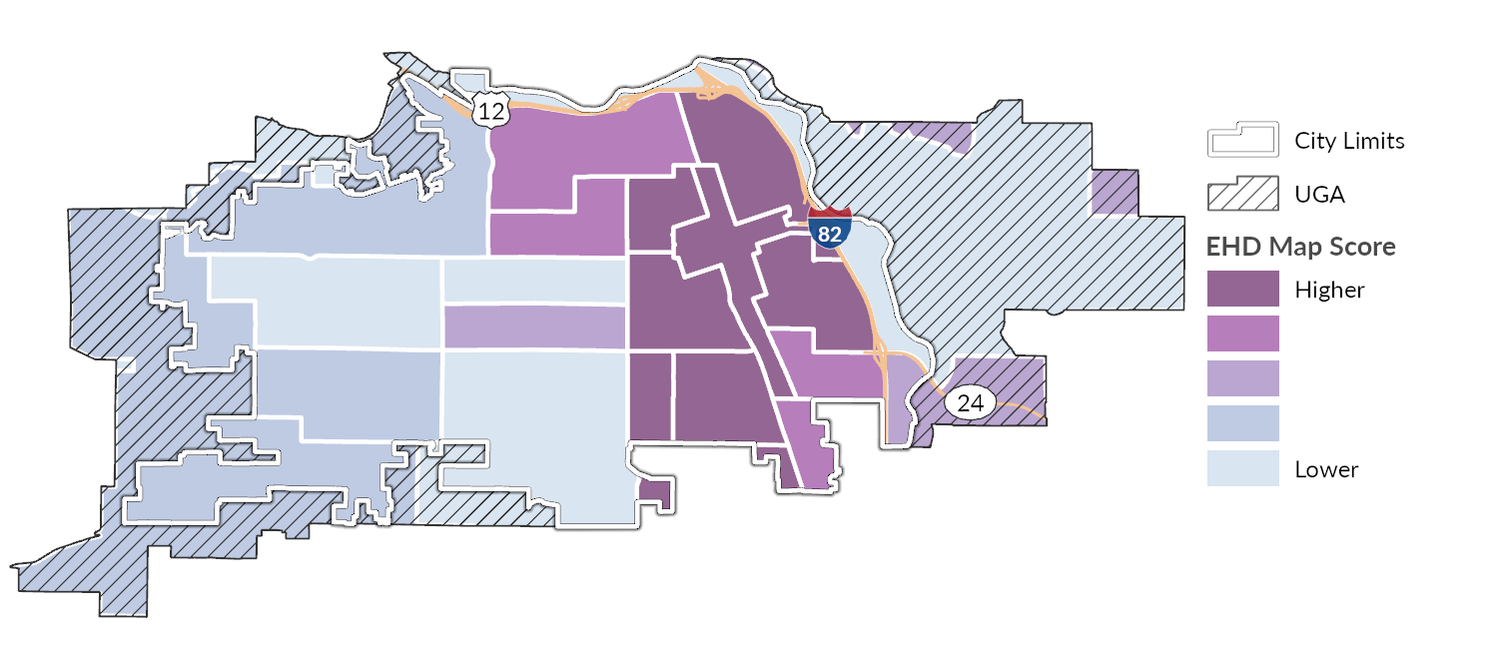
Source: WA Department of Health, Environmental Health Disparities Map, 2022; BERK, 2025.
Noise levels in Yakima are highest along major arterials, near the railway, and under the flight path of the Yakima Air Terminal/McAllister Field. Most other areas within Yakima are below the 45 dBA threshold measured by the U.S. Department of Transportation (USDOT) Noise Map as shown in Exhibit 3-47. Health impacts from noise include hypertension, heart disease, and likely poor school performance among children. Additionally, noise can affect quality of life and cause vibrations that impact hospitals and health care facilities. Direct effects of noise that indirectly affect health include:
• Speech interference
• Sleep disturbance
• Task interference
• Impairment of classroom learning
• Non-auditory health effects
• Aversive effects on emotion and tranquility
Exhibit 3-47. Transportation Noise Levels, City of Yakima, 2020
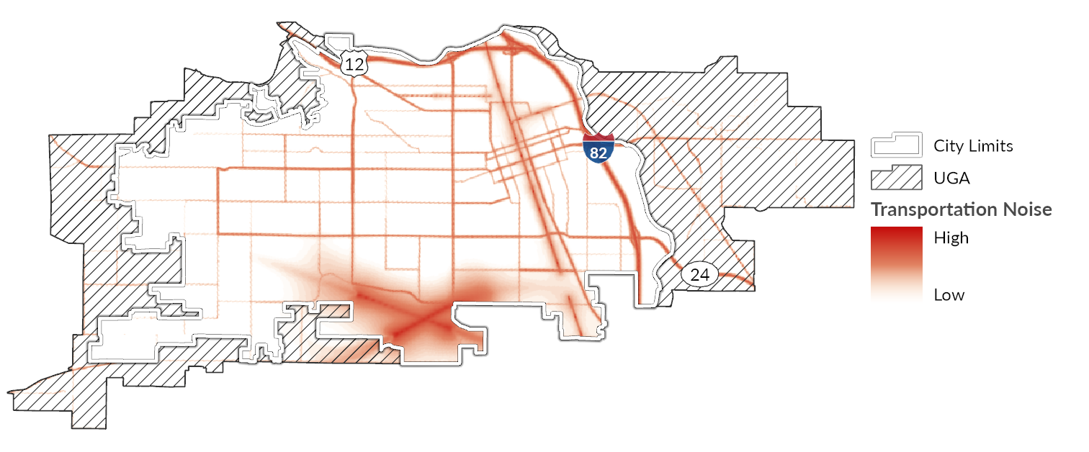
Source: USDOT, 2020; BERK, 2025.
Extreme heat is among the most pervasive weather-related hazards in the United States, and Washington’s summers are becoming increasingly hotter and longer. The city of Yakima and surrounding region are expected to see warmer year-round temperatures, higher maximum summer temperatures, and more frequent and severe heat waves. (University of Washington Climate Impacts Group, 2025) Extreme heat is expected to be an increasingly prevalent hazard in Yakima, with a projected increase of at least 8 additional days of extreme heat (over 100o F) by 2079 in Yakima Couty. Per the City of Yakima Climate Impacts Summary and subsequent Vulnerability Assessment Memo, key risks associated with extreme heat include:
- More extreme heat days puts residents in the Yakima at risk of heat-related illness and death. Prolonged exposure to high temperatures stresses the body and contributes to heat exhaustion and heat stroke. Individuals with chronic health conditions, people without adequate shelter, such as unhoused individuals are more at risk of injury and death from extreme heat. Additionally, older residents (those above age 65) are more likely to have existing health conditions (e.g., diabetes or heart disease) that worsen with significant heat stress.
- Worse air quality due to increasing ground-level ozone formation—a phenomenon known as the "smog effect"—which can aggravate respiratory conditions like asthma and chronic bronchitis (Zhang & Wang, 2016; Fann et al., 2016). This air quality impact especially impacts older residents, younger residents, and individuals who work outside.
- Heightened risk to people who work outside are also at of health issues related to extreme heat. Extreme heat events that put residents at risk of heat-related illnesses can also increase the need for emergency response, straining already strained emergency departments including fire, police, EMS, and hospital systems.
- Disruption to important ecosystems and critical areas through rising surface water temperatures, range shifts, and subsequent competition with invasive species. For example, warming air and water temperatures have contributed to algal blooms and allowed non-native species to thrive throughout Yakima’s wetlands including the Yakima River and Naches River. These invasive species, coupled with heat stress from rising stream temperatures may strain important native species like the several fish and bird species that traverse and spawn in the Lower Yakima River Basin. Summer maximum temperatures are expected to increase and worsen these conditions. Warm winter temperatures can also negatively impact snowpack, stream flow, and increase pest populations.
- Increased cooling demands and place additional stress on older buildings and HVAC systems. Increasing use of air conditioning depends on a stable, affordable electric supply. Rising electricity costs from climate-induced grid strain could further burden low-income households and rural communities. The region's growing population and aging infrastructure increase pressure on existing grid capacity.
- Infrastructure damage as high heat causes roads to warp and buckle, damages bridge joints, and increases deterioration of pavement (Sen, Li, & Khazanovich, 2022). This occurred throughout Washington State during the 2021 heat wave as a result of prolonged exposure to temperatures above 100 Degrees Fahrenheit.
Certain land use decisions may worsen the impacts of extreme heat on these critical assets. "Urban heat islands" contribute to this and occur when natural land cover is replaced by large amounts of pavement, buildings, and other surfaces that absorb and retain heat. Structures such as buildings, roads, and other infrastructure absorb and re-emit the sun’s heat more than natural landscapes such as forests and water bodies. Urban areas, where greenery is limited, become “islands” of higher temperatures relative to outlying areas. This effect increases energy costs (e.g., for air conditioning), air pollution levels, and heat-related illness and mortality and can further exacerbate heat exposure from climate change and the impacts of naturally occurring heat waves. Heat islands are also riskier for sensitive populations, including older adults, young children, populations with low-income, outdoor workers, and people in poor health. High pavement and rooftop surface temperatures can also heat up stormwater runoff, which drains into storm sewers and raises water temperatures as it is released into streams, rivers, ponds, and lakes.
Exhibit 3-48 maps urban heat islands as modeled from satellite-derived information during the summer of 2023. Areas with a lower urban heat island effect are shown in white, while those with a greater effect are shown in deeper color. While all of Yakima is exposed during a heat event, certain areas will be hotter than others due to this effect, including eastern and southeastern portions of the city where Hispanic and Latino population are more prevalent. Parts of the city with more paved surfaces and less tree canopy and other vegetation tend to experience more heat, generally the more commercial and industrial areas of the city (tree canopy coverage is mapped in Exhibit 3-49). Industrial areas along the BNSF railway and in and around Downtown are especially susceptible to extreme heat. The ability to keep cool as temperatures rise during the summer is important especially in areas where heat severity is higher and tree canopy coverage is lower. Keeping cool is a function of surrounding tree canopy as well as how well insulated the building structures are, the presence or capacity of mechanical and/or natural cooling systems, and the ability of the structure to reflect heat during the summer and absorb it during the winter.
Exhibit 3-48. Urban Heat Island Severity, City of Yakima, 2023
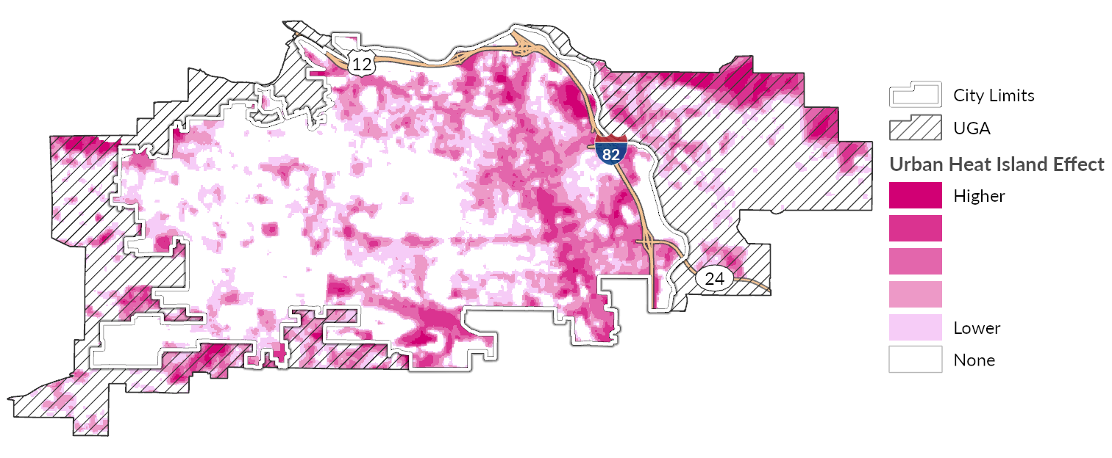
Source: Trust for Public Land, 2023; BERK, 2025.
Exhibit 3-49. Tree Canopy Coverage, City of Yakima, 2021
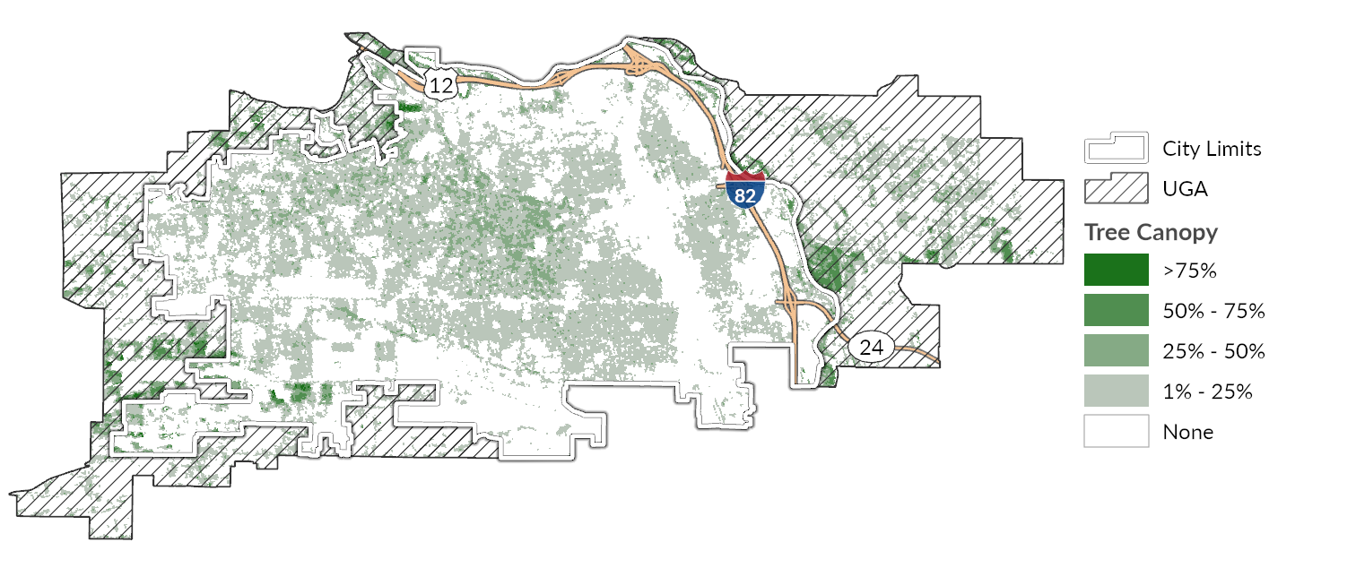
Source: US Geological Survey, National Land Cover Dataset, 2021; BERK, 2025.

Engagement
Housing focused engagement was conducted as part of the Comprehensive Plan Periodic Update to better understand contributing factors to racially disparate impacts, displacement, exclusions in housing, and future displacement risk. Strategies include open houses, and feedback from a Comprehensive Plan Steering Committee. See Comprehensive Plan Draft Appendix XX for a summary of engagement conducted to date, including the following key themes:
- Expand housing typologies and supply: a common theme heard across various engagement strategies is a desire to see more affordable housing options in Yakima, particularly for first time home buyers. Community members also expressed a desire to see more affordable housing typologies, such as middle housing, Accessory Dwelling Units (ADU’s), and more
- Incentivize housing through capital improvements: One of the biggest challenges noted with housing was around infrastructure. It was noted that developers are a critical player in expanding infrastructure capacity in Yakima. However, more city-led infrastructure projects and incentives could help reduce housing costs, and incentivize more residential development
- Consistent design and land use patterns: To balance the potential increase of middle housing, several community members noted that land use patterns should ensure a smooth transition of zones, and building typologies. For Multifamily housing, providing open space with new development was highlighted as a key need. Design standards should offer consistency of residential urban design, and aesthetics.
- Prioritize new housing along key transit and commercial corridors: When asked where there should be more housing, the majority of responses noted a desire for more housing along transit lines, and commercial nodes/corridors. People noted the development of new commercial centers in West Yakima, and agreement to see more multifamily housing in those areas. S 16th Ave was also mentioned as a key neighborhood for additional residential development. In addition, residential development in the UGA was noted as another potential area for additional housing.

Policy Review
A full list of the goals and policies related to housing in the City of Yakima can be found in the body of the Comprehensive Plan Housing Element. Exhibit 3-50 is a summary of updates made to the Housing Element of the Comprehensive Plan as part of the periodic update with the specific objective of lowering racially disparate impacts in housing. These policy changes are meant to address impacts such as hazard resiliency, affordability, access to services, and isolation from community. Enacting these policies is not the only step that needs to be taken to address racially disparate impacts of housing but these changes lay the groundwork for future efforts.
Exhibit 3-50 Racially Disparate Impacts – Housing Policy Analysis and Audit Summary
Goal and Policy # | Previously Adopted Housing Goals and Policies | RDI Related Edits/ Additions made as part of 2026 Periodic Update to Comprehensive Plan
3.1.2. | Promote the preservation, improvement, and development of single family homes in Yakima. | Promote the preservation, improvement, and development of middle housing and single family homes in Yakima.
3.1.4. | Facilitate small lot sizes, condominiums, clustering and other options that increase the supply of affordable homeownership options and the diversity of housing that meet the needs of aging, young professional, and small and large households. | Facilitate small lot sizes, condominiums, townhomes, accessory dwelling units, clustering and other middle housing options that increase the supply of affordable homeownership options and the diversity of housing that meet the needs of aging, young professional, and small and large households.
3.1.8. | Encourage and incentivize affordable housing development. | Encourage and incentivize affordable housing development for moderate, low, very low and extremely low income households.
3.1.9. | Support proposals for affordable assisted and market rate housing based on the following criteria:  - Dispersion of affordable housing throughout the City  - Convenient access to transit  - A range of unit types  - Ownership housing when possible  Long-term affordability | Support proposals for affordable assisted and market rate housing based on the following criteria:  - Dispersion of affordable housing throughout the City  - Convenient access to transit  - A range of unit types including middle housing  - Ownership housing when possible  Long-term affordability
GOAL 3.3. | ENSURE AN ADEQUATE SUPPLY OF HOUSING FOR PERSONS WITH SPECIAL NEEDS. | ENSURE AN ADEQUATE SUPPLY OF HOUSING FOR ALL INCOME GROUPS INCLUDING PERSONS WITH SPECIAL NEEDS.
3.3.1. | Prioritize the provision of fair share housing opportunities to all economic segments of the population and those with special needs. | Prioritize the provision of fair share housing opportunities to all economic segments of the population and those with special needs as allocated through the regional allocation process.
3.3.5 | [NEW] | Support programs to ensure that individuals and families vulnerable to natural hazard impacts have adequate housing options. Vulnerable communities include the following:  - older adults and children  - those with pre-existing health conditions including pulmonary conditions  - individuals with mobility challenges  - low- and extremely low-income individuals  - pregnant people  - people with limited literacy  - people who speak English as a second language
GOAL 3.4. | ENCOURAGE DESIGN, CONSTRUCTION, AND MAINTENANCE OF HIGH QUALITY HOUSING. | ENCOURAGE DESIGN, CONSTRUCTION, AND MAINTENANCE OF HIGH QUALITY HOUSING WITHOUT MAKING UNITS COST PROHIBITIVE.
3.4.5. | Implement utility standards that encourage infill development. | Implement utility standards that encourage infill development and middle housing.
3.4.6 | [NEW] | Encourage or incentivize residential development standards which increase resiliency to natural hazards such as extreme heat, severe storms, drought, and wildfire smoke through cross-ventilation, passive cooling window coverings, and energy efficiency upgrades
3.5.4. | Consider human services objectives in developing City regulations and codes. For example, enforcing code abatement may mean making people homeless. Ensuring there are community resources to assist these residents, before they are abated, is critical. | Consider human services objectives in developing City regulations and codes. For example, Ensure code enforcement does not result in displacement or homelessness enforcing code abatement may mean making people homeless. Ensuring there are community resources to assist these residents, before they are abated, is critical.
3.5.7. | [NEW] | Connect with isolated community groups to ensure effective human service delivery and ensure people and homes are safe in the event of emergencies
3.5.8. | [NEW] | Evaluate services, service delivery, and community-based resources as they relate to making individuals, children, and families more resilient to natural hazards of extreme heat, flooding, wildfires, and drought events
GOAL 3.6. | [NEW] | Prevent discrimination, and displacement in the development and maintenance of housing.
3.6.1 | [NEW] | Collaborate with community groups, organizations, non-profits, and businesses to help vulnerable groups obtain and maintain housing.
3.6.2 | [NEW] | Evaluate the potential for displacement on lands proposed for rezone or redevelopment for public use.
3.6.3 | [NEW] | Collaborate to understand the drivers of displacement through involvement of community groups, organizations, and institutions in affected areas.

Projected Housing Needs
Consistent with new requirements under the Growth Management Act (GMA), Washington State Department of Commerce (Commerce) provides guidance for determining countywide projected housing needs by affordability level, including permanent supportive housing (PSH) and emergency housing. This work involves coordination between a county and each of its constituent jurisdictions. The City of Yakima, in coordination with Yakima County, completed analysis consistent with Commerce guidance. A summary of the process follows.

Population Growth Projection
Yakima County conducted an analysis of countywide population growth trends to derive an average annual growth rate (AAGR) used to project future growth. Using this method, it projects the countywide population will be 297,319 in the year 2024, an increase of 40,591 compared to the population in 2020. This is slightly higher than the Washington State Office of Financial Management (OFM) “Medium” population projection for Yakima County, but significantly less than OFM’s “High” projection.

Projected Countywide Housing Needs
Yakima County used Commerce’s Housing for All Planning Tool (HAPT) to calculate the total countywide housing needs by affordability level associated with the county’s projected population growth. The results are shown in Exhibit 3-.
Exhibit 3-. Project Housing Needs, Yakima County (2020-2046)
 | Total | Affordability Level (% of Area Median Income) |  |  |  |  |  |  | Emergency Housing/ Shelter Beds
 | Total | 0-30% |  | 30-50% | 50-80% | 80-100% | 100-120% | 120%+ | Emergency Housing/ Shelter Beds
 | Total | Non-PSH | PSH
Total Future Housing Needed (2046)** | 114,482 | 8,261 | 4,495 | 25,742 | 36,353 | 12,706 | 8,282 | 18,643 | 1,951
Estimated Housing Supply (2020)* | 89,425 | 4,351 | 228 | 20,264 | 33,325 | 10,917 | 7,070 | 13,270 | 572
Net New Housing Needed (2020-2046) | 25,057 | 3,910 | 4,267 | 5,478 | 3,028 | 1,789 | 1,212 | 5,373 | 1,379
* 2020 supply excludes homes in recreational use. Supply of PSH in 2020 is beds. However, projections of Net New Housing Needed (2020-2046) are in housing units.
** Total Future Housing Needed (2046) excludes 2020 homes in recreational use.

Source: WA State Department of Commerce, Growth Management Services Housing For All Planning Tool (HAPT). Calculations
are based on the Yakima County 2046 Population Projections and Allocations.

Allocation of Projected Housing Needs to Jurisdictions
To allocate countywide Net New Housing Needed to individual jurisdictions, the HAPT requires assumptions for the percentage of growth to allocate to each jurisdiction. The County developed assumption for growth by considering a number of factors, including historic population growth and development patterns, infrastructure capacity, and land capacity for future growth. They also considered existing disparities in affordability, housing supply, and proximity to employment. The results of this analysis are shown in Exhibit 3-.
Exhibit 3-. Allocation of Projected Housing Needs to Jurisdictions and UGAs, 2020-2046
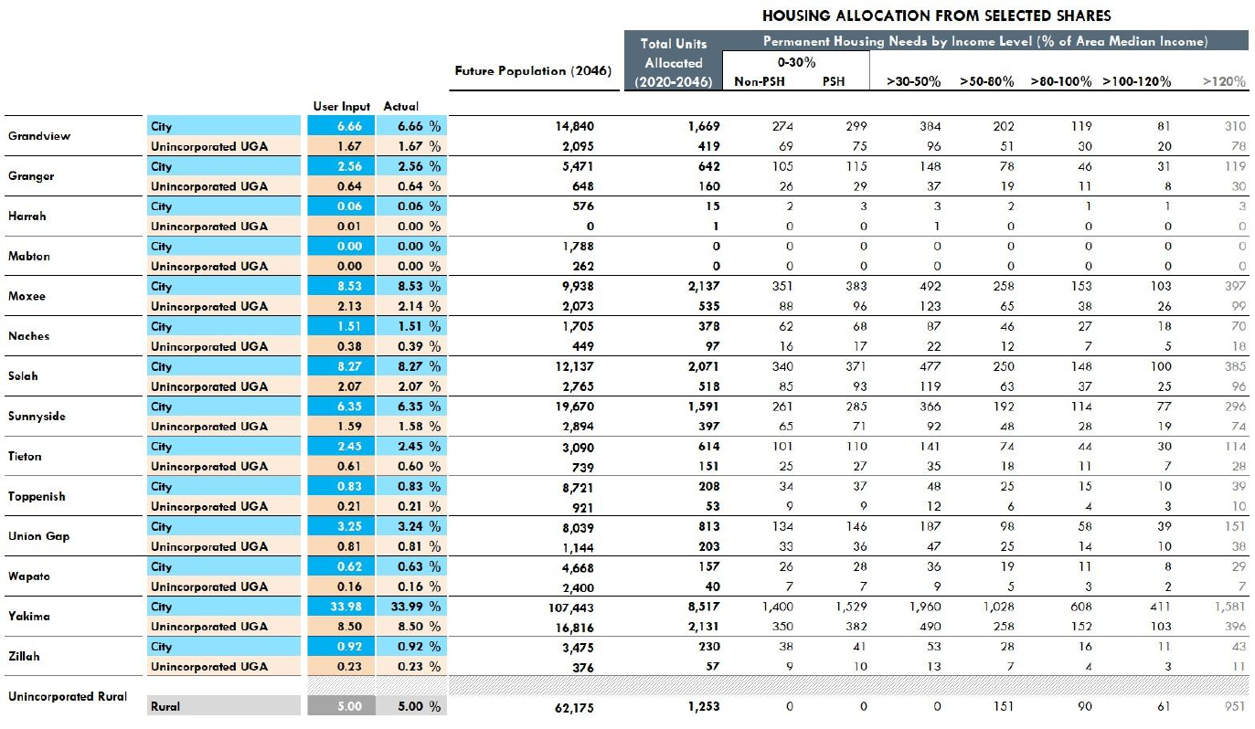
Source: WA State Department of Commerce, Growth Management Services Housing For All Planning Tool (HAPT). Calculations are based on the Yakima County 2046 Population Projections and Allocations.
Exhibit 3- shows the combined allocation for the City of Yakima and its UGA, including the allocation of countywide emergency housing needs.

Exhibit 3-. City of Yakima and UGA Combined Allocation of Projected Housing Needs, 2020-2046
 | Total Units Allocated | Affordability Level (% of Area Median Income) |  |  |  |  |  |  | Emergency Housing/ Shelter Beds
 | Total Units Allocated | 0-30% |  | 30-50% | 50-80% | 80-100% | 100-120% | 120%+ | Emergency Housing/ Shelter Beds
Jurisdiction | Total Units Allocated | Non-PSH | PSH
City of Yakima + UGA | 10,648 | 1,750 | 1,911 | 2,450 | 1,286 | 760 | 514 | 1,977 | 617
Source: WA Department of Commerce, 2025; BERK, 2025.

Capacity for Projected Housing Needs
Under GMA, Yakima is required to plan for and accommodate future housing production to meet these housing need allocations at each income level. This includes demonstrating sufficient buildable land capacity for housing types appropriate to meeting these needs.
Not all housing types are appropriate for meeting all housing needs. Due to differences in land and construction costs per unit, the affordability of new housing depends in part on housing type. For instance, a new single-family home on a large lot is the most expensive type of home to produce per unit. New homes often require an income of over 150% AMI to afford. Multifamily homes, such as apartment buildings, can be produced at a much lower cost per unit.
Exhibit 3- presents seven different housing types that could be built in Yakima, as well as the lowest level of income that can be served assuming the new housing is either market-rate or a subsidized affordable housing project. These housing types and affordability assumptions are consistent with Commerce guidance for updating housing elements and BERK’s assessment of local housing costs.
Exhibit 3-. Housing Types and Potential Income Levels Served
Housing Type | Definition | New Market Rate Housing | Subsidized Affordable Housing | Assumed Affordability Level for Capacity Analysis
Low-Rise Multifamily | Walk up apartment buildings or condominiums (up to 3 floors). | >80-120% AMI | 0-80% AMI | Low-Income  (0-80% AMI)
Mid-Rise Multifamily | Apartments or condominium buildings with 4-8 floors. | >80-120% AMI | 0-80% AMI | Low-Income  (0-80% AMI)
Moderate Density | Also known as “middle housing”. Inclues townhomes, duplexes, triplexes, quadplexes. | >80-120% AMI  & >120% AMI | Not typically feasible at scale | Moderate-Income  (>80-120% AMI)
ADUs | Accessory Dwelling Units | >50-80% AMI | Not typically feasible at scale | >50-80% AMI
Manufactured Homes | Homes that are constructed in a factory and then assembled at the building site in modular sections | >80-120% AMI as primary unit on lot | Not typically feasible at scale | Moderate-Income  (>80-120% AMI)
Low Density | Detached single family homes. | >120% AMI | Not typically feasible at scale | Higher Income  (>120% AMI)
Sources: Washington Department of Commerce Guidance for Updating Your Housing Element, 2023; Benton County, 2025; BERK, 2025.
BERK conducted a buildable land capacity analysis to quantify the number of new housing units that can be produced in the City of Yakima by housing type. See Section 2.3.1. Land Capacity Analysis for a technical description of the analysis. The results are summarized in Exhibit 3-. It shows the City alone has capacity for over 21,000 net new housing units. Moreover, it shows there is sufficient capacity by assumed income level served to accommodate Yakima’s projected housing needs by income level. However, there is limited surplus capacity for low-rise multifamily development compared to the need for 0-50% AMI housing. If much of this capacity is consumed by market rate housing development that doesn’t serve these households, there could be limited remaining capacity to meet those 0-50% AMI housing needs.
Exhibit 3-. Capacity for Housing Compared to Projected Housing Need, City of Yakima
Housing Type | Assumed Income Level Served | Net Housing Unit Capacity | Projected Housing Need | Capacity Surplus or Deficit
Low Density (Detached Single Family) | High (>120% AMI) | 6,537 | 1,977 | 4,560
Moderate Density | Moderate (>80-120% AMI) | 6,494 | 1,274 | 5,220
ADUs | >50-80% AMI | 1,832 | 1,286 | 546
Low-Rise Multifamily | Low (0-50% AMI)* | 6,863 | 6,111 | 752
 |  | 21,728 | 10,648 | 11,080
* Low-rise multifamily buildings, such as apartments, could also accommodate housing needs from 50-120% AMI in this analysis if there is a surplus.
Source: BERK, 2025.
Yakima’s allocation of countywide housing needs is intended for both the City of Yakima and its unincorporated UGA combined. Therefore, BERK also evaluated land capacity within the unincorporated UGA adjoining the City of Yakima. Exhibit 3- presents the combined capacity of both the City of Yakima and UGA, with comparison to projected housing need. The total capacity (44,066 housing units) is over double the capacity within city limits. Most of this additional capacity is for low density, detached single family housing production. However, the UGA also includes additional capacity for low-rise multifamily housing which helps to address the limited surplus of capacity available in the city alone.
Exhibit 3-. Capacity for Housing Compared to Projected Housing Need, City of Yakima and Unincorporated UGA Combined
Housing Type | Assumed Income Level Served | Net Housing Unit Capacity | Projected Housing Need | Capacity Surplus or Deficit
Low Density (Detached Single Family) | High (>120% AMI) | 25,819 | 1,977 | 23,842
Moderate Density | Moderate (>80-120% AMI) | 9,820 | 1,274 | 8,546
ADUs | >50-80% AMI | 2,043 | 1,286 | 757
Low-Rise Multifamily | Low (0-50% AMI)* | 8,133 | 6,111 | 2,022
 |  | 44,066 | 10,648 | 35,167
* Low-rise multifamily buildings, such as apartments, could also accommodate housing needs from 50-120% AMI in this analysis if there is a surplus.
Source: BERK, 2025.

Adequate Provisions
GMA requires that communities ensure that their Comprehensive Plan policies and regulations are designed to achieve housing availability for all community members at all income levels.
Specifically, under RCW 36.70A.070(2)(d), City of Yakima must prepare a Housing Element that “[m]akes adequate provisions for existing and projected needs of all economic segments of the community.” These provisions include “[d]ocumenting programs and actions needed to achieve housing availability including gaps in local funding, barriers such as development regulations, and other limitations. They also include “consideration of housing locations in relation to employment location” as well as “role of accessory dwelling units in meeting housing needs.”

Gaps in Local Funding
Creating or preserving housing affordable to households with incomes of 0-50% AMI requires public subsidies. However, there is a lack of public funding needed to address all current and future needs in Yakima. Over the past X years, there have been X subsidized affordable housing units built in Yakima. If this rate of production continues, there will be a shortage of XXX units affordable by the year 2046. Given the current estimated construction cost per unit in Yakima, Yakima has a $XXX,XXX,XXX gap in funding to meet all housing needs.
Much of the funding for affordable housing comes from federal and state sources. However, local governments in Washington have some local option tools for supporting affordable housing production. These include revenue sources as well as incentives to reduce costs for affordable housing developers. Yakima currently uses the following tools:
- Housing and related services sales tax (RCW 82.14.530). This tax has accumulated about $1 Million in revenue since its inception. As of December 2025, the City was preparing an application for funding of a new affordable housing project with 10 or more units.
- Multifamily Tax Exemption (MFTE) (RCW 84.14). The Downtown Redevelopment Tax Incentive Program provides an incentive for all multifamily housing development in a designated area of the city. While this program has no affordability requirements, it does lower the cost of building new affordable housing projects, which tend to be apartment buildings.
To address the gaps in local funding, the city is considering the following additional tools. However, these tools alone will not be enough to close the gap.
- Expanding the MFTE program to all areas of Yakima that allow for multifamily development.
- Waiving or reducing permit and utility connection fees for affordable housing projects.
- XXX

Barriers to Housing Production
While the City of Yakima has seen an increase in multifamily housing production in recent years (see Exhibit 3-34), there are nonetheless important barriers to the production of new multifamily housing sufficient to meet all low-income housing needs by the year 2046. To help identify barriers, the City reviewed its development regulations, permit process, and environmental constraints with the assistance of checklists provided by the Washington State Department of Commerce.

Development Regulations
The City reviewed its development regulations for barriers to housing production using checklists provided by the Washington State Department of Commerce. Through that process, it identified several changes to its development regulations to simplify its standards and increase flexibility for housing development. These changes are summarized by zone in Exhibit 3-57.
Among these changes are off-street parking requirements. Yakima’s development code requires builders of housing to provide a minimum number of parking spaces per residential unit. These requirements, if set too high, can both increase the cost and limit the density of new housing construction. In 2025 the Washington State Legislature passed SB 5184, which limits the number of minimum parking spaces a city can require. Yakima will need to update its development regulations to comply with this new law by January 2027.
Exhibit 3-58 compares the current parking requirements in Yakima to those in SB 5184. It shows the city will need to significantly reduce its requirements compared to current standards. These changes have potential to reduce the cost of new housing development and increase the achievable density due to the reduced land area required for parking. This reduces barriers to new housing construction by improving the developer’s financial return on investment.

Process Obstacles
The City also reviewed its permitting process and fees for barriers to housing production using checklists provided by the Washington State Department of Commerce. This review identified the following actions for implementation:
- Allow for full online permit application submittal. This will create efficiencies and address a bottleneck in capacity to process building application due to short-staffed planning and building department.
- Establish SEPA threshold exemptions consistent with WAC 197-11-800 (1)(c) to encourage development (up to 30-100 single family units in the city and up to 200 multifamily).

Exhibit 3-: Proposed Changes to Development Standards by Zone
 | SR | R-1 | R-2 | R-3 | HB | B-1 | B-2 | SCC | LCC | GC | CBD | RD | Code Sections
Lot size (minimum)  SF detached | 6,000 sq-ft | 6,000 sq-ft | 5,000 sq-ft | 4,000 sq-ft | No change of existing use | (Do not allow single family residential) |  |  |  |  |  |  | Table 5-2 (YMC 15.05.030)
SF attached/ zero lot line/ townhomes/ common wall | 4,000 sq-ft | 4,000 sq-ft | 3,500 sq-ft | 3,000 sq-ft | No change of existing use |  |  |  |  |  |  |  | Table 5-2 (YMC 15.05.030)
Two-Family Dwelling/ duplex | 6,000 sq-ft | 6,000 sq-ft | 5,000 sq-ft | 4,000 sq-ft | No change of existing use |  |  |  |  |  |  |  | Table 5-2 (YMC 15.05.030)
Multifamily Dwelling/ PD Residential | Density May Not Exceed Maximum Number of Dwelling Units Permitted per Net Residential Acre.
Density (minimum) | 4 DU/NRA | 4 DU/NRA | 8 DU/NRA | 13 DU/NRA |  | 13 DU/NRA | 13 DU/NRA | 13 DU/NRA | 13 DU/NRA | 13 DU/NRA | 13 DU/NRA | 13 DU/NRA | YMC 15.03.020; Table 4-1 (YMC 15.04.030)
Density (Maximum) | 7 DU/NRA | 7 DU/NRA (no change) | 12 DU/NRA | No Max |  |  |  |  |  |  |  |  | YMC 15.03.020; Table 4-1 (YMC 15.04.030)
Lot Coverage | 60% | 60% | 70% | 80% |  |  |  | 85% | 90% | 100% |  |  | Table 5-1 (YMC 15.05.030)
Building Height | 35 ft | 35 ft | 35 ft | 50 ft | 35 ft | 35 ft | 35 ft | 50 ft | 50 ft | 50 ft | NA | 50 ft
Setback (front) | 15 ft | 15 ft | 15 ft | 15 ft
Setback (rear) | 15 ft | 15 ft | 10 ft | 10 ft | 20 ft | 20 ft | 20 ft | 20 ft | 20 ft | 20 ft | 20 ft | 20 ft
Parking | Apply SB 5184. 1 parking spot per detached single family home; 0.5 parking spots per multifamily housing unit. No minimum parking requirement for ADUs. |  |  |  |  |  |  |  |  |  |  |  | Table 6-1 (YMC 15.06.035)
Cottage Housing |  | 10,000 sq-ft |  |  |  | 10,000 sq-ft |  |  |  |  |  | 10,000 sq-ft | YMC 15.09.035 and Table 5-2, (YMC 15.05.030).

Exhibit 3-. Minimum Required Parking Spaces Per Unit by Housing Type in City of Yakima, Current Zoning and New State Requirements
Housing Type | Current Zoning | New statewide requirement under SB 5184
ADU | 1 | 0 if under 1,200 sq ft
Sindle-detached home | 2 | 1
Duplex | 2 | 0.5
Multifamily building with fewer than 10 units | 2 (or 1.5 in CBD) | 0.5
Multifamily building with greater than 10 units | 1.5 (or 1 in CBD) | 0.5
Source: ESSB 5184; YMC 15.06.040, Off-street parking standards, Table 6-1. CBD = Central Business District.

Housing Locations in Relation to Employment Locations
Section 3.3.13. details employment trends and patterns in Yakima. There are over 50,000 jobs located in Yakima, and many of them are concentrated in the downtown area, as shown in Exhibit 3-22. Yakima’s Future Land Use Map, shown in Exhibit 2-18, allows for high- and medium-density residential development, as well as mixed use development, in close proximity to this job center. The land capacity analysis shows significant capacity for new housing in these areas through redevelopment and infill. By facilitating this kind of development, the City can increase the supply of housing and diversity of housing options close to job opportunities.

Consideration for the Role of ADUs
Accessory Dwelling Units (ADUs) have potential to increase the diversity of housing options within areas where detached single-family homes predominate to include smaller and lower cost units. ADUs can be attached or detached from a primary residence on a shared lot. Depending on the context, ADUs can be an affordable housing option for Low-Income (50-80% MFI), Moderate-Income (80-120% MFI) households, or higher-income households.
Consistent with new GMA requirements, City of Yakima will be updating land use regulations to allow two ADUs per in all residential zones, as well as several other changes that can reduce barriers to ADU production. These changes have the potential to increase the production of ADUs and diversify the housing supply in Yakima.

Glossary
This report uses some terminology, acronyms, or data sources that may be unfamiliar. Here are some definitions.
Affordable Housing
The United States Department of Housing and Urban Development (HUD) considers housing to be affordable if the household is spending no more than 30% of its income on housing costs. A healthy housing market includes a variety of housing types that are aﬀordable to a range of diﬀerent household income levels. However, the term “aﬀordable housing” is often used to describe income-restricted housing available only to qualifying low-income households. Income-restricted housing can be located in public, nonprofit, or for-profit housing developments. It can also include households using vouchers to help pay for market-rate housing (see “Vouchers” below for more details).

American Community Survey (ACS)
This is an ongoing nationwide survey conducted by the U.S. Census Bureau. It designed to provide communities with current data about how they are changing. The ACS collects information such as age, race, income, commute time to work, home value, veteran status, and other important data from U.S. households. We use data from the ACS throughout this needs assessment.

Area Median Income (AMI)
This is a term that commonly refers to the area-wide calculation provided by the HUD for a county or metropolitan region. Income limits to qualify for affordable housing are typically set relative to AMI. In this report, unless otherwise indicated, AMI refers to the HUD Area Median Family Income (HAMFI). In 2025, AMI for a 4-person household in Yakima County is $82,300.

Cost Burden
When a household pays more than 30% of their gross income on housing, including utilities, they are considered “cost-burdened.” When a household pays more than 50% of their gross income on housing, including utilities, they are considered “severely cost-burdened.” Cost-burdened households have less money available for other essentials, like food, transportation, and medical care.

Household
A household is a group of people living within the same housing unit. The people can be related, such as a family. A person living alone in a housing unit or a group of unrelated people sharing a housing unit are also counted as households. Group quarters population, such as those living in a college dormitory, military barrack, or nursing home, are not considered to be living in households.

Household Income
The US Census Bureau defines household income as the sum of the income of all people 15 years and older living together in a household.

Income-Restricted Housing
This term refers to housing units that are only available to households with incomes at or below a set income limit and are oﬀered for rent or sale at below-market rates. Some income-restricted rental housing is owned by a city or housing authority, while others may be privately owned. In the latter case the owners typically receive a subsidy in the form of a tax credit or property tax exemption. As a condition of their subsidy, these owners must oﬀer a set percentage of all units as income-restricted and aﬀordable to households at a designated income level.

Low-Income (HUD Income Limits)
Households that are designated as Low-Income may qualify for income-subsidized housing units. HUD categorizes families as Low-Income, Very Low-Income, or Extremely Low-Income relative to AMI, with adjustment for family size. Exhibit 10-1 shows the income thresholds as published by HUD. While these definitions are expressed as a percentage of AMI, HUD includes additional adjustments in Yakima County to increase the income thresholds.
Exhibit 10-1. HUD Income Limits by Household Size (Number of Persons in Household), 2025
Income Category | Household Income Level | 1 | 2 | 3 | 4 | 5 | 6
Extremely Low-Income | 30% of AMI | $19,950 | $22,800 | $26,650 | $32,150 | $37,650 | $43,150
Very Low-Income | 50% of AMI | $33,200 | $37,950 | $42,700 | $47,400 | $51,200 | $55,000
Low-Income | 80% of AMI | $53,100 | $60,700 | $68,300 | $75,850 | $81,950 | $88,000
Source: US HUD, 2020; BERK, 2025.

Median Family Income (MFI)
The median income of all family households in an area. Family households are those that have two or more members who are related. Median income of non-family households is typically lower than for family households, as family households are more likely to have more than one income-earner. Data about median family income comes from the Census American Community Survey (ACS). However, HUD publishes current year MFI estimates for counties and metropolitan regions. These HUD MFI estimates are also known as AMI. Analyses of housing aﬀordability typically group all households by income level relative to AMI.

Vouchers (Tenant-based and Project-based)
HUD provides housing vouchers to qualifying low-income households. These are typically distributed by local housing authorities. Vouchers can be “tenant-based”, meaning the household can use the vouchers to help pay for market-rate housing in the location of their choice. Or they can be “project-based”, meaning they are assigned to a specific building.

Universal Design
Universal design is “the design and composition of an environment so that it can be accessed, understood and used to the greatest extent possible by all people regardless of their age, size, or ability.” When integrated into the built environment, universal design principles ensure that residents who are aging or who have a disability are not blocked from accessing housing and services.

References
Commerce. (2024). Snapshot of Homelessness in Washington State for July 2024. Retrieved from https://deptofcommerce.app.box.com/s/xonalo6msygtcjt0hr7ci7qjg8lug7rc/file/1931344749310
Fann et al. (2016). Ch. 3: Air Quality Impacts. The Impacts of Climate Change on Human Health in the United States: A Scientific Assessment. U.S. Global Change Research Program.
Sen, S., Li, H., & Khazanovich, L. (2022). Effect of climate change and urban heat islands on the deterioration of concrete roads. University of Pittsburgh,, Department of Civil and Environmental Engineering,. Pittsburgh, PA, USA: Engineering. doi:https://doi.org/10.1016/j.rineng.2022.100736.
University of Washington Climate Impacts Group. (2025). Climate Mapping for a Resilient Washington. Retrieved from https://cig.uw.edu/resources/analysis-tools/climate-mapping-for-a-resilient-washington/
Zhang, Y., & Wang, Y. (2016). Climate-driven ground-level ozone extreme in the fall over the Southeast United States.

While 10% is the high end of the participate rate range offered in the Commerce guidance, we think it is justified due to changes in Yakima’s ADU regulations required by state law. These changes require the City and County to allow for up to two ADUs on any residential parcel within a UGA and allow for the sale of the ADUs as independent units. These changes have potential to make ADU production more feasible in Yakima. Additionally, our methodology does not consider the potential for ADUs to be included in new housing development, which adds even more capacity.
Note that when grouping households by income level, HUD adjusts income thresholds based on household size to reflect the fact that the living expenses for a one-person household are significantly less than those of a family of four. These adjustments are based on HUD's published household Income Limits needed to qualify for income-restricted affordable housing that is set aside for households at a specified income level or below. Washington State Housing Finance Commission publishes an expanded version of these income limits for each county in Washington State.
Commerce extracted housing status data from ProviderOne, the Automated Client Eligibility System (ACES), and the Homeless Management Information System (HMIS). "Homeless or Unstably Housed" refers to all clients or households experiencing homelessness or housing instability (e.g., they are literally homeless/unsheltered, receiving housing services that indicate housing instability, residing in transitional housing, or couch surfing). (Commerce, 2024).
“Homeless Only" is a subset of the "Homeless or Unstably Housed" population and includes unsheltered clients/households who lack a fixed nighttime residence, are living outside or in a shelter not fit for human habitation, or are living in emergency shelter. (Commerce, 2024).
See Homelessness is a Housing Problem (Colburn and Aldern, 2022)
Source: American Community Survey 5-year Estimates, 2018-2022
Washington State Employment Security Department, Agricultural Workforce Statistics, 2023
Seasonal adjustment is a statistical technique that accounts for predictable seasonal patterns in agricultural employment. It is calculated by taking the average of monthly employment counts across the entire year.
Washington State Employment Security Department, Agricultural Workforce Statistics, 2023
Sources: WA Employment Security Department, Yakima County Profile, 2025; BERK, 2025.
Sources: U.S. Census Bureau, Center for Economic Studies, 2017 & 2022; BERK, 2025.
Source: Washington Department of Labor and Industries, 2025.
WA Employment Security Department, Occupations in Demand List, 2025.
Source: Redfin Monthly Housing Market Data, 2025.
Source: Redfin Monthly Housing Market Data, 2025.
Sources: US HUD Comprehensive Housing Affordability Strategy, 2017-2021; BERK, 2025.
See Commerce’s Racially Disparte Impacts guidance at https://www.commerce.wa.gov/serving-communities/growth-management/growth-management-topics/planning-for-housing/updating-gma-housing-elements/.
See Yakima County 2046 Housing Allocations, published 6/6/2025.
Insert footnote with citation Commerce guidance noting that we inflated 2022 construction costs per unit in Yakima County using a construction cost index.
Note that HUD sometimes refers to HUD Area Median Family Income as just Median Family Income, or MFI. See https://www.huduser.gov/portal/datasets/il.html
The Census sometimes refers to "occupied housing units" and considers all persons living in an occupied housing unit to be a single household. So, Census estimates of occupied housing units and households should be equivalent.
See https://www.hud.gov/program_offices/public_indian_housing/programs/hcv/tenant and https://www.hud.gov/program_offices/public_indian_housing/programs/hcv/project for more details.
http://universaldesign.ie/What-is-Universal-Design/

