City of Yakima Comprehensive Plan Volume II
Technical Analysis
DRAFT January 2026

Prepared by BERK Consulting

Contents
1. Introduction 1-1
1.1. Planning Framework 1-1
1.2. Context 1-6
2. Land Use 2-1
2.1. Overview 2-1
2.2. Land Use Patterns and Growth 2-1
2.3. Future Land Use 2-17
2.4. Planning and Regulatory Context 2-28
3. Housing Analysis 3-1
3.1. Overview 3-1
3.2. Summary of Key Findings 3-1
3.3. Community Profile 3-3
3.4. Housing Inventory 3-22
3.5. Housing Programs 3-30
3.6. Displacement & Displacement Risk 3-31
3.7. Racially Disparate Impacts 3-34
3.8. Projected Housing Needs 3-48
3.9. Adequate Provisions 3-53
4. Economic Development 4-1
4.1. Overview 4-1
4.2. Downtown Revitalizations 4-1
5. Transportation 5-1
5.1. Background and Planning Context 5-1
5.2. Existing Transportation System 5-11
6. Capital Facilities 6-21
6.1. Overview 6-21
6.2. Capital Facilities Details 6-22
7. Utilities 7-24
7.1. Overview 7-24
7.2. Analysis 7-24
8. Natural Environment 8-1
8.1. Overview 8-1
8.2. Analysis 8-1
9. Glossary 9-1
10. References 10-3
Exhibits
Exhibit 1-1. New Key GMA Requirements for Yakima’s Comprehensive Plan Updates 1-2
Exhibit 1-2. 4th Street from a 1940s Postcard 1-6
Exhibit 1-3. East Yakima Avenue from a 1900s Postcard 1-6
Exhibit 2-1. Existing Land Use Map 2-2
Exhibit 2-2.Existing Land Use within the City Limits and Unincorporated UGA 2-3
Exhibit 2-3. Size of Council Districts in the City Limits (Acres), 2025 2-3
Exhibit 2-4. Current Land Use– District 1 2-4
Exhibit 2-5. Land Use Acres – District 1 2-5
Exhibit 2-6. Current Land Use– District 2 2-6
Exhibit 2-7. Land Use Acres – District 2 2-7
Exhibit 2-8. Current Land Use– District 3 2-8
Exhibit 2-9. Land Use Acres – District 3 2-9
Exhibit 2-10. Current Land Use– District 4 2-10
Exhibit 2-11. Land Use Acres – District 4 2-11
Exhibit 2-12. Current Land Use– District 5 2-12
Exhibit 2-13. Land Use Acres – District 5 2-13
Exhibit 2-14. Current Land Use– District 6 2-14
Exhibit 2-15. Land Use Acres – District 6 2-15
Exhibit 2-16. Current Land Use– District 7 2-16
Exhibit 2-17. Land Use Acres – District 7 2-17
Exhibit 2-18. Future Land Use Map 2-18
Exhibit 2-19. Future Land Use in Acres 2-19
Exhibit 2-20. Future Land Use Areas by Council District 2-19
Exhibit 2-21. Critical Area & Other Deductions 2-20
Exhibit 2-22. Parcel Development Status Definitions 2-21
Exhibit 2-23. Developable Land Area in the Yakima UGA by Zone 2-23
Exhibit 2-24. Density and Mixed-Use Split Assumptions by Zone in the Yakima UGA 2-23
Exhibit 2-25. New ADU Capacity by Zone 2-25
Exhibit 2-26. Net New Housing Units by Zone 2-26
Exhibit 2-27. Square Feet per Job Assumptions 2-26
Exhibit 2-28 Job Capacity by Zone 2-27
Exhibit 2-29 Use Classes for Permitting 2-28
Exhibit 3-1. Population Growth in City of Yakima and Peer Cities, 2014-2024 3-3
Exhibit 3-2. Age Distribution in City of Yakima and Yakima County, 2022 3-4
Exhibit 3-3. Areas with Large Percentages of Senior or Minor Residents, City of Yakima, 2022 3-4
Exhibit 3-4. Percentage of Population by Race and Ethnicity in City of Yakima and Comparison Geographies, 2017 and 2022 3-5
Exhibit 3-5. Languages Spoken at Home in City of Yakima and Washington State, 2017 and 2022 3-6
Exhibit 3-6. Percent of Residents that Identify as Hispanic or Latino, City of Yakima, 2022 3-7
Exhibit 3-7. Household Size by Tenure in City of Yakima, 2018-2022 3-8
Exhibit 3-8. Percentage of Households by Income Level in City of Yakima, 2021 3-9
Exhibit 3-9. Median Household Income by Ethnicity in City of Yakima and Washington State, 2022 3-9
Exhibit 3-10. Median Household Income by Census Tract in City of Yakima, 2022 3-10
Exhibit 3-11. Cost Burden Status by Income Level of Households, City of Yakima, 2017-2021 3-11
Exhibit 3-12. Total Cost-Burdened Households by Income Level, City of Yakima, 2017-2021 3-11
Exhibit 3-13. Household Tenure by Cost Burden in City of Yakima, 2017-2021 3-12
Exhibit 3-14. Cost-Burdened Renter Households by Household Type and Income Level, City of Yakima, 2017-2021 3-12
Exhibit 3-15. Homeless System Project Entries by Project Type, Yakima County, SFY 2024 3-14
Exhibit 3-16. Top Reasons Cited as Cause of Homelessness, Yakima County, 2024 3-15
Exhibit 3-17. Renter Households by Disability Status and Income Level in City of Yakima, 2021 3-16
Exhibit 3-18. Elderly, Cost-Burdened Households by Household Type and Income Level, City of Yakima, 2017-2021 3-16
Exhibit 3-19. Projected Population by Age Range, Yakima County 3-17
Exhibit 3-20. Farmworker Employment Counts, Yakima County, 2023 3-18
Exhibit 3-21. Housing Affordability in Yakima for a Full-Time Minimum-Wage Worker, 2024 3-19
Exhibit 3-22. Employment Density in the City of Yakima, 2022 3-20
Exhibit 3-23. Total Jobs in the City of Yakima, 2012-2022 3-21
Exhibit 3-24. Commute Distance for Workers, City of Yakima, 2022 3-21
Exhibit 3-25. Housing Inventory by Type in City of Yakima, 2024 3-22
Exhibit 3-26. Percentage of Housing Unit Sizes Compared to Household Sizes, City of Yakima, 2022 3-23
Exhibit 3-27. Residential Properties by Year Built, City of Yakima, 2025 3-24
Exhibit 3-28. Household Tenure, City of Yakima, 2022 3-24
Exhibit 3-29. Housing Tenure by Race and Ethnicity, City of Yakima, 2021 3-25
Exhibit 3-30. Percent Change since 2014 in Typical Home Value and Median Family Income (MFI) 3-25
Exhibit 3-31. Home Ownership Affordability in City of Yakima, 2025 3-26
Exhibit 3-32. Yakima County* Rental Rates and Affordability, 2024 3-27
Exhibit 3-33. Yakima County Apartment Rents and Vacancy, 2014-2024 3-28
Exhibit 3-34. Count of Permitted Dwelling Units by Project Type in City of Yakima, 2010-2014 3-29
Exhibit 3-35. Subsidized Rental Housing Units by Number of Bedrooms, City of Yakima, 2023 3-30
Exhibit 3-36. City of Yakima Housing Program 3-30
Exhibit 3-37. Race & Ethnicity in the City of Yakima, Yakima County, and Statewide, 2017 & 2022 3-32
Exhibit 3-38. Displacement Risk in the City of Yakima, 2020 3-33
Exhibit 3-39. Social Vulnerability in the City of Yakima, 2020 3-33
Exhibit 3-40. Demographic Change in the City of Yakima, 2020 3-34
Exhibit 3-41. Dissimilarity Index for the City of Yakima and Comparison Geographies 3-36
Exhibit 3-42. Location Quotient for Residents Identifying as White Alone, City of Yakima, 2020 3-37
Exhibit 3-43. Location Quotient for Residents Identifying as Hispanic or Latino, City of Yakima, 2020 3-37
Exhibit 3-44. Location Quotient for Residents Identifying as Black, Indigenous, or a Person of Color, City of Yakima, 2020 3-38
Exhibit 3-45. PM2.5 Concentration, City of Yakima, 2014-2017 Average 3-39
Exhibit 3-46. Environmental Health Disparities Map Score, City of Yakima, 2022 3-40
Exhibit 3-47. Transportation Noise Levels, City of Yakima, 2020 3-41
Exhibit 3-48. Urban Heat Island Severity, City of Yakima, 2023 3-43
Exhibit 3-49. Tree Canopy Coverage, City of Yakima, 2021 3-43
Exhibit 3-50 Racially Disparate Impacts – Housing Policy Analysis and Audit Summary 3-45
Exhibit 3-51. Project Housing Needs, Yakima County (2020-2046) 3-48
Exhibit 3-52. Allocation of Projected Housing Needs to Jurisdictions and UGAs, 2020-2046 3-49
Exhibit 3-53. City of Yakima and UGA Combined Allocation of Projected Housing Needs, 2020-2046 3-50
Exhibit 3-55. Housing Types and Potential Income Levels Served 3-50
Exhibit 3-56. Capacity for Housing Compared to Projected Housing Need, City of Yakima 3-51
Exhibit 3-57. Capacity for Housing Compared to Projected Housing Need, City of Yakima and Unincorporated UGA Combined 3-52
Exhibit 3-58: Planned Changes to Lot Development Standards by Zone 3-55
Exhibit 3-59. Minimum Required Parking Spaces Per Unit by Housing Type in City of Yakima, Current Zoning and New State Requirements 3-57
Exhibit 9-1. HUD Income Limits by Household Size (Number of Persons in Household), 2025 9-2

Introduction

Planning Framework
The Comprehensive Plan (Plan) guides Yakima’s long term physical development for 20 or more years, addresses community values, activities or functions, and provides policies guiding how Yakima’s desires for growth and character are to be achieved. The City of Yakima needs to update its 2017 Plan consistent with the updated Growth Management Act (GMA) requirements. GMA requires each Washington city and county planning under GMA periodically review and, if needed, revise its Plan and development regulations as part of a periodic review cycle (RCW 36.70A.130). Less extensive revisions and updates are incorporated into the Plan on an annual basis. The Plan Update addresses the following elements: land use, housing, economic development, historic preservation, transportation, parks and recreation, natural environment and shorelines, capital facilities, utilities, and energy. A new climate resilience element, as required by the GMA, is integrated in multiple elements and in the goals and policies. The focus of the Plan and development regulations is the Yakima incorporated city limits. Yakima County is planning for the Yakima unincorporated urban growth areas (UGA) in consultation with the City of Yakima.

Growth Management Act (GMA)
The GMA contains 15 planning goals (RCW 36.70A.020) that guide local jurisdictions as they determine their vision for the future, develop plans, write or amend regulations, and implement programs and budgets that help realize the community’s vision. The 15 goals are summarized below:

- Guide growth in urban areas  - Reduce sprawl  - Encourage an efficient multi-modal transportation system  - Encourage a variety of housing types including affordable housing  - Promote economic development  - Recognize property rights  - Ensure timely and fair permit procedures  - Protect agricultural, forest and mineral lands | - Retain and enhance open space, protect habitat, and develop parks and recreation facilities  - Protect the environment  - Foster citizen participation  - Ensure adequate public facilities and services  - Encourage historic preservation  - Adapt to and mitigate the effects of a changing climate  - Integrate shoreline master program (SMP) goals and policies
Since Yakima’s previous comprehensive plan update in 2017, the Washington State Legislature adopted several significant changes to the GMA goals and requirements for housing. Exhibit 1-1 lists major legislative changes that apply to Yakima and how the City can address them.
Exhibit 1-1. New Key GMA Requirements for Yakima’s Comprehensive Plan Updates
New Statutes and Requirements Applicable to Yakima | Applicable Comprehensive Plan and Code Sections to Update
HB 1220 (2021) - Affordable Housing, Displacement, and Racially Disparate Impacts.  Requires local jurisdictions to plan for and accommodate housing affordable to all economic segments of the population, including moderate, low, very low, and extremely low income, as well as emergency shelters and permanent supportive housing.  Mandates that comprehensive plans identify land use capacity, barriers, and programs to address housing shortage.  Requires jurisdictions to assess and address racially disparate impacts, displacement, and exclusion in housing, identify areas at high risk of displacement, and establish anti-displacement policies. | Amended goal and policy language related to equity, racially disparate impacts, displacement, vulnerable populations, and historically marginalized communities and add supporting goals and policies.  The Housing Chapter of Volume 2 summarizes:  - Displacement, displacement risk, exclusions, and racially disparate impacts.  - Yakima’s allocation of countywide projected housing needs by income level.  - Analysis to demonstrate there is sufficient buildable land capacity to accommodate all projected housing needs in the city and UGA.  - Adequate Provisions identified to address regulatory and process barriers to new multifamily and affordable housing production.
HB 1337 (2023) - Accessory Dwelling Units (ADU)  At least two ADUs (both attached, both detached, or one attached and one detached per lot) must be allowed in residential zones in urban growth areas (UGAs) within all zones in urban growth areas where single family homes are permitted. Applicable standards for Yakima include:  - Two ADUs are allowed per lot  - ADUs do not require owner occupancy  - ADUs allow separate sale  - Parking requirements  - Maximum size limit shall be no less than 1,000 sq-ft  - Setback should not be more restrictive than the that of primary units (can be on lot lines in certain circumstances).  - Height limit at least 24 ft.  ESHB 1293 (2023)  May not impose aesthetic standards or requirements for design review that are more restrictive for ADUs than those for principal units. | YMC 15.09.045 includes attached and detached ADUs with a maximum 1,000 sq-ft floor area limit. The code needs update to comply with HB 1337 as follows:  - Specify the number of ADUS allowed  - Clarify not requiring owner occupancy  - Clarify the size limit and other standards  - Update YMC 15.06.040 for parking  - Clarify the design review requirements
HB 1110 (2023) – Middle Housing  Requires cities to allow a broader range of housing types in areas that previously allowed predominantly detached homes. For Yakima (a Tier 1 City of at least 75,00) must include:  - At least six of the nine middle housing types (duplexes, triplexes, fourplexes, fiveplexes, sixplexes, townhouses, stacked flats, courtyard apartments, cottage housing.)  - 4 units per lot (6 units per lot near major transit) | The City has updated its zoning code. YMC 15.04.030 includes attached single family dwelling (townhomes), duplex, cottage housing, multi-family development. Multifamily development can include apartments, triplex, fourplexes etc.  Update code as follows:  - YMC 15.02 to clarify multi-family definitions to include triplex, fourplexes or multiplexes  - YMC 15.04.030 Table 4-1 to include multiplexes
HB 1181 (2023) – Climate Planning  For the City of Yakima, this requires comprehensive plans to include a Climate Resiliency sub-element. The policy changes must address climate impacts and increase resilience across various local sectors. Jurisdictions must adopt climate policies through a framework consistent with the Department of Commerce’s (“Commerce”). | Yakima integrates climate goals, policies, current conditions, and future trends into other chapters / elements. A climate vulnerability assessment was prepared which is a technical appendix to the Comprehensive Plan. This assessment discusses historical trends and future projections to provide a foundational understanding of how climate-related hazards will affect the City of Yakima now and in the future. The goals and policies are established to identify, protect, and enhance infrastructure, natural areas, and communities to foster resiliency to natural hazards and address impacts exacerbated by climate change.
HB 1998 (2024) – Co-housing  Requires communities to allow co-living on any lot located within a UGA that allows at least six multifamily residential units, including mixed use zoning. This includes any lots required to allow six middle housing units. | Key revisions for the City to include:  - Update YMC 15.02 to add definitions for sleeping units and co-living housing.  - Update YMC 15.04.030 Table 4-1 to allow co-living housing in all zones that allow multifamily housing with six or more units per lot.  - Clarify co-living housing sleeping unit for purposes of calculating dwelling unit density consistent with HB 1998 (e.g. sleeping unit not more than ¼ of a dwelling unit for density purposes).  - Update off-street parking considerations for co-living in YMC 15.06.040
SB 5258 (2023) & SB 5559 (2025) – Unit lot subdivision  This requires cities, towns and counties (RCW 58.17.060(3)) planning under GMA to allow unit lot subdivisions in their short plat regulations, to facilitate townhome and condominium development.  RCW 58.17.060 requires jurisdictions to include procedure allowing “division of a parent lot into separately owned unit lots. Portions of the parent lot not subdivided for individual unit lots shall be owned in common by the owners of the individual unit lots, or by a homeowners’ association comprised of the owners of the individual unit lots.” | Update Short Subdivision Chapter 14.15 to include Unit Lot Subdivision provisions.
HB 1754 (2020) - Limitations on Regulating Temporary Housing Provided by Religious Organizations.  This places new limitations on the ability of jurisdictions to regulate temporary housing for unhoused individuals on religious organization property. Allows jurisdictions to require a religious organization hosting the homeless and the agency managing the hosting to enter a memorandum of understanding to protect the public health and safety of residents. | The City currently complies with this under YMC 6.92.070 and 6.92.080
HB 1377 (2019) - Density Bonus for Affordable Housing for Religious Organizations.  Require fully planning cities and counties provide a density bonus for low-income affordable housing on properties owned by religious organizations. A density bonus is a zoning tool that allows a developer to build higher, more units, or with more floor space than normally permitted in that area | Update the Zoning Code to include density bonus.
SB 6015 (2024) – Residential Parking  This establishes new rules for residential parking standards that cities must enforce including limitations on what can be required to meet minimum parking requirements. It provides various ways to count parking such as enclosed of unenclosed, tandem, grass block paved surface etc. | Update residential parking standards in YMC 15.06.040 Table 6-1, including:  - Clarify parking spaces can be enclosed or unenclosed parking for residential uses; garages and carports can’t be required as a way to meet minimum parking requirements for residential development  - Identify that tandem parking spaces count towards meeting minimum residential parking requirements (one space for every 20 linear feet with any necessary provisions for turning radius)  - Clarify that parking spaces with grass block pavers count towards minimum parking requirements.  - Off-street parking may not be required as a condition of permitting a residential project if compliance with tree retention would otherwise make the proposed residential development or redevelopment infeasible.  - Revise code so that parking spaces are not required to exceed 8 feet by 20 feet except for required parking for people with disabilities
SB 5184 (2025) – Parking Reform  Reduces or eliminates parking requirements for certain residential uses and commercial spaces in cities with a population of 30,000 or more.  Yakima must adopt this by January 2027. | Update YMC 15.06.040 parking standards for compliance with the following parking requirements:  - ADU or residences under 1200 sq-ft: 0 per unit  - Detached single family: 1 per unit  - Duplex: 0.5 per unit  - Multifamily dwellings/ apartments: 0.5 per unit  - Affordable housing or senior housing: 0 per unit  - Commercial spaces under 3,000 square feet: 0 parking  - Commercial space: 2 stalls max per 1,000 sq-ft
SB 5412 (2023) - SEPA Infill Exemptions.  Expands SEPA categorical exemptions for residential projects to reduce local governments’ land use permitting workloads, thereby facilitating more housing development. All project actions with one or more residential housing units that meet certain criteria within incorporated UGAs or middle housing within unincorporated UGAs are categorically exempt from SEPA. | YMC 6.88.070 A.4 refers to infill categorical exemption per RCW 43.21C.229 for a) residential development up to one hundred dwelling units in the GC and CBD zoning districts, and land in the R-3 zoning district located adjacent to a principal arterial; and b) Mixed-use development up to one hundred dwelling units on upper floors in the GC and CBD zoning districts.  Update YMC 6.88.070 to increase the threshold for middle housing.
HB 1799 (2022)- Siting of Organic Materials Management Facilities.  Requires a compost procurement ordinance (CPO). Reduction of organic materials from landfills through a variety of interventions. Encourage cities and counties to procure compost created to turn organic materials into finished products.  Applies each city or county in which organic material collection services are provided under chapter 70A.205 RCW. | Applies to city or county with a population greater than 25,000 residents to identify priority areas within the county for the establishment of organic materials management facilities.
HB 1576: Requiring Property Owner’s Consent for Historic Landmark Designation  prevents a city from designating a property as a historic landmark if the property is less than 40 years old; or the designation would restrict use, alteration, or demolition of the property and the owner’s consent was not obtained. Properties may be nominated as a historic landmark without the property owner’s consent, but the owner’s consent must be obtained before designation | Yakima can consider updating its Historic Element policy to reflect this.

Countywide Planning Policies
The City of Yakima’s Plan, along with other jurisdictions’ plans in the County are to be guided by the Yakima County-wide Planning Policy (CWPP) established in accordance with the GMA. The revised CWPP creates a framework that provides an overall direction for development of jurisdictional comprehensive plans. The updated CWPP will be included with this Comprehensive Plan as Appendix B.

Context
Located in central Washington, on the banks of the Yakima River, the City of Yakima is the largest city in Yakima County and the county seat. The cities of Selah and Union Gap lie immediately to the north and south respectively of Yakima. In addition, the unincorporated suburban areas of West Valley and Terrace Heights are considered part of greater Yakima.
Yakima is comprised of numerous neighborhoods. Older neighborhoods cover the east side of the city, from the Yakima River to approximately 16th Avenue. This area includes the original city and the growth occurring prior to World War II. This area also contains some of the more architecturally-significant, historical neighborhoods in the city, including portions of northeast and southeast Yakima. Exhibit 1-2 and Exhibit 1-3 shows some of the older neighborhoods. Growth in Yakima has been largely westward from Downtown, despite a limited east-west street network and pedestrian-oriented infrastructure. Newer housing in the west provides residents with fewer opportunities to walk to destinations or amenities. Coupled with the long distance from employment centers in the east, this creates greater dependence on cars to access jobs, services, and amenities.
Exhibit 1-2. 4th Street from a 1940s Postcard
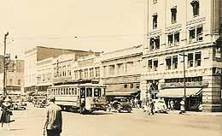
Source: HistoryLink, 2020.
Exhibit 1-3. East Yakima Avenue from a 1900s Postcard
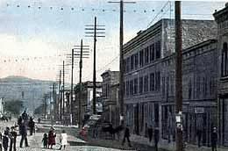
Source: HistoryLink, 2020.

Land Use

Overview
This Land Use analysis provides information on the current land use planning framework in the study area that consists of the city limits and the unincorporated urban growth area (UGA), including adopted land use plans, existing land uses, and future land use designations and zoning applied by the City Yakima and Yakima County. This chapter also characterizes neighborhood features.
This inventory relies primarily on information from the City of Yakima, Yakima County, and the Yakima Valley Conference of Governments. Additional data sources include population and housing estimates from the Washington State Office of Financial Management (OFM), data from the United States (US) Census Bureau and the American Community Survey (ACS).

Land Use Patterns and Growth

Existing Land Use
Yakima’s current land use pattern is dominated by single family residential uses, both in the city limits and the UGA. Exhibit 2-1 provides a map of existing land use in the City of Yakima. Exhibit 2-3 shows the total acreage in each of the seven Council Districts. Sections followed by these exhibits include detailed breakdown of land uses and maps by each Council District.
Exhibit 2-1. Existing Land Use Map
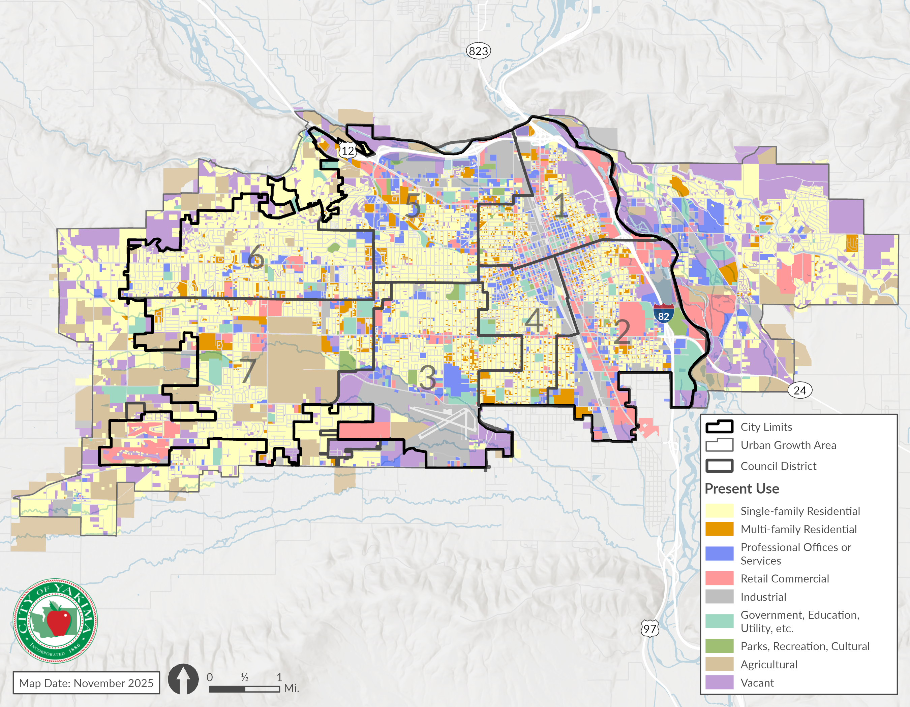Source: City of Yakima, Yakima County Assessor, BERK, 2025.

Exhibit 2-2.Existing Land Use within the City Limits and Unincorporated UGA
Existing Land Use | Incorporated City (acres) | Share (%) | City + Unincorporated UGA (acres) | Share (%)
Single-family Residential | 5,547 | 38% | 9,787 | 38.5%
Multi-family Residential | 1,009 | 7% | 1,144 | 4.5%
Professional Offices or Services | 1,133 | 8% | 1,487 | 5.9%
Retail Commercial | 1,370 | 9% | 1,760 | 6.9%
Industrial | 1,675 | 11% | 2,024 | 8.0%
Government, Education, Utility, etc. | 766 | 5% | 1,071 | 4.2%
Parks, Recreation, Cultural | 263 | 2% | 265 | 1.0%
Agricultural | 1,298 | 9% | 3,570 | 14.1%
Vacant | 1,629 | 11% | 4,298 | 16.9%
Total | 14,692 |  | 25,408
Note: Acreages listed here are derived from parcel-level data and do not include right-of-way space. Total existing land use acreage shown here is slightly lower than the total land area of Yakima and its UGA.
Source: City of Yakima, 2025; Yakima County Assessor’s Office, 2025; BERK, 2025
Exhibit 2-3. Size of Council Districts in the City Limits (Acres), 2025
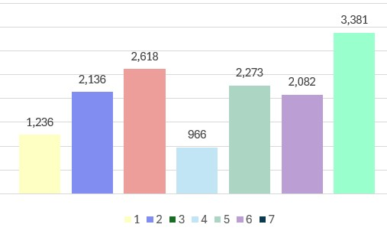
Source: City of Yakima, 2025; Yakima County Assessor’s Office, 2025; BERK, 2025

District 1
District 1 is primarily comprised of single family residential and vacant/undeveloped/open space lands. Exhibit 2-4 shows District 1 map with various existing land uses. Exhibit 2-5 provides the existing acres and shares for each existing land use group.
Exhibit 2-4. Current Land Use– District 1
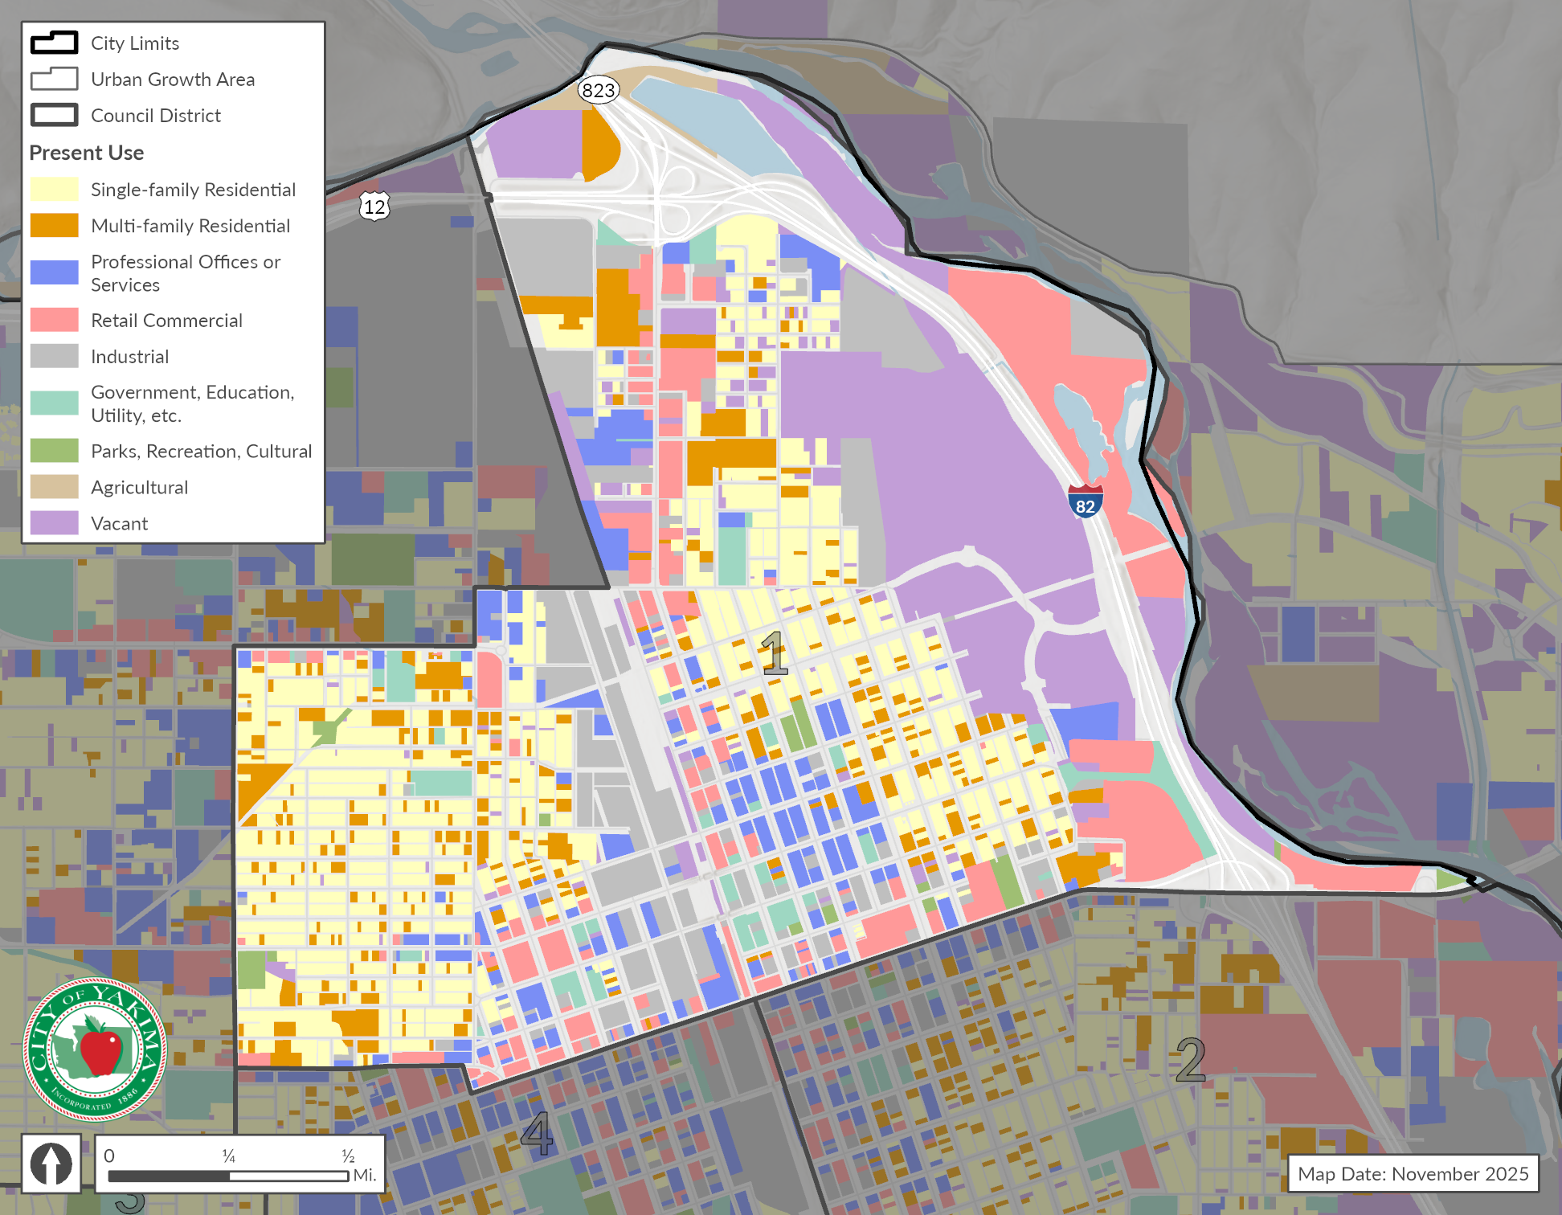
Source: City of Yakima, 2025; Yakima County Assessor’s Office, 2025; BERK, 2025
Exhibit 2-5. Land Use Acres – District 1
Existing Land Use Groups | Acres | Percent
Single-family Residential | 300.0 | 24.3%
Multi-family Residential | 127.0 | 10.3%
Professional Offices or Services | 100.0 | 8.1%
Retail Commercial | 187.0 | 15.1%
Industrial | 177.0 | 14.3%
Government, Education, Utility, etc. | 43.0 | 3.5%
Parks, Recreation, Cultural | 14.5 | 1.2%
Agricultural | 9.1 | 0.7%
Vacant | 278.0 | 22.5%
Total | 1,235.6 | 100%
Source: City of Yakima, 2025; Yakima County Assessor’s Office, 2025; BERK, 2025

District 2
District 2 predominantly includes single family residential and retail commercial. Exhibit 2-6 shows District 2 map with various existing land uses. Exhibit 2-7 provides the existing acres and shares for each existing land use group.
Exhibit 2-6. Current Land Use– District 2
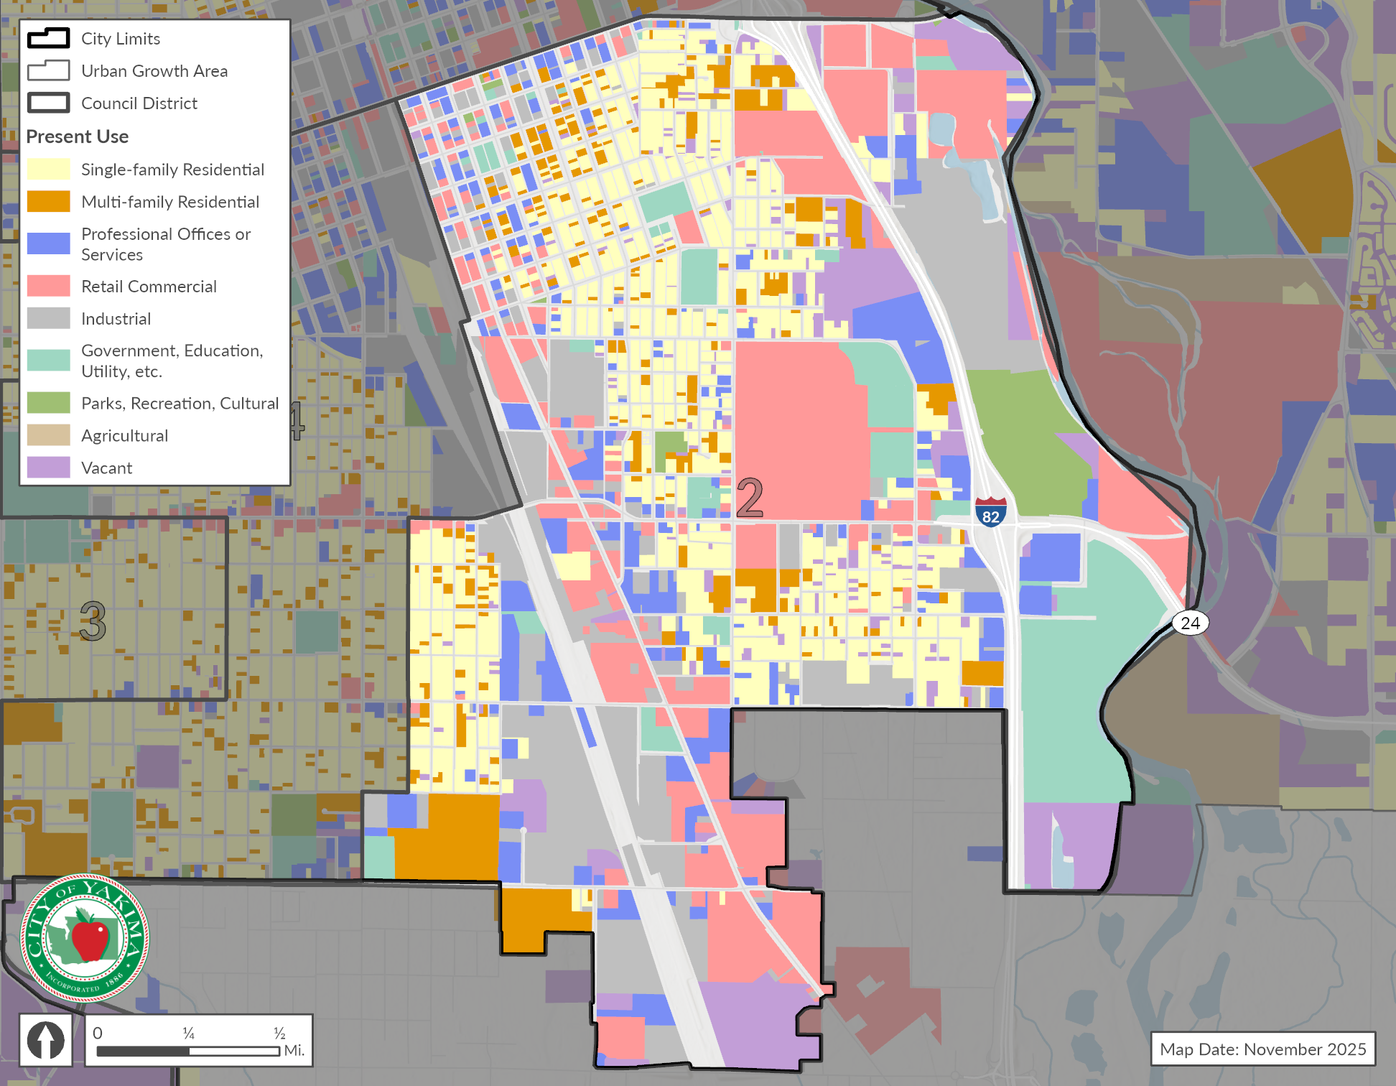
Source: City of Yakima, 2025; Yakima County Assessor’s Office, 2025; BERK, 2025

Exhibit 2-7. Land Use Acres – District 2
Existing Land Use Groups | Acres | Percent
Single-family Residential | 433.0 | 20.3%
Multi-family Residential | 171.0 | 8.0%
Professional Offices or Services | 216.0 | 10.1%
Retail Commercial | 472.0 | 22.1%
Industrial | 372.0 | 17.4%
Government, Education, Utility, etc. | 200.0 | 9.4%
Parks, Recreation, Cultural | 65.0 | 3.0%
Agricultural | 0.1 | 0.0%
Vacant | 207.0 | 9.7%
Total | 2,136.1 | 100%
Source: City of Yakima, 2025; Yakima County Assessor’s Office, 2025; BERK, 2025

District 3
District 3 is primarily comprised of single family residential. It also comprises of a major share of industrial land with the airport use. Exhibit 2-8 shows a District 3 map with various existing land uses. Exhibit 2-9 provides the existing acres and shares for each existing land use group.
Exhibit 2-8. Current Land Use– District 3
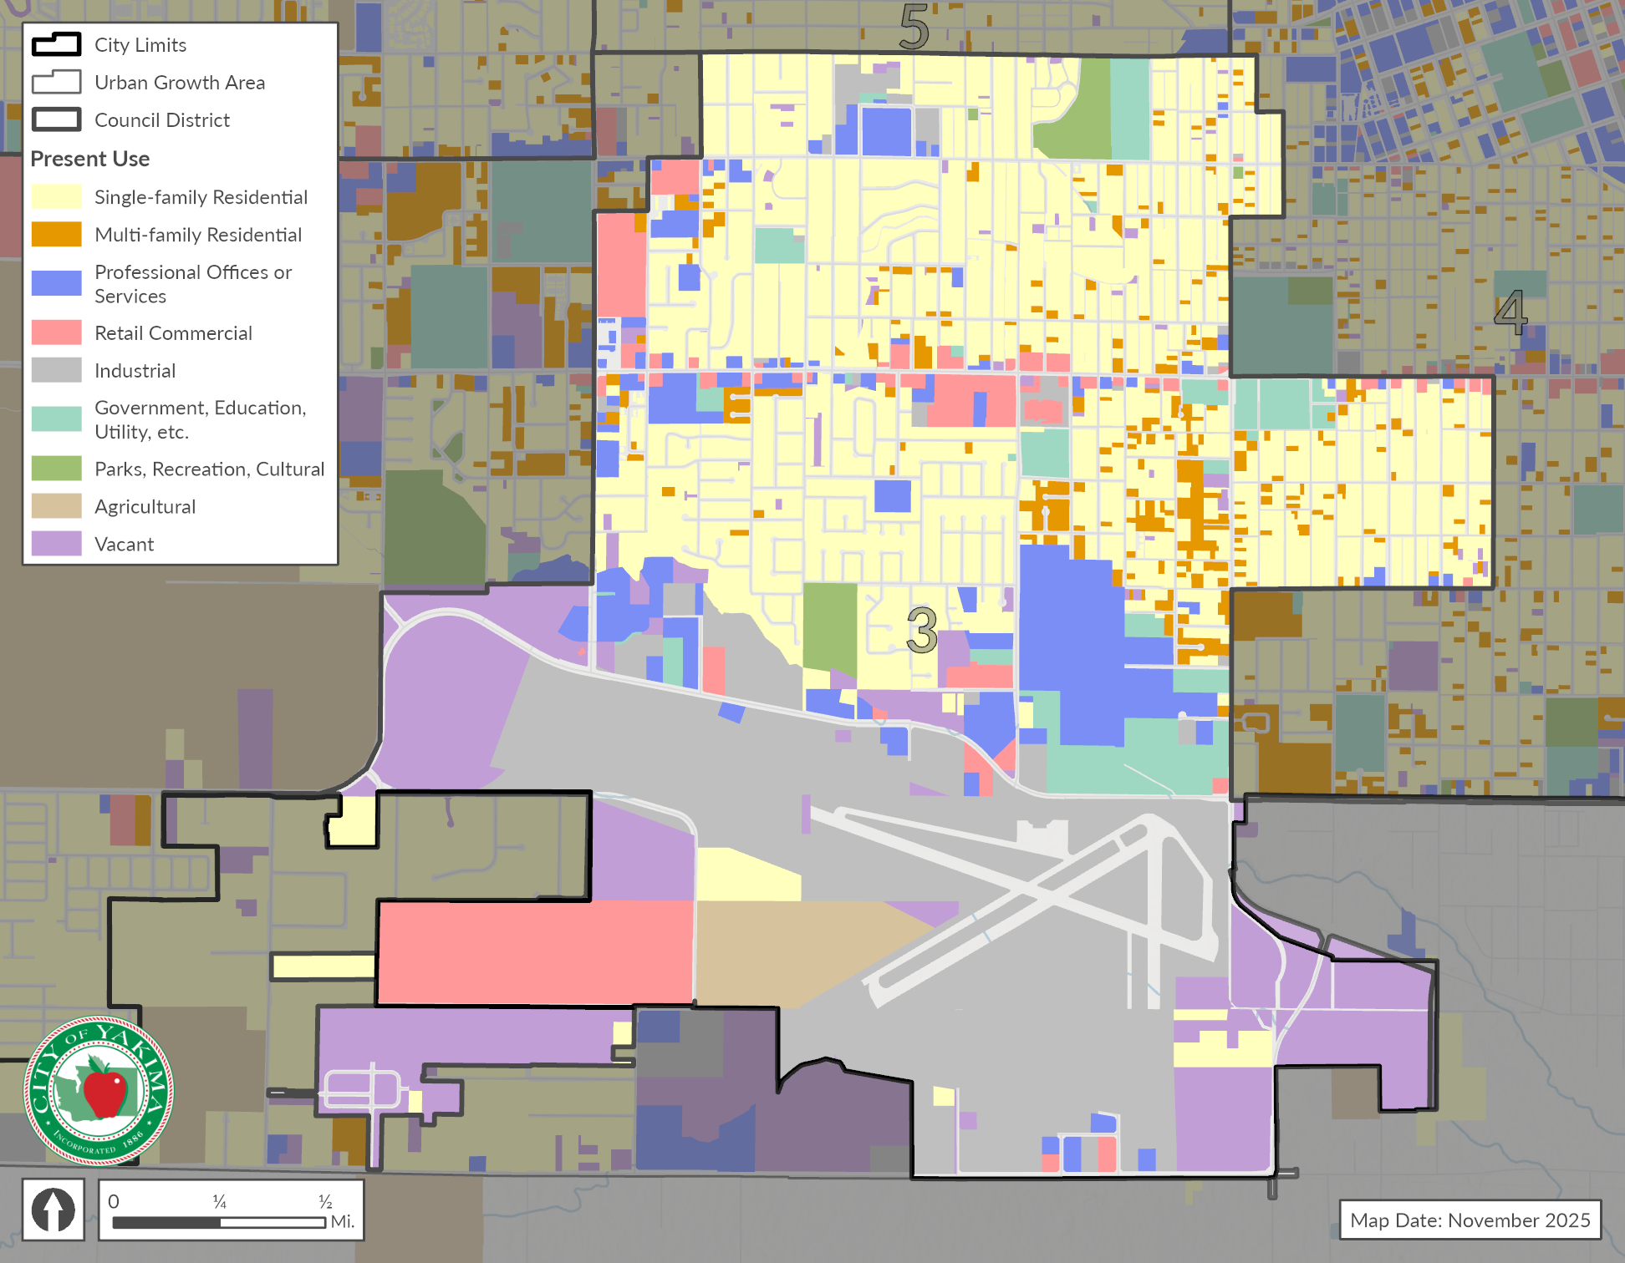
Source: City of Yakima, 2025; Yakima County Assessor’s Office, 2025; BERK, 2025

Exhibit 2-9. Land Use Acres – District 3
Existing Land Use Groups | Acres | Percent
Single-family Residential | 897.0 | 34.3%
Multi-family Residential | 85.0 | 3.2%
Professional Offices or Services | 202.0 | 7.7%
Retail Commercial | 198.0 | 7.6%
Industrial | 620.0 | 23.7%
Government, Education, Utility, etc. | 109.0 | 4.2%
Parks, Recreation, Cultural | 36.0 | 1.4%
Agricultural | 69.0 | 2.6%
Vacant | 402.0 | 15.4%
Total | 2,618.0 | 100%
Source: City of Yakima, 2025; Yakima County Assessor’s Office, 2025; BERK, 2025

District 4
Almost half of District 4 is comprised of single family residential (48.8%). Other uses such as multifamily residential, professional office, industrial, and government, education & utility have almost equal shares of land. Exhibit 2-10 shows the District 4 map with various existing land uses. Exhibit 2-11 provides the existing acres and shares for each existing land use group.

Exhibit 2-10. Current Land Use– District 4
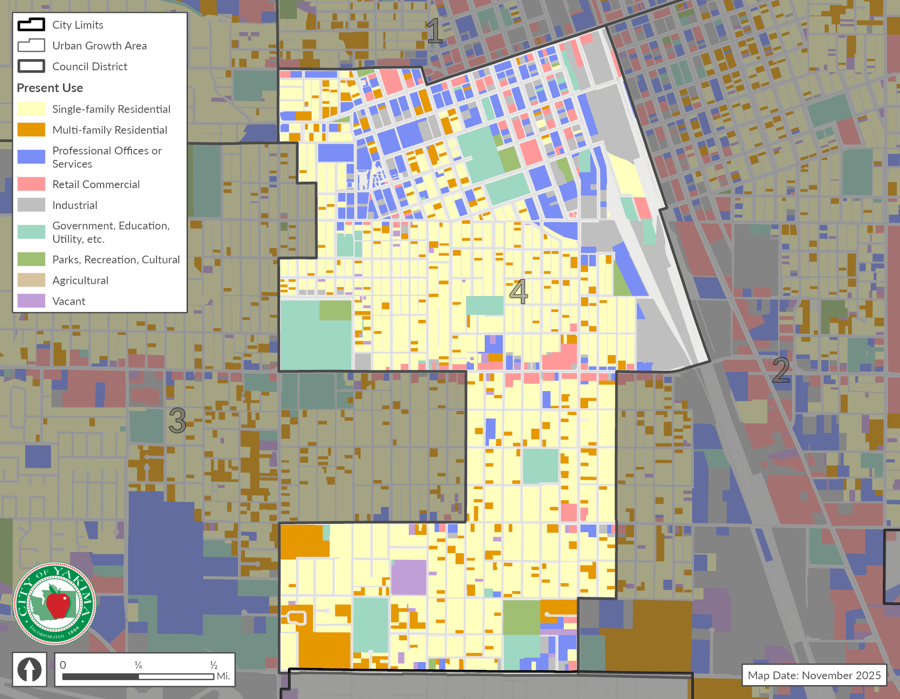
Source: City of Yakima, 2025; Yakima County Assessor’s Office, 2025; BERK, 2025

Exhibit 2-11. Land Use Acres – District 4
Existing Land Use Groups | Acres | Percent
Single-family Residential | 472.0 | 48.8%
Multi-family Residential | 103.0 | 10.7%
Professional Offices or Services | 110.0 | 11.4%
Retail Commercial | 43.0 | 4.4%
Industrial | 101.0 | 10.5%
Government, Education, Utility, etc. | 98.0 | 10.1%
Parks, Recreation, Cultural | 23.0 | 2.4%
Agricultural | 0.0 | 0.0%
Vacant | 16.4 | 1.7%
Total | 966.4 | 100%
Source: City of Yakima, 2025; Yakima County Assessor’s Office, 2025; BERK, 2025

District 5
District 5 is primarily single family residential (34.9%) and industrial (15.5%). Exhibit 2-12 shows District 5 map with various existing land uses. Exhibit 2-13 provides the existing acres and shares for each existing land use group.
Exhibit 2-12. Current Land Use– District 5
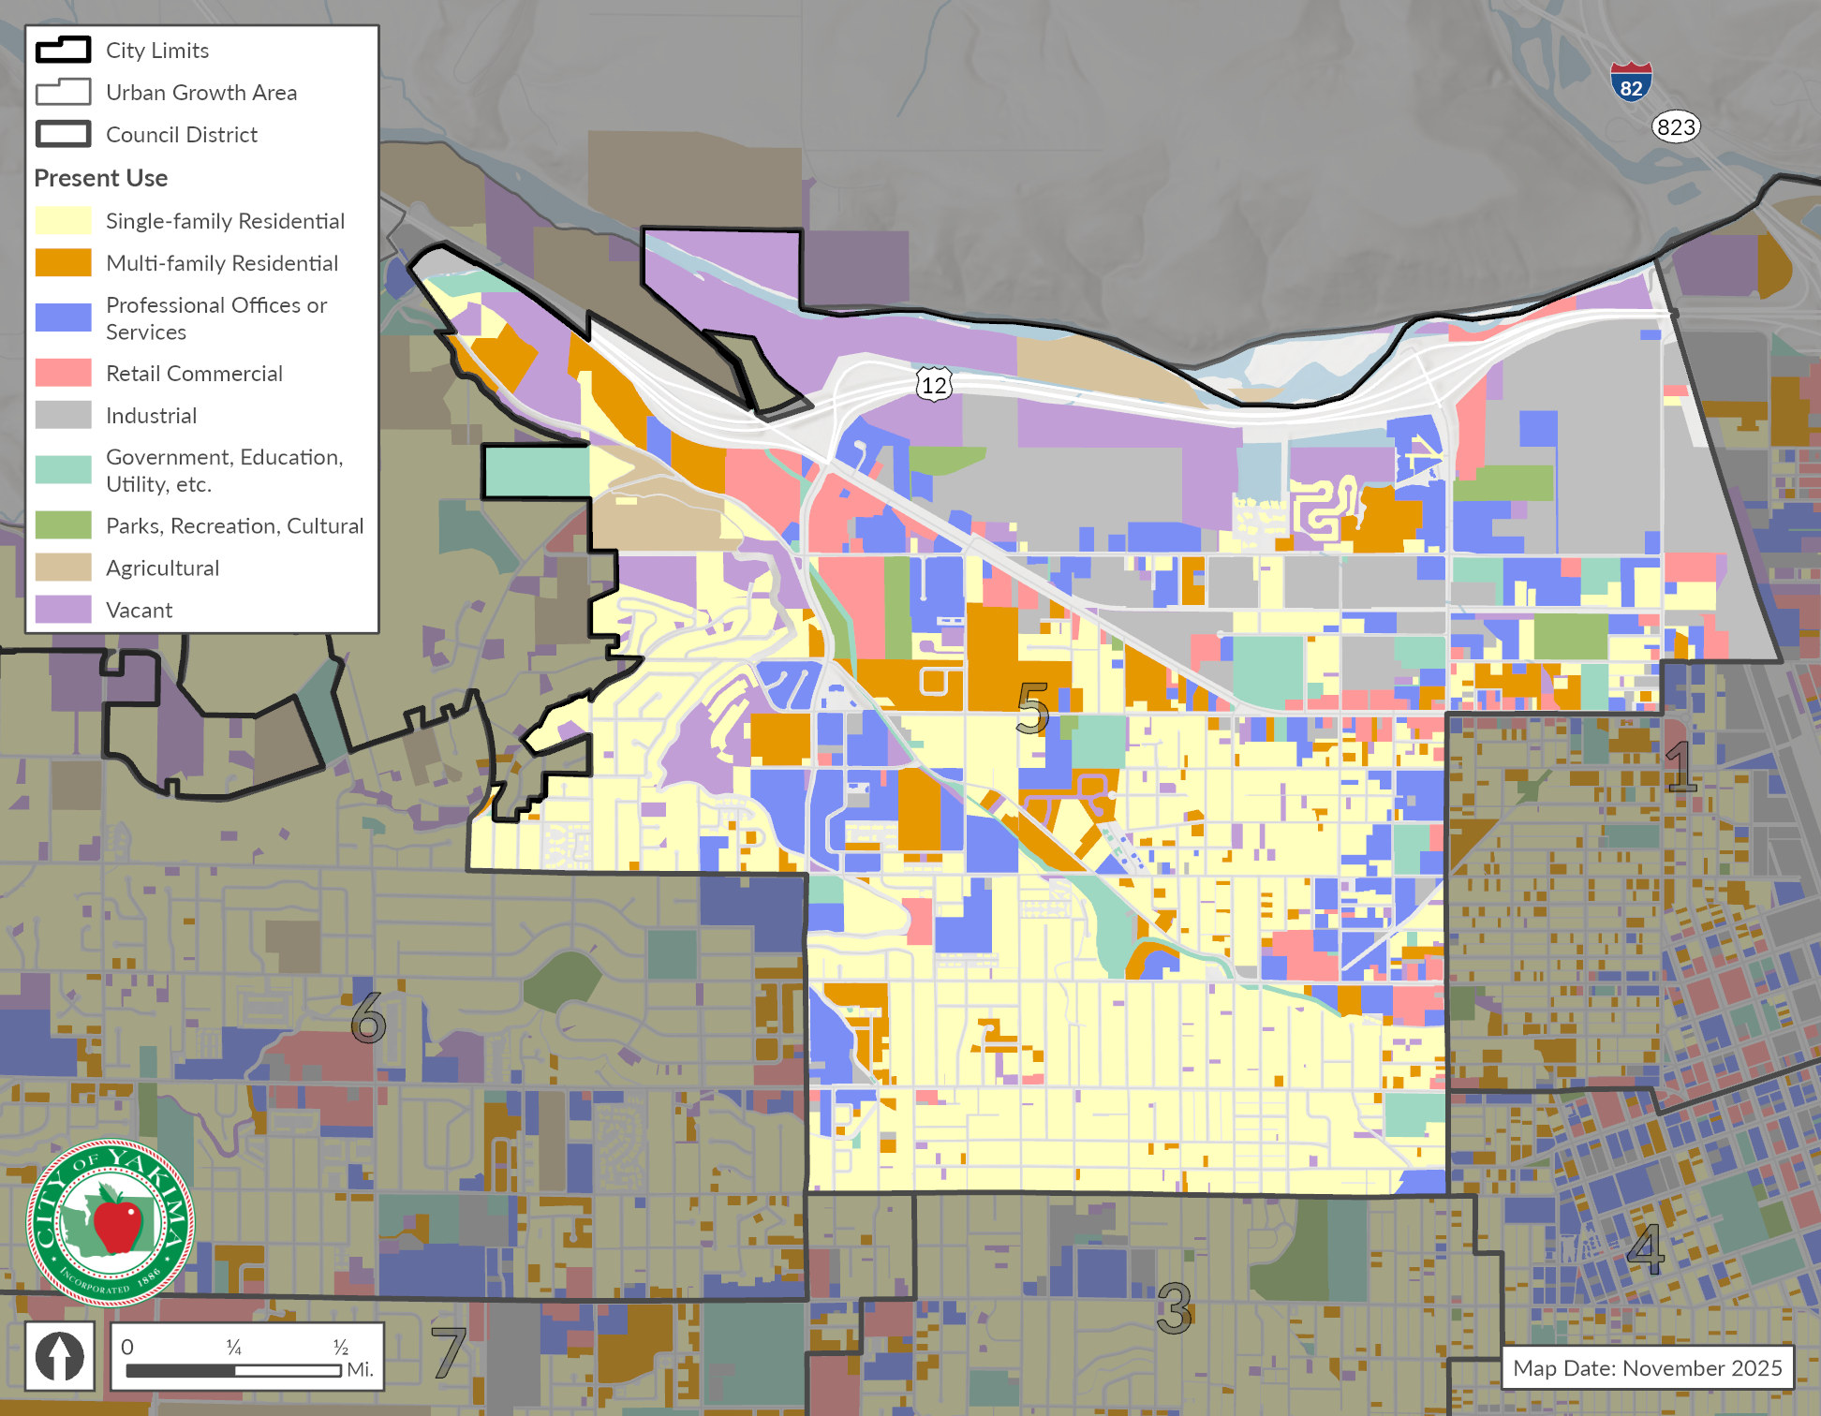
Source: City of Yakima, 2025; Yakima County Assessor’s Office, 2025; BERK, 2025

Exhibit 2-13. Land Use Acres – District 5
Existing Land Use Groups | Acres | Percent
Single-family Residential | 794.0 | 34.9%
Multi-family Residential | 206.0 | 9.1%
Professional Offices or Services | 289.0 | 12.7%
Retail Commercial | 126.0 | 5.5%
Industrial | 353.0 | 15.5%
Government, Education, Utility, etc. | 117.0 | 5.1%
Parks, Recreation, Cultural | 45.0 | 2.0%
Agricultural | 62.0 | 2.7%
Vacant | 281.0 | 12.4%
Total | 2,273.0 | 100%
Source: City of Yakima, 2025; Yakima County Assessor’s Office, 2025; BERK, 2025

District 6
District 6 is mostly single family residential (68.9%). Exhibit 2-14 shows District 6 map with various existing land uses. Exhibit 2-15 provides the existing acres and shares for each existing land use group.
Exhibit 2-14. Current Land Use– District 6
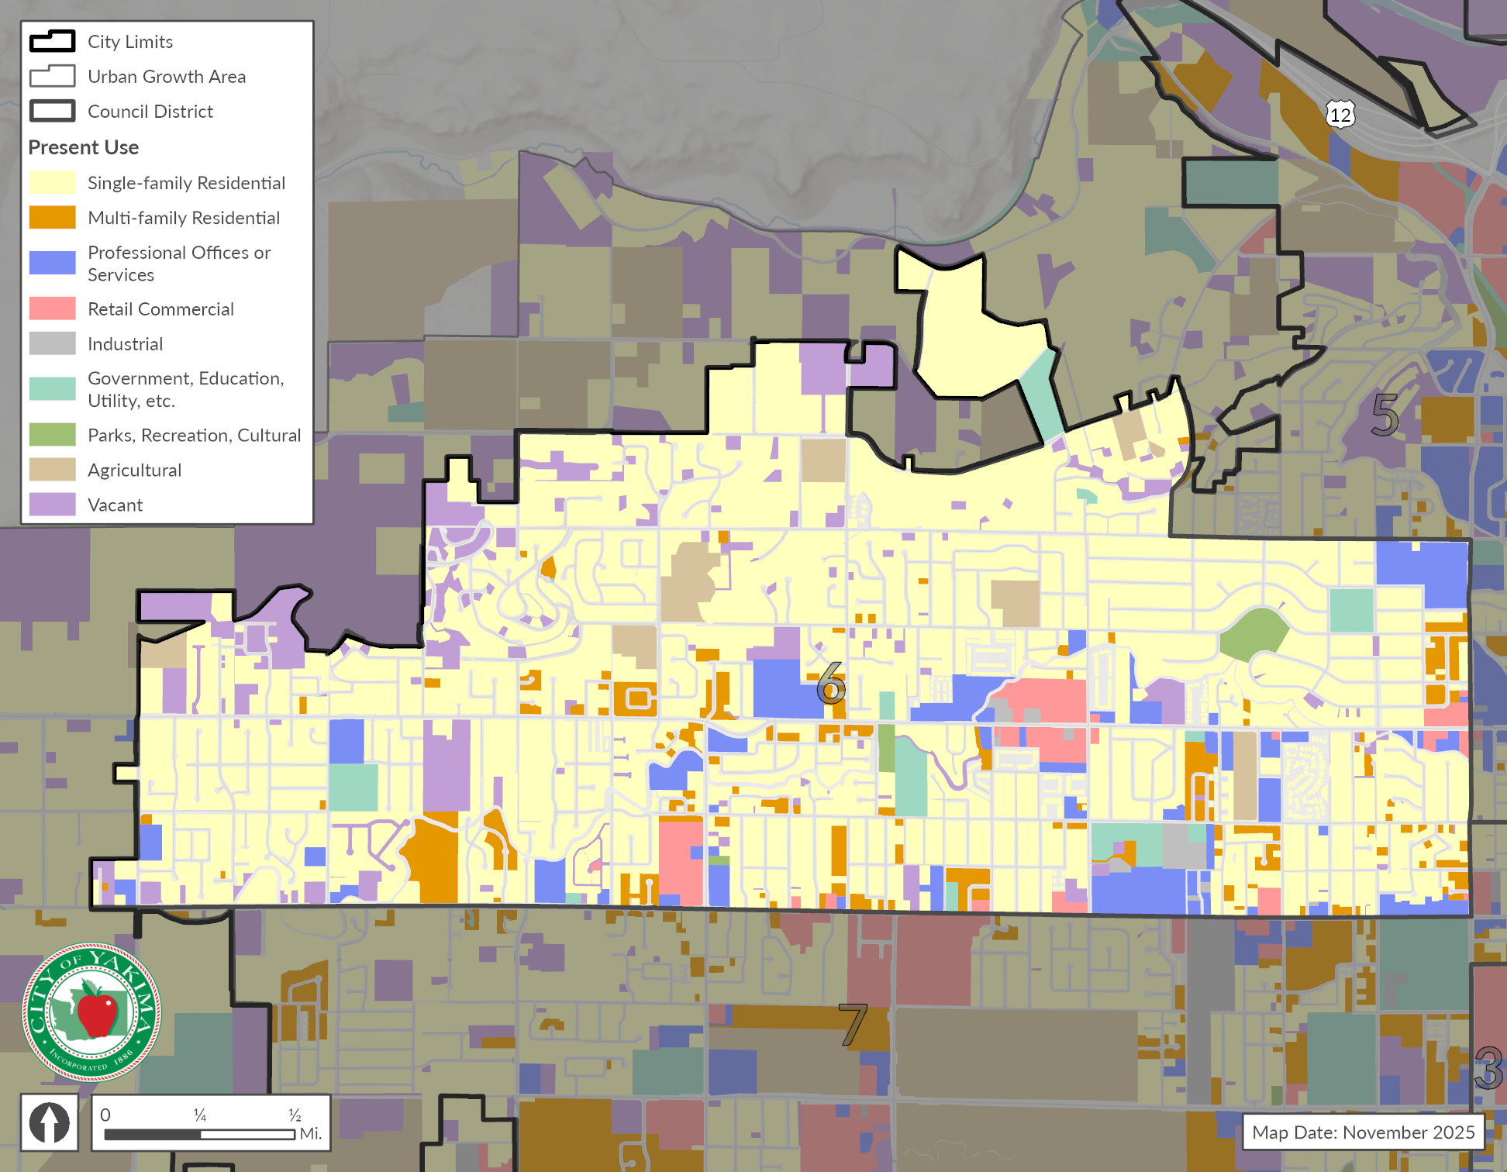
Source: City of Yakima, 2025; Yakima County Assessor’s Office, 2025; BERK, 2025

Exhibit 2-15. Land Use Acres – District 6
Existing Land Use Groups | Acres | Percent
Single-family Residential | 1,435.0 | 68.9%
Multi-family Residential | 113.0 | 5.4%
Professional Offices or Services | 149.0 | 7.2%
Retail Commercial | 55.0 | 2.6%
Industrial | 13.7 | 0.7%
Government, Education, Utility, etc. | 58.0 | 2.8%
Parks, Recreation, Cultural | 15.3 | 0.7%
Agricultural | 62.0 | 3.0%
Vacant | 181.0 | 8.7%
Total | 2,082.0 | 100%
Source: City of Yakima, 2025; Yakima County Assessor’s Office, 2025; BERK, 2025

District 7
Single family residential (36%) and agricultural (32.4%) are two predominant uses in District 7. Exhibit 2-16 shows District 6 map with various existing land uses. Exhibit 2-17 provides the existing acres and shares for each existing land use group.
Exhibit 2-16. Current Land Use– District 7
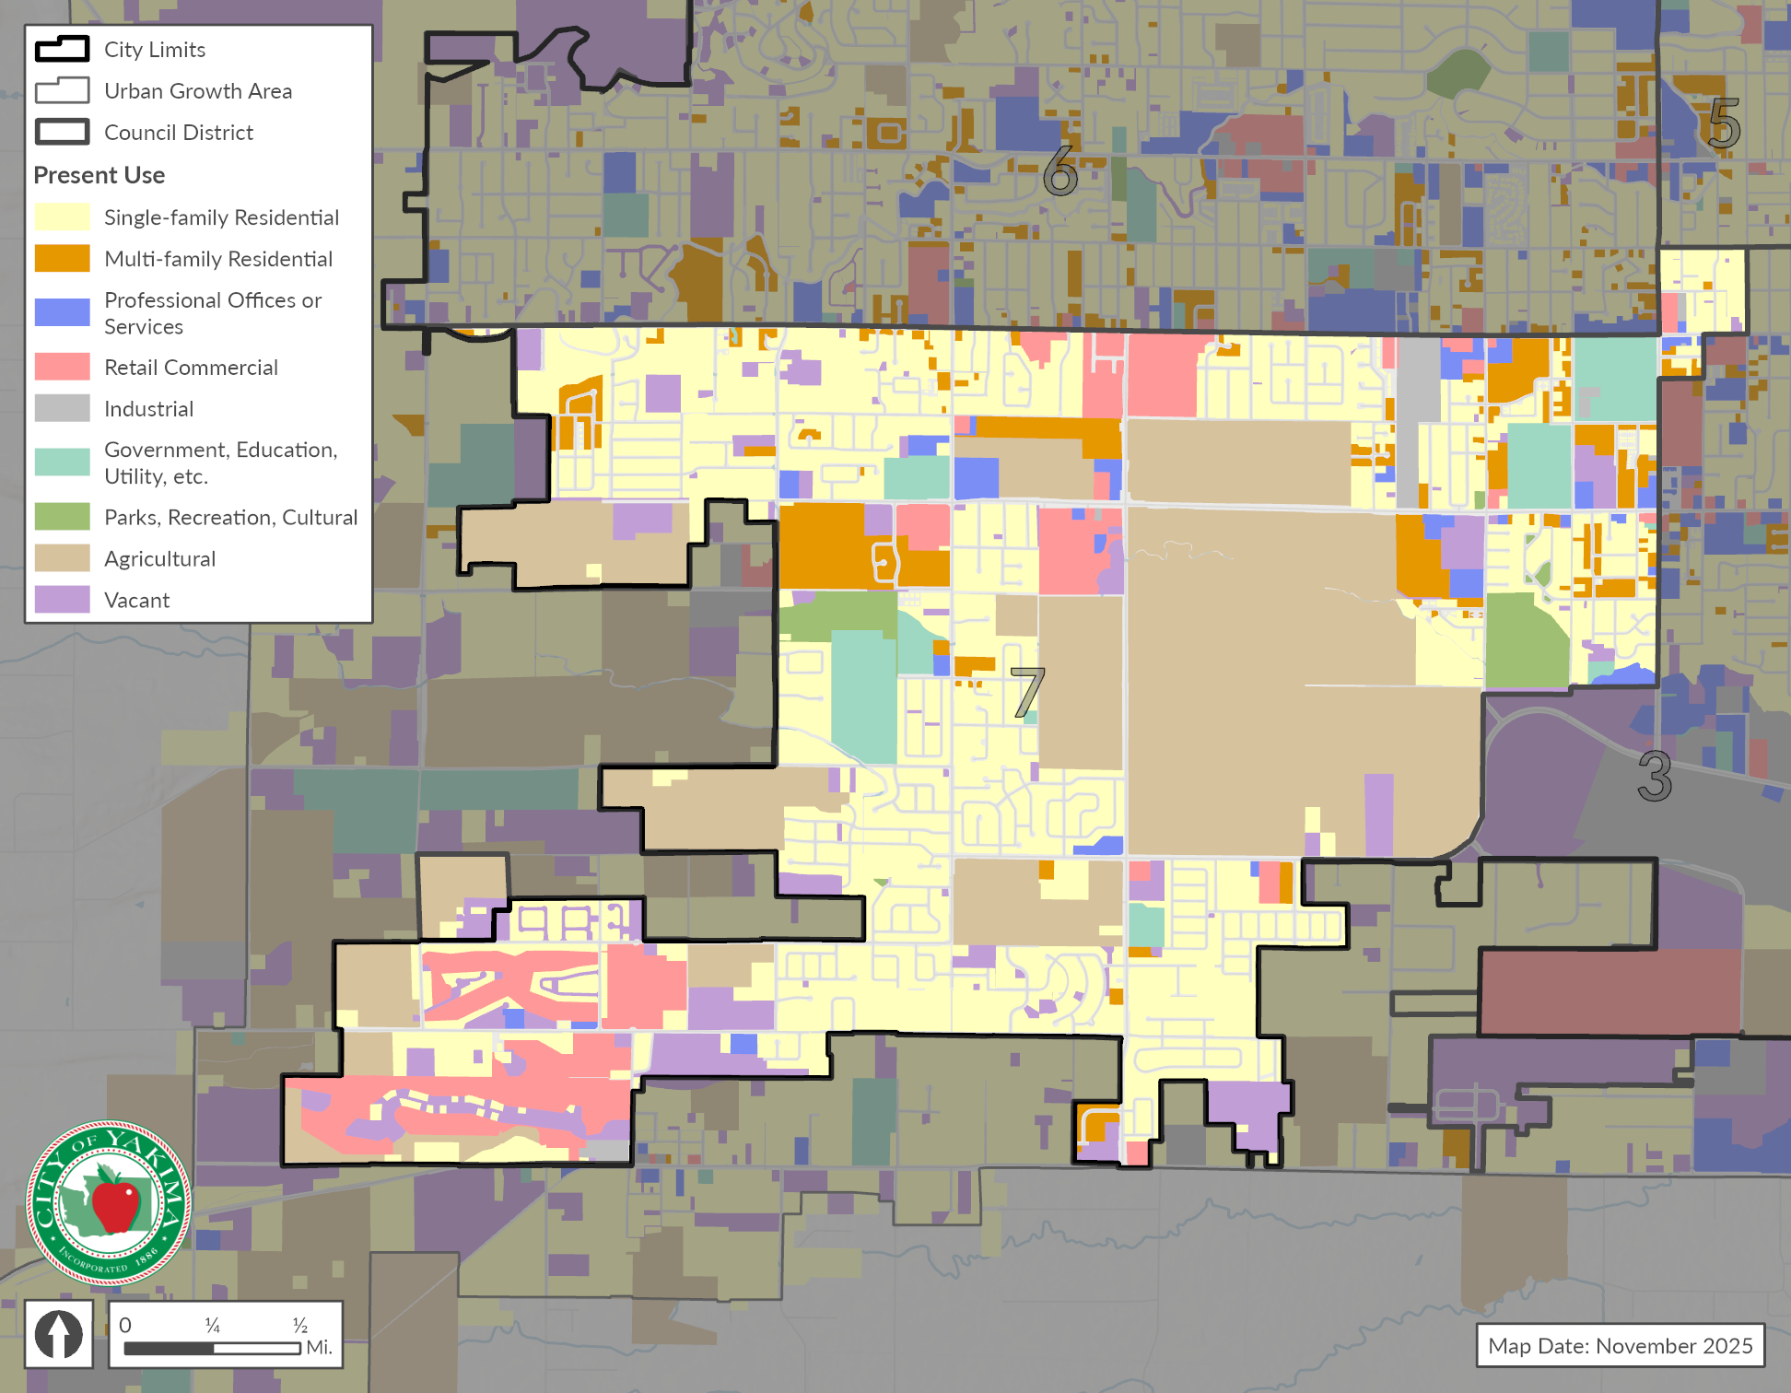
Source: City of Yakima, 2025; Yakima County Assessor’s Office, 2025; BERK, 2025

Exhibit 2-17. Land Use Acres – District 7
Existing Land Use Groups | Acres | Percent
Single-family Residential | 1,216.0 | 36.0%
Multi-family Residential | 204.0 | 6.0%
Professional Offices or Services | 67.0 | 2.0%
Retail Commercial | 289.0 | 8.5%
Industrial | 39.0 | 1.2%
Government, Education, Utility, etc. | 141.0 | 4.2%
Parks, Recreation, Cultural | 65.0 | 1.9%
Agricultural | 1,096.0 | 32.4%
Vacant | 264.0 | 7.8%
Total | 3,381.0 | 100%
Source: City of Yakima, 2025; Yakima County Assessor’s Office, 2025; BERK, 2025

Future Land Use
Yakima’s land use map designates Low Density Residential as a predominant land use constituting about 53% of the total. Exhibit 2-18 shows the future land use map with Council Districts. See land within the City and UGA. See Exhibit 2-19 for the acreages within the city limits and the UGA .

Exhibit 2-18. Future Land Use Map
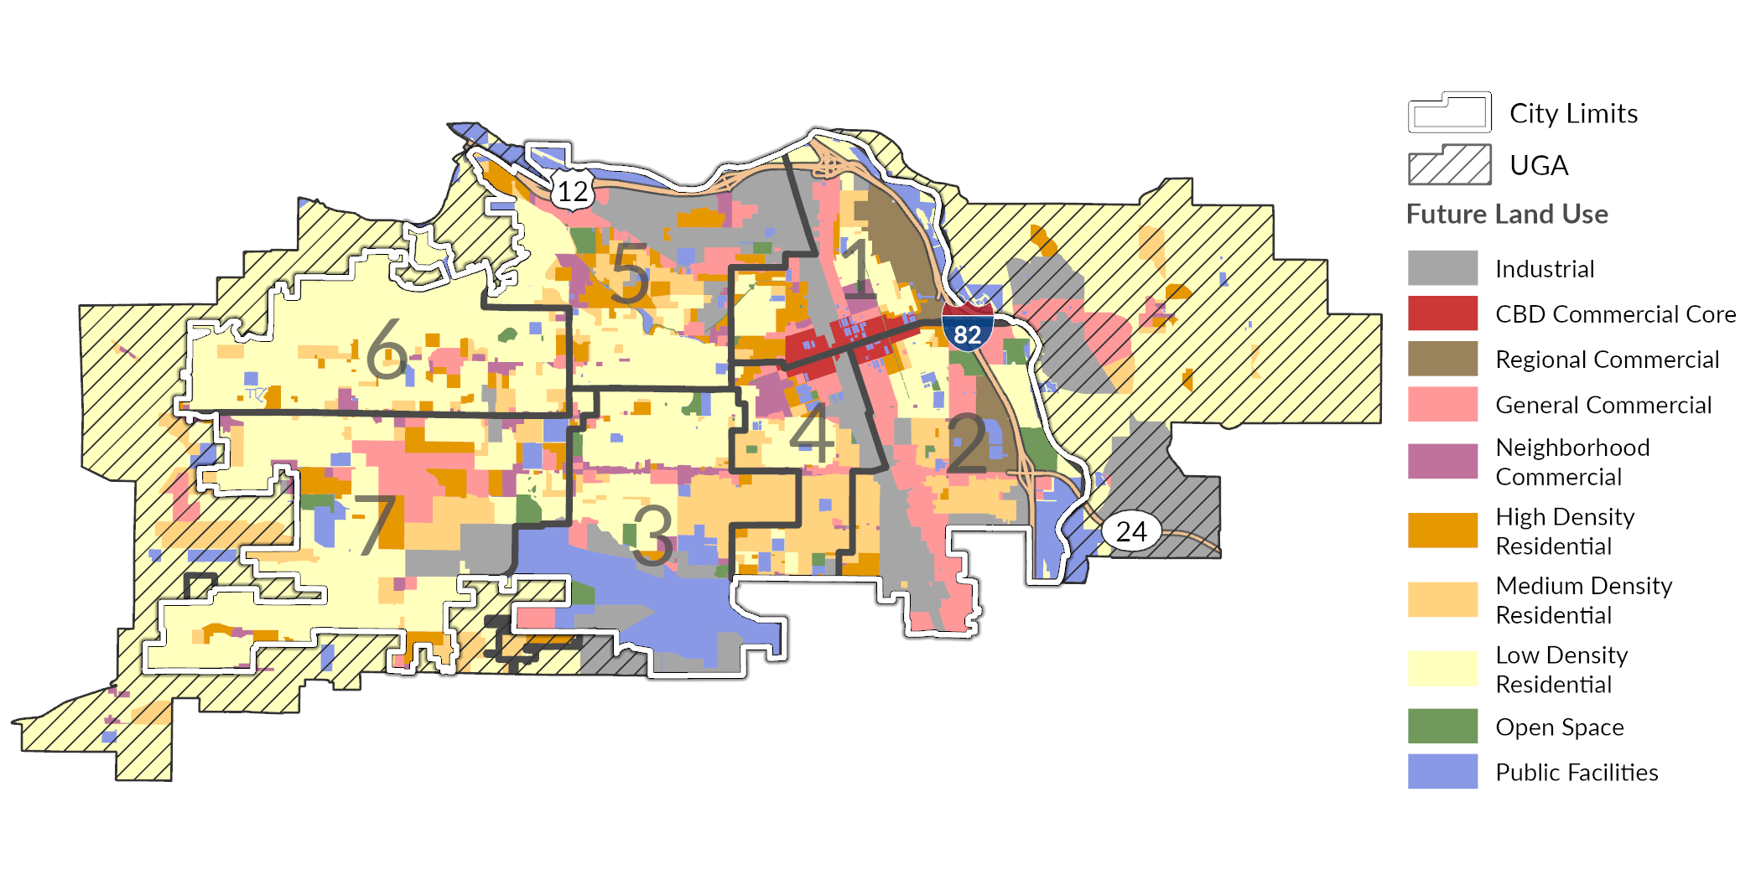
Source: City of Yakima, 2025; Yakima County Assessor’s Office, 2025; BERK, 2025

Exhibit 2-19. Future Land Use in Acres
Future Land Use | Incorporated City (acres) | Unincorporated UGA (acres) | Total (acres) | Share (%)
Industrial | 2,104 | 1,199 | 3,303 | 11.6%
CBD Commercial Core | 254 | 0 | 254 | 0.9%
Regional Commercial | 516 | 0 | 516 | 1.8%
General Commercial | 1,792 | 273 | 2,066 | 7.3%
Neighborhood Commercial | 598 | 52 | 650 | 2.3%
High Density Residential | 1,255 | 115 | 1,369 | 4.8%
Medium Density Residential | 2,194 | 553 | 2,747 | 9.7%
Low Density Residential | 6,910 | 8,022 | 14,932 | 52.5%
Open Space | 403 | 0 | 403 | 1.4%
Public Facilities | 1,797 | 422 | 2,219 | 7.8%

Exhibit 2-20. Future Land Use Areas by Council District
Future Land Use | Council District #1 | Council District #2 | Council District #3 | Council District #4 | Council District #5 | Council District #6 | Council District #7
Industrial | 190 | 461 | 331 | 184 | 665 | 17 | 257
CBD Commercial Core | 140 | 63 | 0 | 51 | 0 | 0 | 0
Regional Commercial | 294 | 222 | 0 | 0 | 0 | 0 | 0
General Commercial | 212 | 674 | 155 | 92 | 247 | 53 | 361
Neighborhood Commercial | 59 | 4 | 113 | 100 | 109 | 82 | 129
High Density Residential | 176 | 92 | 85 | 78 | 342 | 133 | 391
Medium Density Residential | 71 | 374 | 438 | 459 | 257 | 184 | 455
Low Density Residential | 474 | 383 | 878 | 261 | 898 | 2,053 | 2,039
Open Space | 14 | 142 | 92 | 20 | 54 | 15 | 67
Public Facilities | 148 | 247 | 952 | 72 | 208 | 48 | 137

Land Capacity Analysis
As part of the Yakima Comprehensive Plan process, BERK Consulting, Inc. (BERK) conducted a Land Capacity Analysis (LCA) to determine the capacity for housing units and jobs within the City and surrounding unincorporated Urban Growth Area (UGA). This analysis estimated the total amount of new development that could occur on vacant or underutilized residential, commercial, and industrial lands over the planning period (2026-2046). Capacity is determined by several factors, including available land area, zoning regulations, critical areas identified by the city code, and market factors.
BERK’s analysis examined individual parcels and deducted mapped critical areas in accordance with the existing Yakima Municipal Code (Chapter 15.27). The base point-in-time in which capacity was measured is May 2025, and the study area includes the entire city limits and UGA, both incorporated and unincorporated areas. Parcel data was retrieved from the Yakima County Assessor’s publicly available records. Critical area data was obtained as listed in Exhibit 2-21. For each critical area type, BERK applied a spatial buffer according to the City of Yakima development regulation requirements.
Exhibit 2-21. Critical Area & Other Deductions
Category | Definition | Method/Assumption | Data Source(s)
Wetlands | All as determined by the National Wetland Inventory. | Category IV: 40’  All other categories: 150’ | National Wetland Inventory  Washington Department of Ecology  City of Yakima
Streams, lakes, and ponds | All, with attributes for fish-bearing streams. | Streams and lakes:  - Type 1:  - Streams: 100’  - Lakes: 50’  - Type 2: 100’  - Type 3: 50’  - Type 4: 25’ | Washington Department of Natural Resources
Flood zones | 100-yr flood zones. | No buffer | FEMA
Geologic hazards & steep slopes | High risk geologic hazards and slopes >40% across at least 10 feet. | No buffer | City & University of Washington Digital Elevation Models
Sources: City of Yakima Municipal Code Chapter 15.27; BERK, 2025.
Once critical areas and their respective buffers were removed from the parcel land area, certain parcels were selected to be excluded from subsequent analysis based on the assumption that they are unlikely to see new development over the planning period. These parcels were selected based on present use information from the Yakima County Assessor’s Office. The specific use types considered not developable during the planning period, include:
- Schools
- Police & fire stations
- Utilities
- Open spaces & preserves
- State or federally owned land
- Churches & places of worship
- Community centers
After flagging those parcels for removal, the remaining parcels were assigned a current developable status. Exhibit 2-22 defines each parcel development status. Vacant, Agricultural, Partially-used, and Redevelopable parcels are assumed to have capacity for future development. Developed parcels are assumed to not have capacity for additional growth during the planning period.
Exhibit 2-22. Parcel Development Status Definitions
Status Type | Definition | Method/Assumption | Data Source(s)
Vacant | Residential-zoned parcels on which no significant development has occurred. | Improvement value <$10,000 | County Assessor’s Office, City zoning
Agricultural | Residential-zoned parcels with agriculture as current use. | Privately-owned land with agricultural current use | County Assessor’s Office, City zoning
Partially-used | Residential-zoned parcels with existing housing units but capacity to add additional units. | Single-family parcels in SR and R1 zones with single-family current use and greater than 0.5 acres. | County Assessor’s Office, City zoning
Redevelopable | Parcels with existing structures (residential, commercial, or industrial) and a likelihood of redevelopment. | (Not SR or R1 zones) Commercial, multi-family residential, or industrial zoned parcels with single-family current use and/or the ratio of improvement value to land value is <1 | County Assessor’s Office, City zoning
Developed | Already developed and not expected to see new development during the planning period. | All parcels not included in any of the above categories.
Sources: City of Yakima, Yakima County Assessor, BERK, 2025.
Next, BERK summed the buildable areas of developable parcels by zone. Additional deductions were then applied to this aggregated developable area to account for future right of way and market factors – the assumption that not all properties would change in the planning period such as due to property owner preferences. The amount deducted was dependent on the parcel status. For example, space needed for future rights-of-way to serve new development was deducted from all parcels, but Vacant and Agricultural parcels had higher deductions for future rights-of-way as they are less likely to already be served by that infrastructure than Partially-used or Redevelopable parcels. The deductions applied were:
- 2.5% deduction for future public or semi-public uses
- Vacant or Agricultural parcels:
  - 15% deduction for future rights-of-way
  - 15% deduction for market factors
- Partially-used or Redevelopable parcels:
  - 10% deduction for future rights-of-way
  - 25% deduction for market factors
The output is the total developable area for the entire UGA within the planning period. Tagging parcels by their zoning designation and whether they are within the incorporated city illustrates developable area by zone and jurisdiction. Exhibit 2-23 presents the total developable area by zone in acres as determined by this LCA model.
Exhibit 2-23. Developable Land Area in the Yakima UGA by Zone
Zone | Incorporated City (acres) | Unincorporated UGA (acres) | Full UGA (acres)
SR | 128 | 790 | 918
R-1 | 933 | 2,368 | 3,302
R-2 | 948 | 283 | 1,231
R-3 | 264 | 39 | 303
B-1 | 35 | 0 | 36
B-2 | 68 | 17 | 85
HB | 0 | 0 | 0
SCC | 71 | 53 | 124
LCC | 10 | 0 | 10
CBD | 33 | 0 | 33
GC | 330 | 30 | 360
M-1 | 437 | 282 | 720
M-2 | 17 | 0 | 17
RD | 94 | 0 | 94
AS | 40 | 0 | 40
Total | 3,409 | 3,863 | 7,272
Sources: City of Yakima, Yakima County Assessor, BERK, 2025.
Zone-specific density assumptions were then applied to the developable area outputs to determine the capacity for new housing units and jobs within the planning period. Assumptions were largely carried over from analysis completed during the previous City of Yakima Housing Needs Assessment in 2017. These values were the result of the analysis of achieved and potential densities per zone within Yakima. For mixed-use zones, the total developable acreage of that zone was split between commercial and residential uses. Exhibit 2-25 shows density and mixed use split assumptions.
Exhibit 2-24. Density and Mixed-Use Split Assumptions by Zone in the Yakima UGA
Zone | Units per Acre | Floor Area Ratio | Square Feet per Job | Split  (Residential/ Non-Residential)
Residential: SR (single-family) | 4 | N/A | N/A | 100% / 0%
Residential: R-1 (single-family) | 7 | N/A | N/A | 100% / 0%
Residential: R-2 (two-family) | 12 | N/A | N/A | 100% / 0%
Residential: R-3 (multi-family) | 18 | N/A | N/A | 100% / 0%
Mixed-use: B-1 | 15 | 0.26 | 500 | 50% / 50%
Mixed-use: B-2 | 15 | 0.26 | 500 | 50% / 50%
Mixed-use: SCC | 15 | 0.26 | 500 | 50% / 50%
Mixed-use: LCC | 15 | 0.26 | 500 | 50% / 50%
Mixed-use: CBD | 15 | 2.0 | 500 | 50% / 50%
Mixed-use: GC | 15 | 0.26 | 500 | 33% / 67%
Mixed-use: HB | N/A | 1.0 | 500 | 50% / 50%
Industrial: M-1 | N/A | 0.45 | 1,000 | 0% / 100%
Industrial: M-2 | N/A | 0.45 | 1,000 | 0% / 100%
Mixed-use: RD | 15 | 0.35 | 500 | 50% / 50%
Airport: AS | N/A | N/A | 1,000 | 0% / 100%
To calculate capacity for net new housing units, a zoning designation’s total developable acreage (after deductions) was first multiplied by its residential split (e.g. if in a mixed use zone a share would be residential and a share would be commercial) then by its assumed units per acre. For partially-used and redevelopable parcels, existing units were then deducted from the total capacity to achieve a net new unit capacity.
Next, we estimated capacity for accessory dwelling units (ADUs). Our analysis estimates the number of net new housing units that could be built in the form of ADUs on parcels that are already developed with a detached single unit home. To identify parcels that could add an ADU, we used the following criteria:
- Residential parcels that have only one unit as of 2025
- Zoning allows for ADUs
- Lot size beyond the minimum required to support the existing single-family structure but no larger than half an acre, as those parcels would be candidates for subdivision.
Following guidance from the Washington State Department of Commerce, we assumed that 10% of parcels identified as having potential to add an ADU would choose add a single new ADU within the planning horizon.
Presents the capacity of new ADUs for the city of Yakima. The majority of ADU capacity exists in areas zoned R-1.
Exhibit 2-25. New ADU Capacity by Zone
Zone | ADU Capacity (Incorporated City) | ADU Capacity (Unincorporated UGA) | ADU Capacity (Full UGA)
SR | 10 | 6 | 15
R-1 | 1,213 | 198 | 1,412
R-2 | 449 | 2 | 451
R-3 | 104 | 4 | 109
B-1 | 9 | 0 | 9
B-2 | 8 | 1 | 9
HB | 0 | 0 | 0
SCC | 2 | 0 | 2
LCC | 0 | 0 | 0
CBD | 0 | 0 | 0
GC | 36 | 0 | 36
M-1 | 0 | 0 | 0
M-2 | 0 | 0 | 0
RD | 2 | 0 | 2
AS | 0 | 0 | 0
Total | 1,832 | 211 | 2,043
Exhibit 2-25 shows the net new housing unit capacity per zone, including ADUs, as determined by this Land Capacity Analysis.
Exhibit 2-26. Net New Housing Units by Zone
Zone | Unit Capacity (Incorporated City) | Unit Capacity (Unincorporated UGA) | Unit Capacity (Full UGA)
SR | 665 | 3,710 | 4,375
R-1 | 7,095 | 15,776 | 22,871
R-2 | 6,944 | 3,327 | 10,271
R-3 | 3,273 | 617 | 3,890
B-1 | 186 | 1 | 187
B-2 | 426 | 116 | 541
HB | 0 | 0 | 0
SCC | 516 | 396 | 912
LCC | 74 | 0 | 74
CBD | 187 | 0 | 187
GC | 1,301 | 145 | 1,445
M-1 | 0 | 0 | 0
M-2 | 0 | 0 | 0
RD | 1,062 | 0 | 1,062
AS | 0 | 0 | 0
Total | 21,728 | 24,087 | 45,815
Finally, to arrive at total job capacity, buildable square footage capacity was calculated as the developable acreage multiplied by an assumed Floor Area Ratio (FAR) and converted into square feet. The product was then multiplied by the assumed Square Feet per Job value respective of zoning (shown in Exhibit 2-26). The final job capacity outputs from the model are shown in Exhibit 2-27.
Exhibit 2-27. Square Feet per Job Assumptions
Zone | Square Feet per Job
SR | N/A
R-1 | N/A
R-2 | N/A
R-3 | N/A
B-1 | 500
B-2 | 500
HB | 500
SCC | 500
LCC | 500
CBD | 500
GC | 500
M-1 | 1,000
M-2 | 1,000
RD | 500
AS | 1,000
Exhibit 2-28 Job Capacity by Zone
Zone | New Jobs Capacity (Incorporated City) | New Jobs Capacity (Unincorporated UGA) | New Jobs Capacity (Full UGA)
SR | 0 | 0 | 0
R-1 | 0 | 0 | 0
R-2 | 0 | 0 | 0
R-3 | 0 | 0 | 0
B-1 | 374 | 3 | 377
B-2 | 648 | 173 | 821
HB | 11 | 0 | 11
SCC | 600 | 592 | 1,192
LCC | 56 | 0 | 56
CBD | 2,558 | 0 | 2,558
GC | 4,224 | 406 | 4,631
M-1 | 8,337 | 6,313 | 14,650
M-2 | 334 | 0 | 334
RD | 1,997 | 0 | 1,997
AS | 0 | 0 | 0
Total | 19,140 | 7,487 | 26,627

Planning and Regulatory Context
Beyond the Comprehensive Plan Land Use Element, Regulations and Plans shaping the design of the built environment include the City’s zoning ordinance and a series of functional plans guiding infrastructure. Each is addressed below.

Title 15 – Yakima Urban Area Zoning Ordinance
Title 15 of the Yakima Municipal Code provides standards for the various zoning districts and permitted uses throughout the City. Key provisions affecting the design of development include:
Permitted uses (Chapter 15.04) and associated land use classification system. While nearly all cities contain lists of permitted outright, conditional, and permitted uses, Yakima has a system of review approvals from Class 1 to 3. Exhibit 2-28 shows difference use classifications.
Exhibit 2-29 Use Classes for Permitting
Class Type | Description | Example of uses in zones
Class 1 | Permitted subject to administrative approval | Attached or residential uses in R-1 or R-2 zones
Class 2 | Permitted uses also subject to administrative approval, but allows the administrative official to add conditions to mitigate impacts or require Class 2 uses to undergo a Class 3 review if certain conditions are present. Since there are very little design related standards in Title 15, this system adds a level of uncertainty and unpredictability to the review of uses that can be challenging both to applicants and the administrative official. | Parts and Accessories (tires, batteries, etc.) uses in B2 zone.
Class 3 | Uses are generally not permitted in a district, but may be approved by the hearing examiner after Type III review and a public hearing. The hearing examiner may impose conditions to an approval. As with Class 2 approvals, without the benefit of design standards within Title 15, this procedure can add a level of uncertainty and unpredictability to the review of such uses. | Office Contractor Building and Trade (Plumbing, Heating, Electrical, and Painting) in R-3 zone.
Site design and improvement standards (Chapter 15.05) address the following aspects. These standards implement various land use policies of the Plan:
- Maximum lot coverage (percentage of land area covered by structure and other impervious areas)
- Minimum front, side, and rear setbacks (which vary depending on adjacent street classification)
- Maximum height
- Fence and wall height standards
- Access requirement (frontage by a public road or acceptable access easement)
- Sidewalks are required on one side of the street (except for single family structures). If no sidewalks existing within 200 feet of the use, no sidewalks are required.
- Maximum density calculations (dwelling unit/acre)
- Minimum lot size and width (which varies depending on housing type and zone)
- Other development standards in Title 15 of the Yakima Municipal Code. This includes:
- Off-street parking and loading (Chapter 15.06), which addresses minimum parking requirements, driveway locations, parking lot landscaping and lighting, and off street loading requirements.
- Site screening standards (Chapter 15.07), which requires 3-10-feet of landscape screening or fencing for uses along edges of zoning districts.
- Sign standards (Chapter 15.08)
- Special development standards (Chapter 15.09) for specific uses
- Critical areas provisions (Chapter 15.27)
- Master planned development overlay provisions (Chapter 15.28)
- Wireless communication facilities provisions (Chapter 15.29)
- Overlay zone provisions (Chapters 15.28, 15.30, and 15.31 regarding master planned development, airport safety, and institutional overlays)

Adopted Plans and Projects

Yakima Housing Action Plan 2021
The Housing Action Plan developed objectives and strategies for Yakima to promote affordable housing. Objectives were set to increase housing supply and affordability, increase home ownership, and prevent displacement. It set priorities for various strategies for implementation to be led by the City or its partners.

Yakima Parks and Recreation Comprehensive Plan 2022-2027
The Parks and Recreation Comprehensive Plan, adopted in 2022, is the required six-year park plan update, which includes an inventory of park and recreational facilities, needs inventory, opportunities, goals and objectives, industry standards, demands, and needs, and a capital improvement program.

Historic Preservation Element (July 15, 2016)
The Yakima Historic Preservation Commission completed this Element consistent with the GMA. It was incorporated with the 2040 Comprehensive Plan in 2017. YMC 11.62, Historic Preservation Ordinance for Special Evaluation provides implementation code for this element.

2040 Transportation System Plan (adopted in 2017)
The Transportation System Plan is intended to serve as a guide for making transportation decisions to address both short and long term needs. To meet Growth Management Act (GMA) requirements, the Transportation Systems Plan must identify existing transportation system characteristics, establish standards for levels of service, and identify existing and future deficiencies based on land use growth projections.

Six Year Transportation Improvement Plan (From 2025 to 2030)
The Transportation Improvement Plan identifies major projects and funding sources for a six-year time frame. Yakima’s Transportation Element will be updated as part of the Comprehensive Plan, in coordination with Yakima Valley Regional Council’s (YVCOG) data.

Downtown Master Plan
In November of 2013, the City Council approved an Action Plan of steps to be taken to accomplish this priority. The Action Plan was a summary of the Yakima Downtown Master Plan Report prepared in 2013 by Crandall Arambula for the City Council. The Plan provided several action recommendations. Some of the actions have been completed such as a parking plan, and Chestnut Avenue improvement. The City is considering a new strategic plan in 2026 to identify goals and actions for Yakima’s downtown.

Wastewater Collection System Master Plan
This master plan was prepared in 2023 and describes the City’s wastewater collection system, the planning area characteristics, hydraulic criteria, and the hydraulic model development. The prioritized capital improvement program accounts for growth through the Yakima Urban Growth Area and includes suggested construction triggers for the orderly expansion of the wastewater collection system.

Yakima Waste Water Treatment Plant Facility Master Plan, 2022
The purpose of this Plan is to review the overall condition of the treatment plan facility and its capability to meet capacity needs and regulatory requirements through the planning period. The primary factors that will drive WWTP improvements are generally conditions, capacity, and/or regulatory based. This plan identifies existing and future needs or deficiencies of the WWTP and recommends improvements to remedy these items. The Treatment Plan is projected to serve 147,090 people by 2040, identify gaps and includes recommendations.

Yakima 2017 Water System Plan
The City’s water system plan was developed in 2017 to analyze the service area, water system and forecast water demand. This plan identifies policies for providing services such as annexation requirements, performance standards etc. The City aims to connect underserved areas to northeast and south-central areas in the City where utility services currently do not exist.

Housing Analysis

Overview
The City of Yakima’s Housing Element provides a framework for the City to support and encourage housing supply that meets local housing needs. The Housing Element will plan to increase housing choice and affordability for Yakima residents and workers of all income levels.
This Housing Existing Conditions Report will serve as an appendix to the Housing Element. The purpose of this report is to provide an understanding of the Yakima community and its housing conditions. Overall, this report answers the following questions:
- Who lives and works in Yakima and what are their socioeconomic characteristics?
- What types of housing are available in Yakima?
This report includes a Community Profile and Housing Inventory. The Community Profile analyzes Yakima’s population trends and projections, and includes data on age, race and ethnicity, household size, residents with special housing needs such as homelessness, disability status, farm workers, and employment. The Housing Inventory summarizes characteristics of Yakima’s housing stock, including housing types, location, tenure, unit sizes, conditions, and affordability for both rental and owned housing.
Based on this understanding, we conduct analysis to assess future housing needs.

Summary of Key Findings
- There is a housing shortage in Yakima. Only 2.4% of rental housing units in Yakima are vacant, which is lower than what is considered a healthy rate of 5% to 6%. The supply of ownership housing is also constrained. When vacancy rates and supply are low, people looking for homes have fewer options, increasing competition for the limited units available. This drives up both rents and housing prices.
- Housing prices are rising faster than incomes. The typical home value in Yakima has risen by 99%, nearly doubling, between 2014 to 2022. Over the same period, the median family income only increased by 43%. This indicates homeownership is getting further out of reach for many prospective buyers.
- Many households in Yakima are cost-burdened. Between 2018 and 2022, 33% of all households in Yakima were cost burdened. Nearly half (46%) of renter households, and a fifth (20%) of owner households, were cost-burdened. Cost-burdened households spend a large portion (over 30%) of their available income on housing costs. This leaves less money available for other vital needs like food, transportation, healthcare, and education.
- Needs are greatest among low-income households. About 75% of all households with incomes below 50% of the Area Median Income (AMI) are cost-burdened. Nearly half of these households are severely cost-burdened, meaning they spend over 50% of their income on housing costs. While there are low-income households living in neighborhoods across the city, the greatest concentration of low-income households is in eastern Yakima, and many of these households are of Hispanic/Latino ethnicity.
- There is considerable need among elderly residents. There are 3,654 cost-burdened elderly (aged 62+) households in Yakima. Three quarters (75%) of these households are Elderly Non-Family (typically living along), and nearly all have incomes well below the county median. These residents are spending more than 30% of their income on housing costs and often have fixed incomes that don’t keep pace with rising housing costs over time.
- Yakima needs more housing diversity. Over 60% of all housing in the City of Yakima are single-family homes. Not all households require, or can afford, that much space. For example, 30% of all households in Yakima are individuals living alone. Yet only 6% of housing units in Yakima are studios and only 11% have just one bedroom. Increasing the diversity of housing options available will increase housing supply and provide more choices for residents seeking more affordable housing that meets their current needs.

Community Profile

Population
During the last ten years, Yakima County had an annual average population growth rate of about 0.6%, which was less than half Washington’s statewide growth rate of 1.4%. Yakima County’s population was estimated to be 263,200 in 2024, up from the 248,229 county residents in 2014. As the county’s largest population center, the City of Yakima has also grown steadily in recent years. In 2024, the city had an estimated population of 99,370 residents. In 2025, the City reached an estimated population of 100,000 residents and County had an estimated population of 264,650.
While Yakima has grown at a steady rate, the city slower growth than most peer cities in eastern and central Washington, as shown in Exhibit 3-1. Population Growth in City of Yakima and Peer Cities, 2016-2024.
Exhibit 3-1. Population Growth in City of Yakima and Peer Cities, 2014-2024
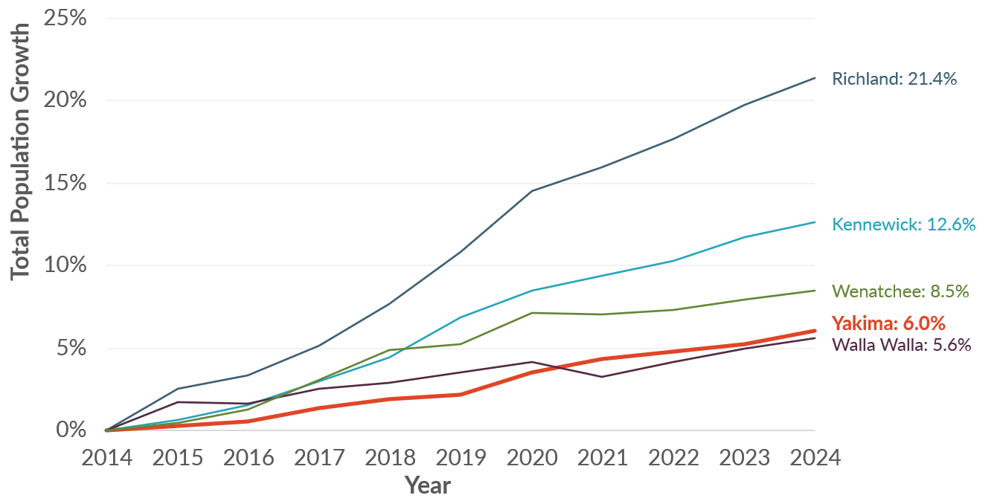
Sources: Washington Office of Financial Management, 2024; BERK, 2025.

Age of Population
The City of Yakima’s age distribution aligns closely with Yakima County, with a slightly smaller proportion of younger residents (0 – 24 years old) and a slightly larger proportion of older residents (70+ years old) than the county, as shown in Exhibit 3-2. Age Distribution in City of Yakima and Yakima County, 2022. The City of Yakima has a large population of children, with 29,558 aged 19 years old or younger (31% of the total population).
Exhibit 3-2. Age Distribution in City of Yakima and Yakima County, 2022
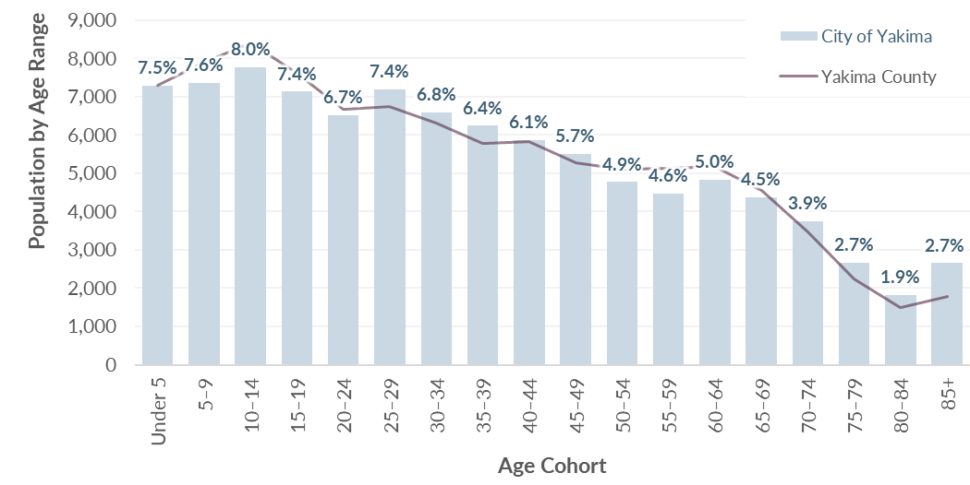
Sources: US Census Bureau, American Community Survey 5-Yr Estimates, 2018-2022; BERK, 2025.
Demographic patterns across Yakima vary by geography. As shown in Exhibit 3-3, residents aged 65 or older are more typically located in the north central and western parts of the city. This aligns with the locations of local retirement communities and assisted living facilities such as The Terraces at Summitview and Fieldstone. Residents under 18 are more typically located in the south central and eastern parts of the city. Many of the areas with larger youth populations have larger proportions of Hispanic or Latino residents, as shown later in Exhibit 3-6.
Exhibit 3-3. Areas with Large Percentages of Senior or Minor Residents, City of Yakima, 2022
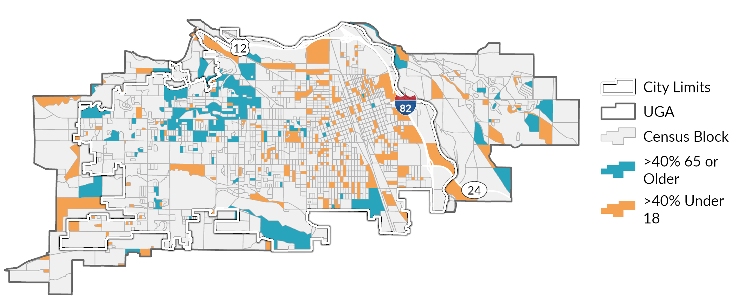
Sources: US Census Bureau, American Community Survey 5-Yr Estimates, 2018-2022; BERK, 2025.

Race and Ethnicity
Yakima is ethnically diverse. The City of Yakima’s Hispanic or Latino population comprises 47% of the total population, the largest of any reported comparison geographies besides Yakima County. The share of people who identify as Non-Hispanic People of Color grew from 5% in 2017 to 8% in 2022. A comparison of Yakima’s Hispanic or Latino population to comparable communities is shown in Exhibit 3-4. Percentage of Population by Race and Ethnicity in City of Yakima and Comparison Geographies, 2017 and 2022.
The Non-Hispanic People of Color group includes those who identify as American Indian or Alaska Native, which makes up 1% of the city’s population, as well as other races. This percentage likely reflects the nearby presence of the Yakama Nation in Yakima County.
Exhibit 3-4. Percentage of Population by Race and Ethnicity in City of Yakima and Comparison Geographies, 2017 and 2022
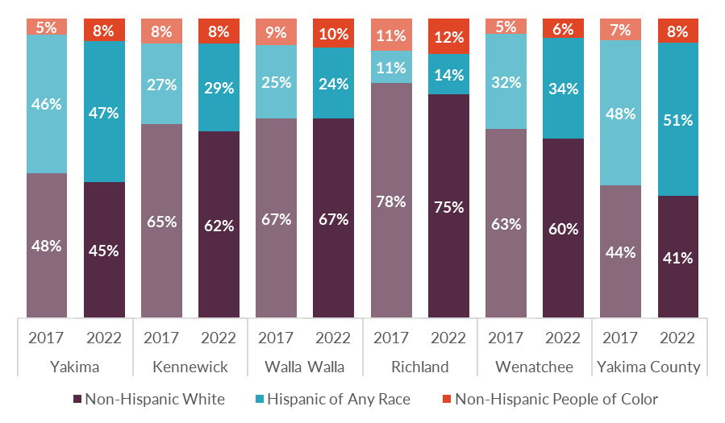
Sources: US Census Bureau, American Community Survey 5-Yr Estimates, 2018-2022; BERK, 2025.
Reflecting its ethnic diversity, Yakima has a high proportion of residents (38%) who speak a language other than English at home compared to 21% statewide, shown in Exhibit 3-5. Spanish is the most common language among non-English speakers, with 36% of the city’s total population speaking it at home.
History of The Latino community in yakima County
The large number of Latino and Hispanic residents in the city reflects historical patterns of migration and employment, tied mostly to the local agricultural industry. While the city has been a destination for migrant Hispanic farmworkers over the years, growing numbers of Hispanic farmworkers began permanently settling in the area from the 1930s to 1980s due to changes in the agricultural industry and immigration reforms.
Yakima’s population grew from roughly 3,200 residents in 1900, steadily increasing decade after decade, to 45,500 in 1960. These population increases were in part due to the arrival of Mexican American farmworkers from Texas in the early 1930s. During World War II, the U.S. government established the Bracero program, which allowed Mexican citizens to come to the Yakima Valley to work. While these workers did not settle in the Valley, this established the Yakima Valley as a destination for Latinx farmworkers. By the 1980s many former seasonal workers settled permanently in the Yakima Valley due to changes in immigration policies. By the 1980s, Yakima County's Hispanic population was 14.8%, and by the 2000 census, 33% of the residents of Yakima County were of Hispanic or Latino origin, compared to 7.5% in the state. In 2022, 51% of Yakima County’s population identified as Hispanic, nearly four times the statewide percentage of 13.1%
Source: HistoryLink.org Essay 9187 by Jim Kershner

Exhibit 3-5. Languages Spoken at Home in City of Yakima and Washington State, 2017 and 2022
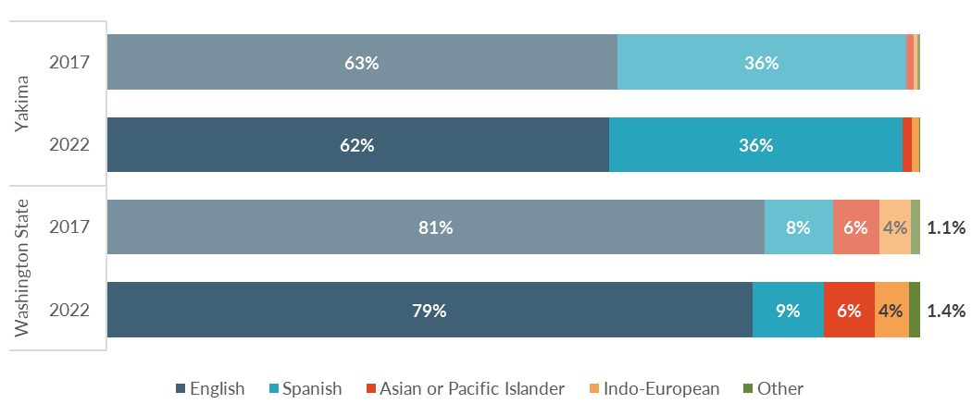
Sources: US Census Bureau, American Community Survey 5-Yr Estimates, 2018-2022; BERK, 2025.
Areas on the east half of the city and near downtown have larger proportions of residents of Hispanic or Latino origin than areas on the west half of the city, as shown in Exhibit 3-6. Comparing to the age distribution map shown in Exhibit 3-3 reveals that there are larger populations of residents under 18 in areas that have large proportions of Hispanic or Latino residents.
Exhibit 3-6. Percent of Residents that Identify as Hispanic or Latino, City of Yakima, 2022
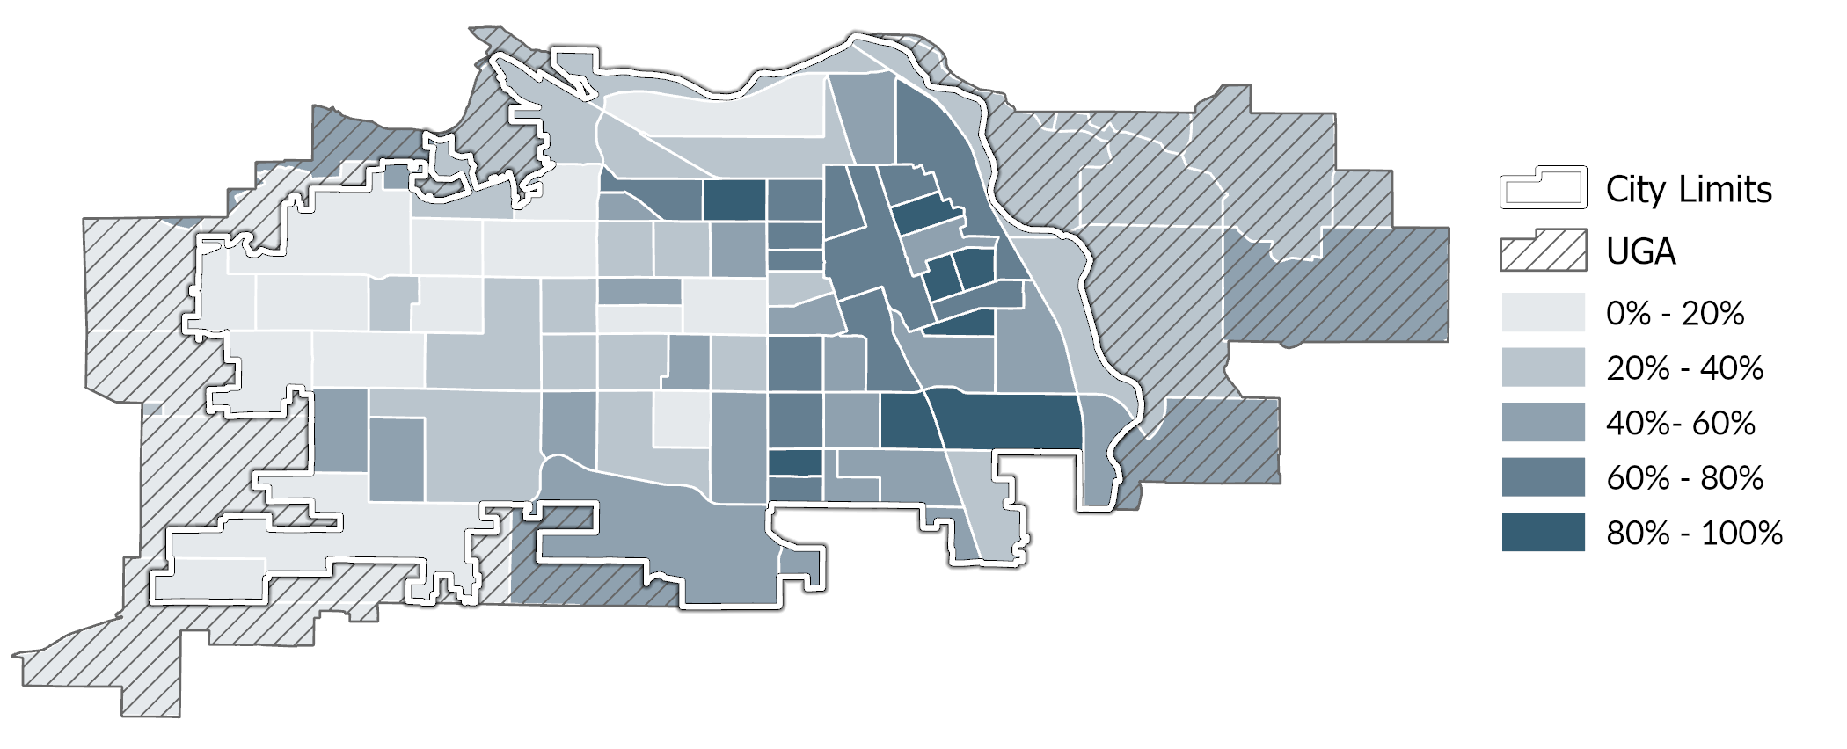
Source: US Census Bureau, American Community Survey, 2018-2022; BERK Consulting, 2025.

Households
A household is a group of people who live in a single dwelling unit, such as a house or apartment. Households can have one member or many members. They can be families or unrelated people living together. As of 2022, there are an estimated 34,830 total households in the City of Yakima. Understanding the makeup of the households in the city across age, race, and family sizes helps us to better understand the diversity of household types and sizes which can help support affordable housing strategies.

Household Size
The average household size in Yakima is 2.61 people, down slightly from 2017’s average size of 2.71. More than half (59%) of the city’s residents live in single or two-member households. Exhibit 3-7 shows the breakdown of households by size by tenure.
Exhibit 3-7. Household Size by Tenure in City of Yakima, 2018-2022
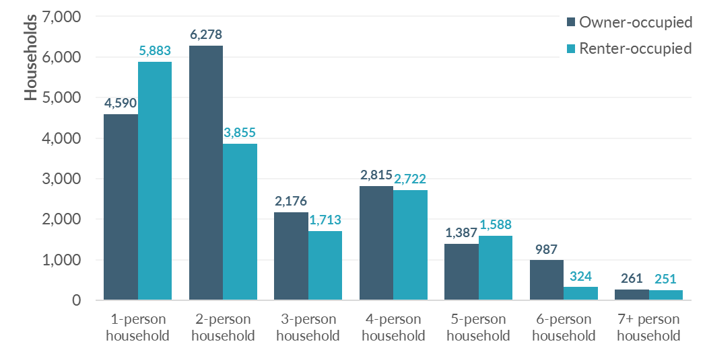
Sources: US Census Bureau, American Community Survey 5-Yr Estimates, 2018-2022; BERK, 2025.

Household Income
When summarizing housing affordability by income level, households are typically grouped relative to the U.S. Department of Housing and Urban Development (HUD) Area Median Family Income (also known as “AMI”). The 2025 AMI for Yakima County is $82,300. However much of the data in this section reflects conditions as of 2022, when AMI was $72,300. HUD also applies adjustments for household size when determining the income level of a household. This is to reflect the fact that it requires more income to affordably support a larger family compared to just one or two household members. Exhibit 3-8 breaks down renter- and owner-occupied households in the City of Yakima by income level relative to AMI. It shows a significant difference between owner-occupied and renter-occupied households, with owner households much more likely to have incomes above 100% AMI. Only 22% of renter households had income at or above AMI, compared to 56% of owner households. More than a fifth of renter households have extremely low incomes, compared to 9% of owner households.
Exhibit 3-8. Percentage of Households by Income Level in City of Yakima, 2018-2022
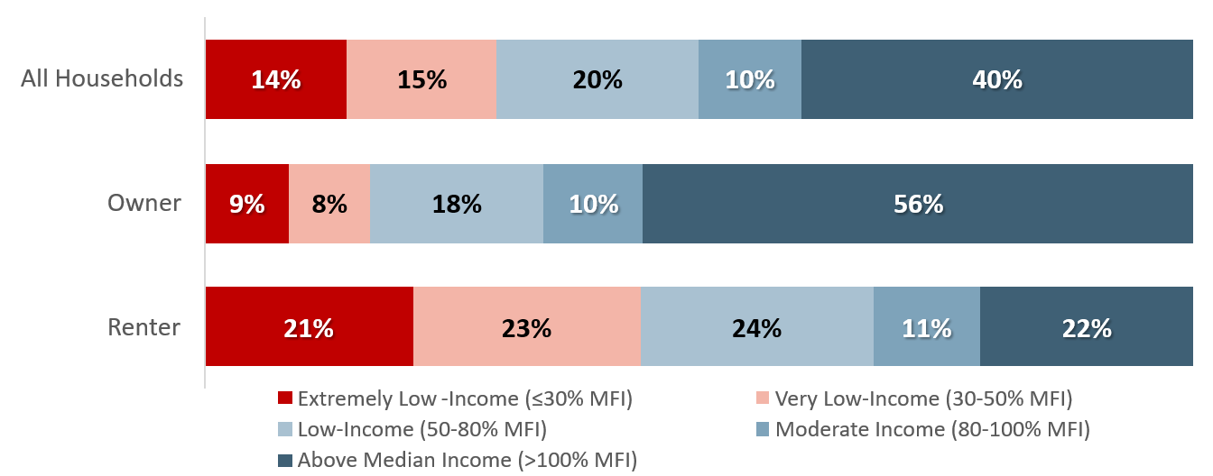
Sources: US HUD Comprehensive Housing Affordability Strategy, 2018-2022; BERK, 2025.
Median household incomes vary by ethnicity as well, as shown in Exhibit 3-9. The median Hispanic or Latino household has an income about 9% lower than median Non-Hispanic White households.
Exhibit 3-9. Median Household Income by Ethnicity in City of Yakima and Washington State, 2022
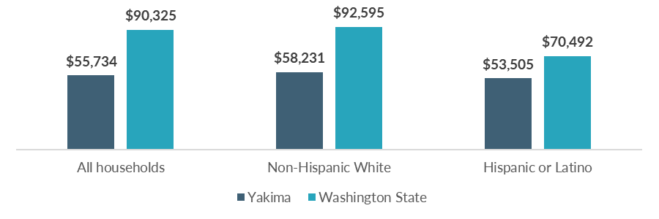
Sources: US Census Bureau, American Community Survey 5-Yr Estimates, 2018-2022; BERK, 2025.
A map showing disparities in income by neighborhood is provided in Exhibit 3-10. Areas with lower incomes are concentrated near the urban core of Yakima, while areas with higher incomes above AMI are typically found on the outskirts of the city, or in the west half.
Exhibit 3-10. Median Household Income by Census Tract in City of Yakima, 2022
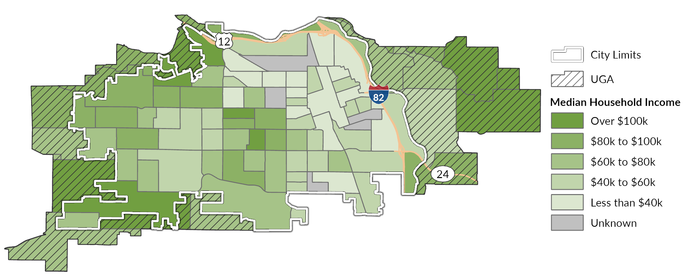
Source: US Census Bureau, American Community Survey 5-Yr Estimates, 2018-2022; BERK, 2025.

Cost-Burdened Households
One of the most common indicators of affordable housing needs is the number of households that are "cost-burdened" or spending a large share of their income on housing. These households have limited resources left over to pay for other life necessities such as food, medical care, transportation, and education. They are also at higher risk of displacement when housing costs rise, or life circumstances change.
HUD considers housing to be affordable if it costs no more than 30% of a household’s income. Households paying more than 30% of their income for housing are considered cost-burdened, and households paying more than 50% are considered severely cost-burdened.
In 2022, at least 33% of all households in Yakima were cost-burdened, as shown in Exhibit 3-11. Households with lower incomes are more likely to be cost-burdened.
Exhibit 3-11 and Exhibit 3-12 present estimates of total households by income level and cost-burdened status. It differentiates households that are moderately cost-burdened (spending 30-50% of their income on housing) from those that are severely cost-burdened (spending more than 50% of their income on housing). While there are cost-burdened households across the income spectrum, severe cost-burden is most prevalent among the lowest income groups. This includes slightly over 3,000 households with extremely low incomes (less than 30% AMI), roughly 1,600 households with very low incomes (30 – 50% AMI), and 700 households with low incomes (50-80% AMI).
Exhibit 3-11. Cost Burden Status by Income Level of Households, City of Yakima, 2018-2022

Sources: US HUD Comprehensive Housing Affordability Strategy, 2018-2022; BERK, 2025.
Exhibit 3-12. Total Cost-Burdened Households by Income Level, City of Yakima, 2018-2022
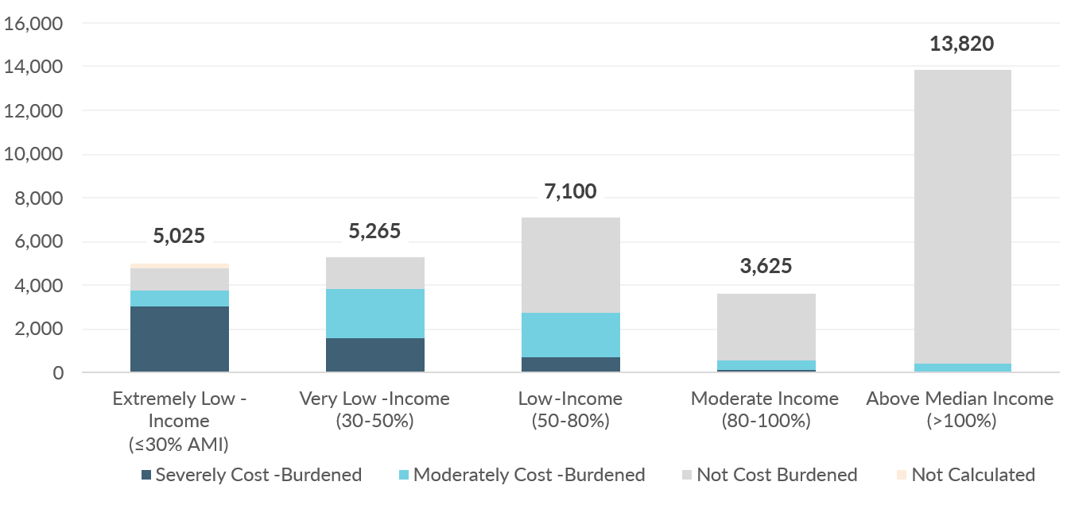
Sources: US HUD Comprehensive Housing Affordability Strategy, 2018-2022; BERK, 2025.
As shown in Exhibit 3-13, renters are more likely to be cost-burdened than owners, with nearly half (46%) of renter households cost-burdened, compared to just under a quarter (20%) of owner households. Renters are also more severely cost-burdened than owners, with 24% of renter households severely cost-burdened compared to 8% of owner households.
Exhibit 3-13. Household Tenure by Cost Burden in City of Yakima, 2018-2022
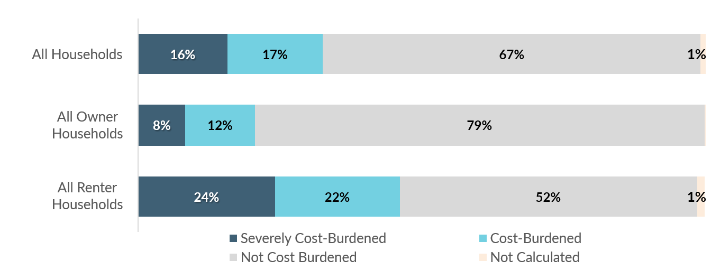
Sources: US HUD Comprehensive Housing Affordability Strategy, 2018-2022; BERK, 2025.
Renter households are most vulnerable to the impacts of rising housing costs. Exhibit 3-14 shows estimated counts of cost-burdened renter-occupied households by household type and income level. While there are households struggling with housing costs across the entire income spectrum, the greatest number are among household types with incomes below 50% of AMI. The greatest need is among Small Family, Elderly Non-Family, and Other (non-family) households, which are typically people living alone or with unrelated housemates.
Exhibit 3-14. Cost-Burdened Renter Households by Household Type and Income Level, City of Yakima, 2018-2022
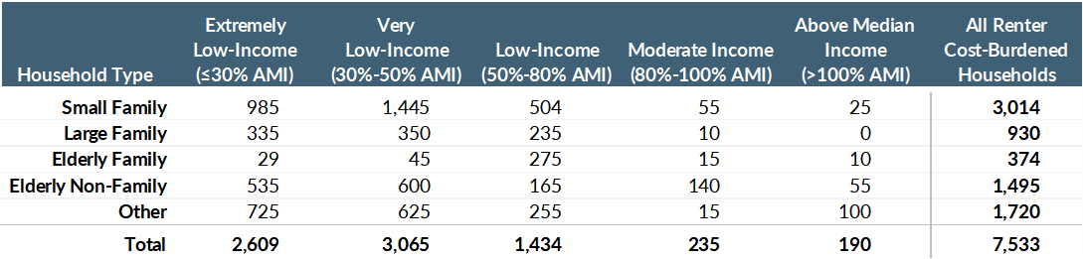
Household Type | Description
Family household | A household that includes two or more people related by birth marriage or adoption. (Definition applies to all household types that include “family.”)
Small Family | Two persons, neither aged 62 or older, or 3 or 4 persons
Large Family | Five or more persons
Elderly Family | Two persons, with either or both aged 62 or older
Elderly Non-Family | One or two unrelated people with either aged 62 or older
Other | Non-family, non-elderly households (includes those living alone or with housemates)
Note: AMI = HUD Area Median Family Income
Sources: US HUD Comprehensive Housing Affordability Strategy, 2018-2022; BERK, 2025.

Residents with Special Housing Needs
Several groups may have special housing needs or need supportive services, such as residents experiencing homelessness, residents with disabilities, and older residents. Given the city’s proximity to agricultural areas with significant seasonal workforce needs, farmworker housing needs also merit consideration.

Residents Experiencing Homelessness
According to the Department of Commerce’s Snapshot of Homelessness in Washington State for July 2024, there were 11,971 persons who were homeless or unstably housed in Yakima County. This was approximately 5% of the county population. Among these people, 9,906 were considered homeless. During the same year, 2,894 individuals countywide accessed homelessness services, according to the Commerce Homeless System Performance County Report Card. Entries are broken down by project type, with nearly half (49%) of entries occurring at Emergency Shelters. A summary of the results is shown in Exhibit 3-15.
Exhibit 3-15. Homeless System Project Entries by Project Type, Yakima County, SFY 2024
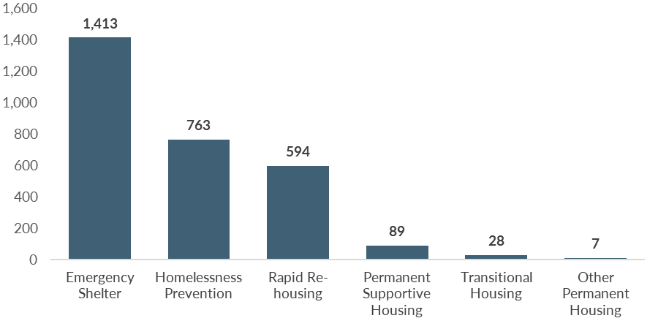
Sources: Department of Commerce, 2024; BERK, 2025.
The 2024 Yakima County Homeless Point-in-Time (PIT) Count surveyed individuals on causes of homelessness. The top reasons included eviction, alcohol/substance use, and family crisis. However, there are often a combination of factors that contribute to housing insecurity and homelessness. Exhibit 3-16 ranks the reasons cited by survey respondents. Research consistently indicates that the primary driver of homelessness is a lack of affordable housing supply. So while these individuals may have had life circumstances that made them more vulnerable to becoming homeless, the root challenge is housing affordability.
Exhibit 3-16. Top Reasons Cited as Cause of Homelessness, Yakima County, 2024
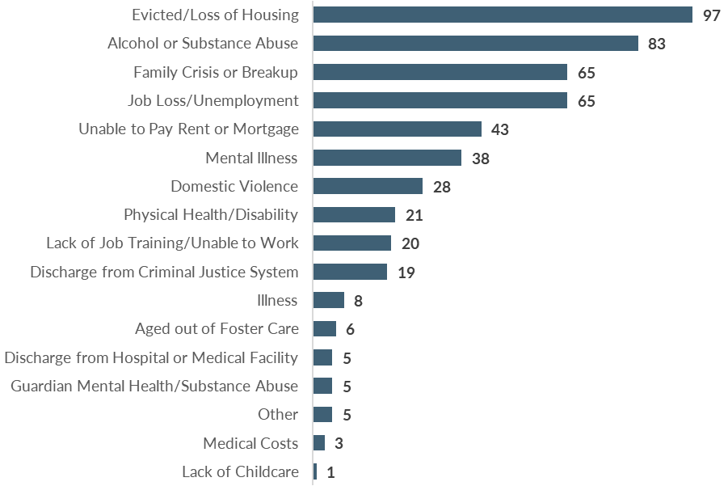
Note: Participants could select more than one cause.
Source: Yakima County Point-in-Time Community Report, 2024; BERK, 2025.
While conditions may have changed since its report, Yakima County’s Five-Year Plan to End Homelessness (2018) identified the following population as needing specific attention with regards to homelessness care:
- Individuals experiencing chronic homelessness,
- Unaccompanied youth,
- Veterans,
- Families with children (including victims of domestic violence), and
- Individuals over the age of 62.

Households with Disabilities
Exhibit 3-17 shows renter households in Yakima by disability status and income. While there are households with disabilities across the entire income spectrum, lower income households are more likely to have a member living with a disability than higher income households. Of the disabilities listed, the most common conditions include ambulatory limitations and hearing or vision impairments. People with disabilities often have special housing needs, and benefit from accessible layouts, supportive design, and proximity to healthcare services.
Exhibit 3-17. Renter Households by Disability Status and Income Level in City of Yakima, 2018-2022
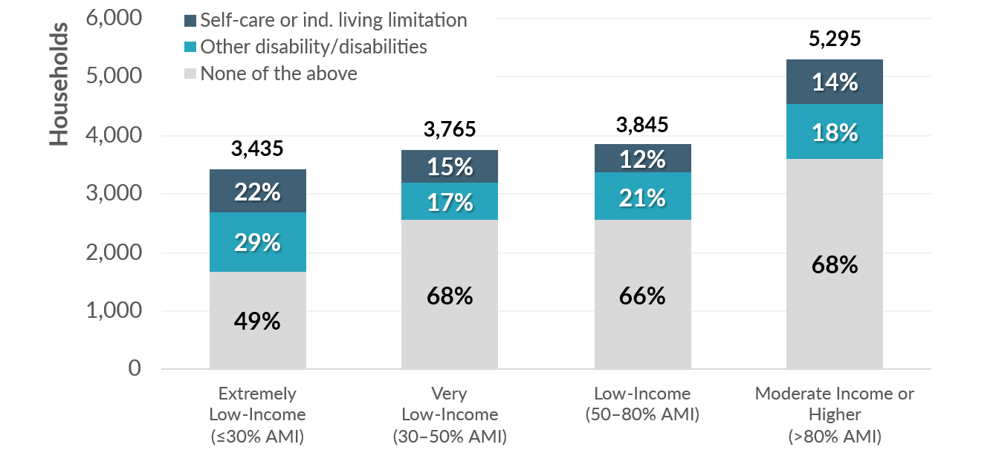
Note: AMI = HUD Area Median Family Income
Sources: US HUD Comprehensive Housing Affordability Strategy, 2018-2022; BERK, 2025.

Older Residents
15,250 residents in Yakima are aged 65 or older, or about 16% of the population. While older residents have a range of housing preferences, many need affordable, accessible housing in age-friendly neighborhoods with close links to healthcare and other supports. Some of these households in Yakima have the financial means to afford appropriate housing and services. Many others do not.
Exhibit 3-18 shows the prevalence of cost burden among elderly households across income ranges. The greatest need is among Elderly Non-Family households (typically people living alone) with incomes below 30% AMI.
Exhibit 3-18. Elderly, Cost-Burdened Households by Household Type and Income Level, City of Yakima, 2018-2022
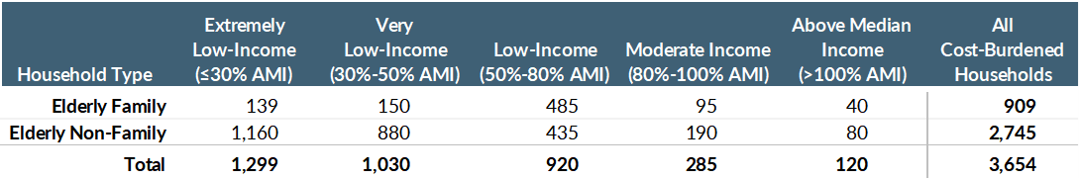
Note: AMI = HUD Area Median Family Income
Sources: US HUD Comprehensive Housing Affordability Strategy, 2018-2022; BERK, 2025.
Washington State Office of Financial Management (OFM) projects that the population of elderly households in Yakima County will increase faster than younger age groups. Exhibit 3-19 shows that by the year 2050, 20% of the population will be over age 65, up from 15% in 2022. This indicates the need for housing appropriate for elderly households will increase in the years ahead.
Exhibit 3-19. Projected Population by Age Range, Yakima County
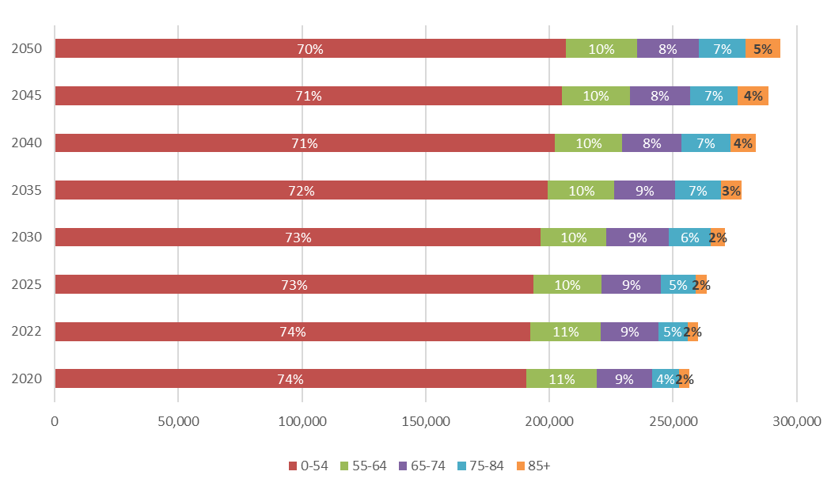
Source: OFM, 2022; BERK, 2025.

Farmworkers
Yakima County is the biggest county in Washington for agriculture, measured both by number of workers and by number of farms. In 2023, there were 28,603 farmworker jobs in Yakima County, seasonally adjusted. However, as shown in Exhibit 3-20 there are more workers in the summer months than in the remainder of the year. This is due to the demand for seasonal farmworkers during the harvest months. Many of these seasonal workers are migrants who need temporary housing. A 2022 study by the Department of Commerce found that the number of beds available in seasonal farmworker housing in Yakima does not nearly accommodate all the demand for seasonal housing, resulting in a gap of over 8,000 seasonal beds. The remainder of these seasonal workers must compete for housing with other renter households in Yakima.
The average year-round agricultural employee in this region is estimated to earn $39,750 annually in wages, significantly less than the median household income. While a household with this income can afford an average 1-bedroom apartment, it is far less than needed to afford a family sized rental or homeownership.
Exhibit 3-20. Farmworker Employment Counts, Yakima County, 2023
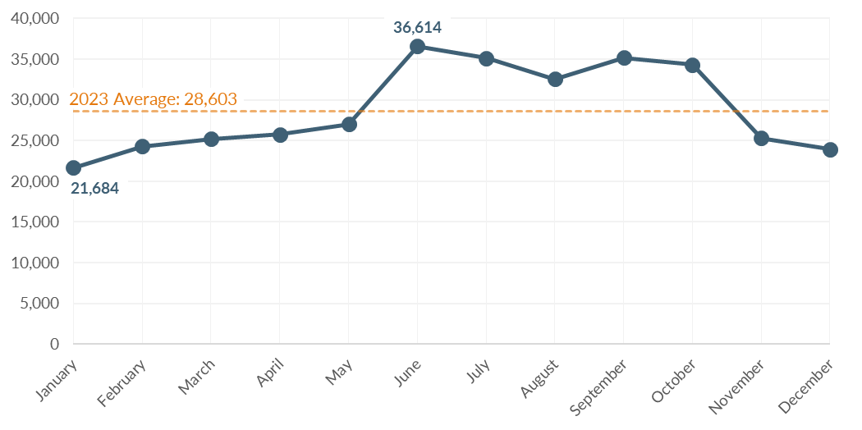
Source: Washington State Employment Security Department, 2023; BERK, 2025.

Employment

Countywide Employment
Yakima County had a total covered employment of 116,064 in 2023. The average annual wage was $49,831, or 57.2% of the state average of $87,091. The agricultural sector accounted for 25% of jobs (28,695 in total). The next largest employment sectors are Government with 16% (18,379 jobs), Health Care and Social Assistance at 15% (17,853 jobs), and Retail trade with 10% (11,509 jobs).

Citywide Employment
According to the Census, as of 2022 there were 50,087 jobs in the City of Yakima. Between 2017 and 2022, the city gained about 2,799 jobs, averaging ~1.2% growth (560 jobs) per year. Top sectors in the city include agriculture, health care, retail, and manufacturing. The City of Yakima's agricultural and manufacturing employers are diverse and include fruit packers, beef processors, and canneries. The jobs in the health sector reflect the city’s role as a regional medical center, with a hospital and the nearby Pacific Northwest University of Health Sciences (in Terrace Heights). The highest concentration of jobs in Yakima are Downtown and in the eastern part of the city.
About 1 in 7 (14%) primary jobs in Yakima paid less than $1,250 per month in 2022 (equivalent to $15,000 annually). However, not all these jobs are full-time. In 2022, a full-time minimum wage worker earned $2,511 a month. About a third (35%) of the jobs in Yakima paid between $1,250 and $3,333 per month. Many of those working these jobs would be cost-burdened by a one-bedroom rental without working multiple jobs, or rooming or cohabitating with others. The annual minimum wage increased annually to $16.28 per hour, or $2,821 per month for a full-time worker in 2024. Exhibit 3-21 shows that the average 1-bedroom rental in Yakima requires slightly more than 30% of monthly earnings for a full-time minimum wage worker.
Exhibit 3-21. Housing Affordability in Yakima for a Full-Time Minimum-Wage Worker, 2024
Monthly Earnings for Full-Time Minimum Wage Worker | Average 1-Bedroom Rental Cost | Share of Earnings Spent on Housing
$2,821 | $896 | 32%
Sources: Washington Department of Labor & Industries, 2024; Washington Center for Real Estate Research, 2024; BERK, 2025.
Exhibit 3-22 presents employment density within the City of Yakima in 2022. Employment is most dense around the downtown core near the east side of the city. A few other points of dense employment exist in Yakima, including one at the MultiCare Yakima medical campus in central Yakima. There is also a smaller concentration of industrial and commercial jobs along Fruitvale Blvd in northern Yakima. Job density is lowest in aeras predominated by residential development.
Exhibit 3-22. Employment Density in the City of Yakima, 2022
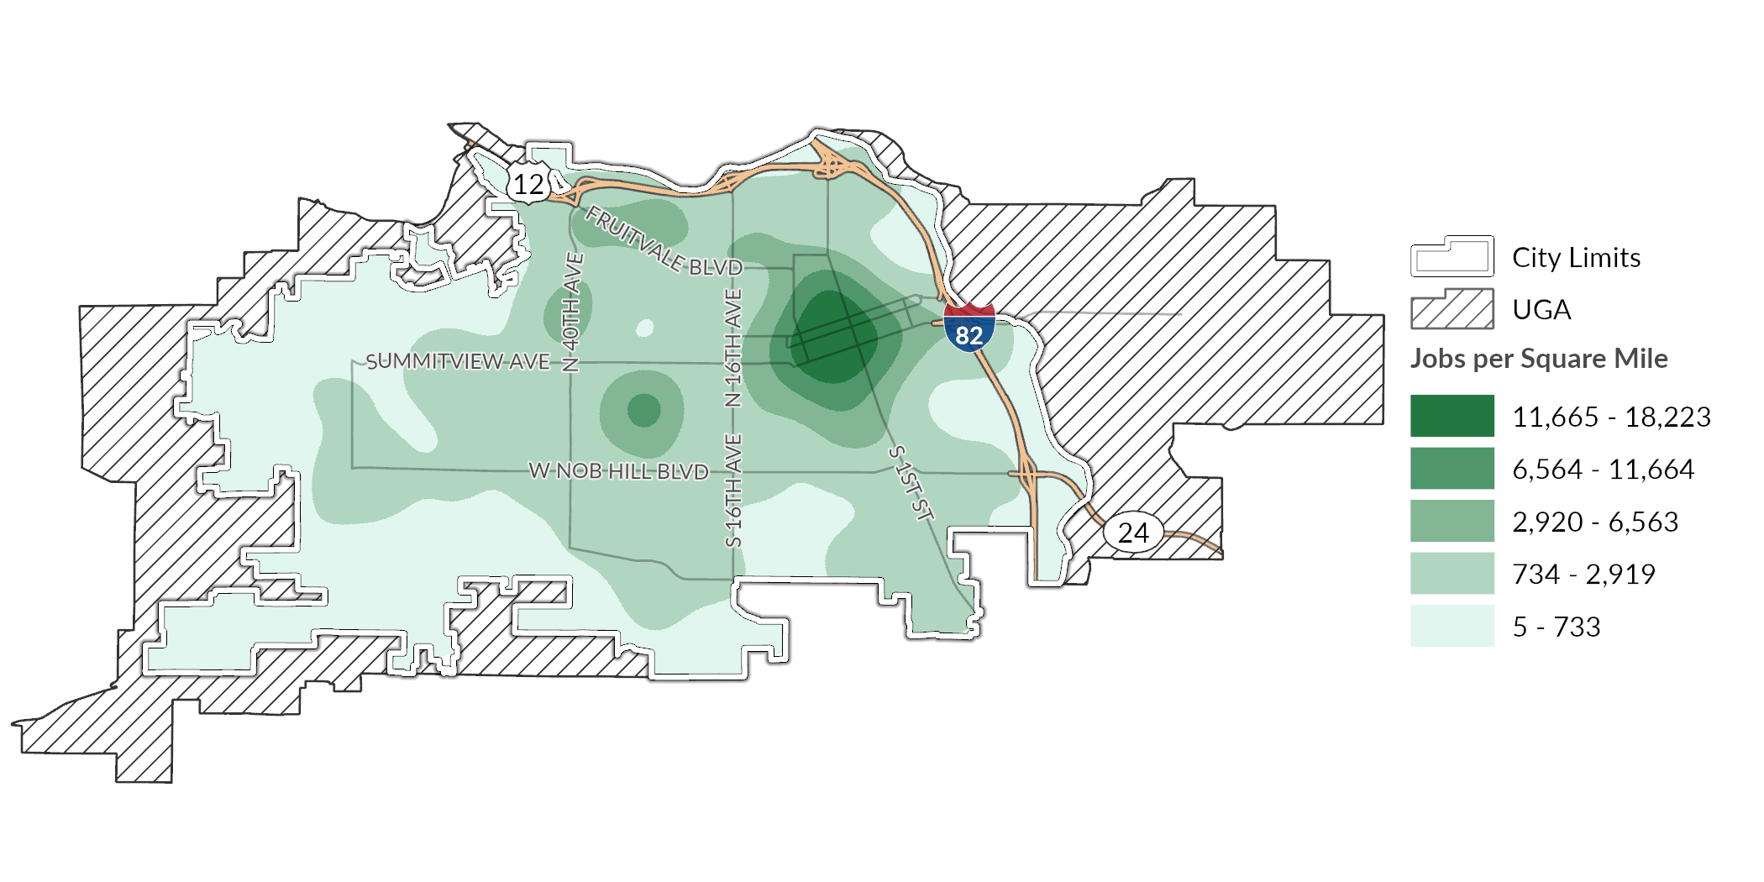
Source: US Census Bureau, Longitudinal Employer-Household Dynamics, 2022; BERK, 2025.

Employment Trends
Employment growth between 2012 and 2022 has been mostly healthy: an average of +2.1% growth per year during the period. This period includes the COVID-19 pandemic, which impacted employment and job growth. By 2022, employment recovered to levels seen before the pandemic, as shown in Exhibit 3-23. Many lower-paying employment sectors, such as healthcare support (nursing/medical assistants or home health aides), retail, and the food service industry, are currently in demand.
Exhibit 3-23. Total Jobs in the City of Yakima, 2012-2022
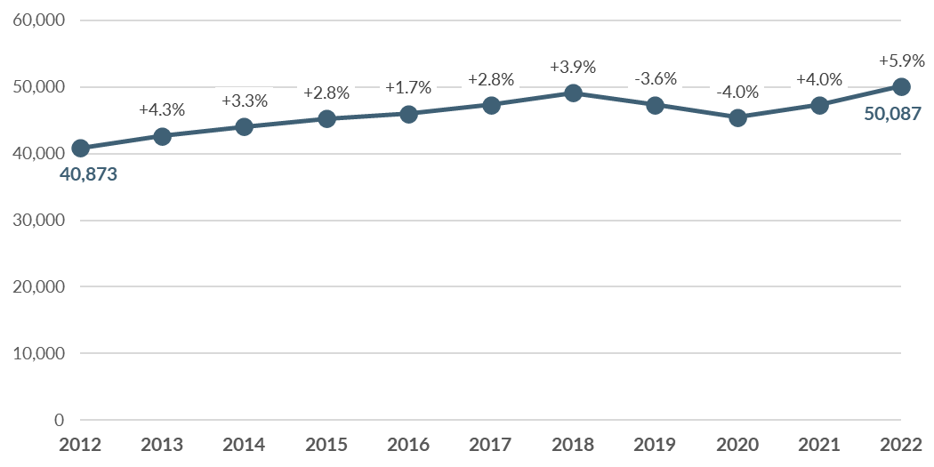
Sources: US Census Bureau, Center for Economic Studies, 2012-2022; BERK, 2025.

Worker Residential Locations
Many who work within the city of Yakima live elsewhere. Often, a lack of affordable housing in an economic center leads workers to search for living arrangements outside of their place of work. These workers have longer commutes, spend more of their income on gas and vehicle maintenance, and often live further from services.
Exhibit 3-24 shows the commute distances for people who work within the city of Yakima. While most workers live within 10 miles of the city, a large share (almost 40%, or nearly 20,000 jobs) commute more than 10 miles. More than 12,000 workers commute more than 50 miles, bringing in people from places such as the Tri-Cities to the east or Wenatchee to the north.
Exhibit 3-24. Commute Distance for Workers, City of Yakima, 2022
Commute Distance | Count | Share
Less than 10 miles | 30,370 | 61%
10 to 24 miles | 4,652 | 9%
25 to 50 miles | 2,907 | 6%
Greater than 50 miles | 12,158 | 24%
Source: US Census Bureau, Center for Economic Studies, 2022; BERK, 2025.

Housing Inventory

Housing Supply Characteristics

Housing Units by Type
There is a total of 38,584 housing units in Yakima, shown in Exhibit 3-25. Well over half (61%) of these units are single family homes and 18% are multi-family buildings of 5+ units. Another 7% of units are smaller multi-family structures such as triplex and quadplex buildings, while duplexes account for 9%. Mobile and manufactured homes make up 5% of the housing inventory.
Exhibit 3-25. Housing Inventory by Type in City of Yakima, 2024
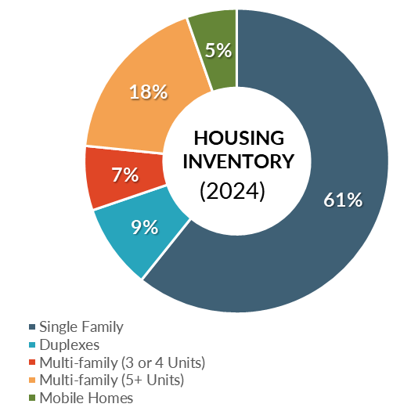
Source: Washington Office of Financial Management, 2024; BERK Consulting, 2025.

Unit Size
Exhibit 3-26 shows the Yakima housing supply by number of bedrooms and the share of households by household size. While roughly 17% of housing units are studios or 1-bedroom units 30% of households have one-person. This indicates a potential undersupply of smaller units compared to need.
Exhibit 3-26. Percentage of Housing Unit Sizes Compared to Household Sizes, City of Yakima, 2022
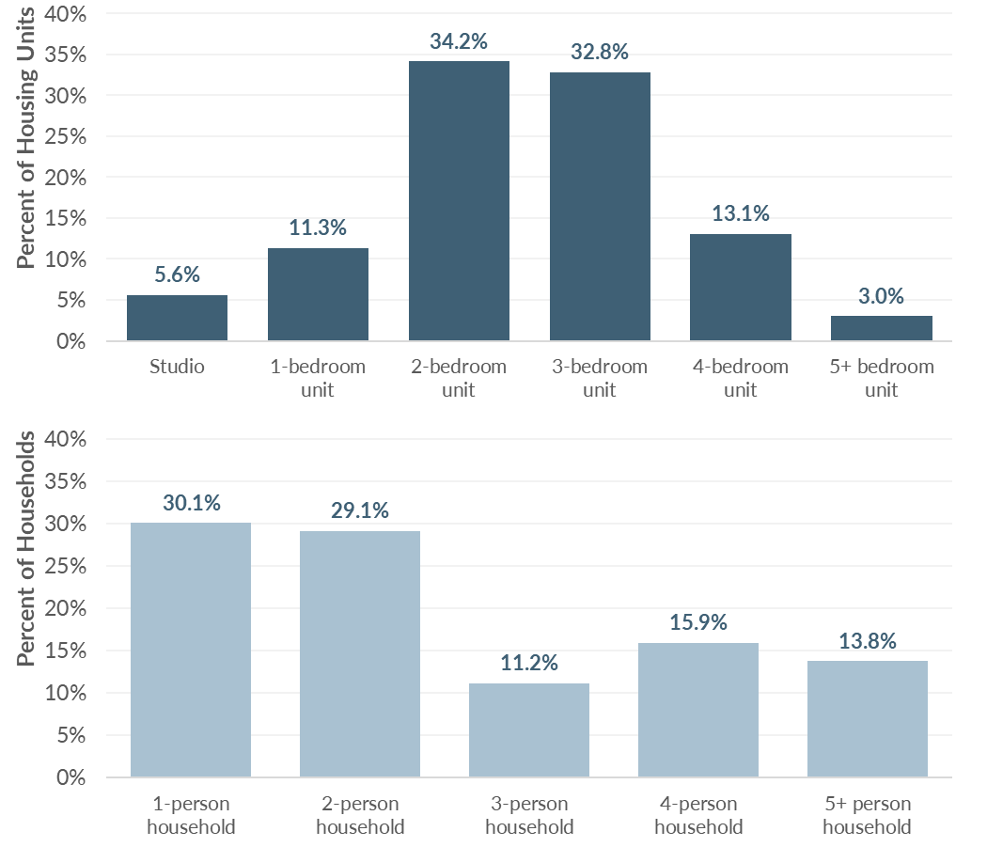
Source: US Census Bureau, American Community Survey 5-Yr Estimates, 2018-2022; BERK, 2025.

Housing Condition
According to the Yakima County Assessor’s Office as of April 2025, about 20% of the city’s residential parcels had primary structures that were built since 2000, and nearly two-thirds (63%) of units were built 40 or more years ago. These older units may represent lower quality housing stock that may require additional investments for upkeep. Older housing may also need modifications to ensure they are accessible for older residents, differently-abled residents, and families. While some older units may need maintenance or accessibility improvements, older housing stock may be the more affordable housing available in the city.
Exhibit 3-27 maps the geographical distribution of residential structure by year built. It shows that much of the older housing stock in the city is located in central and eastern Yakima, in areas that are typically close to amenities, services, and jobs. Preservation and support for home maintenance in these areas can contribute to sustaining this relatively affordable component of Yakima’s market housing supply.
Exhibit 3-27. Residential Properties by Year Built, City of Yakima, 2025
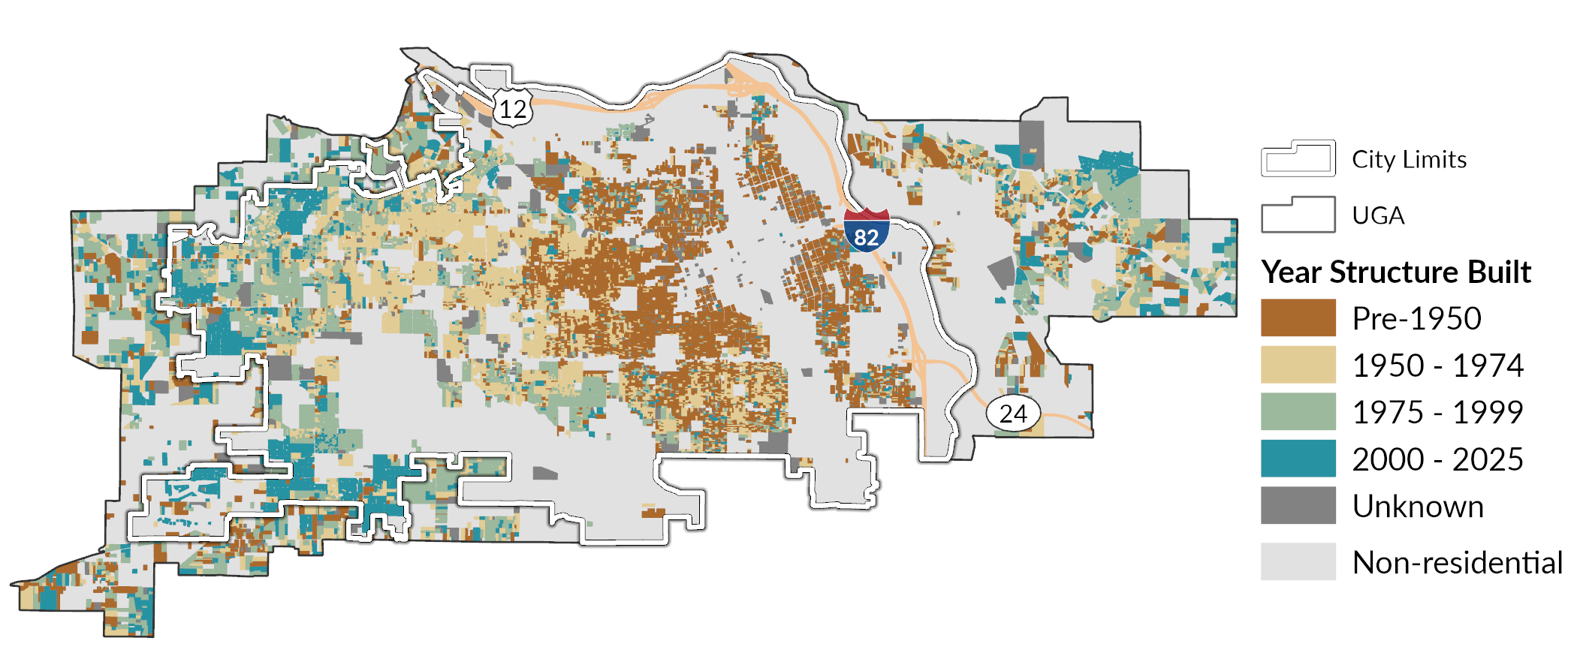
Source: Yakima County Assessor’s Office, 2025; BERK, 2025.

Housing Tenure
In Yakima, just over half (54%) of housing units are owner-occupied (32% with a mortgage and 22% without) while 46% are renter-occupied, as shown in Exhibit 3-28. There are major disparities in homeownership by race and ethnicity. Exhibit 3-29 shows that 62% of White, Non-Hispanic households own their homes, compared to only 40% of Hispanic or Latino households.
Exhibit 3-28. Household Tenure, City of Yakima, 2022
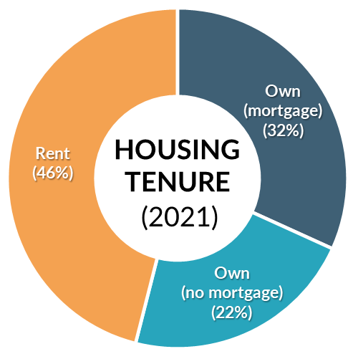
Source: US Census Bureau, American Community Survey 5-Yr Estimates, 2018-2022; BERK, 2025.
Exhibit 3-29. Housing Tenure by Race and Ethnicity, City of Yakima, 2018-2022

Note: Households of color includes Hispanic or Latino households as well as households of a race other than White alone.
Sources: US HUD Comprehensive Housing Affordability Strategy, 2018-2022; BERK, 2025.

Home Ownership
Homeownership is the primary way most American families accumulate wealth. Homeownership in advantaged neighborhoods also provides access to higher performing school districts, amenities, and social capital that can lead to better opportunities. In 2021, there was a total of 18,500 owner-occupied housing units in Yakima.
Exhibit 3-30 shows change in housing values over time in the city of Yakima compared to median family incomes in Yakima County. The separation between home value and income has grown between 2014 and 2022. In that period, the typical home value in Yakima rose by 99%, nearly doubling. Over the same period, the median family income only increased by 43%. This indicates homeownership is getting further out of reach for many prospective home buyers.
Exhibit 3-30. Percent Change since 2014 in Typical Home Value and Median Family Income (MFI)

Note: Historic MFI and home value data are not adjusted for inflation.
Sources: Zillow, 2025; US Census Bureau, American Community Survey, 2014-2024; BERK, 2025.
One reason home values have increased so rapidly is the shortage of homes for sale. As of March 2025, there was just 2.3 months of supply. This supply measure compares the number of homes listed for sale to the rate at which homes are purchased. A healthy housing market has at least four months of supply available for home buyers. When the supply is limited, competition among homebuyers drives up sales prices.

Homeownership Affordability
Exhibit 3-31 estimates the income needed to afford purchasing home in the City of Yakima, assuming the household has 3.5% down payment in savings available. Unfortunately, data about household savings is not available, so it is impossible to estimate how many households have accumulated the savings necessary for the assumed downpayment.
The majority of home sales in Yakima are detached single family homes. In many areas, townhomes provide a slightly lower cost option for homeownership. However, available data about townhome sales in Yakima indicates the costs of these homes are on par with the average home shown in Exhibit 3-31.
Exhibit 3-31. Home Ownership Affordability in City of Yakima, 2025
 | Home price | 3.5% Down Payment | Annual income needed to afford (Assuming 3.5% down payment)
New home | $498,317 | $17,441 | $161,625  (196% of AMI for 3-person HH)
Average home | $345,114 | $12,079 | $111,935  (136% of AMI for 3-person HH)
“Bottom-tier” home | $246,581 | $8,630 | $79,976  (97% of AMI for 3-person HH)
Notes: New home price is estimated based on Zillow “top tier” home value, which is the weighted average of all homes in the top third of home values in the region. Average home price corresponds to Zillow’s weighted average of the middle third of all home values in the region. “Bottom-tier” home corresponds to Zillow’s weighted average of the bottom third of all home values in the region.
Source: Zillow, 2025; BERK, 2025.

Rental Housing
There are a total of 16,335 occupied rental housing units in Yakima. Nearly half (48%) of these units are rented by Non-Hispanic White residents, meaning 52% of rental units in Yakima are occupied by people of color. Of the residents in Yakima who identify as Hispanic or Latino, more than half (58%) are renters.

Rental Housing Costs and Vacancy
Exhibit 3-32 shows average apartment rents as of 2024 as well as the household income level needed to afford the unit as a percentage of AMI. Households with incomes at 50% of AMI can still afford average market rents for 1- and 2-bedroom apartments. Those with lower incomes cannot. This helps to explain the fact that so many lower-income households in Yakima are cost-burdened.
Exhibit 3-32. Yakima County* Rental Rates and Affordability, 2024
 | 1-bedroom | 2-bedroom
Average monthly rent | $896 | $1,094
Annual income needed to afford | $35,840 | $43,760
% AMI needed to afford (adjusted for assumed household size)** | 50% | 50%
Notes: *Most apartment buildings surveyed for these county-wide estimates are assumed to be in the City of Yakima.
** Percent AMI calculations reflect adjustments by HUD, including adjustments for assumed household size.
Source: Washington Center for Real Estate Research, 2024; WSHFC, 2025; BERK, 2025.
Rents in Yakima are also rising at a faster rate than incomes. Between 2014 and 2024, the average monthly rent for a 2-bedroom apartment has risen by nearly 60%. During the same period median family income increased by only 34%.
One likely reason for the continued increase in rent is extremely low vacancy rates, as shown in Exhibit 3-33. From 2014 to 2021, the vacancy rate in apartment buildings remained under 2%, while rents increased. In 2022, the county experienced a sharp increase in vacancy rate up to nearly 6%, likely due to impacts from the COVID-19 pandemic. The rate has decreased since then to just over 2%. A healthy housing market has a vacancy rate of around 5%. When vacancy rates sink much below 5%, there are fewer options on the market for households seeking to move. This increases competition for the limited supply of available units and results in upward pressure on market rents.
Exhibit 3-33. Yakima County Apartment Rents and Vacancy, 2014-2024
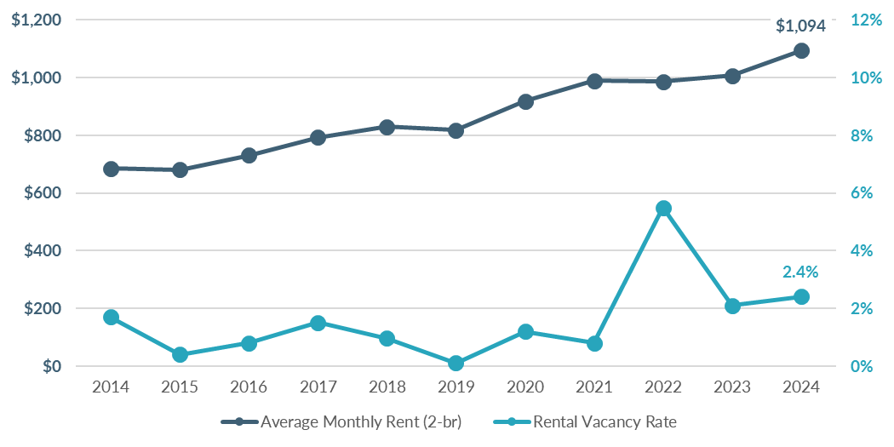
Note: Average rent does not adjust for inflation.
Source: Washington Center for Real Estate Research, 2014-2024; BERK, 2025.

Housing Production
Single family homes have been developed at a steady pace over the past several years in Yakima, as shown in Exhibit 3-34. Recent years have seen a decrease in permitting for duplexes with an increase in units in other multi-family structures. Housing production has increased considerably since 2019 compared to the preceding 10 years. Overall, 2,341 units of new housing units have been permitted in Yakima since 2019, with units in duplexes or multi-family buildings making up nearly 70%. These new units are adding diversity to the local housing stock, which provides more options at more affordability levels.
Exhibit 3-34. Count of Permitted Dwelling Units by Project Type in City of Yakima, 2010-2014
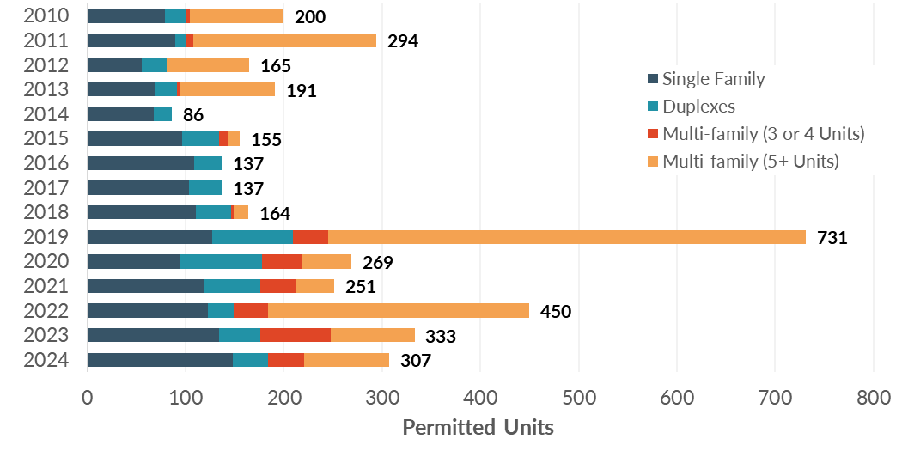
Sources: Washington Office of Financial Management, 2024; BERK, 2020.

Subsidized Affordable Housing
As of 2023, Yakima had 5,064 units of subsidized rental affordable housing, as summarized in Exhibit 3-35. These housing units are typically available at below market rents to households that meet income eligibility standards. Subsidies can come either from local, state, or federal agencies. Funding sources include the Washington State Housing Finance Commission (which manages federal Low Income Housing Tax Credits), Washington State Department of Commerce programs (including the Housing Trust Fund), US Department of Agriculture’s Rural Housing Service programs, and HUD’s project-based Section 8 and other multi-family programs.
Exhibit 3-35 shows the count of subsidized rental housing units in city of Yakima by unit size (number of bedrooms). Among units with known unit size, there is a relatively equal number of subsidized units that have between one to three bedrooms, with much less availability in studio units or units with four or more bedrooms.
Exhibit 3-35. Subsidized Rental Housing Units by Number of Bedrooms, City of Yakima, 2023
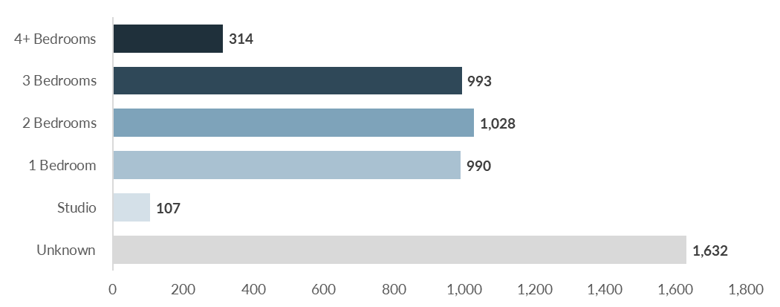
Source: Washington Center for Real Estate Research, 2023; BERK, 2025.

Housing Programs
The City of Yakima operates the following programs to support housing stability and affordability.
Exhibit 3-36. City of Yakima Housing Program
Program | Description | Desired Outcome
Senior/Disabled Persons Home Repair Program | City housing program to support home repairs for senior and disabled residents administered through the Office of Neighborhood Development to those who qualify (income and asset restrictions) | - Increased investment in neighborhoods  - Aesthetic improvements
Single-Family Emergency Repair Program | City housing program to support home repairs for low-income residents administered through the Office of Neighborhood Development to those who qualify (income and asset restrictions) | - Support housing and financial stability for low-income homeowners
Exterior Paint Program | City housing program administered through the Office of Neighborhood Development to those who qualify (age and disability restrictions) | - Increased investment in neighborhoods  - Aesthetic improvements
Homeownership Through New Construction | City housing program administered through the Office of Neighborhood Development to those who qualify (income restrictions) | - Increased homeownership
Tenant/Landlord Counseling | Office of Neighborhood Development Services program to assist either tenants or landlords with disputes and advice on reaching agreements or seeking legal support. | - Improved tenant/landlord relationships  - Education on legal support for those in need
Lot Acquisition Program | A City program within the Yakima Target Area that provides funds to purchase lots for residential development projects. Lots must be residentially zoned, have vacant or substandard buildings, and be developed within 12 months of purchase. | - New housing stock  - Neighborhood revitalization  - New infill development
Downtown Redevelopment Tax Incentive Program (YMC 11.63) | A City program that provides a tax incentive to stimulate new multi-family housing and the rehabilitation of vacant and underutilized buildings for multi-family housing. | - Increased housing options in residentially deficient urban centers.

Displacement & Displacement Risk
Policy guidance from Washington State Department of Commerce (Commerce) calls for comprehensive plans to study displacement and establish anti-displacement policies. Displacement refers to instances when a household is forced or pressured to move from their home against their will. Displacement can be physical, economic, or cultural. Direct, physical displacement occurs in cases of eviction, the termination of a tenant’s lease, or public land claims through eminent domain. Physical displacement can also occur when a property owner decides to renovate units to appeal to higher-income tenants or when buildings are sold for redevelopment. Another cause might be the expiration of an affordability covenant and resulting conversion of the unit to market rate housing. Economic displacement occurs when a household relocates due to the financial pressure of rising housing costs. Renters are more vulnerable to economic displacement, particularly those who are low-income, although some homeowners can experience this as well with significant increases to property tax bills. Cultural displacement is the result of fractured social fabrics. When physical and/or economic displacement affects community businesses, social institutions, and a concentration of racial or ethnic households, other households who affiliate with the affected cultural group may begin to feel increased pressure or desire to relocate.
While it is not possible to directly quantify the number of households displaced in a given year, we can analyze indicators of displacement to identify communities that may face displacement pressure. One indicator of potential displacement is a reduction in households of a particular racial or ethnic group over time. As presented below in Exhibit 3-37, the proportion of Yakima’s population that identifies as non-Hispanic White decreased from 2017 to 2022, while the proportion of those who identify as Hispanic or Latino or non-Hispanic persons who identify as two or more races increased. This reflects trends countywide and statewide and does not provide evidence of displacement of BIPOC communities overall in the city of Yakima. However, this finding does not tell us whether there is evidence of displacement at the neighborhood scale. Displacement risk and displacement that may have already occurred within Yakima are discussed in more detail below.
Exhibit 3-37. Race & Ethnicity in the City of Yakima, Yakima County, and Statewide, 2017 & 2022
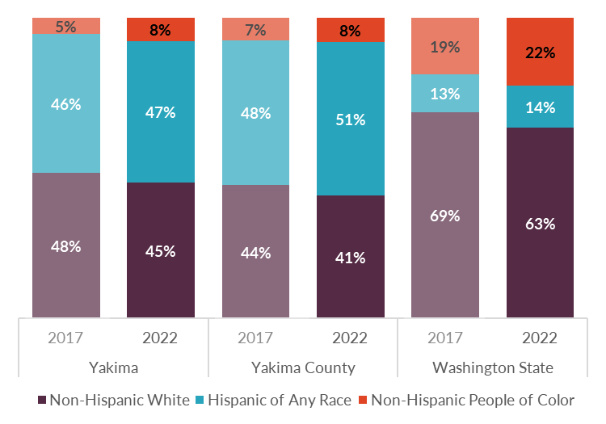
Source: US Census Bureau, American Community Survey 5-yr Estimates, 2017-2022; BERK, 2025.

Displacement Risk Mapping
Commerce provides a displacement risk mapping tool that identifies areas where residents are at greater risk of displacement. This tool evaluates relative displacement risk on a Census tract-level with a focus on three core categories: (1) social vulnerability; (2) demographic change; and (3) market trends:
- Social vulnerability: Calculates the share of BIPOC residents, the share of renter households, and median household income at a tract level. Each indicator is assigned a score (1-5) based on its level compared to the same measurement at the broader county level. Cumulative scores of 10 or more constitute higher social vulnerability.
- Demographic change: Calculates the change in the BIPOC population and lower income households between 2010 and 2020 (BIPOC) or 2021 (low-income households). Each characteristic is assigned a score based on its change relative to the countywide change, and the combination of these two indicators produces a demographic change score of “gentrification,” “disinvestment,” or “no change.”
- Market trends: Calculates 2015 rent levels for each tract, relative to the broader county, and also evaluates rental appreciation rates from 2010 to 2021 relative to the county. The combination of these two indicators produces a market trend of “Appreciated,” “Accelerating,” or “Stable.”
Exhibit 3-38 maps the displacement risk assessment for every Census tract overlapping the city. The tool shows variation in displacement risk throughout Yakima, with areas of high and moderate displacement risk concentrated on the eastern side of the city (including Downtown and areas toward Interstate 82). Downtown and the areas surrounding it are considered socially vulnerable (e.g., there is a higher share of BIPOC residents, renter households, and median household income is ≤80% of AMI). These mostly include areas within the city near Interstate 82 and along the industrial corridor created by the BNSF railway. The pattern follows for Demographic Change (Exhibit 3-40), with nearly all of Council District 1 at the northeast of the city having experienced gentrification.
Displacement risk is low in the western parts of the city. Some areas within Council District 3 and 5 are considered at moderate risk of displacement, with districts 6 and 7 having no areas at risk of displacement according to the Commerce tool. The entirety of Council District 4 is identified as socially vulnerable, with most of 1, 2, and 5 vulnerable as well. Again, districts 6 and 7 are not identified by the tool to be considerably vulnerable.
Note that Census tracts are often larger than neighborhoods experiencing gentrification and displacement. Yakima can use census tract data to monitor trends and review displacement risks in each Council district.
Exhibit 3-38. Displacement Risk in the City of Yakima, 2020
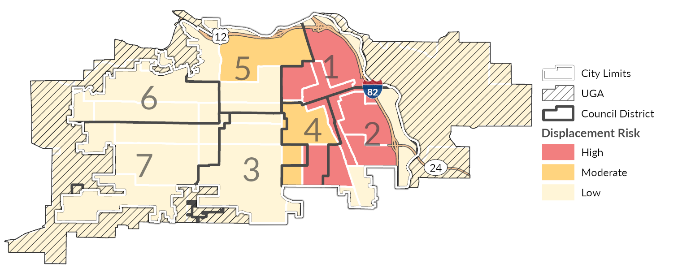
Source: WA State Department of Commerce, 2023; BERK, 2025.
Exhibit 3-39. Social Vulnerability in the City of Yakima, 2020
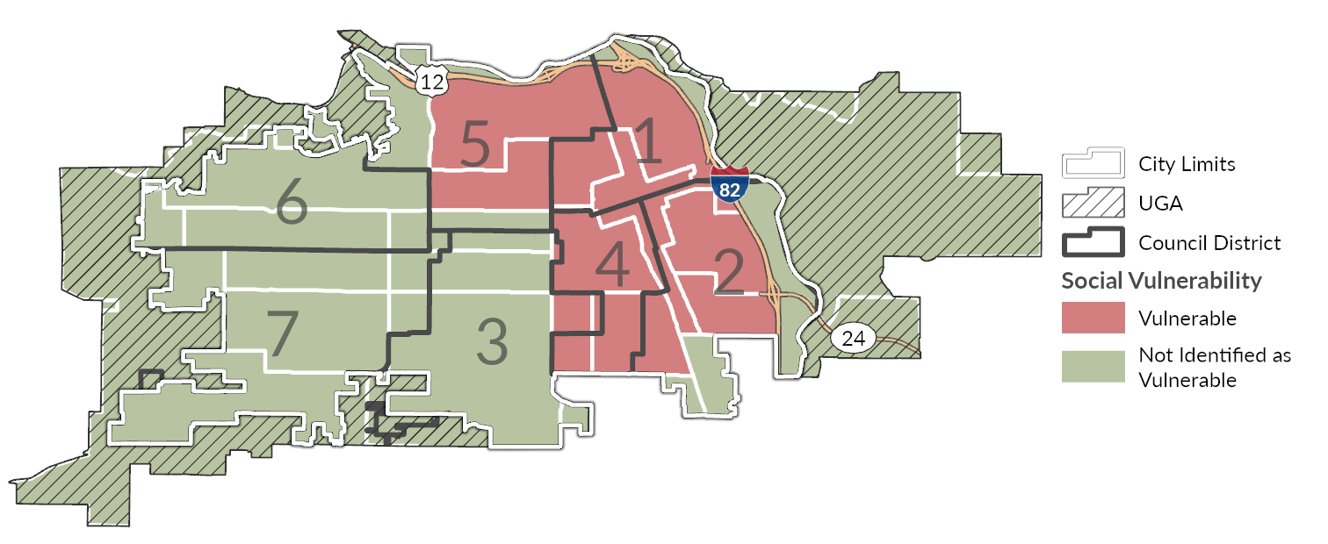
Source: WA State Department of Commerce, 2023; BERK, 2025.
Exhibit 3-40. Demographic Change in the City of Yakima, 2020
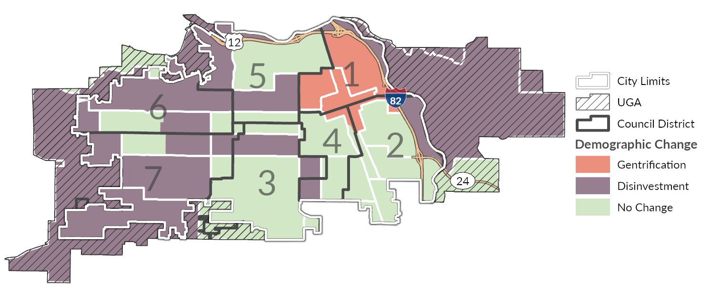
Source: WA State Department of Commerce, 2023; BERK, 2025.

Racially Disparate Impacts
New State and County requirements call for cities to assess whether racially disparate housing impacts are happening in their community, and to address them through policy and regulatory change. The requirements are not a charge against current communities in which there are racially disparate outcomes in housing, but an acknowledgement of the role land use policy has played in creating and institutionalizing race-based advantages and disadvantages. The statute uses the term “racially disparate” but does not identify protected groups based on race. Racially disparate impacts occur when policies, practices, rules, or other systems result in a disproportionate effect on one or more racial groups. Disparities in housing measures among different racial and ethnic groups are evidence of racially disparate impacts.
A community’s current housing situation is the product of many forces including historical factors, policy, regulations, macroeconomic changes, lending practices, cost of development, and individual preference. City governments cannot control all of these factors, but they can change local land use policies and regulations. Local land use policies and regulations have a significant impact on accessibility of housing for different households. As such, they are a key tool the City can use to address racially disparate impacts.
The City and consultant team used several measures to explore whether racially disparate impacts exist in Yakima. Some of these measures were covered earlier in this document, such as rates of homeownership, household income, and cost-burdened status by racial and ethnic groups. Those measures show evidence of racially disparate impacts. Homeownership rates are lower among Hispanic or Latino households (Exhibit 3-29). Median household income is also lower for Hispanic or Latino households than it is for non-Hispanic White households ($53,505 versus $58,231; Exhibit 3-9) and Census block groups with median household incomes below the citywide median correspond with greater concentrations of Hispanic or Latino populations (Exhibit 3-10 and Exhibit 3-6).
The team also explored displacement risk with the mapping tool provided by Commerce, as discussed in the prior section. The tool highlights areas of high and moderate displacement risk in and around Downtown and the eastern side of the city. It also indicates that displacement may already be occurring or have already occurred in primarily residential areas along Interstate 82. Additional measures the team used to explore exclusion and racially disparate impacts in Yakima are described in the following section, including a dissimilarity index and location quotient. These show evidence of segregation impacts the City should consider as it updates its housing policies.

Segregation Measures
The team used two measures to help understand whether racial and ethnic segregation is happening in the city of Yakima to assess possible exclusion in housing: a dissimilarity index and a location quotient. These measures explore whether certain populations are excluded from housing within a specified area, in a manner that may be intentional or unintentional, but which nevertheless leads to non-inclusive impacts. The dissimilarity index compares the city of Yakima to itself and considers segregation citywide for various populations. The location quotient compares each Census block group in the city of Yakima to Yakima County.

Dissimilarity Index
A dissimilarity index is a statistical method for measuring segregation based on the demographic composition of an area and smaller geographic units within that area. One way of understanding the index is that it indicates how evenly two demographic groups are distributed throughout an area: if the composition of both groups in each geographic unit (e.g., Census block group) is the same as in the area as a whole (e.g., countywide), then the dissimilarity index score for that count will be 0 (suggesting no segregation). By contrast, if one population is clustered entirely within one Census block group, the dissimilarity index score for the county will be 1 (complete segregation). The higher the dissimilarity index value, the higher the level of segregation in an area. Generally, areas with a dissimilarity index score above 0.4 are considered more highly segregated. Scores between 0.3 and 0.39 are associated with moderate segregation, and scores below 0.3 are considered to have a low level of segregation.
This methodology, as applied here, evaluates some of the largest non-White groups relative to the White population in Yakima. The scores therefore only represent the level of segregation between each group (Hispanic or Latino, Black, Asian, and all BIPOC) and the non-Hispanic White population. A similar analysis could be done to compare non-White groups to each other (e.g., Hispanic/Latino to American Indian or Alaska Native alone) to understand other dynamics; however, given the history of exclusionary housing practices in many places along with current residential trends, using the non-Hispanic White population as a point of comparison for understand relative segregation is often a useful starting point for evaluating disparate impacts related to housing.
Exhibit 3-41 shows dissimilarity indices for Yakima as well as the cities of Kennewick, Richland, West Richland, and Pasco along with Benton and Franklin counties for comparisons. Based on this data, the city of Yakima has a high level of segregation (0.44) within the city for Hispanic/Latino residents (who make up approximately 47% of the city population; Exhibit 3-37), and moderate segregation for the Black and All BIPOC populations. This suggests a moderate-to-high level of segregation within Yakima, which is consistent with mapping presented earlier in this report showing White, non-Hispanic populations are more prevalent in western areas of the city, while populations who identify as Hispanic or Latino (of any race) are more concentrated in and around Downtown and the areas surrounding it, especially to the southeast.
Exhibit 3-41. Dissimilarity Index for the City of Yakima and Comparison Geographies
 | Hispanic or Latino | Black | Asian | All BIPOC
Yakima | 0.44 | 0.37 | 0.27 | 0.39
Kennewick | 0.34 | 0.34 | 0.25 | 0.27
Richland | 0.22 | 0.24 | 0.28 | 0.13
West Richland | 0.21 | 0.17 | 0.24 | 0.14
Pasco | 0.48 | 0.29 | 0.24 | 0.44
Yakima County | 0.48 | 0.34 | 0.30 | 0.39
Source: US Census Bureau, Decennial Census, 2020; BERK, 2025.

Location Quotient
A location quotient is a helpful complement to other disparate impact measures and can reveal some trends that may otherwise be obscured. More specifically, it shows the concentration of communities in smaller areas within the city of Yakima (e.g., a Census block group) compared to Yakima County as a whole. Unlike the above application of the dissimilarity index, which compares the city to itself and considers segregation citywide for various populations, this use of the location quotient provides a more granular view, helping to show whether there are specific areas within Yakima that have disproportionately high or low populations of certain communities relative to countywide trends.
The methodology assigns a block-group level score for each community. For example, if 7% of the UGA population is Black, and 7% of a particular block group population is Black, then the location quotient for the Black community within that block group is 1. A block group where 14% of residents are Black would have a location quotient of 2. And a block group where only 3.5% of residents are Black would have a location quotient of 0.5. In other words, block groups with high location quotient scores have a greater share of that population compared to the rest of the urban growth area.
Exhibit 3-42, Exhibit 3-43Exhibit 3-44 show the location quotient for three race/ethnic groups in Yakima: White alone, Hispanic or Latino, and All BIPOC. They are based on block group population calculations. All areas with location quotients above 1.0 (green block groups) have a higher share of that particular group than the UGA as a whole. Areas with scores below 1.0 (purple block groups) have a lower share than the UGA. As shown, people identifying as White alone more consistently reside on the western half of the city, with very low quotient values within the Downtown area. There is a higher concentration of Hispanic or Latino populations in and around Downtown, especially to the southeast along Interstate 82. Examining the distribution of all BIPOC peoples (those identifying as any race other than White or a combination of two or more races) shows a point of concentration in the east near the edge of Downtown and around the Washington Park neighborhood, with most of the western half of the city and all of the unincorporated UGA having disproportionally less people identifying as BIPOC.
Exhibit 3-42. Location Quotient for Residents Identifying as White Alone, City of Yakima, 2020
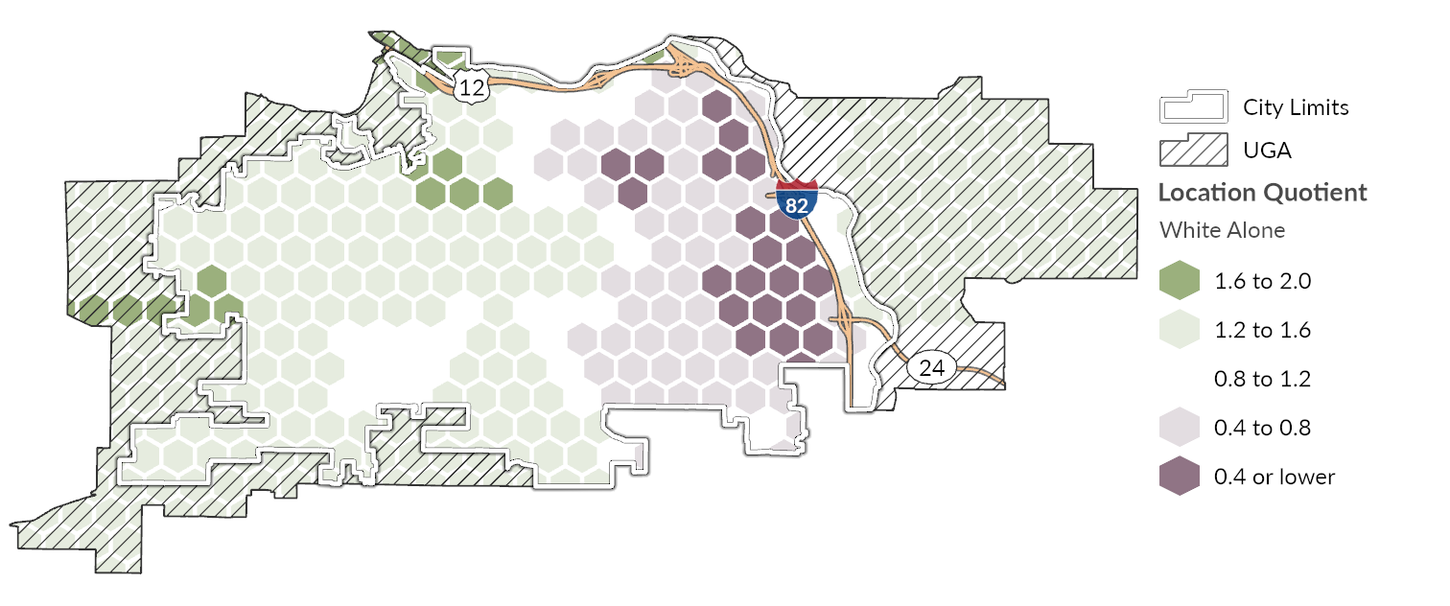
Source: US Census Bureau, Decennial Census, 2020; BERK, 2025.
Exhibit 3-43. Location Quotient for Residents Identifying as Hispanic or Latino, City of Yakima, 2020
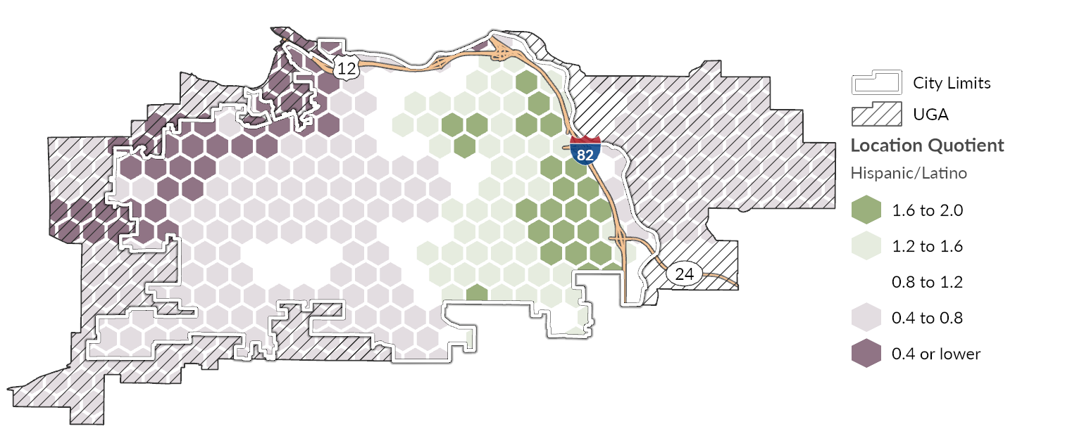
Source: US Census Bureau, Decennial Census, 2020; BERK, 2025.
Exhibit 3-44. Location Quotient for Residents Identifying as Black, Indigenous, or a Person of Color, City of Yakima, 2020
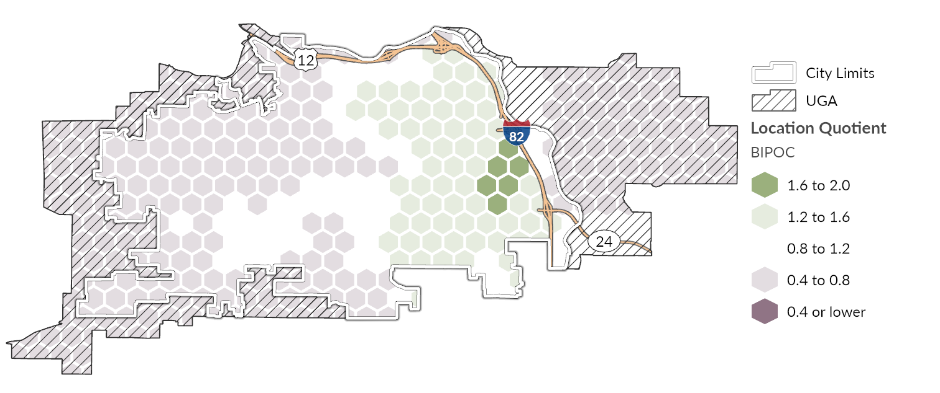
Source: US Census Bureau, Decennial Bureau, 2020; BERK, 2025.

Environmental Health Disparities
Environmental justice is concerned with the right of all people to enjoy a safe, clean, and healthy environment, and with fairness across racial, social, and economic groups in the siting and operation of infrastructure, facilities, or other large land uses. This section considers whether there are concentrations of racial groups in certain areas of the city with increased exposure to environmental health hazards or with limited access to transit, parks, or other services. Placing additional growth near high-volume roadways could expose future residents or workers to diminished air quality and heightened noise affecting quality of life and land use compatibility. It is particularly important to understand the health-related impacts of various land use patterns on spaces used by vulnerable populations, such as schools, daycares, elder care facilities, and medical centers.
Roadway users and adjacent neighborhoods experience air pollution from vehicle exhaust and brake/tire/road wear. Pollutant particle size, topography, and wind patterns affect the geographic extent of concern, with the greatest impacts immediately adjacent to and downwind of major freeways. Roadway traffic, especially larger vehicles (i.e., trucks and buses) also produce noise, and urban heat is generally of greatest concern where most of the ground area is covered by pavement, buildings, and other surfaces that absorb and retain heat.
Environmental exposure is affected by pollutants from both natural and manmade sources. Air quality and greenhouse gas (GHG) emissions are generally the greatest environmental exposure concerns in Yakima. These are areawide issues that are often discussed at a regional or even state level but there can be distinct differences between urbanized, populated areas and rural and undeveloped areas. Vehicles and equipment that burn fossil fuels are typically among the largest contributors to transportation-related emissions and can contribute to regional and localized concentrations of state and federally regulated pollutants. High concentrations of PM2.5 and other air pollutants contribute to respiratory problems, long-term health challenges, and increased healthcare costs. Exhibit 3-45 maps PM2.5 concentration levels in Yakima with an observed 2014-2017 average. Concentrations of PM2.5 are highest in the east and northeast portions of the city, including Downtown and industrial areas, where many Hispanic or Latino residents live.
Exhibit 3-45. PM2.5 Concentration, City of Yakima, 2014-2017 Average
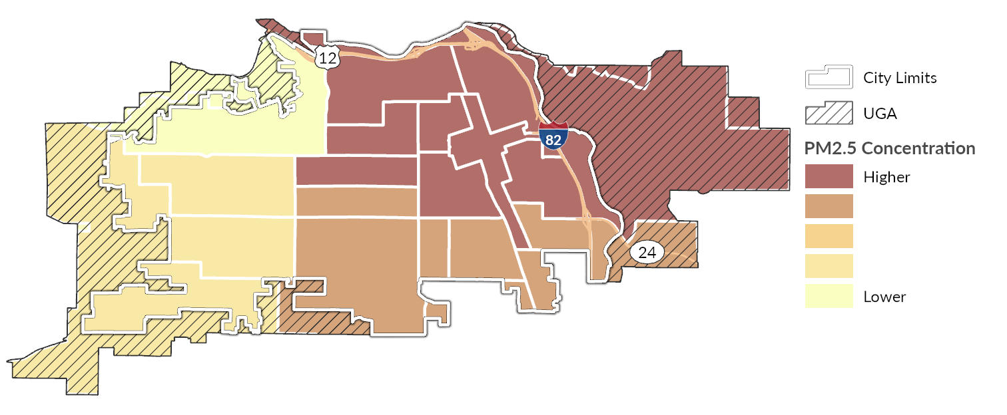
Source: WA Department of Health, Environmental Health Disparities Map, 2022; BERK, 2025.
The Washington State Department of Health (DOH) also produces an Environmental Health Disparities Map to evaluate environmental health risk factors in communities across Washington. The Environmental Health Disparities Map provides an index of environmental exposures (e.g., diesel emissions and proximity to traffic and hazardous waste sites) and socioeconomic and health factors (e.g., poverty and cardiovascular disease prevalence). Health disparities generally rank higher in the eastern portions of the city in and around Downtown where Hispanic or Latino populations are more concentrated.
A higher health disparity ranking represents an outsized burden of exposure and sensitivity to environmental harm. Prevailing socioeconomic characteristics and health factors—such as rates of poverty, chronic disease (like asthma) or low birthweight, limited English proficiency, race/ethnicity, or transportation expenses—can lead to worse health outcomes in some parts of the city than others despite varying levels of environmental exposures throughout the city. Environmental exposures include the levels of certain pollutants that residents and workers come into contact with, including airborne pollutants (e.g., diesel emissions, O3, and PM2.5) and proximity to traffic density or hazardous waste sites. Environmental exposure occurs when pollution sources get into the environment and affect individuals or populations. Prolonged exposure to pollutants may lead to poor health outcomes. Sensitive or vulnerable populations—including older adults, households living in poverty, disabled individuals, those without health insurance, households without access to a vehicle or other transportation options, and those experiencing homelessness—are at increased risk.
Exhibit 3-46. Environmental Health Disparities Map Score, City of Yakima, 2022
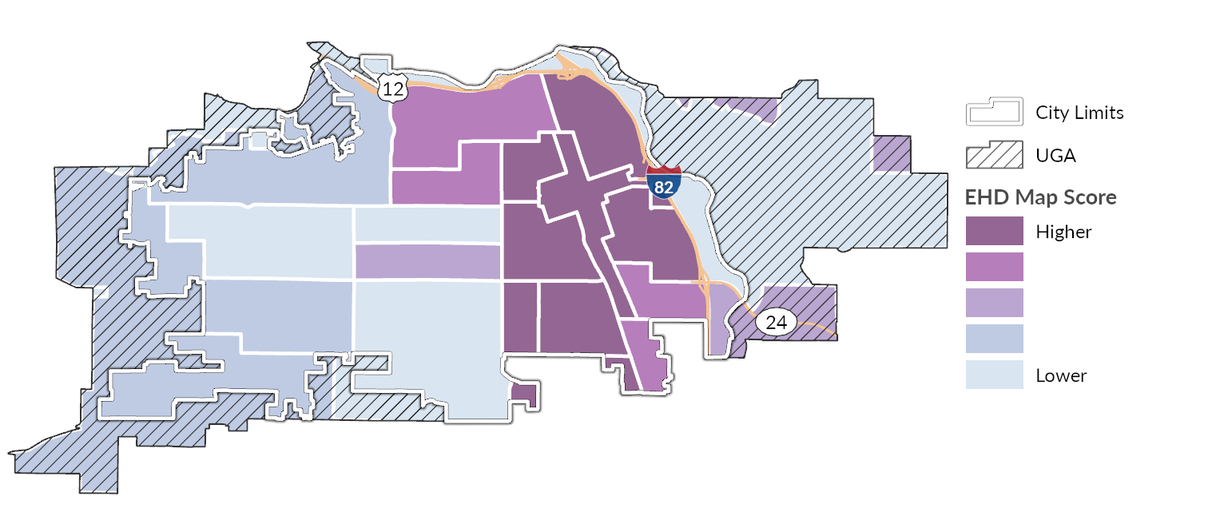
Source: WA Department of Health, Environmental Health Disparities Map, 2022; BERK, 2025.
Noise levels in Yakima are highest along major arterials, near the railway, and under the flight path of the Yakima Air Terminal/McAllister Field. Most other areas within Yakima are below the 45 dBA threshold measured by the U.S. Department of Transportation (USDOT) Noise Map as shown in Exhibit 3-47. Health impacts from noise include hypertension, heart disease, and likely poor school performance among children. Additionally, noise can affect quality of life and cause vibrations that impact hospitals and health care facilities. Direct effects of noise that indirectly affect health include:
• Speech interference
• Sleep disturbance
• Task interference
• Impairment of classroom learning
• Non-auditory health effects
• Aversive effects on emotion and tranquility
Exhibit 3-47. Transportation Noise Levels, City of Yakima, 2020
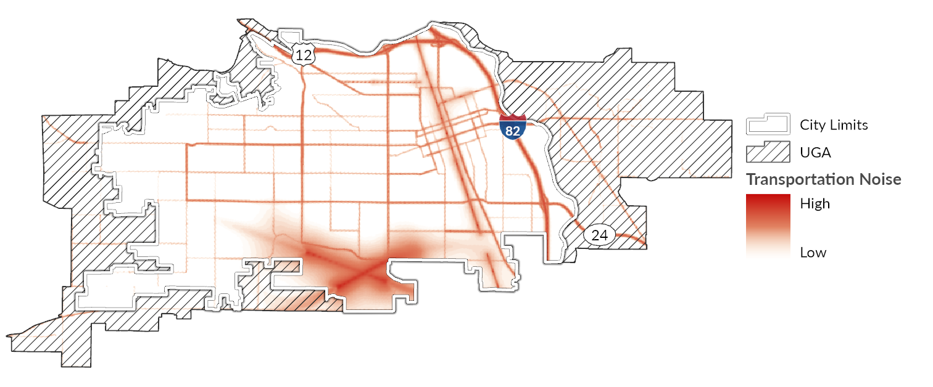
Source: USDOT, 2020; BERK, 2025.
Extreme heat is among the most pervasive weather-related hazards in the United States, and Washington’s summers are becoming increasingly hotter and longer. The city of Yakima and surrounding region are expected to see warmer year-round temperatures, higher maximum summer temperatures, and more frequent and severe heat waves. (University of Washington Climate Impacts Group, 2025) Extreme heat is expected to be an increasingly prevalent hazard in Yakima, with a projected increase of at least 8 additional days of extreme heat (over 100o F) by 2079 in Yakima Couty. Per the City of Yakima Climate Impacts Summary and subsequent Vulnerability Assessment Memo, key risks associated with extreme heat include:
- More extreme heat days puts residents in the Yakima at risk of heat-related illness and death. Prolonged exposure to high temperatures stresses the body and contributes to heat exhaustion and heat stroke. Individuals with chronic health conditions, people without adequate shelter, such as unhoused individuals are more at risk of injury and death from extreme heat. Additionally, older residents (those above age 65) are more likely to have existing health conditions (e.g., diabetes or heart disease) that worsen with significant heat stress.
- Worse air quality due to increasing ground-level ozone formation—a phenomenon known as the "smog effect"—which can aggravate respiratory conditions like asthma and chronic bronchitis (Zhang & Wang, 2016; Fann et al., 2016). This air quality impact especially impacts older residents, younger residents, and individuals who work outside.
- Heightened risk to people who work outside are also at of health issues related to extreme heat. Extreme heat events that put residents at risk of heat-related illnesses can also increase the need for emergency response, straining already strained emergency departments including fire, police, EMS, and hospital systems.
- Disruption to important ecosystems and critical areas through rising surface water temperatures, range shifts, and subsequent competition with invasive species. For example, warming air and water temperatures have contributed to algal blooms and allowed non-native species to thrive throughout Yakima’s wetlands including the Yakima River and Naches River. These invasive species, coupled with heat stress from rising stream temperatures may strain important native species like the several fish and bird species that traverse and spawn in the Lower Yakima River Basin. Summer maximum temperatures are expected to increase and worsen these conditions. Warm winter temperatures can also negatively impact snowpack, stream flow, and increase pest populations.
- Increased cooling demands and place additional stress on older buildings and HVAC systems. Increasing use of air conditioning depends on a stable, affordable electric supply. Rising electricity costs from climate-induced grid strain could further burden low-income households and rural communities. The region's growing population and aging infrastructure increase pressure on existing grid capacity.
- Infrastructure damage as high heat causes roads to warp and buckle, damages bridge joints, and increases deterioration of pavement (Sen, Li, & Khazanovich, 2022). This occurred throughout Washington State during the 2021 heat wave as a result of prolonged exposure to temperatures above 100 Degrees Fahrenheit.
Certain land use decisions may worsen the impacts of extreme heat on these critical assets. "Urban heat islands" contribute to this and occur when natural land cover is replaced by large amounts of pavement, buildings, and other surfaces that absorb and retain heat. Structures such as buildings, roads, and other infrastructure absorb and re-emit the sun’s heat more than natural landscapes such as forests and water bodies. Urban areas, where greenery is limited, become “islands” of higher temperatures relative to outlying areas. This effect increases energy costs (e.g., for air conditioning), air pollution levels, and heat-related illness and mortality and can further exacerbate heat exposure from climate change and the impacts of naturally occurring heat waves. Heat islands are also riskier for sensitive populations, including older adults, young children, populations with low-income, outdoor workers, and people in poor health. High pavement and rooftop surface temperatures can also heat up stormwater runoff, which drains into storm sewers and raises water temperatures as it is released into streams, rivers, ponds, and lakes.
Exhibit 3-48 maps urban heat islands as modeled from satellite-derived information during the summer of 2023. Areas with a lower urban heat island effect are shown in white, while those with a greater effect are shown in deeper color. While all of Yakima is exposed during a heat event, certain areas will be hotter than others due to this effect, including eastern and southeastern portions of the city where Hispanic and Latino population are more prevalent. Parts of the city with more paved surfaces and less tree canopy and other vegetation tend to experience more heat, generally the more commercial and industrial areas of the city (tree canopy coverage is mapped in Exhibit 3-49). Industrial areas along the BNSF railway and in and around Downtown are especially susceptible to extreme heat. The ability to keep cool as temperatures rise during the summer is important especially in areas where heat severity is higher and tree canopy coverage is lower. Keeping cool is a function of surrounding tree canopy as well as how well insulated the building structures are, the presence or capacity of mechanical and/or natural cooling systems, and the ability of the structure to reflect heat during the summer and absorb it during the winter.
Exhibit 3-48. Urban Heat Island Severity, City of Yakima, 2023
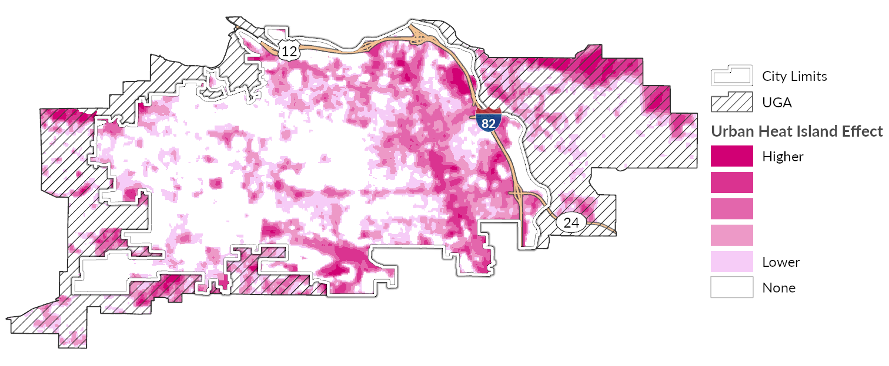
Source: Trust for Public Land, 2023; BERK, 2025.
Exhibit 3-49. Tree Canopy Coverage, City of Yakima, 2021
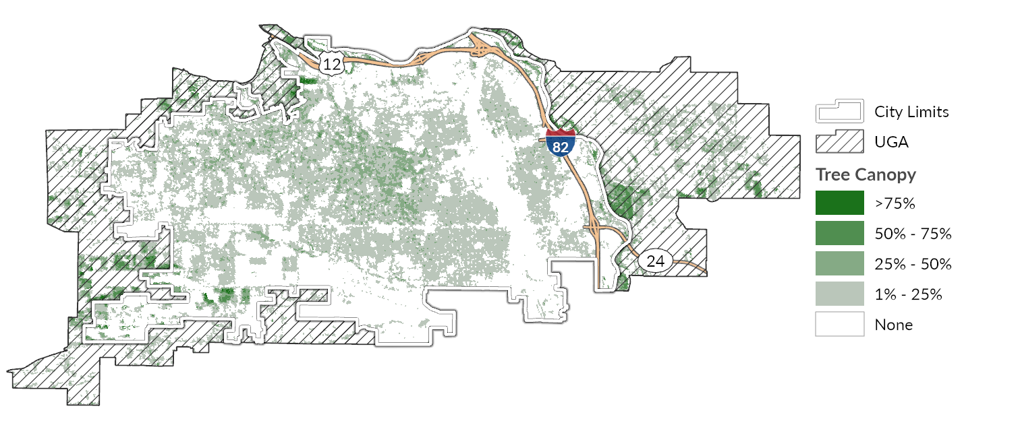
Source: US Geological Survey, National Land Cover Dataset, 2021; BERK, 2025.

Engagement
Housing focused engagement was conducted as part of the Comprehensive Plan Periodic Update to better understand contributing factors to racially disparate impacts, displacement, exclusions in housing, and future displacement risk. Strategies include open houses, and feedback from a Comprehensive Plan Steering Committee. See Comprehensive Plan Draft Appendix D for a summary of engagement conducted to date, including the following key themes:
- Expand housing typologies and supply: a common theme heard across various engagement strategies is a desire to see more affordable housing options in Yakima, particularly for first time home buyers. Community members also expressed a desire to see more affordable housing typologies, such as middle housing, Accessory Dwelling Units (ADU’s), and more
- Incentivize housing through capital improvements: One of the biggest challenges noted with housing was around infrastructure. It was noted that developers are a critical player in expanding infrastructure capacity in Yakima. However, more city-led infrastructure projects and incentives could help reduce housing costs, and incentivize more residential development
- Consistent design and land use patterns: To balance the potential increase of middle housing, several community members noted that land use patterns should ensure a smooth transition of zones, and building typologies. For Multifamily housing, providing open space with new development was highlighted as a key need. Design standards should offer consistency of residential urban design, and aesthetics.
- Prioritize new housing along key transit and commercial corridors: When asked where there should be more housing, the majority of responses noted a desire for more housing along transit lines, and commercial nodes/corridors. People noted the development of new commercial centers in West Yakima, and agreement to see more multifamily housing in those areas. S 16th Ave was also mentioned as a key neighborhood for additional residential development. In addition, residential development in the UGA was noted as another potential area for additional housing. Air quality was identified as a key concern for people with health conditions during smoke and wildfire days. New housing design should consider addressing noise and indoor air quality.

Policy Review
A full list of the goals and policies related to housing in the City of Yakima can be found in the body of the Comprehensive Plan Housing Element. Exhibit 3-50 is a summary of updates made to the Housing Element of the Comprehensive Plan as part of the periodic update with the specific objective of lowering racially disparate impacts in housing. These policy changes are meant to address impacts such as hazard resiliency, affordability, access to services, and isolation from community. Enacting these policies is not the only step that needs to be taken to address racially disparate impacts of housing but these changes lay the groundwork for future efforts.
Exhibit 3-50 Racially Disparate Impacts – Housing Policy Analysis and Audit Summary
Goal and Policy # | Previously Adopted Housing Goals and Policies | RDI Related Edits/ Additions made as part of 2026 Periodic Update to Comprehensive Plan
3.1.2. | Promote the preservation, improvement, and development of single family homes in Yakima. | Promote the preservation, improvement, and development of middle housing and single family homes in Yakima.
3.1.4. | Facilitate small lot sizes, condominiums, clustering and other options that increase the supply of affordable homeownership options and the diversity of housing that meet the needs of aging, young professional, and small and large households. | Facilitate small lot sizes, condominiums, townhomes, accessory dwelling units, clustering and other middle housing options that increase the supply of affordable homeownership options and the diversity of housing that meet the needs of aging, young professional, and small and large households.
3.1.8. | Encourage and incentivize affordable housing development. | Encourage and incentivize affordable housing development for moderate, low, very low and extremely low income households.
3.1.9. | Support proposals for affordable assisted and market rate housing based on the following criteria:  - Dispersion of affordable housing throughout the City  - Convenient access to transit  - A range of unit types  - Ownership housing when possible  Long-term affordability | Support proposals for affordable assisted and market rate housing based on the following criteria:  - Dispersion of affordable housing throughout the City  - Convenient access to transit  - A range of unit types including middle housing  - Ownership housing when possible  Long-term affordability
GOAL 3.3. | ENSURE AN ADEQUATE SUPPLY OF HOUSING FOR PERSONS WITH SPECIAL NEEDS. | ENSURE AN ADEQUATE SUPPLY OF HOUSING FOR ALL INCOME GROUPS INCLUDING PERSONS WITH SPECIAL NEEDS.
3.3.1. | Prioritize the provision of fair share housing opportunities to all economic segments of the population and those with special needs. | Prioritize the provision of fair share housing opportunities to all economic segments of the population and those with special needs as allocated through the regional allocation process.
3.3.5 | [NEW] | Support programs to ensure that individuals and families vulnerable to natural hazard impacts have adequate housing options. Vulnerable communities include the following:  - older adults and children  - those with pre-existing health conditions including pulmonary conditions  - individuals with mobility challenges  - low- and extremely low-income individuals  - pregnant people  - people with limited literacy  - people who speak English as a second language
GOAL 3.4. | ENCOURAGE DESIGN, CONSTRUCTION, AND MAINTENANCE OF HIGH QUALITY HOUSING. | ENCOURAGE DESIGN, CONSTRUCTION, AND MAINTENANCE OF HIGH QUALITY HOUSING WITHOUT MAKING UNITS COST PROHIBITIVE.
3.4.5. | Implement utility standards that encourage infill development. | Implement utility standards that encourage infill development and middle housing.
3.4.6 | [NEW] | Encourage or incentivize residential development standards which increase resiliency to natural hazards such as extreme heat, severe storms, drought, and wildfire smoke through cross-ventilation, passive cooling window coverings, and energy efficiency upgrades
3.5.4. | Consider human services objectives in developing City regulations and codes. For example, enforcing code abatement may mean making people homeless. Ensuring there are community resources to assist these residents, before they are abated, is critical. | Consider human services objectives in developing City regulations and codes. For example, Ensure code enforcement does not result in displacement or homelessness enforcing code abatement may mean making people homeless. Ensuring there are community resources to assist these residents, before they are abated, is critical.
3.5.7. | [NEW] | Connect with isolated community groups to ensure effective human service delivery and ensure people and homes are safe in the event of emergencies
3.5.8. | [NEW] | Evaluate services, service delivery, and community-based resources as they relate to making individuals, children, and families more resilient to natural hazards of extreme heat, flooding, wildfires, and drought events
GOAL 3.6. | [NEW] | Prevent discrimination, and displacement in the development and maintenance of housing.
3.6.1 | [NEW] | Collaborate with community groups, organizations, non-profits, and businesses to help vulnerable groups obtain and maintain housing.
3.6.2 | [NEW] | Evaluate the potential for displacement on lands proposed for rezone or redevelopment for public use.
3.6.3 | [NEW] | Collaborate to understand the drivers of displacement through involvement of community groups, organizations, and institutions in affected areas.

Projected Housing Needs
Consistent with new requirements under the Growth Management Act (GMA), Washington State Department of Commerce (Commerce) provides guidance for determining countywide projected housing needs by affordability level, including permanent supportive housing (PSH) and emergency housing. This work involves coordination between a county and each of its constituent jurisdictions. The City of Yakima, in coordination with Yakima County, completed analysis consistent with Commerce guidance. A summary of the process follows.

Population Growth Projection
Yakima County conducted an analysis of countywide population growth trends to derive an average annual growth rate (AAGR) used to project future growth. Using this method, it projects the countywide population will be 297,319 in the year 2024, an increase of 40,591 compared to the population in 2020. This is slightly higher than the Washington State Office of Financial Management (OFM) “Medium” population projection for Yakima County, but significantly less than OFM’s “High” projection.

Projected Countywide Housing Needs
Yakima County used Commerce’s Housing for All Planning Tool (HAPT) to calculate the total countywide housing needs by affordability level associated with the county’s projected population growth. The results are shown in Exhibit 3-.
Exhibit 3-51. Project Housing Needs, Yakima County (2020-2046)
 | Total | Affordability Level (% of Area Median Income) |  |  |  |  |  |  | Emergency Housing/ Shelter Beds
 | Total | 0-30% |  | 30-50% | 50-80% | 80-100% | 100-120% | 120%+ | Emergency Housing/ Shelter Beds
 | Total | Non-PSH | PSH
Total Future Housing Needed (2046)** | 114,482 | 8,261 | 4,495 | 25,742 | 36,353 | 12,706 | 8,282 | 18,643 | 1,951
Estimated Housing Supply (2020)* | 89,425 | 4,351 | 228 | 20,264 | 33,325 | 10,917 | 7,070 | 13,270 | 572
Net New Housing Needed (2020-2046) | 25,057 | 3,910 | 4,267 | 5,478 | 3,028 | 1,789 | 1,212 | 5,373 | 1,379
* 2020 supply excludes homes in recreational use. Supply of PSH in 2020 is beds. However, projections of Net New Housing Needed (2020-2046) are in housing units.
** Total Future Housing Needed (2046) excludes 2020 homes in recreational use.

Source: WA State Department of Commerce, Growth Management Services Housing For All Planning Tool (HAPT). Calculations
are based on the Yakima County 2046 Population Projections and Allocations.

Allocation of Projected Housing Needs to Jurisdictions
To allocate countywide Net New Housing Needed to individual jurisdictions, the HAPT requires assumptions for the percentage of growth to allocate to each jurisdiction. The County developed assumption for growth by considering a number of factors, including historic population growth and development patterns, infrastructure capacity, and land capacity for future growth. They also considered existing disparities in affordability, housing supply, and proximity to employment. The results of this analysis are shown in Exhibit 3-52.
Exhibit 3-52. Allocation of Projected Housing Needs to Jurisdictions and UGAs, 2020-2046
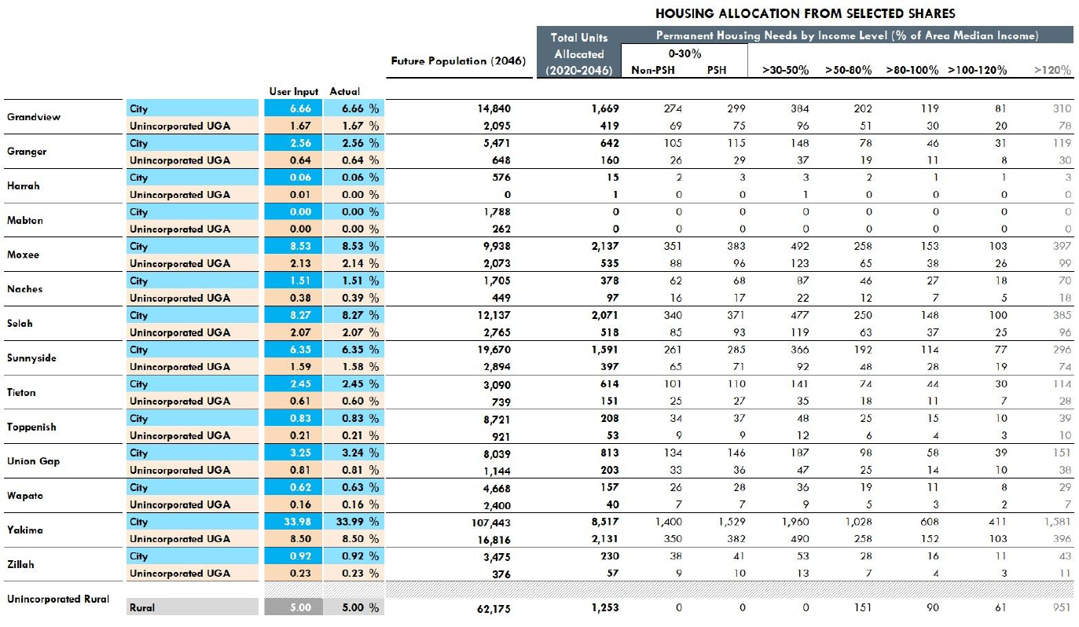
Source: WA State Department of Commerce, Growth Management Services Housing For All Planning Tool (HAPT). Calculations are based on the Yakima County 2046 Population Projections and Allocations.
Exhibit 3-53 shows the combined allocation for the City of Yakima and its UGA, including the allocation of countywide emergency housing needs.

Exhibit 3-53. City of Yakima and UGA Combined Allocation of Projected Housing Needs, 2020-2046
 | Total Units Allocated | Affordability Level (% of Area Median Income) |  |  |  |  |  |  | Emergency Housing/ Shelter Beds
 | Total Units Allocated | 0-30% |  | 30-50% | 50-80% | 80-100% | 100-120% | 120%+ | Emergency Housing/ Shelter Beds
Jurisdiction | Total Units Allocated | Non-PSH | PSH
City of Yakima + UGA | 10,648 | 1,750 | 1,911 | 2,450 | 1,286 | 760 | 514 | 1,977 | 617
Source: WA Department of Commerce, 2025; BERK, 2025.

Capacity for Projected Housing Needs
Under GMA, Yakima is required to plan for and accommodate future housing production to meet these housing need allocations at each income level. This includes demonstrating sufficient buildable land capacity for housing types appropriate to meeting these needs.
Not all housing types are appropriate for meeting all housing needs. Due to differences in land and construction costs per unit, the affordability of new housing depends in part on housing type. For instance, a new single-family home on a large lot is the most expensive type of home to produce per unit. New homes often require an income of over 150% AMI to afford. Multifamily homes, such as apartment buildings, can be produced at a much lower cost per unit.
Exhibit 3-54 presents seven different housing types that could be built in Yakima, as well as the lowest level of income that can be served assuming the new housing is either market-rate or a subsidized affordable housing project. These housing types and affordability assumptions are consistent with Commerce guidance for updating housing elements and BERK’s assessment of local housing costs.
Exhibit 3-54. Housing Types and Potential Income Levels Served
Housing Type | Definition | New Market Rate Housing | Subsidized Affordable Housing | Assumed Affordability Level for Capacity Analysis
Low-Rise Multifamily | Walk up apartment buildings or condominiums (up to 3 floors). | >80-120% AMI | 0-80% AMI | Low-Income  (0-80% AMI)
Mid-Rise Multifamily | Apartments or condominium buildings with 4-8 floors. | >80-120% AMI | 0-80% AMI | Low-Income  (0-80% AMI)
Moderate Density | Also known as “middle housing”. Inclues townhomes, duplexes, triplexes, quadplexes. | >80-120% AMI  & >120% AMI | Not typically feasible at scale | Moderate-Income  (>80-120% AMI)
ADUs | Accessory Dwelling Units | >50-80% AMI | Not typically feasible at scale | >50-80% AMI
Manufactured Homes | Homes that are constructed in a factory and then assembled at the building site in modular sections | >80-120% AMI as primary unit on lot | Not typically feasible at scale | Moderate-Income  (>80-120% AMI)
Low Density | Detached single family homes. | >120% AMI | Not typically feasible at scale | Higher Income  (>120% AMI)
Sources: Washington Department of Commerce Guidance for Updating Your Housing Element, 2023; Benton County, 2025; BERK, 2025.
BERK conducted a buildable land capacity analysis to quantify the number of new housing units that can be produced in the City of Yakima by housing type. See Section 2.3.1. Land Capacity Analysis for a technical description of the analysis. The results are summarized in Exhibit 3-55. It shows the City alone has capacity for over 21,000 net new housing units. Moreover, it shows there is sufficient capacity by assumed income level served to accommodate Yakima’s projected housing needs by income level. However, there is limited surplus capacity for low-rise multifamily development compared to the need for 0-50% AMI housing. If much of this capacity is consumed by market rate housing development that doesn’t serve these households, there could be limited remaining capacity to meet those 0-50% AMI housing needs.
Exhibit 3-55. Capacity for Housing Compared to Projected Housing Need, City of Yakima
Housing Type | Assumed Income Level Served | Net Housing Unit Capacity | Projected Housing Need | Capacity Surplus or Deficit
Low Density (Detached Single Family) | High (>120% AMI) | 6,537 | 1,977 | 4,560
Moderate Density | Moderate (>80-120% AMI) | 6,494 | 1,274 | 5,220
ADUs | >50-80% AMI | 1,832 | 1,286 | 546
Low-Rise Multifamily | Low (0-50% AMI)* | 6,863 | 6,111 | 752
 |  | 21,728 | 10,648 | 11,080
* Low-rise multifamily buildings, such as apartments, could also accommodate housing needs from 50-120% AMI in this analysis if there is a surplus.
Source: BERK, 2025.
Yakima’s allocation of countywide housing needs is intended for both the City of Yakima and its unincorporated UGA combined. Therefore, BERK also evaluated land capacity within the unincorporated UGA adjoining the City of Yakima. Exhibit 3-56 presents the combined capacity of both the City of Yakima and UGA, with comparison to projected housing need. The total capacity (44,066 housing units) is over double the capacity within city limits. Most of this additional capacity is for low density, detached single family housing production. However, the UGA also includes additional capacity for low-rise multifamily housing which helps to address the limited surplus of capacity available in the city alone.
Exhibit 3-56. Capacity for Housing Compared to Projected Housing Need, City of Yakima and Unincorporated UGA Combined
Housing Type | Assumed Income Level Served | Net Housing Unit Capacity | Projected Housing Need | Capacity Surplus or Deficit
Low Density (Detached Single Family) | High (>120% AMI) | 25,819 | 1,977 | 23,842
Moderate Density | Moderate (>80-120% AMI) | 9,820 | 1,274 | 8,546
ADUs | >50-80% AMI | 2,043 | 1,286 | 757
Low-Rise Multifamily | Low (0-50% AMI)* | 8,133 | 6,111 | 2,022
 |  | 44,066 | 10,648 | 35,167
* Low-rise multifamily buildings, such as apartments, could also accommodate housing needs from 50-120% AMI in this analysis if there is a surplus.
Source: BERK, 2025.

Adequate Provisions
GMA requires that communities ensure that their Comprehensive Plan policies and regulations are designed to achieve housing availability for all community members at all income levels.
Specifically, under RCW 36.70A.070(2)(d), City of Yakima must prepare a Housing Element that “[m]akes adequate provisions for existing and projected needs of all economic segments of the community.” These provisions include “[d]ocumenting programs and actions needed to achieve housing availability including gaps in local funding, barriers such as development regulations, and other limitations. They also include “consideration of housing locations in relation to employment location” as well as “role of accessory dwelling units in meeting housing needs.”

Gaps in Local Funding
Creating or preserving housing affordable to households with incomes of 0-50% AMI requires public subsidies. However, there is a lack of public funding needed to address all current and future needs in Yakima. In order to meet the City’s allocation of housing needs, Yakima needs to add a total of 13,655 housing units affordable households with incomes from 0-50% AMI between 2020 and 2045. Based on data from the Washington State Housing Finance Commission, the average cost of constructing a new affordable housing unit in Yakima County in 2025 was $314,296 (Washington State Housing Finance Commission, 2025). This means affordable housing providers would need nearly $4.3 Billion dollars in public subsidies during this period to build the housing needed. This does not include operational costs, which can be significant for permanent supportive housing. This also does not include emergency housing needs.
Much of the funding for affordable housing comes from federal and state sources. However, local governments in Washington have some local option tools for supporting affordable housing production. These include revenue sources as well as incentives to reduce costs for affordable housing developers. Yakima currently uses the following tools:
- Housing and related services sales tax (RCW 82.14.530). This tax has accumulated about $1 Million in revenue since its inception. As of December 2025, the City was preparing an application for funding to partially support a new affordable housing project with 10 or more units.
- Multifamily Tax Exemption (MFTE) (RCW 84.14). The Downtown Redevelopment Tax Incentive Program provides an incentive for all multifamily housing development in a designated area of the city. While this program has no affordability requirements, it does lower the cost of building new affordable housing projects, which tend to be apartment buildings.
To address the gaps in local funding, the city is considering the following additional tools. However, these tools alone will not be enough to close the gap.
- Expanding the MFTE program to all areas of Yakima that allow for multifamily development.
- Waiving or reducing permit and utility connection fees for affordable housing projects.

Barriers to Housing Production
While the City of Yakima has seen an increase in multifamily housing production in recent years (see Exhibit 3-34), there are nonetheless important barriers to the production of new multifamily housing sufficient to meet all low-income housing needs by the year 2046. To help identify barriers, the City reviewed its development regulations, permit process, and environmental constraints with the assistance of checklists provided by the Washington State Department of Commerce.

Development Regulations
The City reviewed its development regulations for barriers to housing production using checklists provided by the Washington State Department of Commerce. Through that process, it identified several changes to its development regulations to simplify its standards and increase flexibility for housing development. These changes are summarized by zone in Exhibit 3-57.
Among these changes are off-street parking requirements. Yakima’s development code requires builders of housing to provide a minimum number of parking spaces per residential unit. These requirements, if set too high, can both increase the cost and limit the density of new housing construction. In 2025 the Washington State Legislature passed SB 5184, which limits the number of minimum parking spaces a city can require. Yakima will need to update its development regulations to comply with this new law by January 2027.
Exhibit 3-58 compares the current parking requirements in Yakima to those in SB 5184. It shows the city will need to significantly reduce its requirements compared to current standards. These changes have potential to reduce the cost of new housing development and increase the achievable density due to the reduced land area required for parking. This reduces barriers to new housing construction by improving the developer’s financial return on investment.

Process Obstacles
The City also reviewed its permitting process and fees for barriers to housing production using checklists provided by the Washington State Department of Commerce. This review identified the following actions for implementation:
- Allow for full online permit application submittal. This will create efficiencies and address a bottleneck in capacity to process building application due to short-staffed planning and building department.
- Establish SEPA threshold exemptions consistent with WAC 197-11-800 (1)(c) to encourage development (up to 30-100 single family units in the city and up to 200 multifamily).

Exhibit 3-57: Planned Changes to Lot Development Standards by Zone
 | SR | R-1 | R-2 | R-3 | HB | B-1 | B-2 | SCC | LCC | GC | CBD | RD | Code Sections
Lot size (minimum)  SF detached | 6,000 sq-ft | 6,000 sq-ft | 5,000 sq-ft | 4,000 sq-ft | No change of existing use | (Do not allow single family residential) |  |  |  |  |  |  | Table 5-2 (YMC 15.05.030)
SF attached/ zero lot line/ townhomes/ common wall | 4,000 sq-ft | 4,000 sq-ft | 3,500 sq-ft | 3,000 sq-ft | No change of existing use |  |  |  |  |  |  |  | Table 5-2 (YMC 15.05.030)
Two-Family Dwelling/ duplex | 6,000 sq-ft | 6,000 sq-ft | 5,000 sq-ft | 4,000 sq-ft | No change of existing use |  |  |  |  |  |  |  | Table 5-2 (YMC 15.05.030)
Multifamily Dwelling/ PD Residential | Density May Not Exceed Maximum Number of Dwelling Units Permitted per Net Residential Acre.
Density (minimum) | 4 DU/NRA | 4 DU/NRA | 8 DU/NRA | 13 DU/NRA |  | 13 DU/NRA | 13 DU/NRA | 13 DU/NRA | 13 DU/NRA | 13 DU/NRA | 13 DU/NRA | 13 DU/NRA | YMC 15.03.020; Table 4-1 (YMC 15.04.030)
Density (Maximum) | 7 DU/NRA | 7 DU/NRA (no change) | 12 DU/NRA | No Max |  |  |  |  |  |  |  |  | YMC 15.03.020; Table 4-1 (YMC 15.04.030)
Lot Coverage | 60% | 60% | 70% | 80% |  |  |  | 85% | 90% | 100% |  |  | Table 5-1 (YMC 15.05.030)
Building Height | 35 ft | 35 ft | 35 ft | 50 ft | 35 ft | 35 ft | 35 ft | 50 ft | 50 ft | 50 ft | NA | 50 ft
Setback (front) | 15 ft | 15 ft | 15 ft | 15 ft
Setback (rear) | 15 ft | 15 ft | 10 ft | 10 ft | 20 ft | 20 ft | 20 ft | 20 ft | 20 ft | 20 ft | 20 ft | 20 ft
Parking | Apply SB 5184. 1 parking spot per detached single family home; 0.5 parking spots per multifamily housing unit. No minimum parking requirement for ADUs. |  |  |  |  |  |  |  |  |  |  |  | Table 6-1 (YMC 15.06.035)
Cottage Housing |  | 10,000 sq-ft |  |  |  | 10,000 sq-ft |  |  |  |  |  | 10,000 sq-ft | YMC 15.09.035 and Table 5-2, (YMC 15.05.030).

Exhibit 3-58. Minimum Required Parking Spaces Per Unit by Housing Type in City of Yakima, Current Zoning and New State Requirements
Housing Type | Current Zoning | New statewide requirement under SB 5184
ADU | 1 | 0 if under 1,200 sq ft
Sindle-detached home | 2 | 1
Duplex | 2 | 0.5
Multifamily building with fewer than 10 units | 2 (or 1.5 in CBD) | 0.5
Multifamily building with greater than 10 units | 1.5 (or 1 in CBD) | 0.5
Source: ESSB 5184; YMC 15.06.040, Off-street parking standards, Table 6-1. CBD = Central Business District.

Housing Locations in Relation to Employment Locations
Section 3.3.13. details employment trends and patterns in Yakima. There are over 50,000 jobs located in Yakima, and many of them are concentrated in the downtown area, as shown in Exhibit 3-22. Yakima’s Future Land Use Map, shown in Exhibit 2-18, allows for high- and medium-density residential development, as well as mixed use development, in close proximity to this job center. The land capacity analysis shows significant capacity for new housing in these areas through redevelopment and infill. By facilitating this kind of development, the City can increase the supply of housing and diversity of housing options close to job opportunities.

Consideration for the Role of ADUs
Accessory Dwelling Units (ADUs) have potential to increase the diversity of housing options within areas where detached single-family homes predominate to include smaller and lower cost units. ADUs can be attached or detached from a primary residence on a shared lot. Depending on the context, ADUs can be an affordable housing option for Low-Income (50-80% MFI), Moderate-Income (80-120% MFI) households, or higher-income households.
Consistent with new GMA requirements, City of Yakima will be updating land use regulations to allow two ADUs per in all residential zones, as well as several other changes that can reduce barriers to ADU production. These changes have the potential to increase the production of ADUs and diversify the housing supply in Yakima.

Economic Development

Overview

Downtown Revitalizations

Transportation
The multimodal transportation system is integral to many facets of the City of Yakima, including land use, economic development, tourism, and recreation. This Technical Appendix is the background and companion document to the Transportation Element of the City’s Comprehensive Plan. The Transportation Element establishes the City’s goals and policies for developing the multimodal transportation system within the City. The Transportation Element and Technical Analysis provide a long-range vision for the City’s multimodal transportation system to guide City decision makers, staff, advisory bodies, and citizens on transportation priorities and projects over the next twenty-five years.
Volume II Technical Analysis coordinates and plans for the development of a balanced, multimodal transportation system by recognizing the regional nature of the transportation system and the need for continuing interagency coordination. Volume II Technical Analysis is organized into four chapters:

- Existing Transportation System
- Travel Forecasts and Alternatives Evaluation
- Transportation Systems Plan
- Financing Program

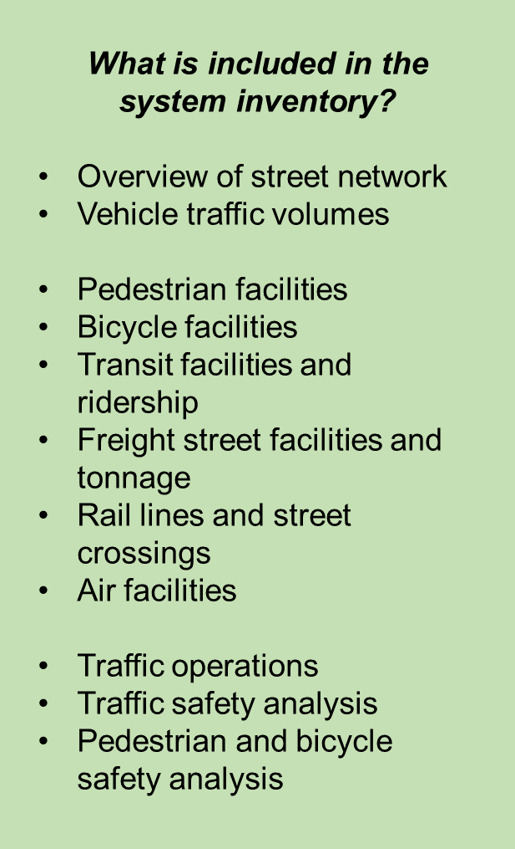
Existing Transportation System
This chapter summarizes key components of the existing transportation system serving the City of Yakima that represent the transportation system in its current condition. An inventory of transportation facilities is presented through maps, figures, and descriptions that provide a foundation for identifying and prioritizing the City’s transportation improvement projects and programs, presented later in the 2045 Transportation Plan.
The transportation system within the City of Yakima consists of streets and highways, pedestrian and bicycle facilities, and transit service. Freight and goods, which are vital to the City’s economic development, are primarily carried by trucks and rail lines. Following a description of the street system, subsequent sections describe the existing multimodal transportation system within the current City Limits and Urban Growth Area (UGA).

Transportation System Networks
The transportation system inventory identifies key transportation issues to be addressed in this plan update. The networks that comprise the transportation system include the arterial and collector street system, pedestrian and bicycle facilities, transit service, freight routes, rail lines, and air facilities. Most travel within the City of Yakima occurs on the streets and highways that also provide public space for other modes.
Street Network and Traffic Controls
The street system provides mobility and access for a range of travel modes and users. Streets in the central business district and older sections of the City are laid out in a dense grid, while the newer neighborhoods in the western sections of the City have greater spacing between major roadways. The City limits, existing streets, and traffic signal locations are shown in Exhibit 5-1. Exhibit 5-2 summarizes the number of lanes of major north-south and east-west roadways within the City.
Yakima City is at the crossroads of two major Washington State transportation corridors. Interstate 82 (I-82) provides access to Oregon and the Tri-Cities area to the south, and the I-90 corridor to the north. US 12 provides an alternate pathway to Western Washington with connections to the I-5 corridor and the Puget Sound area (via SR 410).
Interchanges (I-82 and US 12)
The interchanges with I-82 and US 12 act as major gateways in and out of the City of Yakima. Along I-82, the City of Yakima has three interchanges: 1st Street, Yakima Avenue, and Nob Hill Boulevard. In addition, the Valley Mall Boulevard interchange in Union Gap provides a major I-82 access to southern areas of the City of Yakima. Along US 12, there are three interchanges: 40th Avenue/Fruitvale Boulevard, 16th Avenue, and 1st Street. Given the direct connections to these regional routes, these City streets are considered Principal Arterials.
Major East-West Corridors
The Summitview Avenue/Yakima Avenue corridor is a major east-west corridor connecting I-82, Yakima downtown, western areas of the City, and west valley areas in the county. This corridor crosses the railroad at-grade in the downtown area on Yakima Avenue. While travelling west at 16th Avenue, Yakima Avenue transitions to a local access street that dead ends at S 36th Avenue. For continued westerly travel, drivers must travel north along 16th to Summitivew, or access Summitview directly at 7th Avenue. This corridor is generally 4 to 5 lanes within the city.
The Nob Hill Boulevard corridor is another major east-west corridor within the city. It provides a more direct connection to I-82 for western areas of the city. East of I-82 Nob Hill Boulevard connects to SR 24. It is generally 4 to 5 lanes within the city, and has a grade-separated crossing of the railroads.
The Washington Avenue/Valley Mall Boulevard corridor is a major east-west corridor in the southern areas of the city. It provides access to the regional airport and connections to I-82 for southern areas of the city. The corridor is generally 4 to 5 lanes within the city, and has a grade-separated crossing for the railroad on Valley Mall Boulevard.
Fruitvale Boulevard provides access to US 12 and industrial areas in the northern areas of the City. Lincoln Avenue and Martin Luther King Jr Boulevard provide a higher speed parallel route to Yakima Avenue with grade-separated rail crossings. Other east-west corridors include Tieton Drive, Walnut Street, Mead Avenue, and ‘I’ Street.
Major North-South Corridors
The 1st Street corridor provides a major north-south connection between US 12 and I-82 to the north, the Yakima downtown area, and Union Gap to the south. It is the only continuous route throughout the City east of the railroad. It is generally 4 to 5 lanes within the City.
The 16th Avenue corridor provides north-south mobility in the central areas of the City. It connects US 12 to the north and the regional airport to the south, as well as connections to most major east-west City corridors. It is generally 4 lanes wide.
The 40th Avenue corridor provides north-south mobility in the western areas of the City. It connects US 12 to the north and connections to most major east-west City corridors. It is general 4 lanes wide.
Other Principal Arterial connections providing north-south mobility include 72nd Avenue, 5th Avenue, 8th Street, and Fair Avenue. Minor Arterial north-south corridors include 96th Avenue, 80th Avenue, 64th Avenue, 3rd Avenue, Fair Avenue, 18th Street, and Rudkin Road.

Exhibit 5-1. Existing Roadway Network and Signals
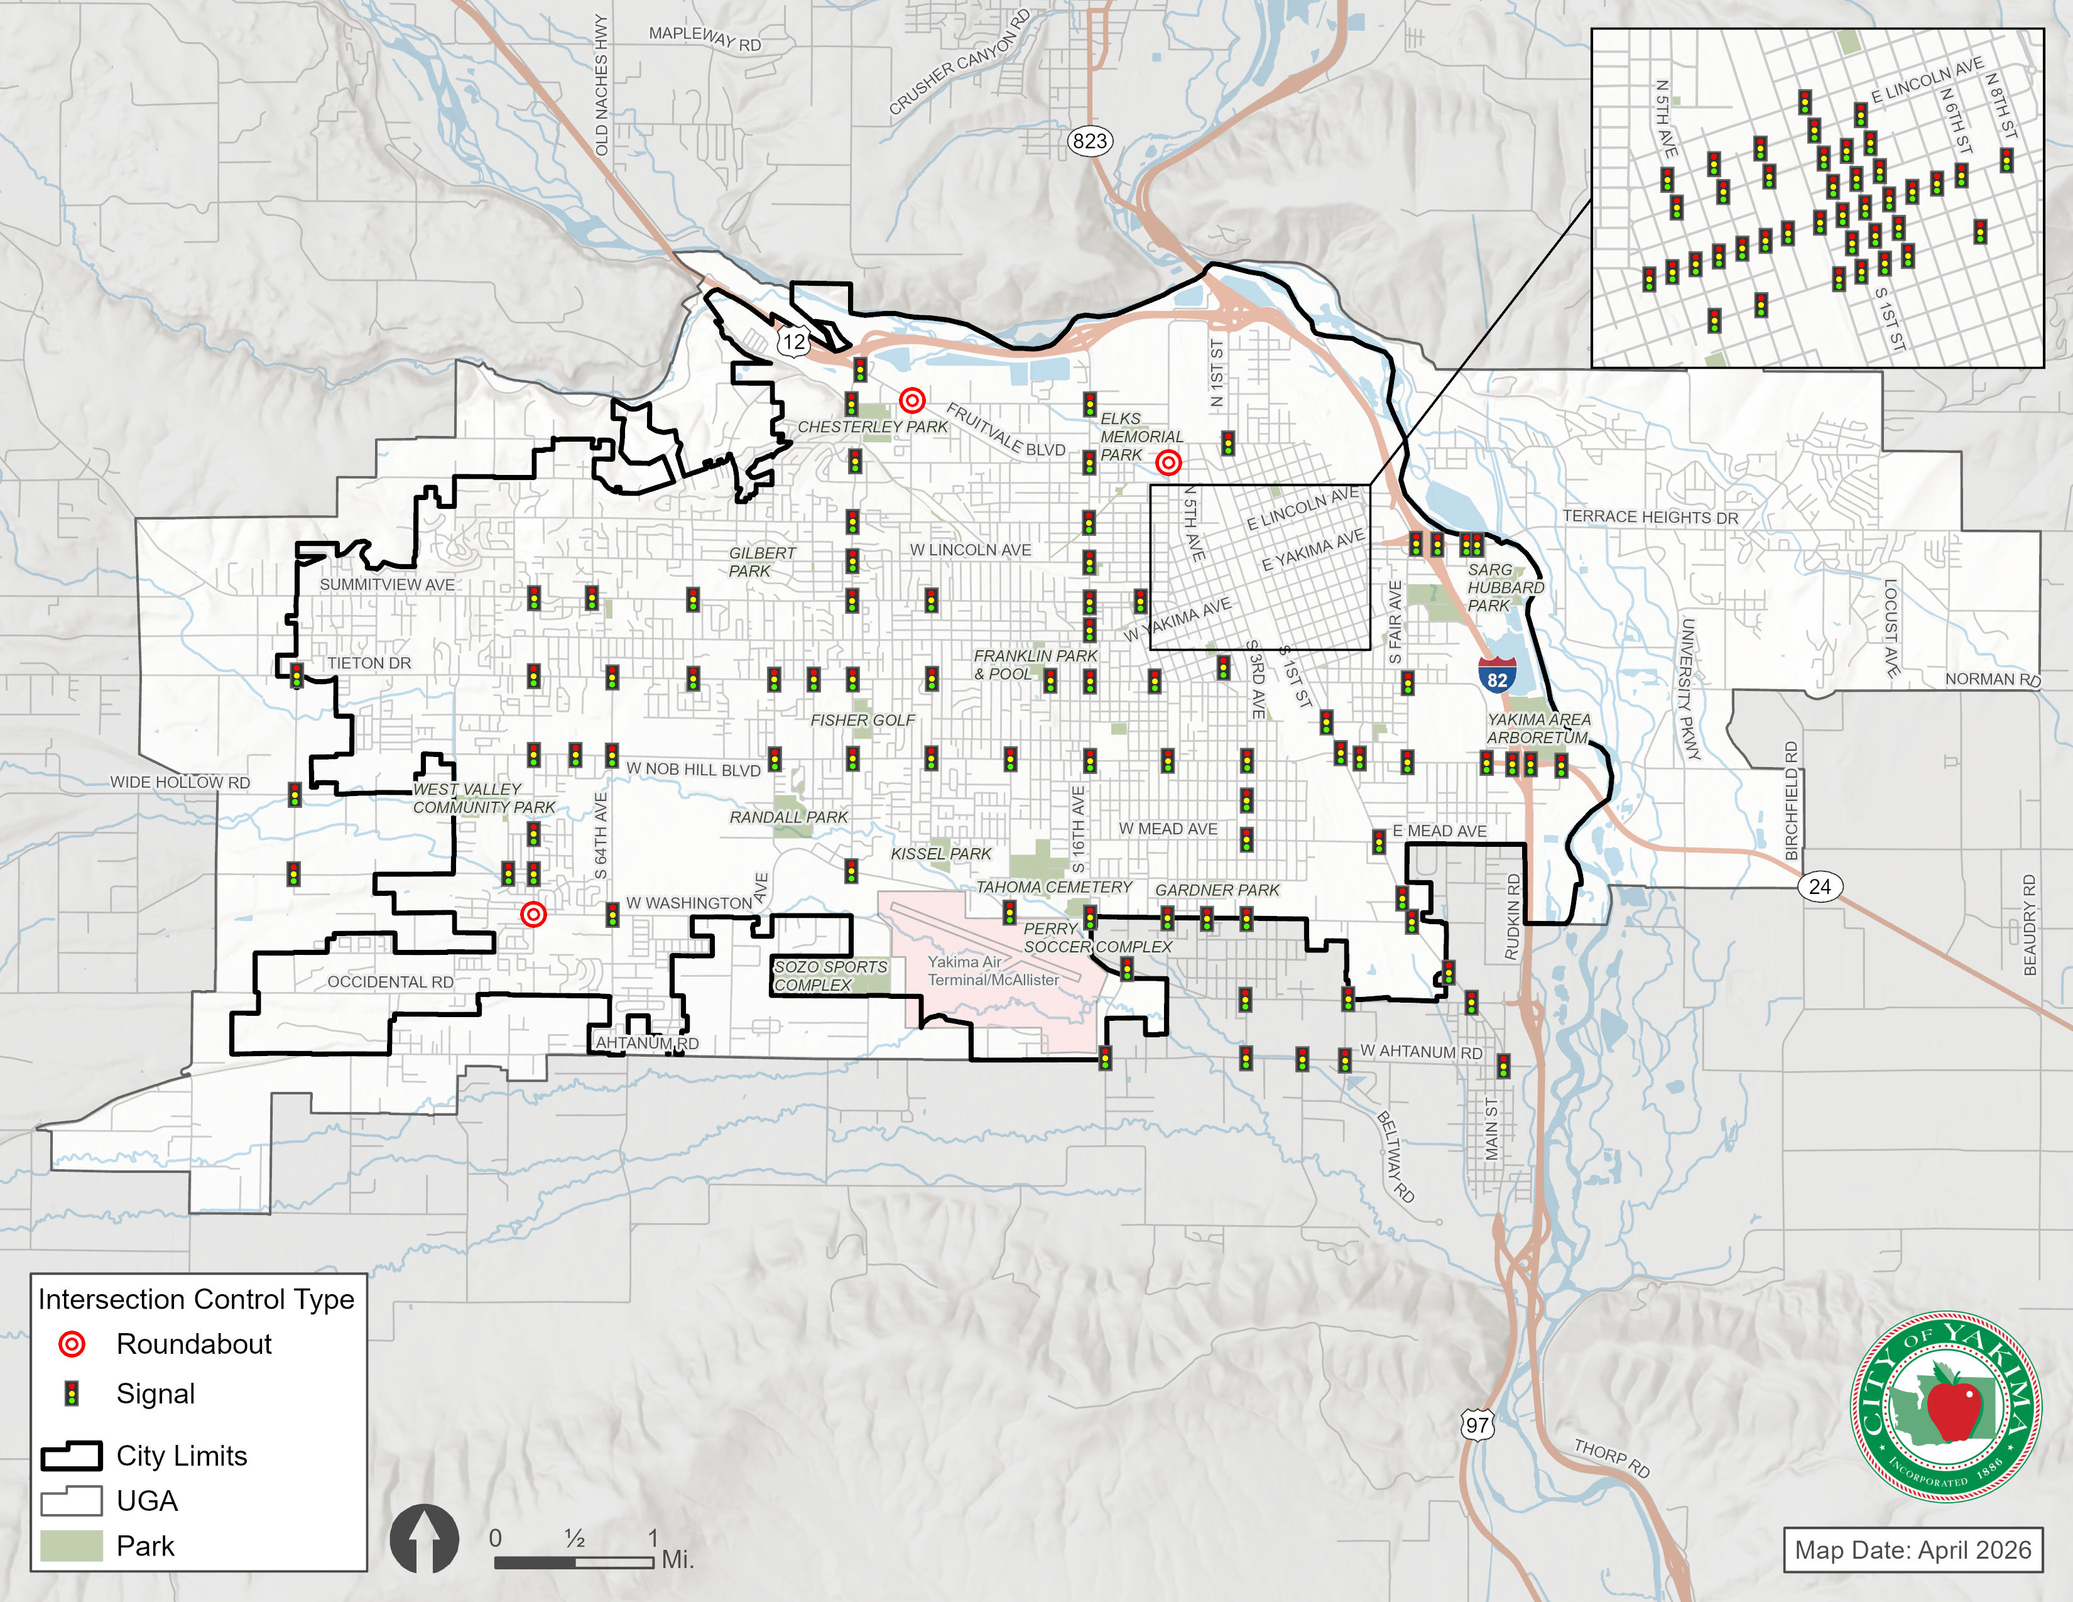
Traffic Volumes
Traffic counts were collected at several locations on City roadways in 2025. These recent tube counts were used to update historical average daily traffic (ADT) volumes on City roadways to represent existing traffic conditions. Existing (2025) average daily traffic volumes for major roadways are shown in Exhibit 5-2. Significant volumes over 10,000 ADT occur on Yakima’s major streets, including east-west connectors such as Fruitvale Blvd, Summitview Ave/Lincoln Ave, Tieton Dr and Nob Hill Blvd, and on north-south routes like 40th Ave, 16th Ave, 3rd Ave and 1st St.

Exhibit 5-2. Existing (2025) Average Daily Traffic Volumes
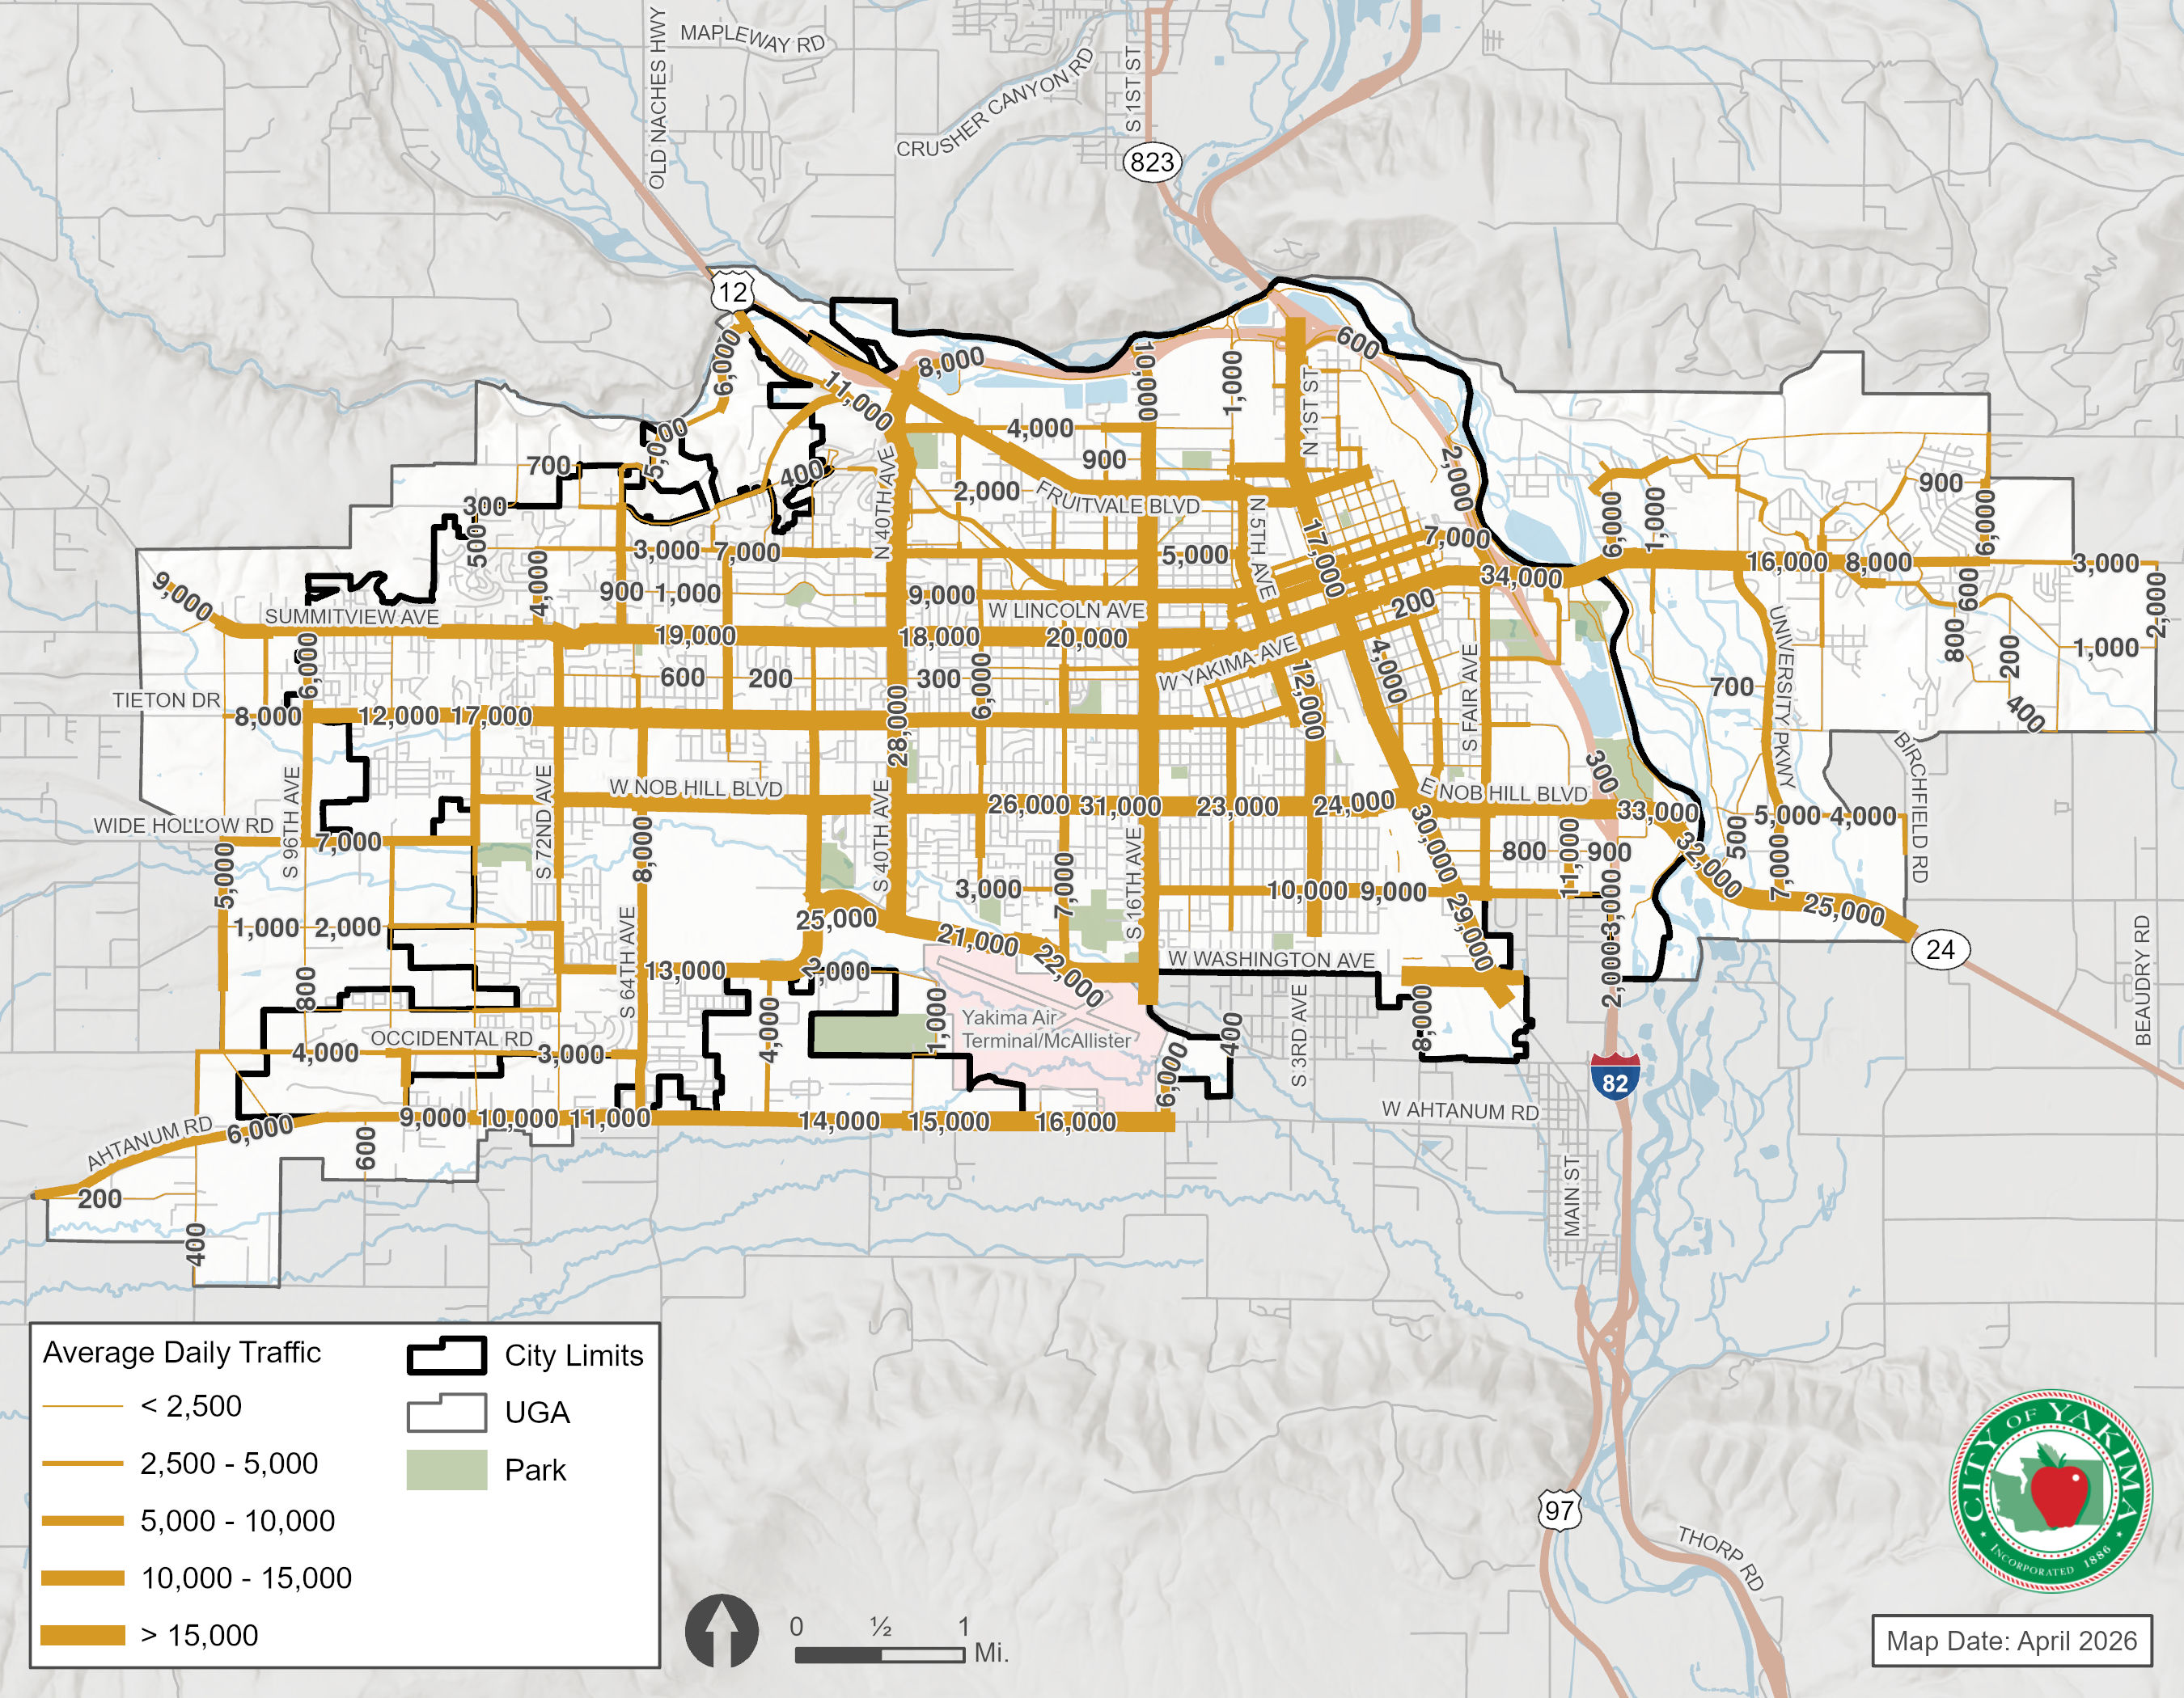
Pedestrian Facilities
Every trip begins and ends with a walk. People walk to their cars and drive to a location where they will walk into a building or facility, or they need to walk to a transit station. A well-established pedestrian system encourages healthy reactional activities, reduces travel demand on roadways, and enhances safety within a livable community. Non-motorized facilities provide critical access to and from transit stops, which can increase the use of active transportation. Along with shared-use trails, sidewalks are the primary facility type for pedestrians. Sidewalks are generally provided adjacent to the street on one or both sides. Where sidewalks are not available, pedestrians must use the roadway shoulders. The Draft Yakima Washington Pedestrian Master Plan (City of Yakima, 2021) provides recommendations to address Yakima’s current and future pedestrian needs. The Plan defines the network and outlines priority routes for pedestrian improvements in the City based on the priority routes identified in the 2050 Transportation Element. Existing pedestrian facilities in the City of Yakima are illustrated in Exhibit 5-3.
Sidewalks
The most complete system of sidewalks is located within the central business district and downtown area. Sidewalks are generally provided on both sides of the street in these areas, but may not have standard curb ramps or other ADA facilities. Many of the older residential neighborhoods east of 16th Avenue also have sidewalks, along with the east-west arterial and collector roadways extending to the western sections of the city.
Shared-Use Trails
Yakima has several important shared-use trails that provide critical connections and enhance pedestrian travel. These off-street facilities include pathways and unpaved trails that are used by all types of non-motorized users. The Powerhouse Canal Pathway, Yakima Greenway, Walter Ortman Parkway, William O. Douglas Heritage Trail and several unnamed neighborhood connector paths support pedestrian travel in Yakima.
The Powerhouse Trail, Walter Ortman Parkway, and the Yakima Valley Greenway Trail are recreational and commuting trails. The Yakima Valley Greenway Trail is approximately 18 miles long and provides access to several parks, fishing lakes, playgrounds, and natural areas along the north and east sides of the city. The Powerhouse Trail is an in-city trail that connects to schools, city parks, and residential areas. The Walter Ortman Parkway, along Willow Street from 10th to 6th Ave, connects to the Powerhouse Canal Pathway through McGuinness Park.
Shared-use trails may be primarily used for recreational purposes, but also serve commuter and utility travel between neighborhoods and to surrounding areas. Standard trails are separated from the roadways and vary in width from approximately 5 feet to 12 feet wide. ADA access is provided on many trails, but some may not include these features. Shared-use trails are also important linkages for bicycle travel.
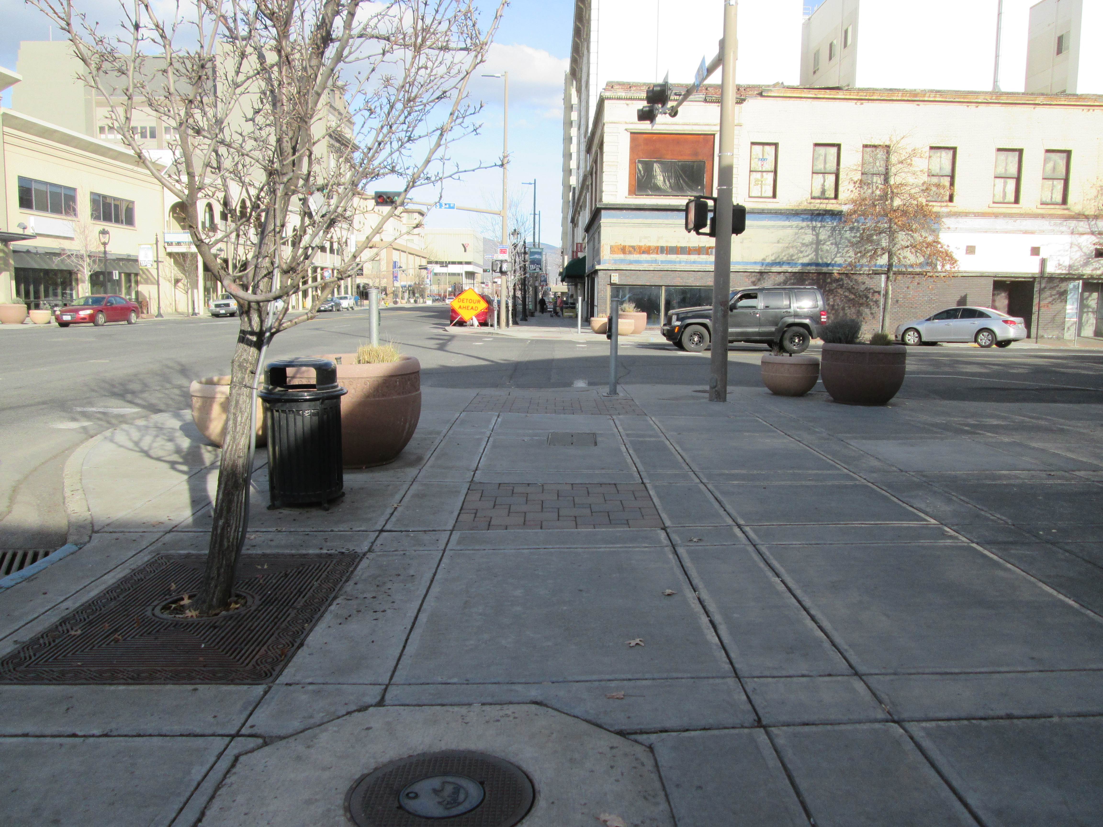
Exhibit 5-3. Existing Pedestrian Facilities
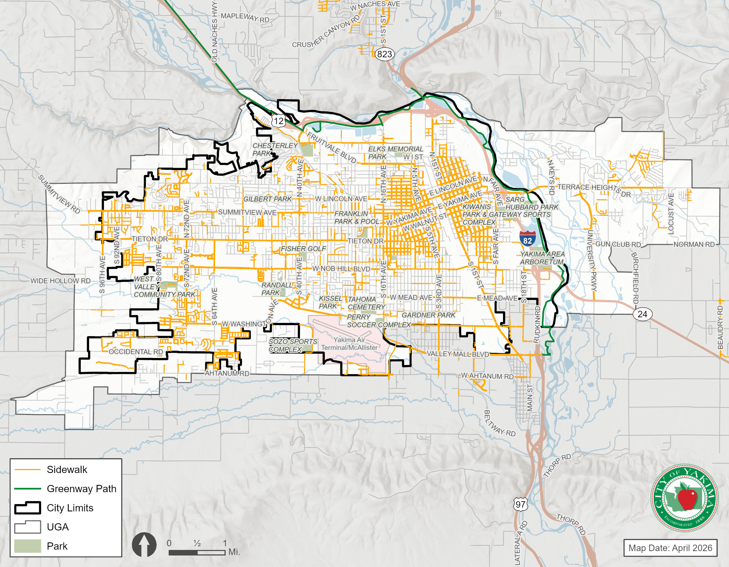

Bicycle Facilities
Bicycling is an important and growing mode of travel for people in cities across the country. When appropriately planned, bicycle routes have a role in reducing congestion, improving air quality, providing travel choices, encouraging exercise and recreation, and providing greater mobility for those without access to a vehicle. Existing bicycle facilities and descriptions are coordinated and consistent with the Bicycle Master Plan (City of Yakima, 2017).
There are a range of bicycle treatments available for cities to provide comfortable space for cyclists of all ages and abilities. The City of Yakima has three types of bicycle treatments: shared lanes, bicycle lanes, and shared-use trails. Existing bicycle facilities are shown in Exhibit 5-4 and described in the sections that follow.
Shared Lanes
While not formal bicycle facilities, roadways with shared lane markings, or sharrows, can provide connectivity for experienced cyclists. Shared lane markings are a tool that can assist cyclists and motorists by providing wayfinding and bicycle route definition, indicating appropriate bicycle positioning on a roadway, and increasing safety and visibility. The Yakima Bicycle Masterplan recommends conversion of many of the City’s existing signed bike routes and roadways with shared lane markings to dedicated bicycle facilities.
Bicycle Lanes
Bicycle lanes are striped roadway space dedicated for cyclists and are typically provided on the edge of the traveled way. Bicycle lanes may be included on both sides of the roadway or on one side of a sloped roadway where there is not sufficient space for bicycle lanes in both directions. They are typically 4 to 6 feet in width (not including vehicle buffers) and are marked with a wide white stripe or buffer area.
Yakima has approximately 5 miles of bike lanes currently installed. Bicycle lanes are present in the central business district on W Lincoln Avenue, W MLK Jr. Boulevard, S 3rd Street, and S 6th Street. There are also a few segments of bike lanes on the east end of town on Tieton Drive, W Nob Hill Boulevard, and W Washington Avenue.
Shared-Use Trails
The shared-use trails that are part of the pedestrian network are important for bicycle travel. Paved trails are preferred by many cyclists who also travel on streets, but finely crushed gravel surfaces may be suitable alternatives.
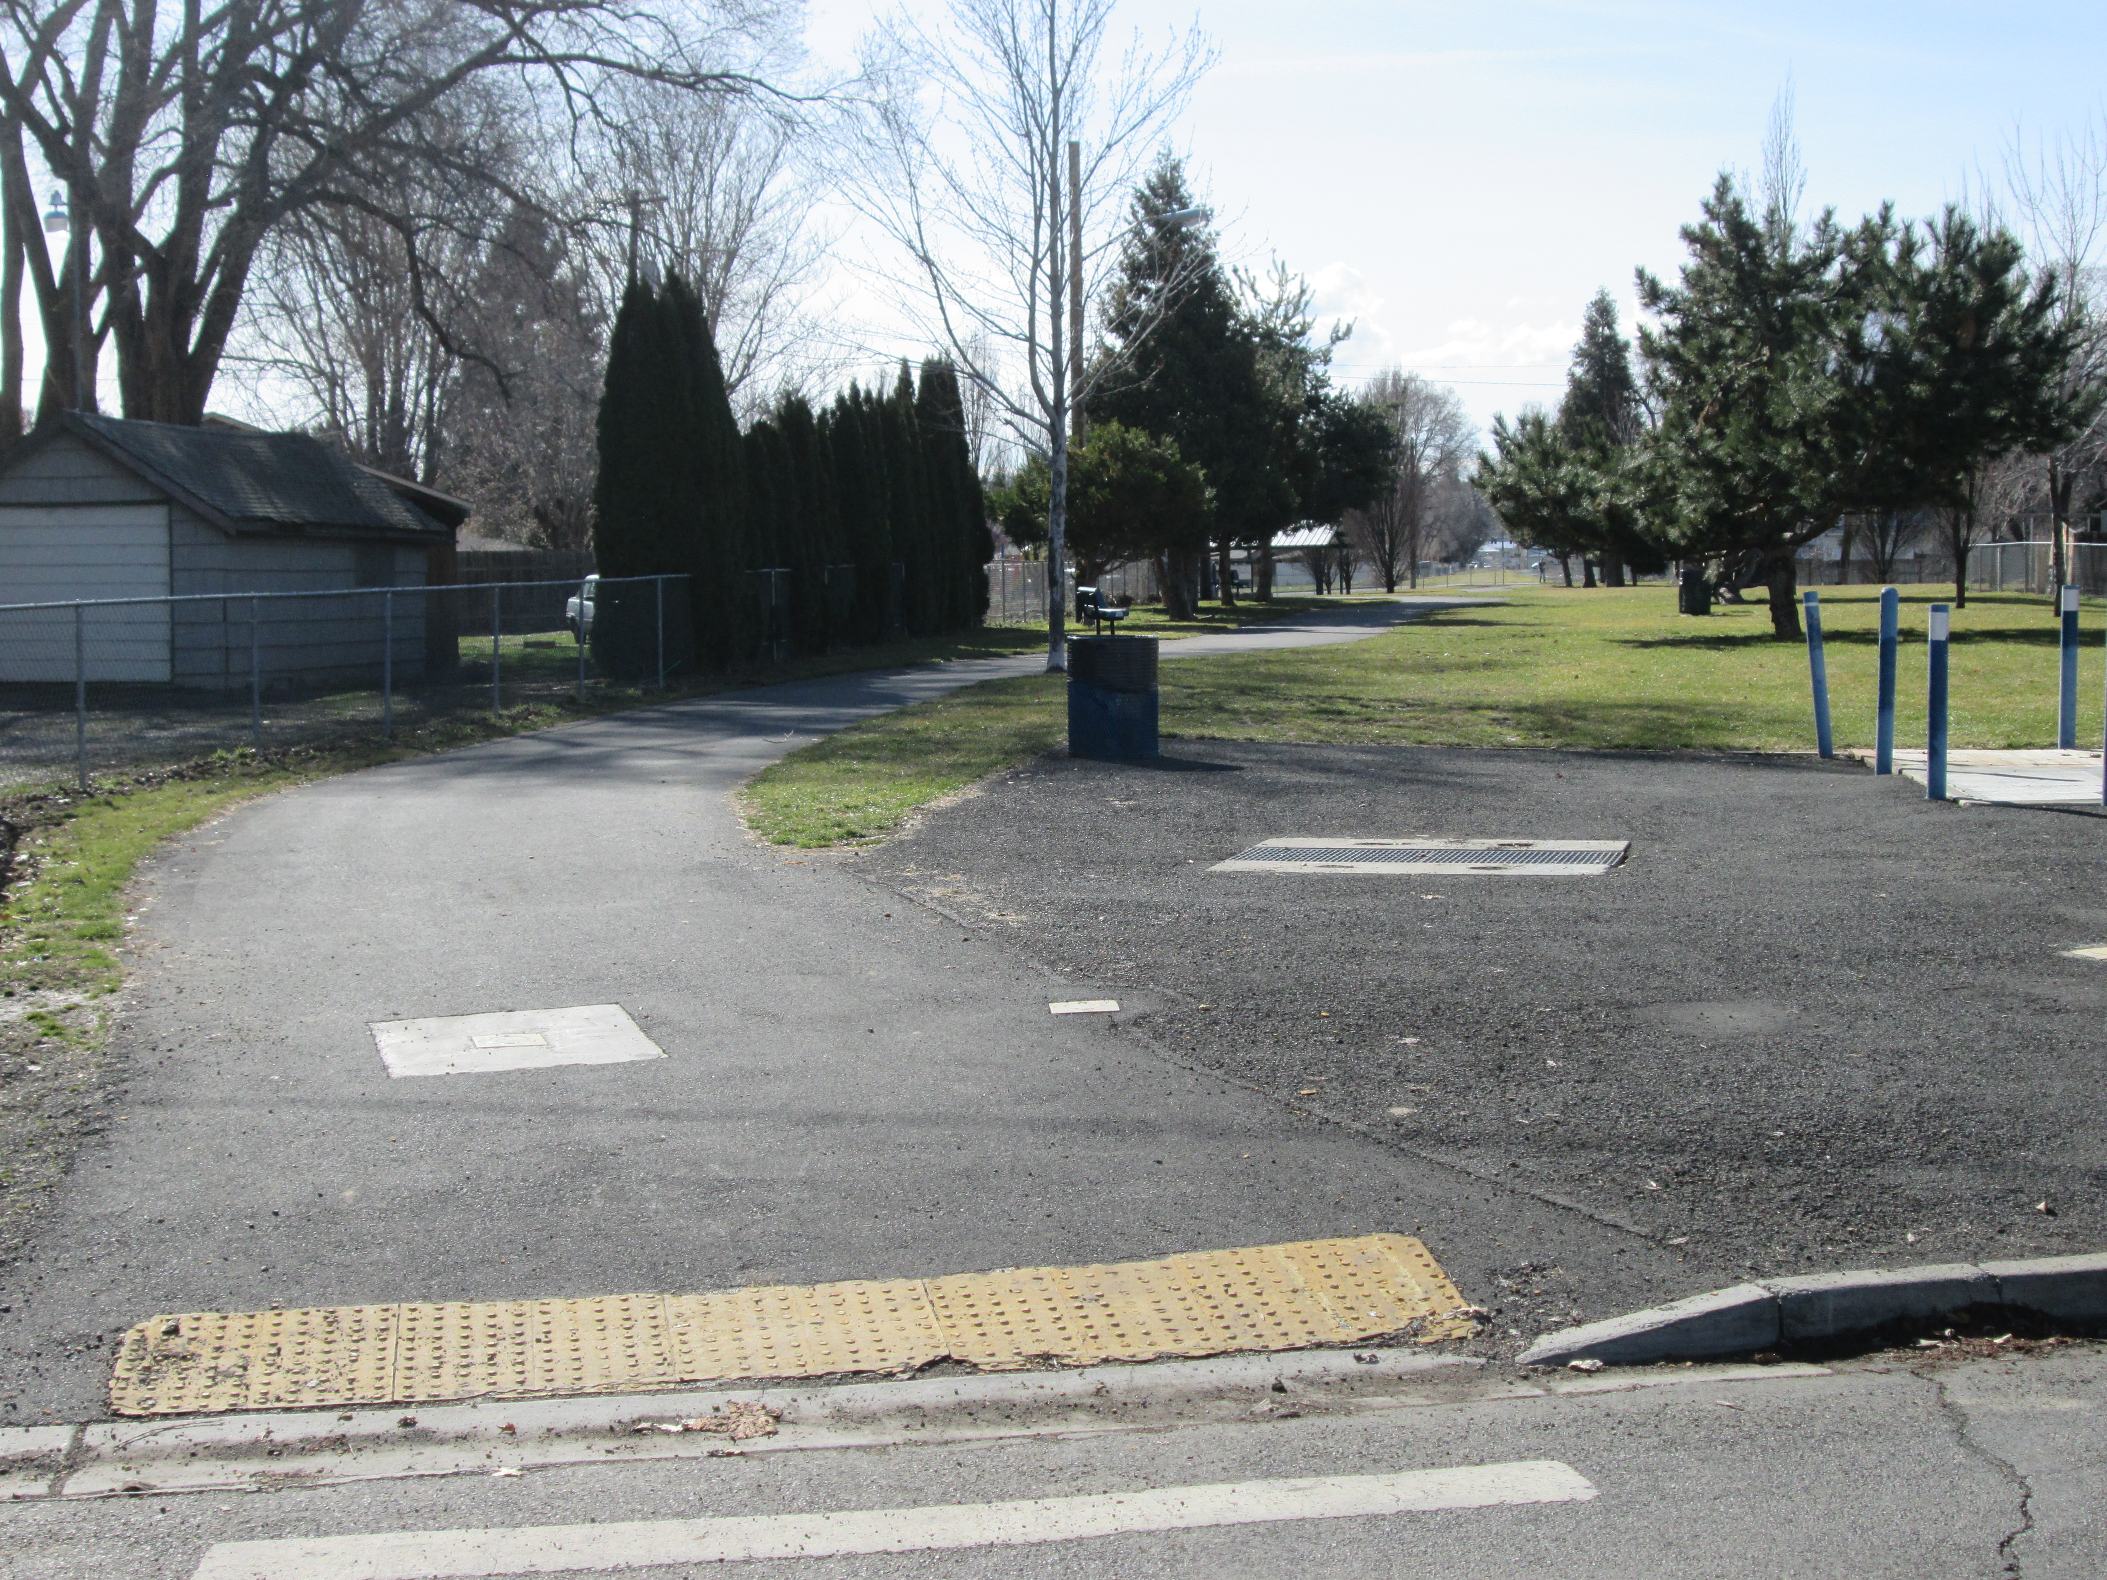

Exhibit 5-4. Existing Bicycle Facilities
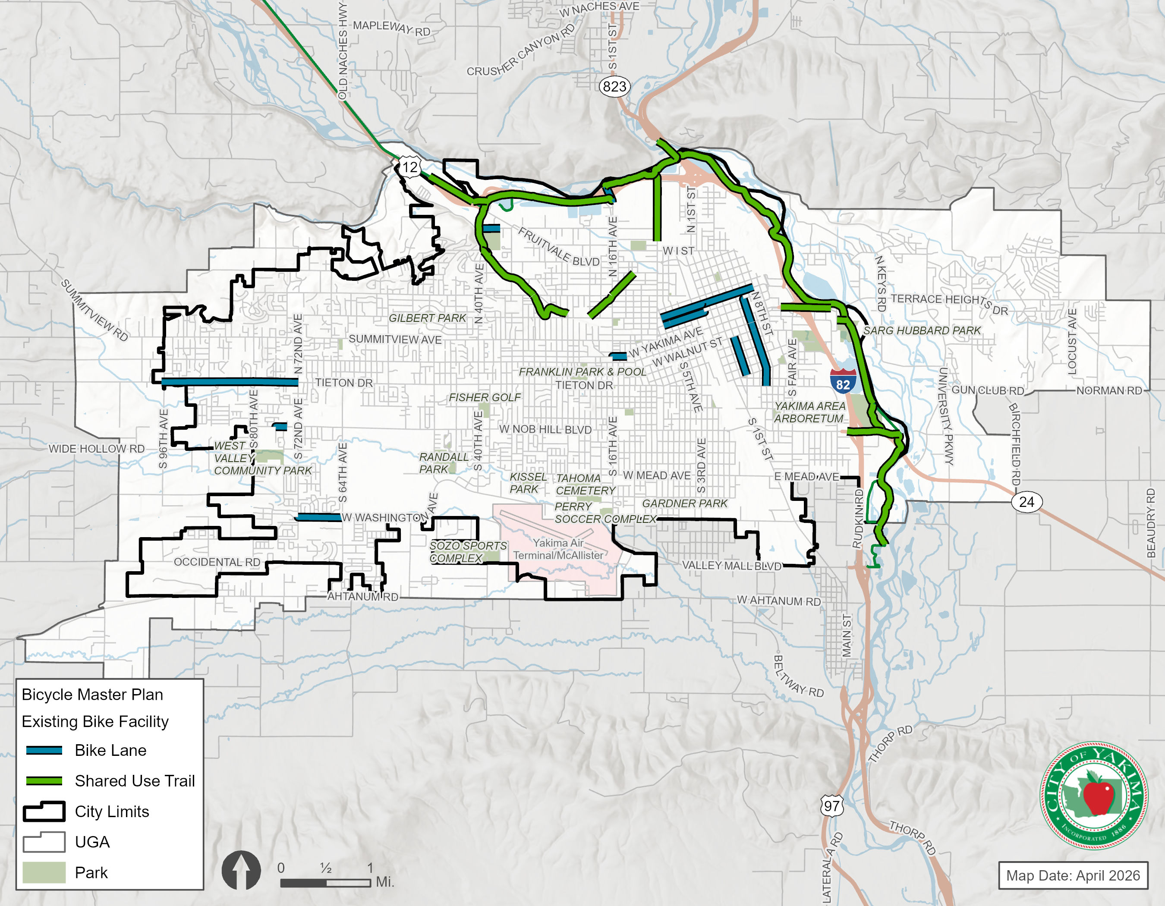

Transit Facilities and Ridership
Yakima Transit serves the city of Yakima with fixed route and paratransit services. In addition to these core services, Yakima Transit also provides the Yakima-Ellensburg Commuter service during morning and evening commute periods. Yakima Transit provides connections to rail, air, and other fixed-route services. Information in this section is coordinated and consistent with the Transit Development Plan (Yakima Transit, 2023).
Fixed Route Service
As of 2026, Yakima Transit operated Fixed-route bus service along ten different routes that operate between the hours of 6:00am and 7:00pm within the City of Yakima. Weekday routes are operated with one-hour and half-hour headways on most routes, while Saturday and Sunday routes are operated on an hourly basis. Exhibit 5-5 summarizes fixed route service, including the commuter route service between Yakima and Ellensburg.
Yakima–Ellensburg Commuter Service
Yakima Transit hired Central Washington Airporter to operate the Yakima–Ellensburg Commuter service as a partnership with Central Washington University and WSDOT.
Exhibit 5-5. Existing (2026) Fixed Route Summary
Route | Description | Type of Service | Frequency
1 | Service along Summitview / Lincoln Avenue from 96th Avenue to Yakima Transit Center | Weekday,  Saturday,  Sunday | Every 60 mins
2 | Service via Tieton Drive and Nob Hill Boulevard to Yakima Transit Center | Weekday,  Saturday,  Sunday | Every 30 mins
3 | Service from Castlevale to Yakima Transit Center via 40th Avenue and River Road | Weekday, Saturday | Every 60 mins
4 | Service from Yakima Transit Center to Castlevale via 16th Avenue | Weekday,  Saturday,  Sunday | Every 60 mins
5 | Service from 72nd Avenue on Nob Hill Boulevard to Yakima Transit Center via Tieton Drive | Weekday, Saturday | Every 30 mins
6 | Service from Yakima Transit Center to N 4th Street via Fair Avenue (and back) | Weekday,  Saturday,  Sunday | Every 30 mins
7 | Service from BiMart and Chesterly Park P&R to Yakima Transit Center via 40th Avenue, Washington Avenue, and S 1st Street | Weekday,  Saturday | Every 30 mins
8 | Service from Yakima Transit Center to City Hall via Yakima Avenue and N 1st Street | Weekday,  Saturday,  Sunday | Every 30 mins
9 | Service from Yakima Transit Center to BiMart and Chesterly P&R via Fruitvale Boulevard | Weekday,  Saturday,  Sunday | Every 30 mins
11 | Yakima – Ellensburg Commuter from Yakima Airport to downtown Ellensburg | Commuter | Every 90 mins
Exhibit 5-6 identifies the roadways with transit service, which are identified as transit corridors.
Exhibit 5-6. Existing Transit Corridors
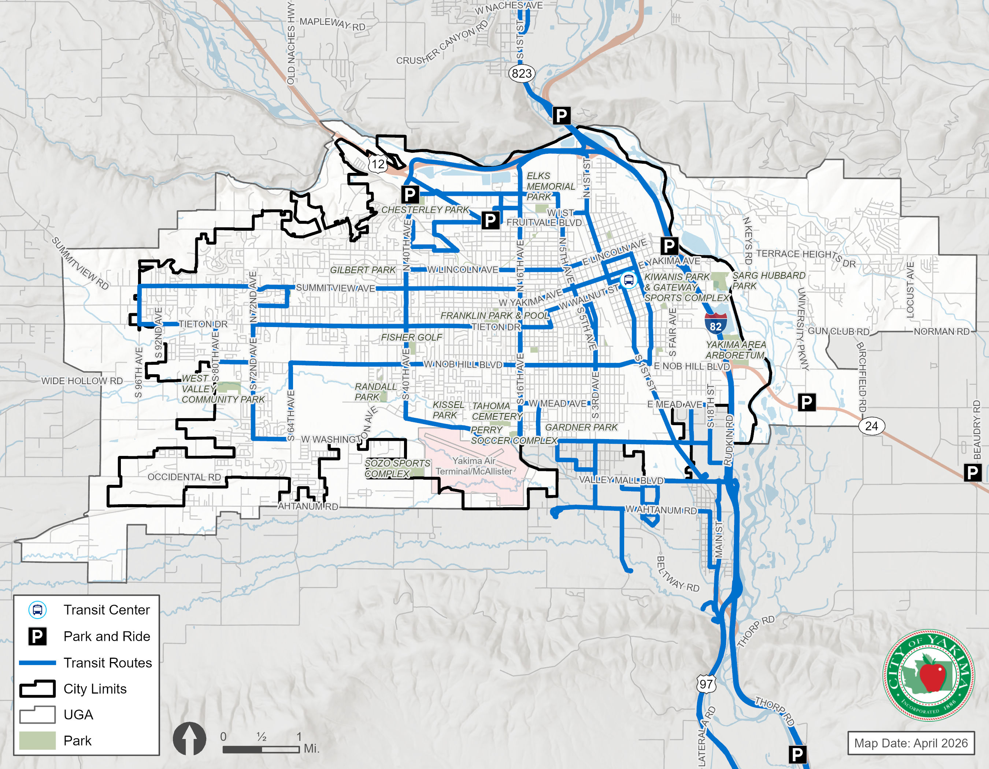

Paratransit Service
Paratransit service (Dial-a-Ride) is provided by Yakima Transit for patrons who cannot use fixed-route bus services due to a disability and in accordance with ADA. This service provides curb-to-curb paratransit service during the same operating days and hours of local fixed route service. Paratransit services are provided, door-to-door, to eligible clients and serves the areas within the city limits of Yakima and Selah and some trips into the City of Union Gap.
System-Wide Ridership
Yakima Transit reports ridership for all services in the Transit Development Plan. Similar to tracking trends in vehicle volumes, the number of annual passenger boards is important to the success and performance of a transit system. Exhibit 5-7 shows system-wide annual boardings for the most recent 5 years of available data.
Exhibit 5-7. Historical Yakima Transit Ridership

As shown in Exhibit 5-7, annual boards exceeded 560,000 in 2025 and 2026, and are expected to increase in coming years.
Park-and-Rides There are five park and ride locations served by Yakima Transit:
- Chesterly Park at the North 40th Ave / River Road intersection has approximately 50 spaces.
- Gateway Information Center along Fair Avenue at I-82 ramps has approximately 64 parking spaces.
- Public Works Facility at N 23rd Avenue / Fruitvale Boulevard has approximately 88 spaces.
- Firing Center Park & Ride Lot in Selah is served by the Yakima—Ellensburg Commuter service and has approximately 35 parking spaces.
- Selah Civic Center Park & Ride lot located next to the Selah Civic Center in downtown Selah
Exhibit 5-6 illustrates the locations of designated Park-and-Ride lots.
Yakima Transit Center
Yakima has one major transit center in its downtown area. The Yakima Transit Center is located along 4th Street between Chestnut Avenue and Walnut Avenue. All Yakima Transit Routes are routed through the Yakima Transit Center. The transit center can accommodate up to 12 buses at a time.
Exhibit 5-6 illustrates the location of the Yakima Transit Center.
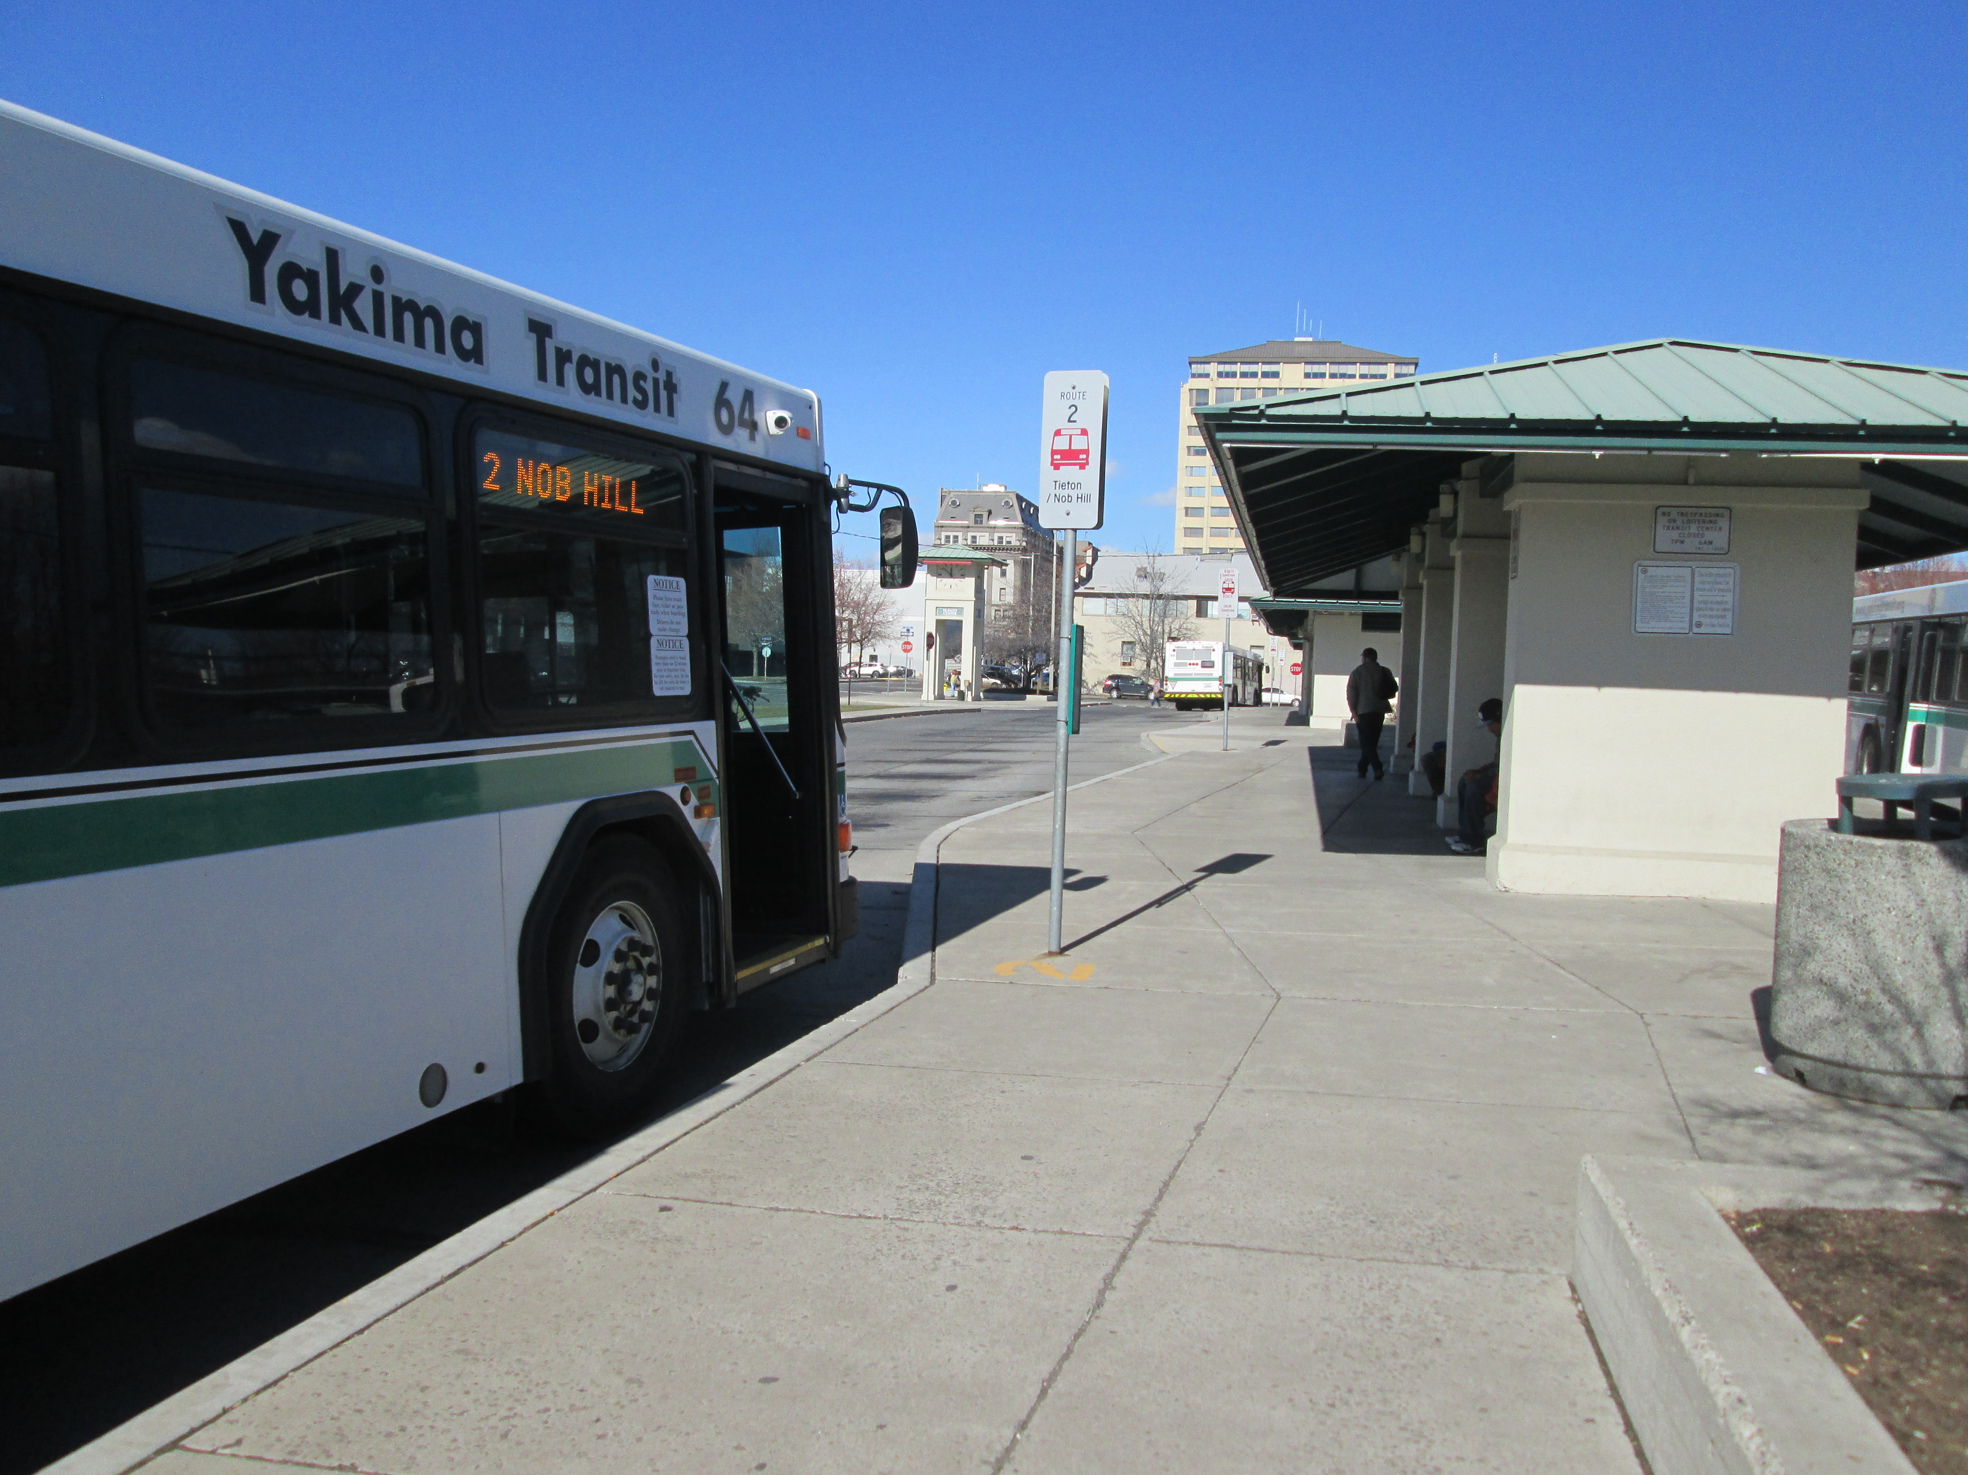

Freight Corridors
Centrally located for companies that rely on distribution throughout Washington State, the City of Yakima is a natural distribution hub served by many freight routes. Planning for freight is an important component to Yakima’s overall economy. While the City does not have designations for freight routes, WSDOT maintains a classification system for freight corridors statewide, including Yakima.
The Washington State Freight and Goods Transportation System (FGTS) classifies highways, county roads, and city streets according to the average annual gross truck tonnage they carry. Truck tonnage values are derived from actual or estimated truck traffic count data that is converted into average weights by truck type.
The FGTS uses five truck classifications, T-1 through T-5, depending on the annual gross tonnage the roadway carries. Yakima has roadways or roadway segments that fall into every classification level.
- T-1: more than 10 million tons per year
- T-2: 4 million to 10 million tons per year
- T-3: 300,000 to 4 million tons per year
- T-4: 100,000 to 300,000 tons per year
- T-5: at least 20,000 tons in 60 days and less than 100,000 tons per year
Corridors with the highest annual gross tonnage, T-1 and T-2 routes, are also identified as Strategic Freight Corridors. I-82 is a T-1 route that runs through Yakima County and connects to other freeways in Washington and Oregon. Many roadways with ramps to I-82, including US 12 and SR 24, are T-2 corridors and important connections to other regional destinations. Freight corridors are illustrated in Exhibit 5-8.
Exhibit 5-8. Existing Freight Corridors
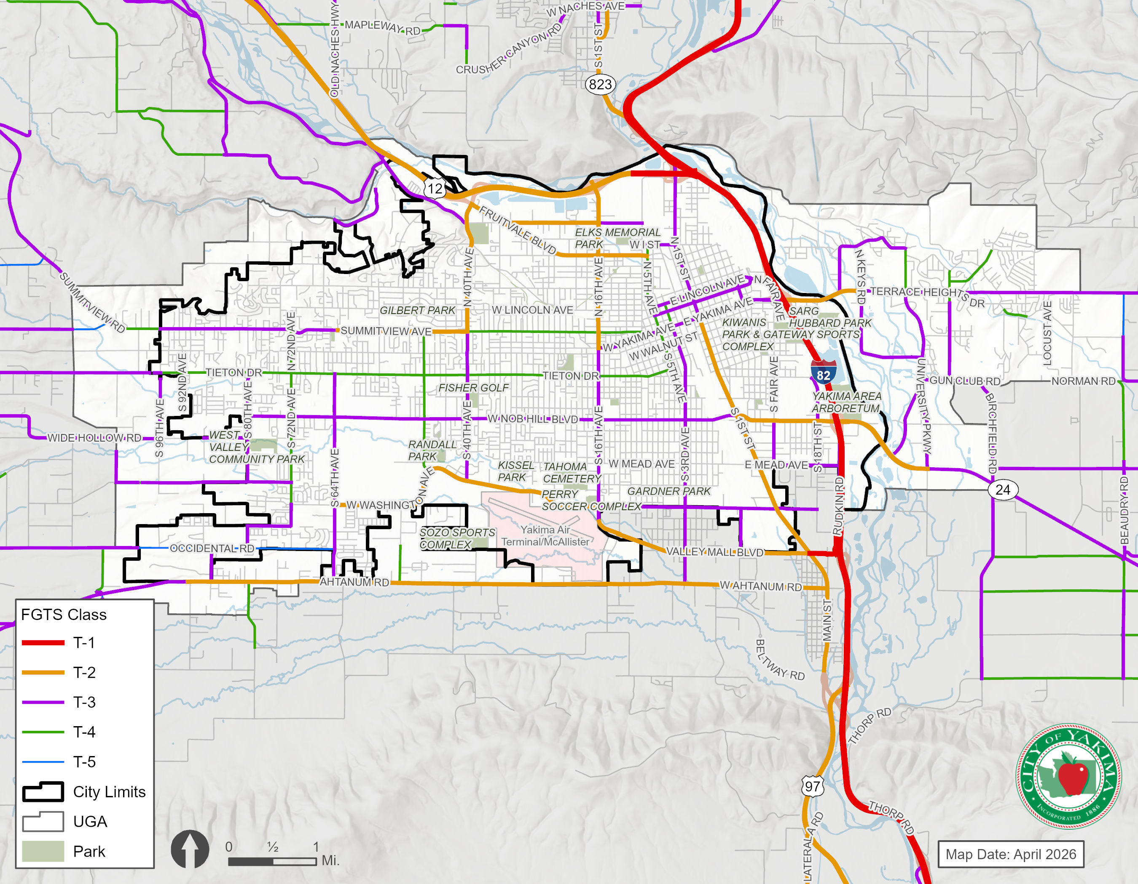

Rail Lines and Crossings
Rail lines in the City of Yakima are exclusively used for freight transportation and do not include passenger service. The double-tracked line through the City’s central business district is a Strategic Rail Corridor (WSDOT, 2013) and one of three statewide east-west rail lines. Owned by BNSF, these tracks connect Auburn and Pasco via Stampede Pass. Additional spur lines within the City and its UGA carry less train traffic, but many remain important connections for the rail community.
At-Grade Rail Crossings
Safety for all at-grade rail crossings is of potential concern for all modes near the crossing when the rail line is active. At-grade rail crossings typically include warning systems and signage to inform drivers of the conflict zone with rail traffic. Highly active crossings include gate arms to stop vehicle traffic, but spur tracks may not include these types of warning devices.
To reduce the negative impacts of at-grade rail crossings, the City has completed several grade separation projects, including the completion of the MLK Jr. and Lincoln Avenue grade separation projects in 2013 and 2014.

Air Facilities
The Yakima Airport (McAllister Field) is a general aviation air facility between Washington Avenue and Ahtanum Road in the south-central area of the City. The airport handles small passenger aircraft that includes flights to and from SeaTac Airport in Seattle.

Transportation System Performance
Performance of the transportation system includes an evaluation of all modes based on City standards and available analysis tools. The existing performance results contained in this section will set the stage for the evaluation of the forecast (2050) transportation system. The following sections describe vehicular operations at intersections and on corridors, non-motorized operations, and transit service operations.
Intersection Operations
Intersection traffic operations evaluate the performance of signalized and stop-controlled intersections according to the industry standards set forth in the HCM 7th Edition and described in 2.2.1 Vehicle Level of Service. PM peak hour traffic operations were evaluated at 30 study intersections using Synchro version 10.1. The PM peak hour intersection operations were selected due to the higher typical traffic volumes occurring during that time period for a single hour between 4 and 6 p.m.
Existing (2026) Intersection LOS
City of Yakima LOS standards are identified in this Comprehensive Plan for roadways within the City. For these roadways, the standard is LOS D. Existing levels-of-service at key intersections in City of Yakima are shown in Figure 2-9. The results of the LOS analysis indicate that all study intersections currently meet City LOS standards, except for three intersections located at S 72nd Ave / W Washington Ave, and S 40th Ave / W Nob Hill Blvd, and S 18th St / E Nob Hill Blvd (Signal). These three intersections are located on arterial roadways which are designated to serve a high number of vehicles.

Corridor Capacity
The existing regional travel demand model includes a roadway capacity that provides an estimated volume-to-capacity (v/c) ratio that is used to identify general areas where weekday PM peak hour volumes approach or exceed the capacity of the roadway. A roadway with a v/c ratio of 1.0 is assumed to be at capacity. As vehicle volumes approach peak roadway capacity, travel times and vehicle delays typically increase. While this does not necessarily mean the roadways would need widening, it does mean that these sections of roadway may need to be monitored closely.
In situations where the roadway has an excess of capacity, the number of travel lanes could be reduced to include bike lanes or other enhanced non-motorized facilities in the street right-of-way. Average Daily Traffic is shown in Exhibit 5-6.
General Guidance on Corridor Capacities
The specific corridor capacity is calculated based on hourly vehicle traffic volumes and can be impacted by many characters such as speeds, number of lanes, lane widths, on-street parking, and the number of access points per mile. In addition, intersection capacity constraints can limit the number of vehicles that a corridor can efficiently move. However, transportation professionals have created general guidance (“rules of thumb”) on how to size major urban streets based on Average Daily Traffic volumes, such as:
- 3-lane urban street capacity: 18,000 ADT
- 4-lane urban street capacity: 25,000 ADT
- 5-lane urban street capacity: 34,000 ADT
Exhibit 5-9. Existing Intersection Vehicle Level of Service
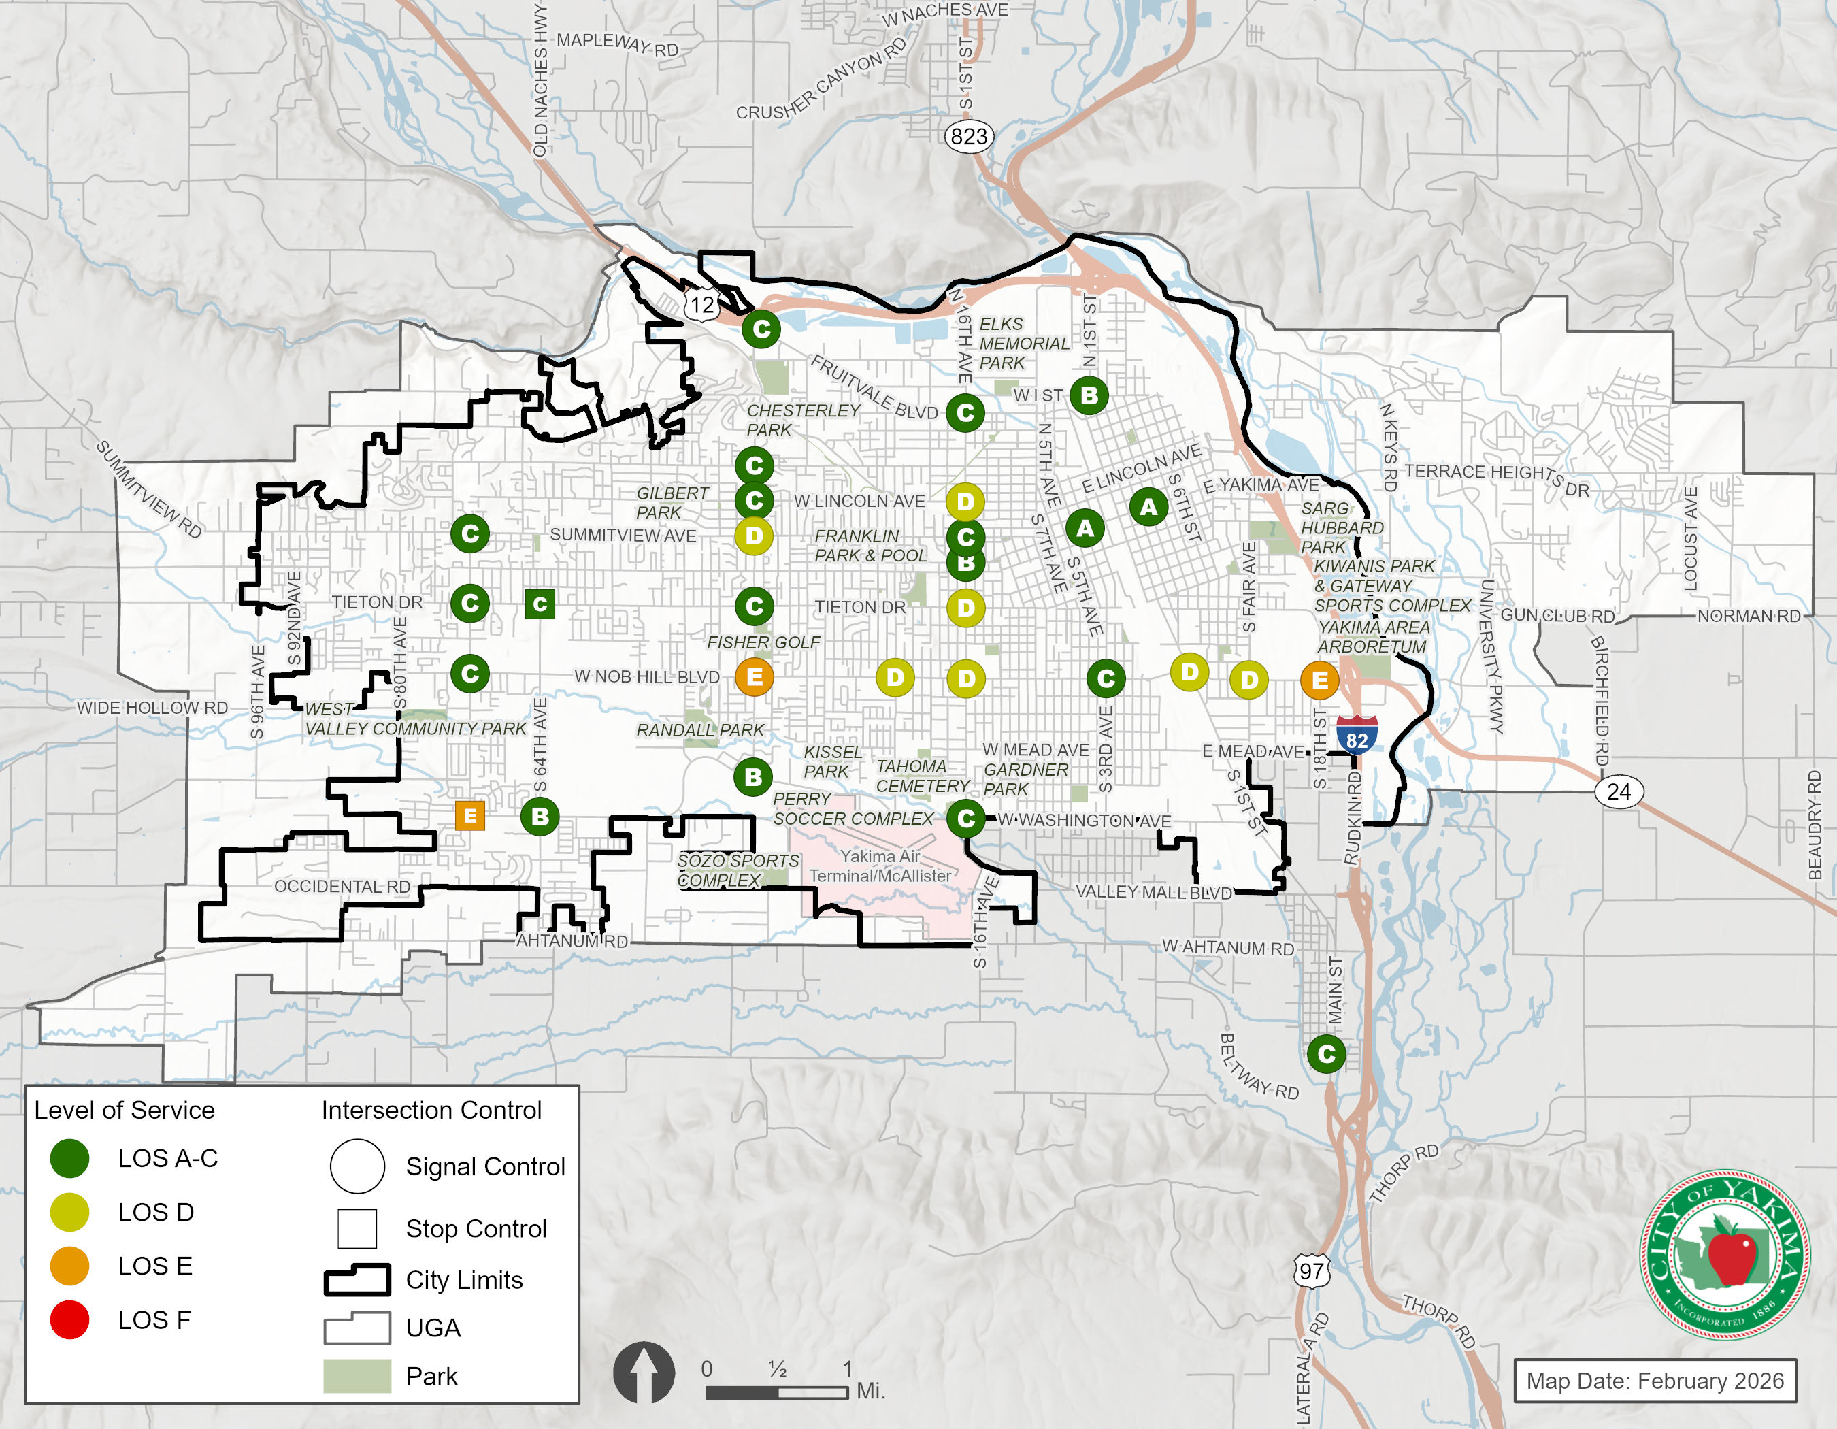
Active Transportation LOS
The 2026 Transportation Element supplements the 2021 Pedestrian Master Plan and the 2017 Bicycle Master Plan to meet current policy direction from the GMA and WSDOT by establishing an active transportation network, performance measures, and MMLOS standards. Background information on the level of service standards is discussed in Volume I of the Comprehensive Plan.
Pedestrian Route Classification
The Yakima Pedestrian Master plan identifies priority routes for pedestrian improvements in the city. These routes were based in part on the modal priorities set in the preceding 2040 Transportation Systems Plan, as well as the results of a needs assessment and public engagement. The network identifies specific infrastructure needs in various parts of the city by identifying network typologies. These network typologies are based on the pedestrian travel demand and character of the roads along these corridors. The LOS standards for each typology are based on the recommended sidewalk network, however, when planning for the needs of each location related to crossings, ADA accessibility, and other safety improvements, further study and consultation with the pedestrian master plan are recommended. Exhibit 5-10 shows the distribution of network typologies in the city and their corresponding LOS standards. The LOS standards for the network were developed to indicate how closely the existing facilities match the intended facilities from the network typology.
Exhibit 5-10. Network Typology and LOS Standard
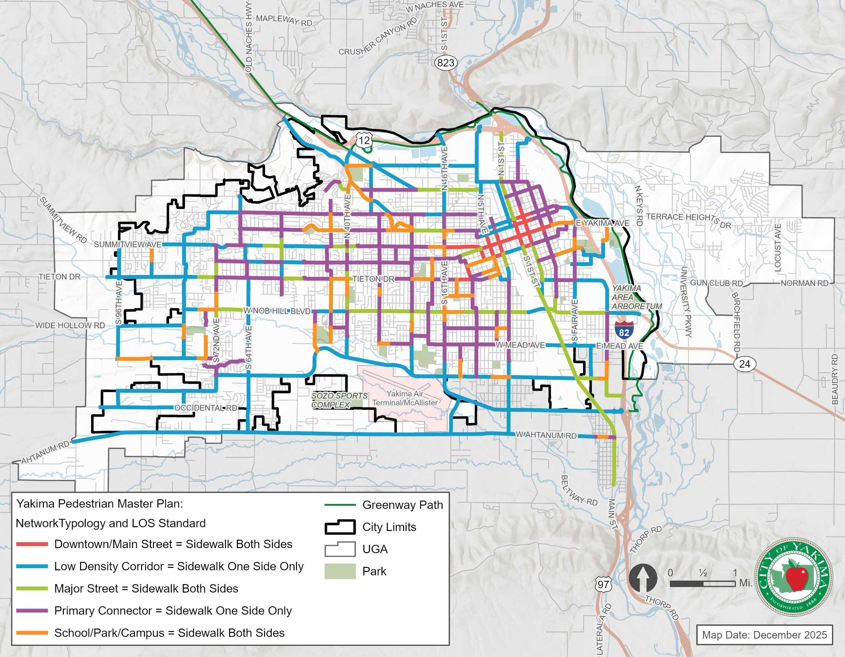
Existing pedestrian LOS is shown on Exhibit 5-11.
Exhibit 5-11. Existing Pedestrian Level of Service
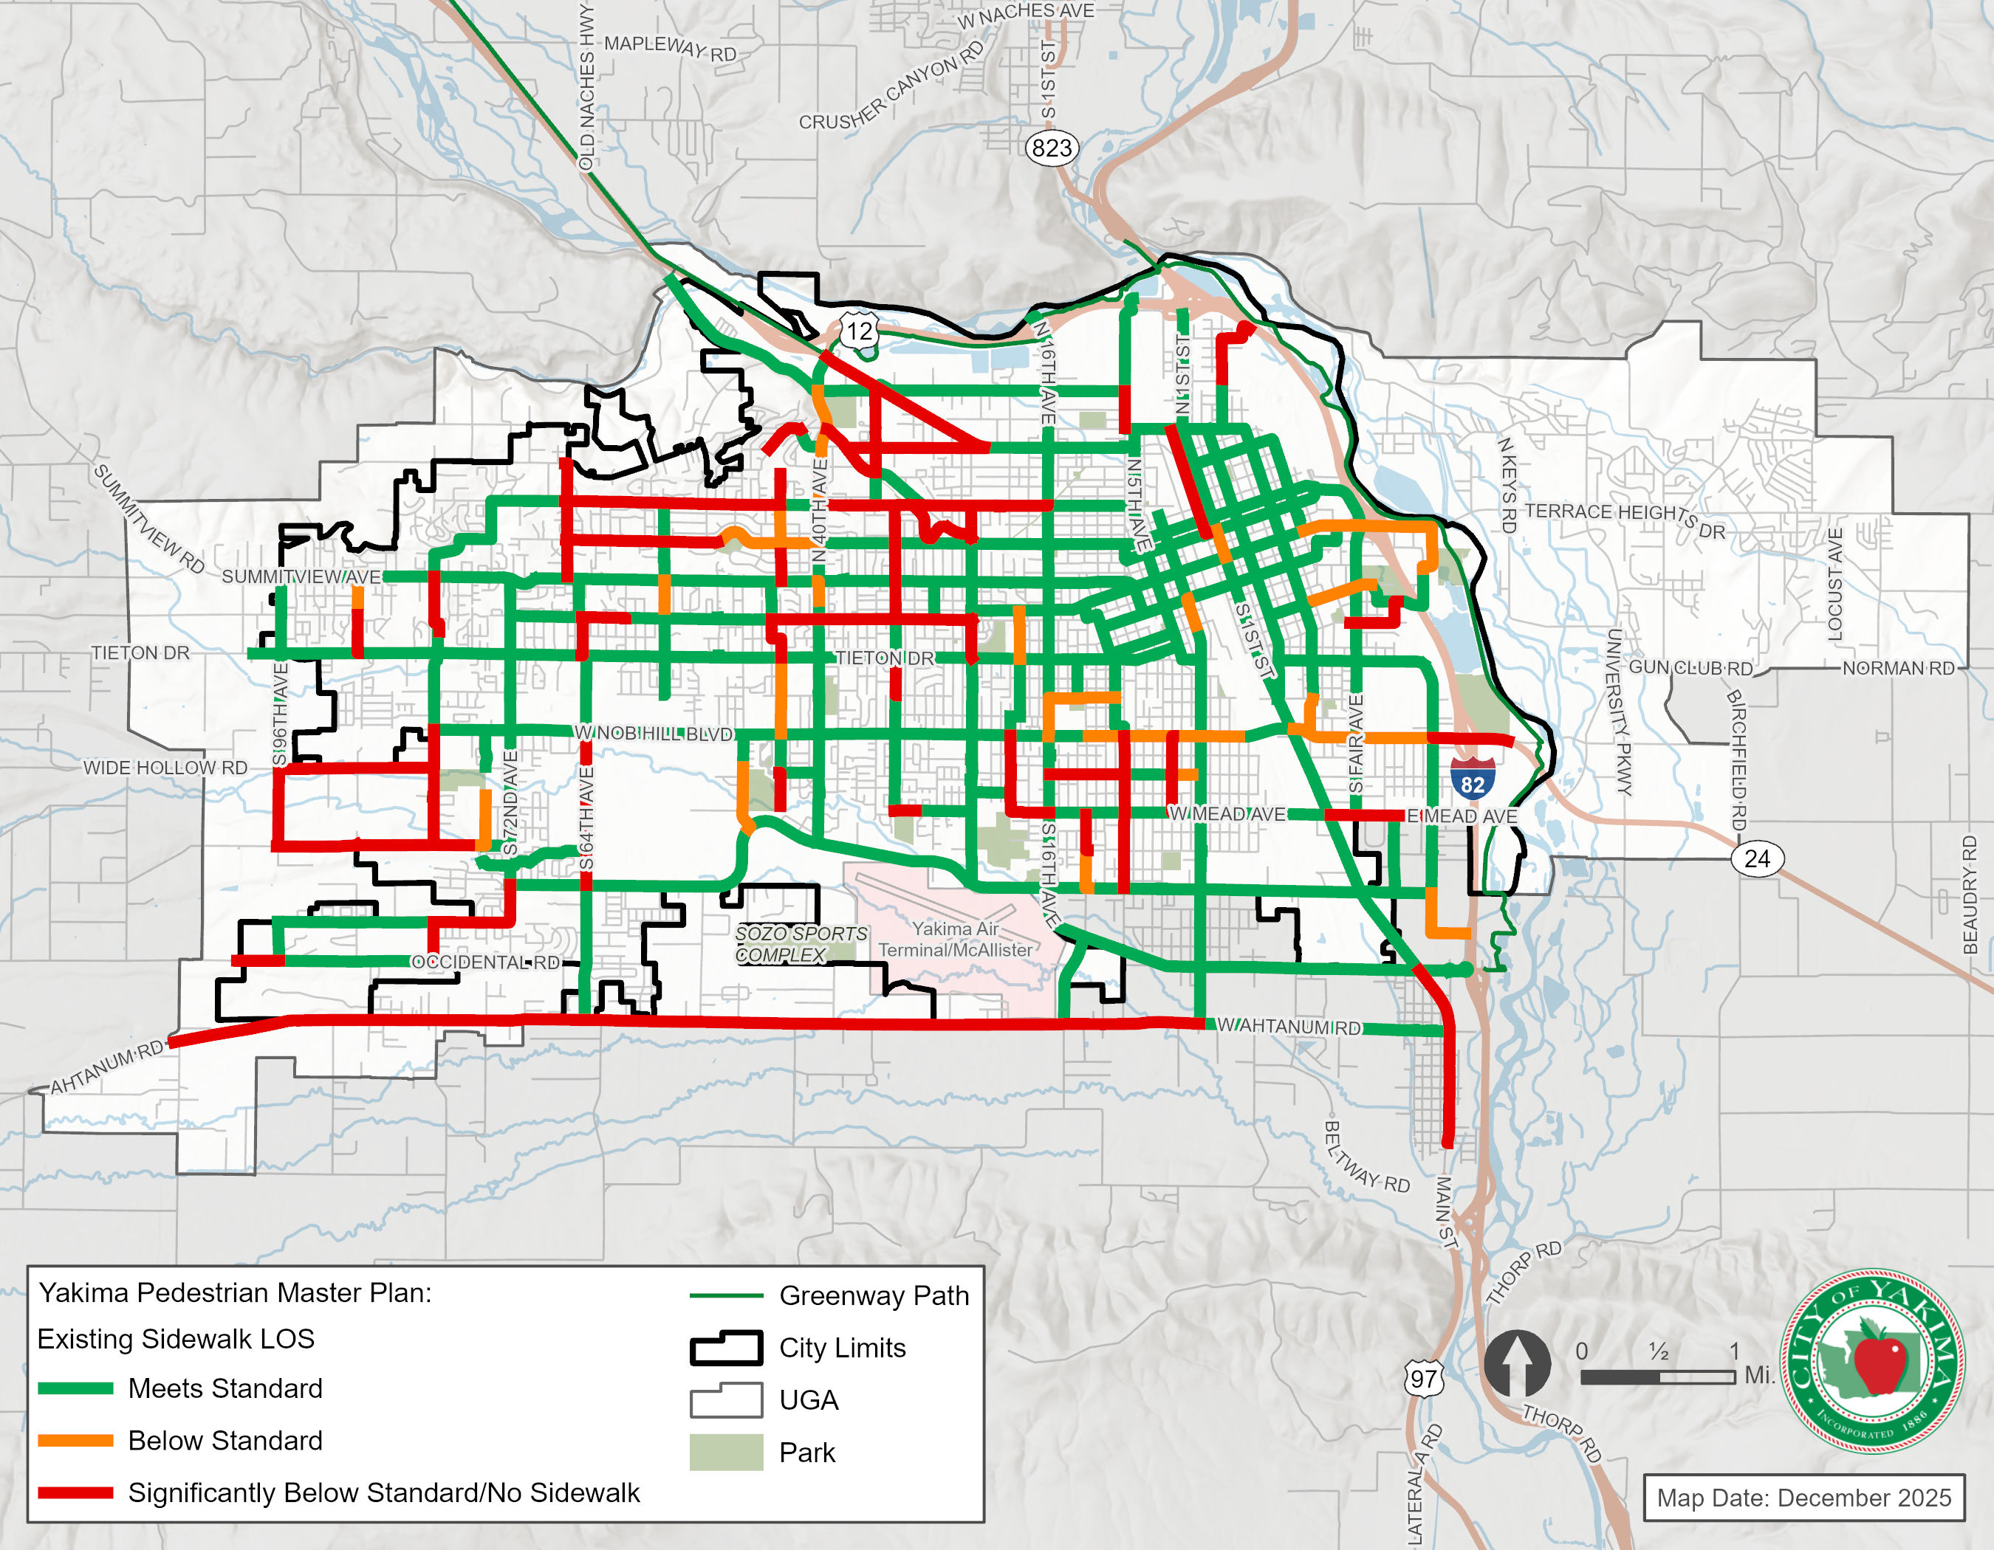
Existing Pedestrian LOS generally meets standards in the downtown area, with a few key exceptions. The sidewalk network is largely built out in the downtown core and along major east west corridors like Nob Hill, Tieton and Summitview. However, many roadways in the northern areas of the city (such as Englewood) lack sidewalks.
Bicycle Levels of Service
The 2017 Bicycle Master plan (BMP) developed a proposed bicycle network by combining Yakima’s existing bicycle facilities with critical access connections across barriers such as railways and freeways, arterials with excess capacity, trail network connections and continuous residential streets. The bicycle master plan recommended several different facility types including bike lanes, shared use trails, and shared roadways. Facility types were chosen for the identified corridors based on need, ease of implementation, and public input. An additional facility type, “bicycle boulevards” was also included, with planned facilities such as signage, speed humps, and other traffic calming measures. Many of these corridors already existed as signed bicycle routes but were not up to existing MUTCD and AASHTO standards at the time of writing the BMP. Exhibit 5-12 shows the existing and proposed facilities in the bicycle network.
The LOS standards for the bicycle network are a direct measurement of the planned network identified in the BMP. Wherever a facility is proposed where none are present this is considered a ‘gap’ in the network.
Exhibit 5-12. Existing and Proposed Bicycle Facilities
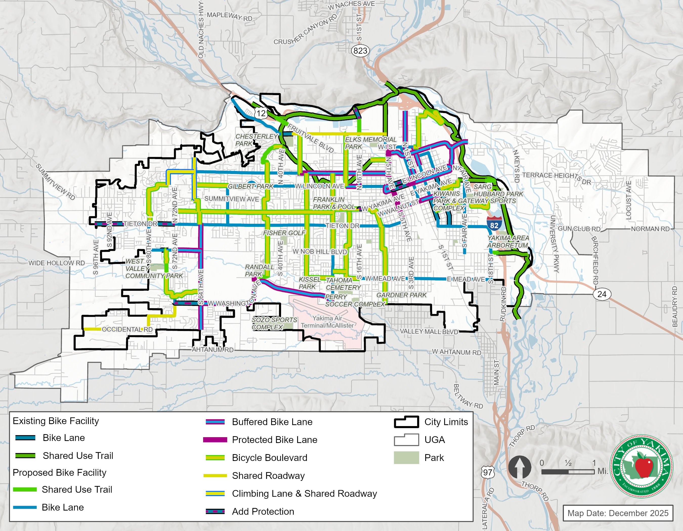

The existing levels of service for the bicycle network are shown in Exhibit 5-13.

Exhibit 5-13 Existing Bicycle Level of Service
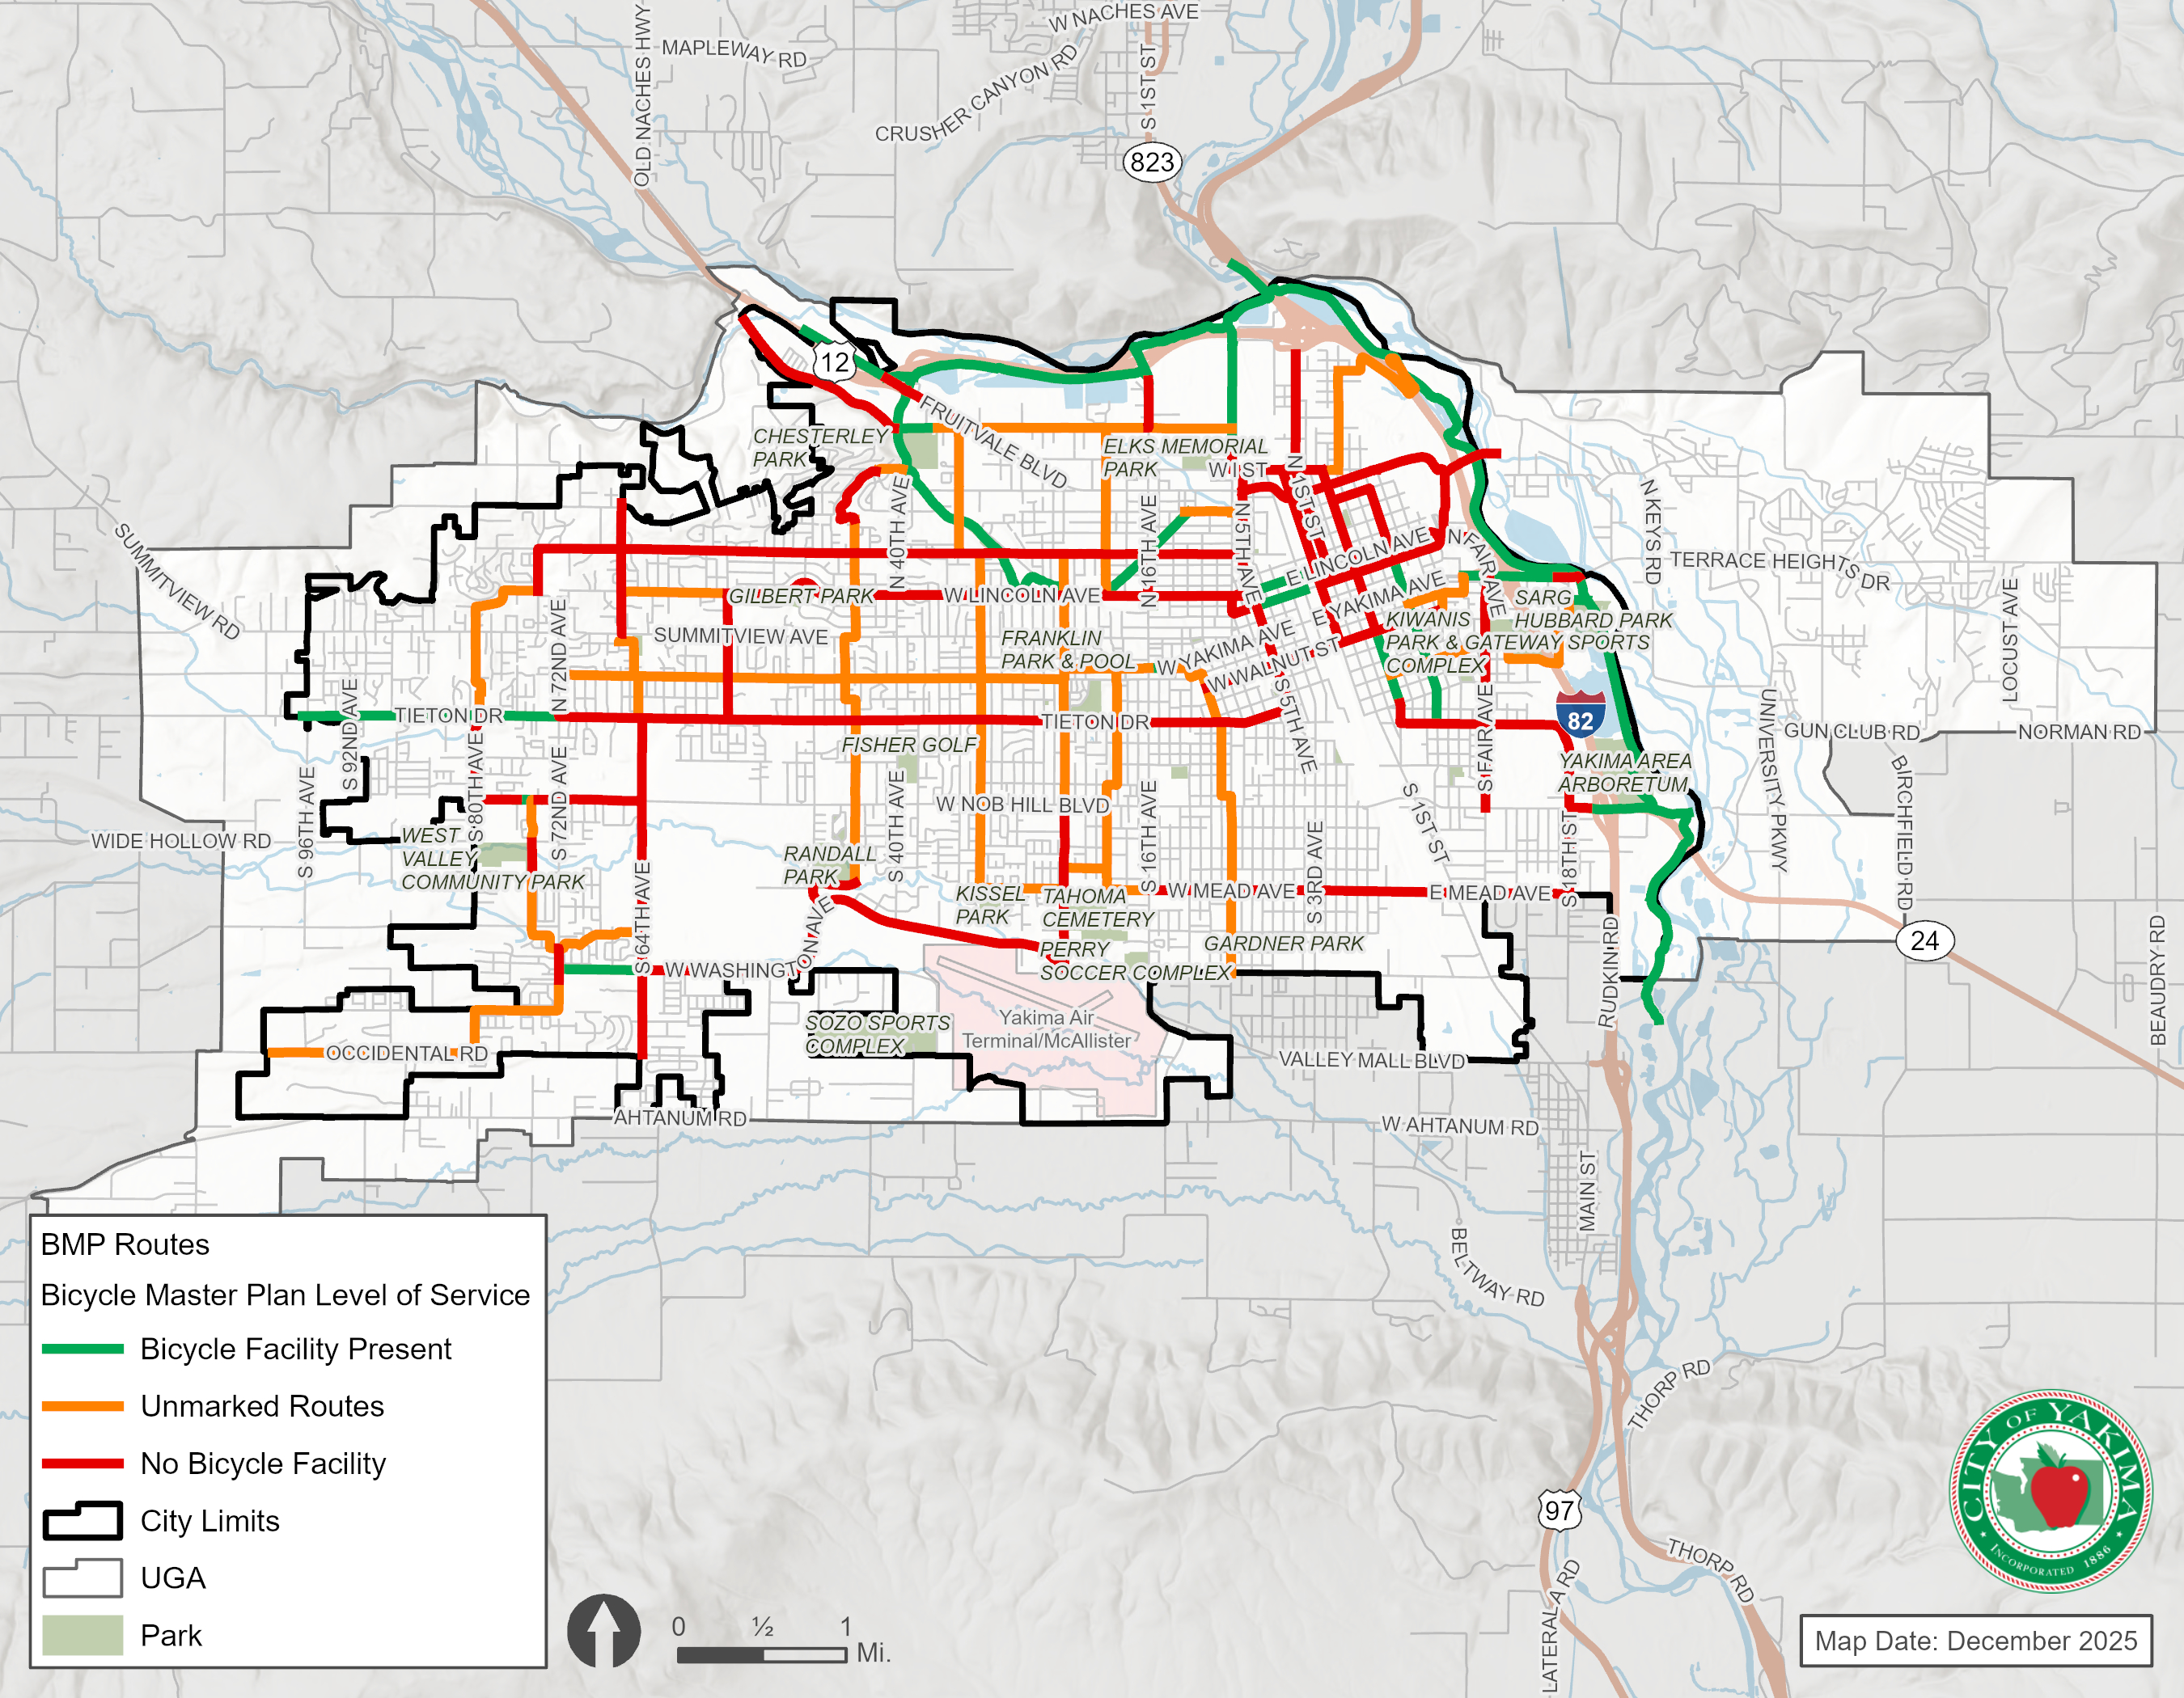

Transportation System Safety
The collision history of the transportation system can help identify crash patterns for all modes and is used in the development of projects to improve the safety of the City’s roadways. Records for the most recent complete five-year period were reviewed and include all collisions reported for the period of January 1, 2020 to December 31, 2024 in City of Yakima as provided by WSDOT. An evaluation of the location and severity of reported collisions was completed to identify potential safety issues for vehicles, pedestrians, and cyclists.

Safety Analysis
The most recent collision data during a five-year period for all roadways in the City of Yakima, excluding state highways and interstates, were used for analysis. The total number of collision records reviewed over the 5-year period totaled over 8,000, and the number of collisions reported by year is shown in Exhibit 5-14.
Exhibit 5-14. Total of All Reported Collisions (2020 – 2024)

As shown in the figure, the total number of collisions was lowest in 2020 before significantly increasing through 2022. Though crashes declined between 2022 and 2024, the graph in Figure 2-10 shows a steady increase in the crash trend over the total five-year period. This trend follows national observations in the total number of crashes during COVID stay-at-home orders, and the sharp increase in crashes in the years following the end of the quarantine as more people began driving again.
The total collisions over the 5-year study period are shown in Exhibit 5-15.
The locations of collisions were mapped to identify roadway segments and intersections with the most frequent number of collisions. Roadways with higher volumes, such as Principal Arterials, generally have higher numbers of collisions.
Exhibit 5-15. Vehicle Collisions (2020 – 2024)
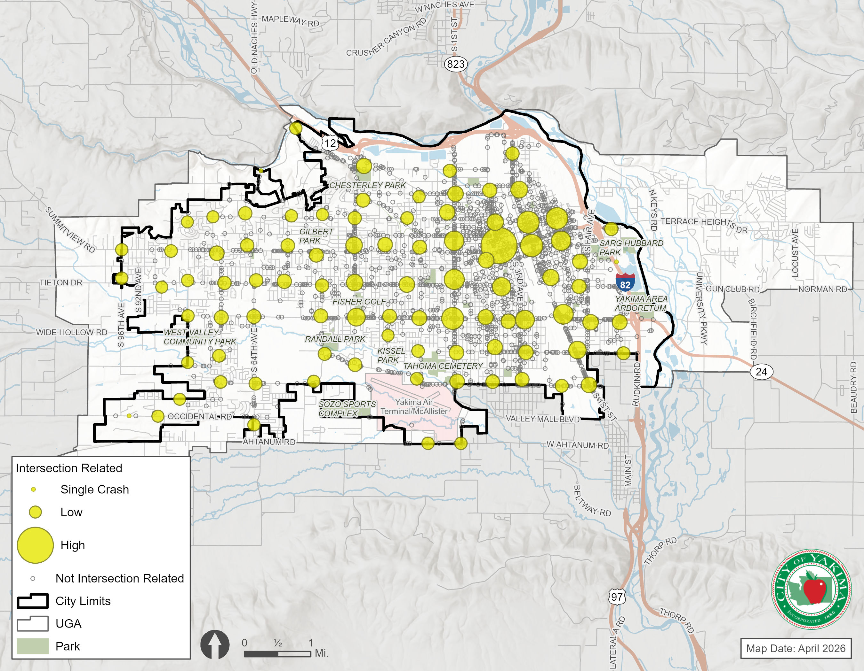

Collision Severity
Intersections with observed collision rates higher than the critical collision rate were flagged for further review, consistent with guidance provided in the Highway Safety Manual (AASHTO, 2010). The type and severity of reported collisions provides insight into the circumstances that resulted in higher collision rates at these intersections.
The critical collision rate calculated for each intersection compares that location to other intersections in the City that have similar characteristics. Three groups of intersections were evaluated that included signals, two-way stop-controls, and all-way stop-controls. This is consistent with guidance provided in Chapter 4 of the Highway Safety Manual. Exhibit 5-16 summarizes the factors and calculations used to determine the critical collision rate for the study intersections.
As shown in Exhibit 5-16, 13 intersections had an observed collision rate higher than the intersection’s critical collision rate. The 16th Avenue/Nob Hill Boulevard intersection had the highest observed collision rate at 0.99 with “approach turn” and “rear-end” being the predominant collision types.
The remaining intersections had rates between 0.51 and 0.83 with angle crashes being the most common. Generally angle crashes are associated with poor visibility conditions.
Eight of the thirteen intersections had collisions with pedestrians or bicycles. Of those 8 intersections, the 16th Avenue/ Fruitvale Boulevard intersection had the most with two pedestrian collisions and one bicycle collision.
Both of the two-way stop-controlled study intersections, W Washington Avenue/S72nd Avenue, and 64th Avenue/Tieton Drive had observed collision rates higher than critical collision rates.
Exhibit 5-16. Intersections with Collision Rates Exceeding the Critical Collision Rate (2020-2024)
Intersection | Peak Hour TEV¹ | Intersection Control | Number of Collisions | Pedestrian/Bicyclist Collisions | Observed Collison Rate² | Critical Crash  Rate⁴ | Primary Collision Type
E Nob Hill Blvd/Fair Ave | 2,266 | Signal | 37 | 0 | 0.89 | 0.41 | Angle
W Washington Ave/S 72nd Ave | 1,128 | TWSC | 10 | 0 | 0.49 | 0.21 | Angle
N 3rd Ave/Yakima Ave | 1,824 | Signal | 18 | 0 | 0.54 | 0.33 | Angle
18th Ave/Nob Hill Blvd | 2,736 | Signal | 28 | 1 | 0.56 | 0.50 | Rear End
72nd Ave/Nob Hill Blvd | 2,210 | Signal | 21 | 2 | 0.52 | 0.40 | Approach Turn
64th Ave/Tieton Dr | 1,570 | TWSC | 15 | 0 | 0.52 | 0.29 | Angle
40th Ave/Washington Ave | 2,388 | Signal | 24 | 0 | 0.55 | 0.44 | Approach Turn
16th Ave / Fruitvale Blvd | 3,020 | Signal | 43 | 3 | 0.78 | 0.55 | Approach Turn
16th Ave/Lincoln Ave | 3,398 | Signal | 52 | 2 | 0.84 | 0.62 | Rear End
16th Ave/Yakima Ave | 2,451 | Signal | 23 | 2 | 0.51 | 0.45 | Rear End
16th Ave / Nob Hill Blvd | 3,726 | Signal | 67 | 1 | 0.99 | 0.68 | Approach Turn
3rd Ave/Nob Hill Blvd | 3,420 | Signal | 39 | 1 | 0.62 | 0.62 | Approach Turn
1st Ave/I St | 1,968 | Signal | 24 | 1 | 0.67 | 0.36 | Angle/ Rear End
      - Total Entering Vehicles.
      - Collisions per MEV.
      - Calculated per Equation 4-11 in the Highway Safety Manual.

Exhibit 5-17. Fatal and Serious Injury Crashes (2020 – 2024)
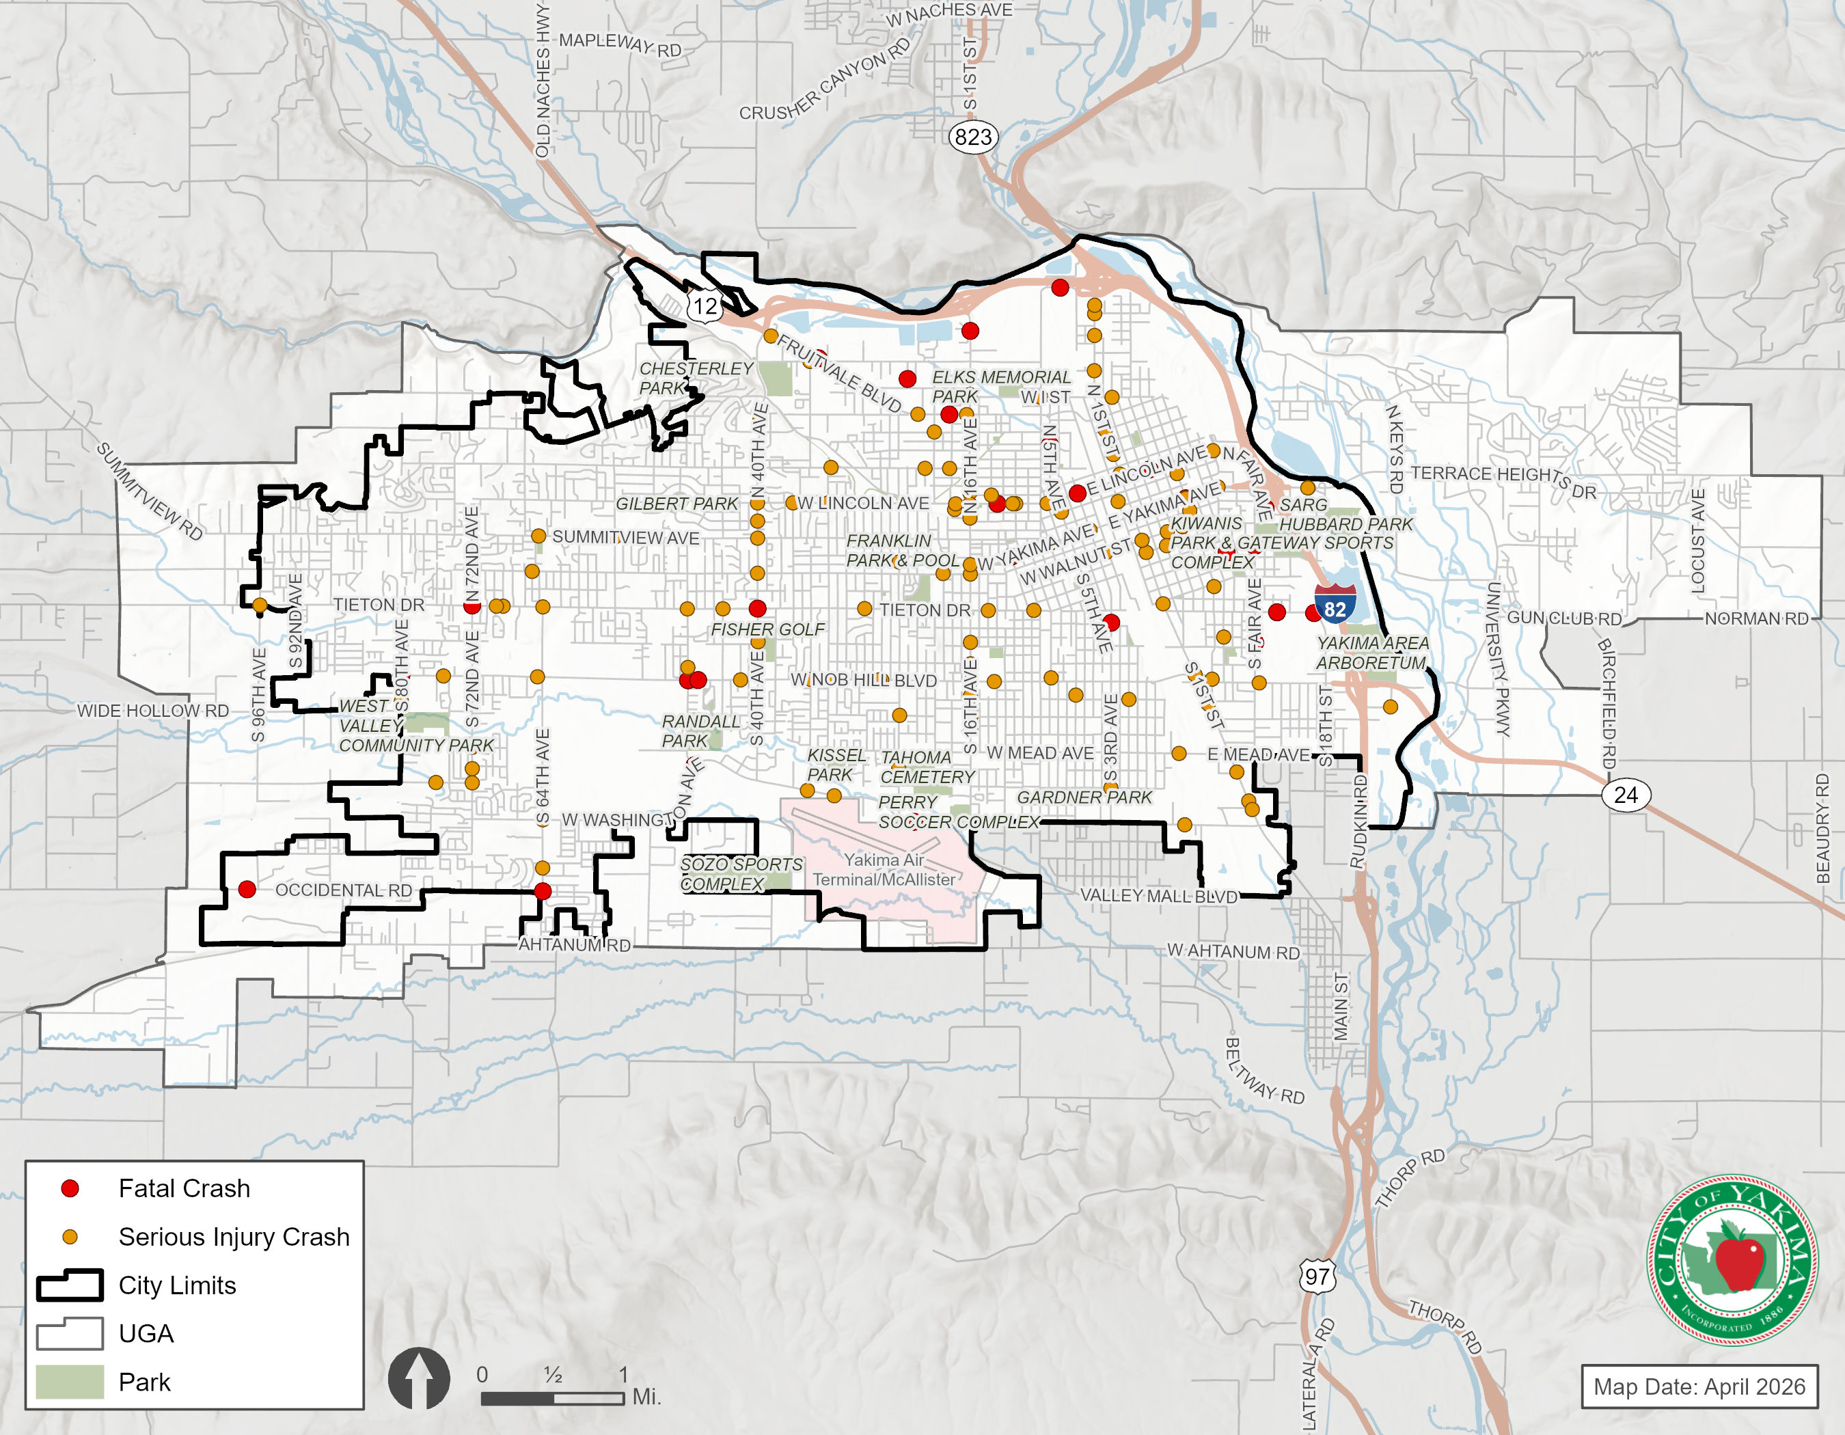

Pedestrian and Bicycle Safety
Collisions with pedestrian and bicycle crashes were reviewed over the 5-year period of crash data obtained from WSDOT. There were a total of 196 pedestrian and bicycle crashes reported in the city during the analysis period, including 12 fatal and 33 serious injury crashes. Twenty-six of the 196 pedestrian and bike crashes occurred at study intersections. Locations that experienced multiple non-motorized collisions were reviewed for any crash patterns. Roadways with higher vehicle turning movements create safety concerns for pedestrians and cyclists. Locations where sidewalks are not present or only available on one side of the street can also be particularly hazardous. In addition, the lack of safe crossings on some corridors may be a factor because pedestrians and cyclists could be crossing at unsafe locations.
The location of all non-motorized collisions reported over the 5-year study period are shown in Exhibit 5-18.

Exhibit 5-18. Pedestrian and Bicycle Collisions (2020 – 2024)
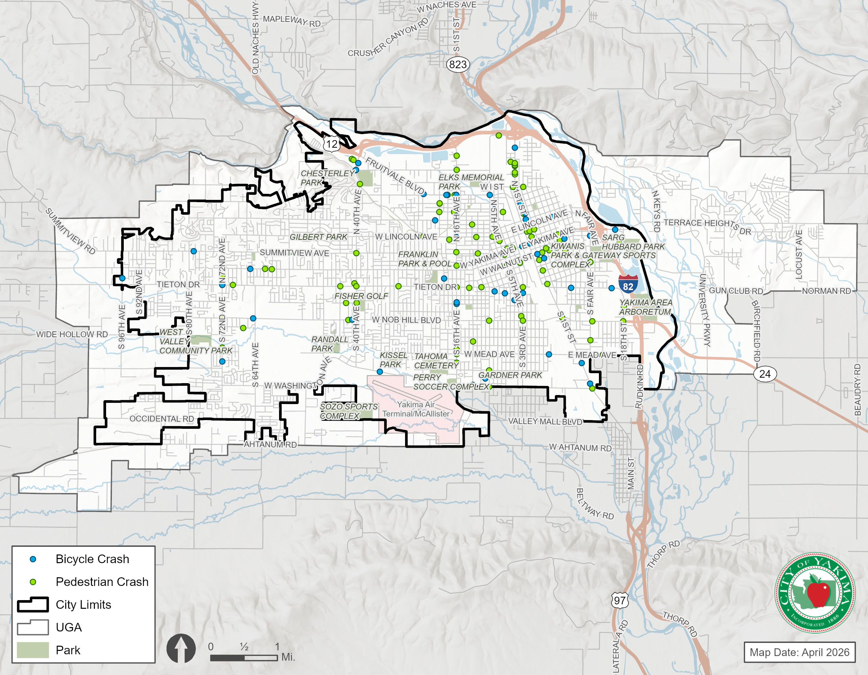

Travel Forecasts and Alternatives Evaluation
In addition to addressing existing needs, the City must develop its transportation system to accommodate forecast growth. The GMA requires that the transportation planning horizon be at least ten years in the future. For this current update effort, the City decided to use 2050 as the long-range horizon, consistent with the Land Use Element of the City’s Comprehensive Plan. The longer-range horizon year allows the City to better plan for and scale transportation facilities that are needed as the City changes over the next two decades.
The following provides an overview of the travel demand model used to create the forecasts and evaluate alternatives. It summarizes the land use assumptions and network alternatives. The alternatives evaluations are presented, resulting in the development of the framework for the Transportation Element and improvement projects, which are presented in 5.3.

Travel Demand Model and Land Use Forecasts
The YVCOG’s regional travel demand model was used to support the City’s transportation planning efforts. The travel demand model provides a tool for forecasting long-range traffic volumes based on the projected growth in housing and employment. The model is also useful in evaluating the impact of changes to the roadway network.
Travel forecasts are largely derived based on changes in households and employment within the study area. In addition, the model land use forecasts reflect regional planning assumptions as defined by Yakima County’s growth allocations and YVCOG. Additional information on residential and employment land use forecasts assumed for the transportation analysis can be found in the Land Use Element of the City’s Comprehensive Plan. The 2050 forecast assumed the following improvements:
- Construction of a roundabout at 72nd Avenue and Washington Boulevard
- Construction of a roundabout at 40th Avenue and Fruitvale Boulevard
- Add left turn lanes at the intersection of 16th Avenue and Tieton Drive
- Realign the intersection of Washington Avenue and S 1st Street & add two-way left turn lane to Washington Avenue.

Vehicle Forecast Conditions (2050)
Forecast travel conditions estimate where future bottlenecks may occur based on future travel demand. Travel demand is based on anticipated changes to land use and the types of trips generated based on the population and employment allocations described in the Land Use Element. The aggregation of those trips on City roadways provides planners with a future snapshot of the transportation system as a whole.
Exhibit 5-19. Existing and Future Intersection LOS Summary
Intersection Location | Traffic Control | Existing (2025) | 2050 Forecasts
72nd Ave / Summitview Ave | Signal | C | D
72nd Ave / Tieton Dr | Signal | C | C
72nd Ave / Nob Hill Blvd | Signal | C | C
72nd Ave / Washington Ave | TWSC | E | A
64th Ave / Tieton Dr | TWSC | C | F
64th Ave / Washington Ave | Signal | B | C
40th Ave / Fruitvale Blvd | Signal | C | B
40th Ave / Englewood Ave | Signal | C | C
40th Ave / Lincoln Ave | Signal | C | C
40th Ave / Summitview Ave | Signal | D | D
40th Ave / Tieton Dr | Signal | C | E
40th Ave / Nob Hill Blvd | Signal | E | E
40th Ave / Washington Ave | Signal | B | B
24th Ave / Nob Hill Blvd | Signal | D | D
16th Ave / Fruitvale Blvd | Signal | C | C
16th Ave / Lincoln Ave | Signal | D | D
16th Ave / Summitview Ave | Signal | C | D
16th Ave / Yakima Ave | Signal | B | B
16th Ave / Tieton Dr | Signal | D | C
16th Ave / Nob Hill Blvd | Signal | D | E
16th Ave / Washington Blvd | Signal | C | C
3rd Ave / Yakima Ave | Signal | A | A
3rd Ave / Nob Hill Blvd | Signal | C | D
1st St / ‘I’ St | Signal | B | B
1st St / Yakima Ave | Signal | C | C
1st St / Nob Hill Blvd | Signal | D | E
1st St / Washington Ave | Signal | C | C
3rd St / Yakima Ave | Signal | A | A
Fair Ave / Nob Hill Blvd | Signal | D | D
18th St / Nob Hill Blvd | Signal | E | D
Traffic volumes in urban areas are typically highest during the weekday PM peak hour. This reflects the combination of commuter work trips, shopping trips, and other day-to-day activities which result in travel between 4:00 and 6:00 p.m., Monday through Friday. Therefore, the weekday PM peak hour is typically used for evaluating transportation system needs.
The 2050 Baseline transportation system includes committed transportation system projects – those currently under construction or fully funded. As a conservative assessment of vehicle forecast conditions, the Baseline model did not assume significant changes to the City of Yakima network. The YVCOG model included an additional lane of capacity along I-82 through the urban areas of the county. In addition, the YVCOG model included a new east-west road corridor connecting northeast Yakima to eastern county areas across I-82 and the Yakima River.

Forecast Operations with Plan Framework
The 2050 Baseline model includes roadway capacities that provide an estimated volume-to-capacity (v/c) ratio that is used to identify general areas where weekday PM peak hour volumes approach or exceed the capacity of the roadway. A roadway with a v/c ratio of 1.0 is assumed to be at capacity. As vehicle volumes approach peak roadway capacity, travel times and vehicle delays typically increase. While this does not necessarily mean the roadways would need widening, it does mean that these sections of roadway may need to be monitored closely. No roadway v/c issues were identified within the study area.
As described in the Existing Conditions section, intersection traffic operations evaluate the performance of signalized and stop-controlled intersections according to the industry standards set forth in the Highway Capacity Manual 7th Edition (Transportation Research Board). Peak hour traffic operations were evaluated at the study intersections based on level-of-service (LOS) methodology.
City of Yakima LOS standards are identified in this Comprehensive Plan for roadways within the incorporated areas of the City. For these roadways, the City maintains an adopted standard of LOS D. The results of the LOS analysis indicate that all study intersections will meet City LOS standards with existing configurations and controls, except for the intersections highlighted in red in Exhibit 5-19.
Selected transportation projects described in 5.3. were developed to address intersection and roadway deficiencies found in the land use scenarios. 5.4. has more discussion about how and why projects were identified and selected for the Transportation Element.

Non-Motorized Forecast Conditions
The non-motorized transportation network within the City of Yakima and its UGA serves pedestrians, cyclists, and other types of non-motorized users. The future non-motorized transportation network contained in the Transportation Element builds upon previous planning efforts that have identified future routes for bicyclists and pedestrians. These plans identify future pedestrian and bicycle routes for the City of Yakima through a combination of on-street facilities and off-street pathways provide the core network for walkers, cyclists, and other non-motorized users to travel.
The City of Yakima will continue to develop pedestrian and bicycle facilities as part of its transportation system improvements. The TSP identifies the desired pedestrian and bicycle systems plans, which will guide the development and implementation of improvement projects throughout the City. The non-motorized systems plan includes facilities on arterials, collectors, and local streets, as well as multi-use trails. The bicycle and pedestrian systems plans are discussed in 5.3.1. .

Transit Forecast Conditions
To provide a comprehensive transportation system, the City of Yakima recognizes the importance of transit. As growth and density is encouraged in the downtown core, a frequent and reliable transit system can help move people efficiently without the use of a personal vehicle. The six-year (2016-2021) Yakima Transit - Transit Development Plan, contains the transit agency’s short and long-range priorities, capital improvements, and planned operating changes. The City’s transit system plan is discussed in 5.3.3. .

Plan Framework
A Plan Framework was established for creating the city’s long-range multimodal street network vision. The framework builds from the City’s prior Comprehensive Plan and Subarea Plans, as well as other agency transportation improvement programs. Below are the five key themes used to create the Transportation Master Plan and project list.

Maintain Connected Networks
The Transportation Element specifically identifies the primary and secondary routes for each of the major travel modes within the city. When layering these separate network plans together, urban corridors were classified as “Auto Priority”, “Bike/Ped Priority”, or “Shared Priority”. This allows project funding resources to be targeted to the best types of improvements that would complete the overall system. In addition, maintenance dollars could also be prioritized based on the anticipated street functions.

Expand Capacity on Key Corridors
Reviewing the travel demand model volume forecasts and intersection operations analysis made it clear that Principal Arterials will continue to be the core vehicle routes throughout the City. Principal Arterials should provide maximum vehicle capacity with 5 lanes, or if 5 lanes are not feasible, 4 lanes with greater access control. Arterial-to-arterial intersections should have traffic signals with separate left-turn lanes, and if necessary dual left-turn lanes and/or right-turn lanes.

Right-Size Urban Corridors
Many urban streets within the City are oversized for the traffic demands expected by 2040 and beyond. These are mostly 4-lane roads classified as local streets, major collectors, and even some minor arterials. Reducing the number of lanes to 2 or 3 lanes improves safety, allows for on-street parking, or provides space for bicycle facilities. It is also much easier to create safe pedestrian crossings on 2- or 3-lane facilities compared to 4-lane facilities.

Bridge Non-Motorized Gaps
A review of the existing pedestrian and bicycle facilities shows that there are major gaps in connectivity throughout the overall system. While all roads should accommodate all users, the Transportation Element focuses on projects that help bridge the existing gaps in the system.

Facilitate Economic Development
The transportation system can be a major component in development of economic growth in the area. Increased capacity along I-82 and related interchanges helps drive opportunities to the City. New roadways in the Cascade Mill Site area provide the backbone for redevelopment in that area. In downtown areas and other activity centers within the city, providing lower stress multimodal urban corridors promotes economic vitality for the City.

Emerging Transportation Trends
In addition to formal transportation analysis and forecasting, long-range planning also includes anticipating emerging transportation trends that may change basic assumptions concerning how people travel and how transportation systems operate. Transportation-related technology has advanced quickly over the past decade, will continue to accelerate, and will create major shifts in transportation within the City of Yakima. This section describes some of these technology-related trends and the potential impacts on Yakima’s transportation system.

Autonomous Vehicles (AVs)
There is a great deal of uncertainty for communities planning for autonomous vehicles. Potential outcomes carry a wide range of possibilities. Over the next 15 years, a portion of the vehicles on the City’s streets and highways could be operating without drivers. It is possible that 30 to 40 years from now all, or nearly all, vehicles will be driverless or will have driverless capabilities in certain situations. The implementation of some of these technologies may be within the 2040 planning horizon, and thus the City should consider the ramifications of these technologies on its transportation network. A few key issues rise to the top of what local agencies should contemplate while preparing long-range plans.
Roadway Capacity and Safety
AVs will be able to space themselves closer together, effectively increasing the capacity of streets and highways. This is especially true if AVs travel in narrower lanes with smaller vehicles (assuming AV-only lanes and/or AV-only urban areas). This implies that roadway capacity improvements to accommodate more vehicles could be postponed as the potential of AVs becomes realized. In addition, AVs may reduce many common accident risks.
Transit Service
Over half of the cost of operating buses is related to the driver. In the future, replacing the driver with AV technology may enable transit operators to offer more service for the same cost. Technology that clears lanes when buses approach may allow them to avoid the same congestion they now face. This would also increase service as buses will be able to run routes faster. Such technology may reduce the need for investments in rail transit infrastructure as buses may operate with close to the same freedom that trains do on dedicated rights-of-way.
On-Demand or Shared Ride Regulations
The demand for shared ride services such as Lyft and Uber may likely increase as the economics improve without drivers. Public agencies would likely need to address regulations regarding these types of services, especially those that offer pooling options for two, three or more people to ride together.
Human Services Transportation
AVs may provide independent mobility for low-income and disabled populations, reducing the need for conventional demand response services.

Parking Demand Shifts
It is likely that the economics of transportation will dramatically change with widespread use of on-demand or shared ride services. Car ownership in urban areas may further decrease if on-demand travel (with or without driverless vehicles) becomes a legitimate alternative. This would reduce the need for off-street parking at places of employment or residential areas, but would increase the demand for curbside areas set aside for loading/unloading activities.

Connected Vehicles
Although it is not yet clear what the demand for vehicle-to-infrastructure may ultimately look like, cities might look ahead to providing infrastructure as efficient reference points. For example, light poles could become hubs of wireless communication to/from vehicles. Connected vehicle technology has the potential to optimize traffic flow as computer systems communicate with vehicles to moderate flow. Cities should monitor technologies to prepare for phased implementation of such systems.

Teleworking
Advances in technology and communication infrastructure as well as major changes resulting from the COVID-19 pandemic have facilitated the exponential growth of teleworking over the last several years and these trends are expected to continue. The land use and transportation implications of this trend are wide ranging including: reduced vehicle-miles traveled, reduced roadway congestion; reduced greenhouse gas emissions; and, greater number of employees choosing to live further from job sites.

Transportation Funding Methods
The traditional transportation funding method of taxing fuels has become unsustainable as transportation technology changes. The emerging funding trends point to user fees in the form of facility tolling or pay-per-mile taxes. These “user fees” would directly impact commuting costs and incentivize less frequent or shorter vehicle trips.

Emerging Trends Takeaways
It remains unclear whether these new technologies (or others) will be implemented by agencies, vehicle manufacturers, and related industries. The shifts may be relatively quick (within a decade) or take much longer to develop. The following list highlights the emerging trends takeaways as the City of Yakima plans for the future.
- Growth in commute vehicle trips is likely to decline over time as teleworking technology improves.
- Agencies can play a major role in how connected vehicle infrastructure gets implemented, which can lead to better traffic management.
- Growth in car ownership is likely to continue to decline due to on-demand services and commuting costs. This would likely increase demands for non-motorized and transit modes. This would also decrease the need for off-street parking.
- Demand for curb space for loading/unloading for AV and on-demand services would likely increase dramatically. This could impact on-street parking or default cross-sections.

Transportation Systems Plan
The Transportation Systems Plan provides the blueprint for improvement projects and programs to meet the multimodal transportation needs of the community. Each mode has a separate systems plan that harmonize together to build the overall City plan. The Transportation Systems Plan is based on the evaluation of existing system deficiencies and forecasts of future travel demands. The improvement projects and programs must be balanced with the availability of funding, as discussed in the Financing Program.
The Transportation Systems Plan is organized and presented by travel mode to provide an overview of key components of each element. However, the Plan is integrated to create a multimodal transportation system. For example, improvements along arterial streets and highways also incorporate appropriate non-motorized improvements. The non-motorized systems were defined to support access to transit, and to provide alternatives to automobile travel within the City. As improvement projects move toward implementation, the City will conduct detailed design studies, supported with project-level environmental review, and input from the public and other stakeholders.
A key implementation tool of the Transportation Systems Plan is a defined network classification system. Network classifications include the Roadway Functional Classification and the Truck Route Classification. These classifications directly influence the street cross-section design standards as City streets are reconstructed, improved, or enhanced.
Each of the mode plans illustrate how the City of Yakima’s transportation system supports, and relies on, transportation facilities and programs provided by other agencies. These include new or improved interchanges with I-82 and US 12, consistency of the arterial and collector road system, connectivity of trails and non-motorized transportation systems, additional transit service and facilities, and rideshare programs. The City will continue to coordinate with WSDOT, Yakima County, and adjacent cities develop a comprehensive multimodal transportation system for the greater Yakima area.

System Plans by Travel Mode
The Yakima Transportation System Plan combines the system plans from three different travel modes: vehicles, pedestrians, and bicycles. The following sections highlights detail included in each of the system plans: Highway and Street System Plan, Pedestrian System Plan, and Bicycle System Plan.
Highway and Street System
Roadways are classified by their intended function to provide for a selection of roadways that provide varying degrees of access and mobility. Exhibit 5-20 shows the relationship between access, mobility, and street types. The City of Yakima maintains a functional classification that is tied to the City’s roadway plans and street standards. In addition to the City’s functional classification system, there are federal and state roadway designations. Federal and state grant programs provide funding for improvement projects that are on streets classified by federal or state roadway designations.
City of Yakima Functional Classification
The City’s Functional Classification defines the characteristics of individual roadways to accommodate the travel needs of all roadway users. The functional classification of the City of Yakima street system establishes five types of streets: State Highways, Principal Arterials, Minor Arterials, Major Collectors, and Local Streets. Exhibit 5-22 describes the roadway characteristics of these classifications recognized by the City. A map depicting the functional classification designations for City roadways is provided in Exhibit 5-21.
Access Management and Vehicle Capacity
The term access management relates directly to the functional classification. Higher mobility means that greater access control is necessary, meaning better management of streets and driveways accessing the street. That access control on City streets is called Access Management. Many Principal Arterials within the city have a high number of access points (driveways and streets) which inherently limit mobility, and ultimately vehicle capacity. In other words, better aligning the functional classification and access management will improve vehicle capacity on the arterial street corridors.
Exhibit 5-20. Functional Classification Relationship between Mobility and Access
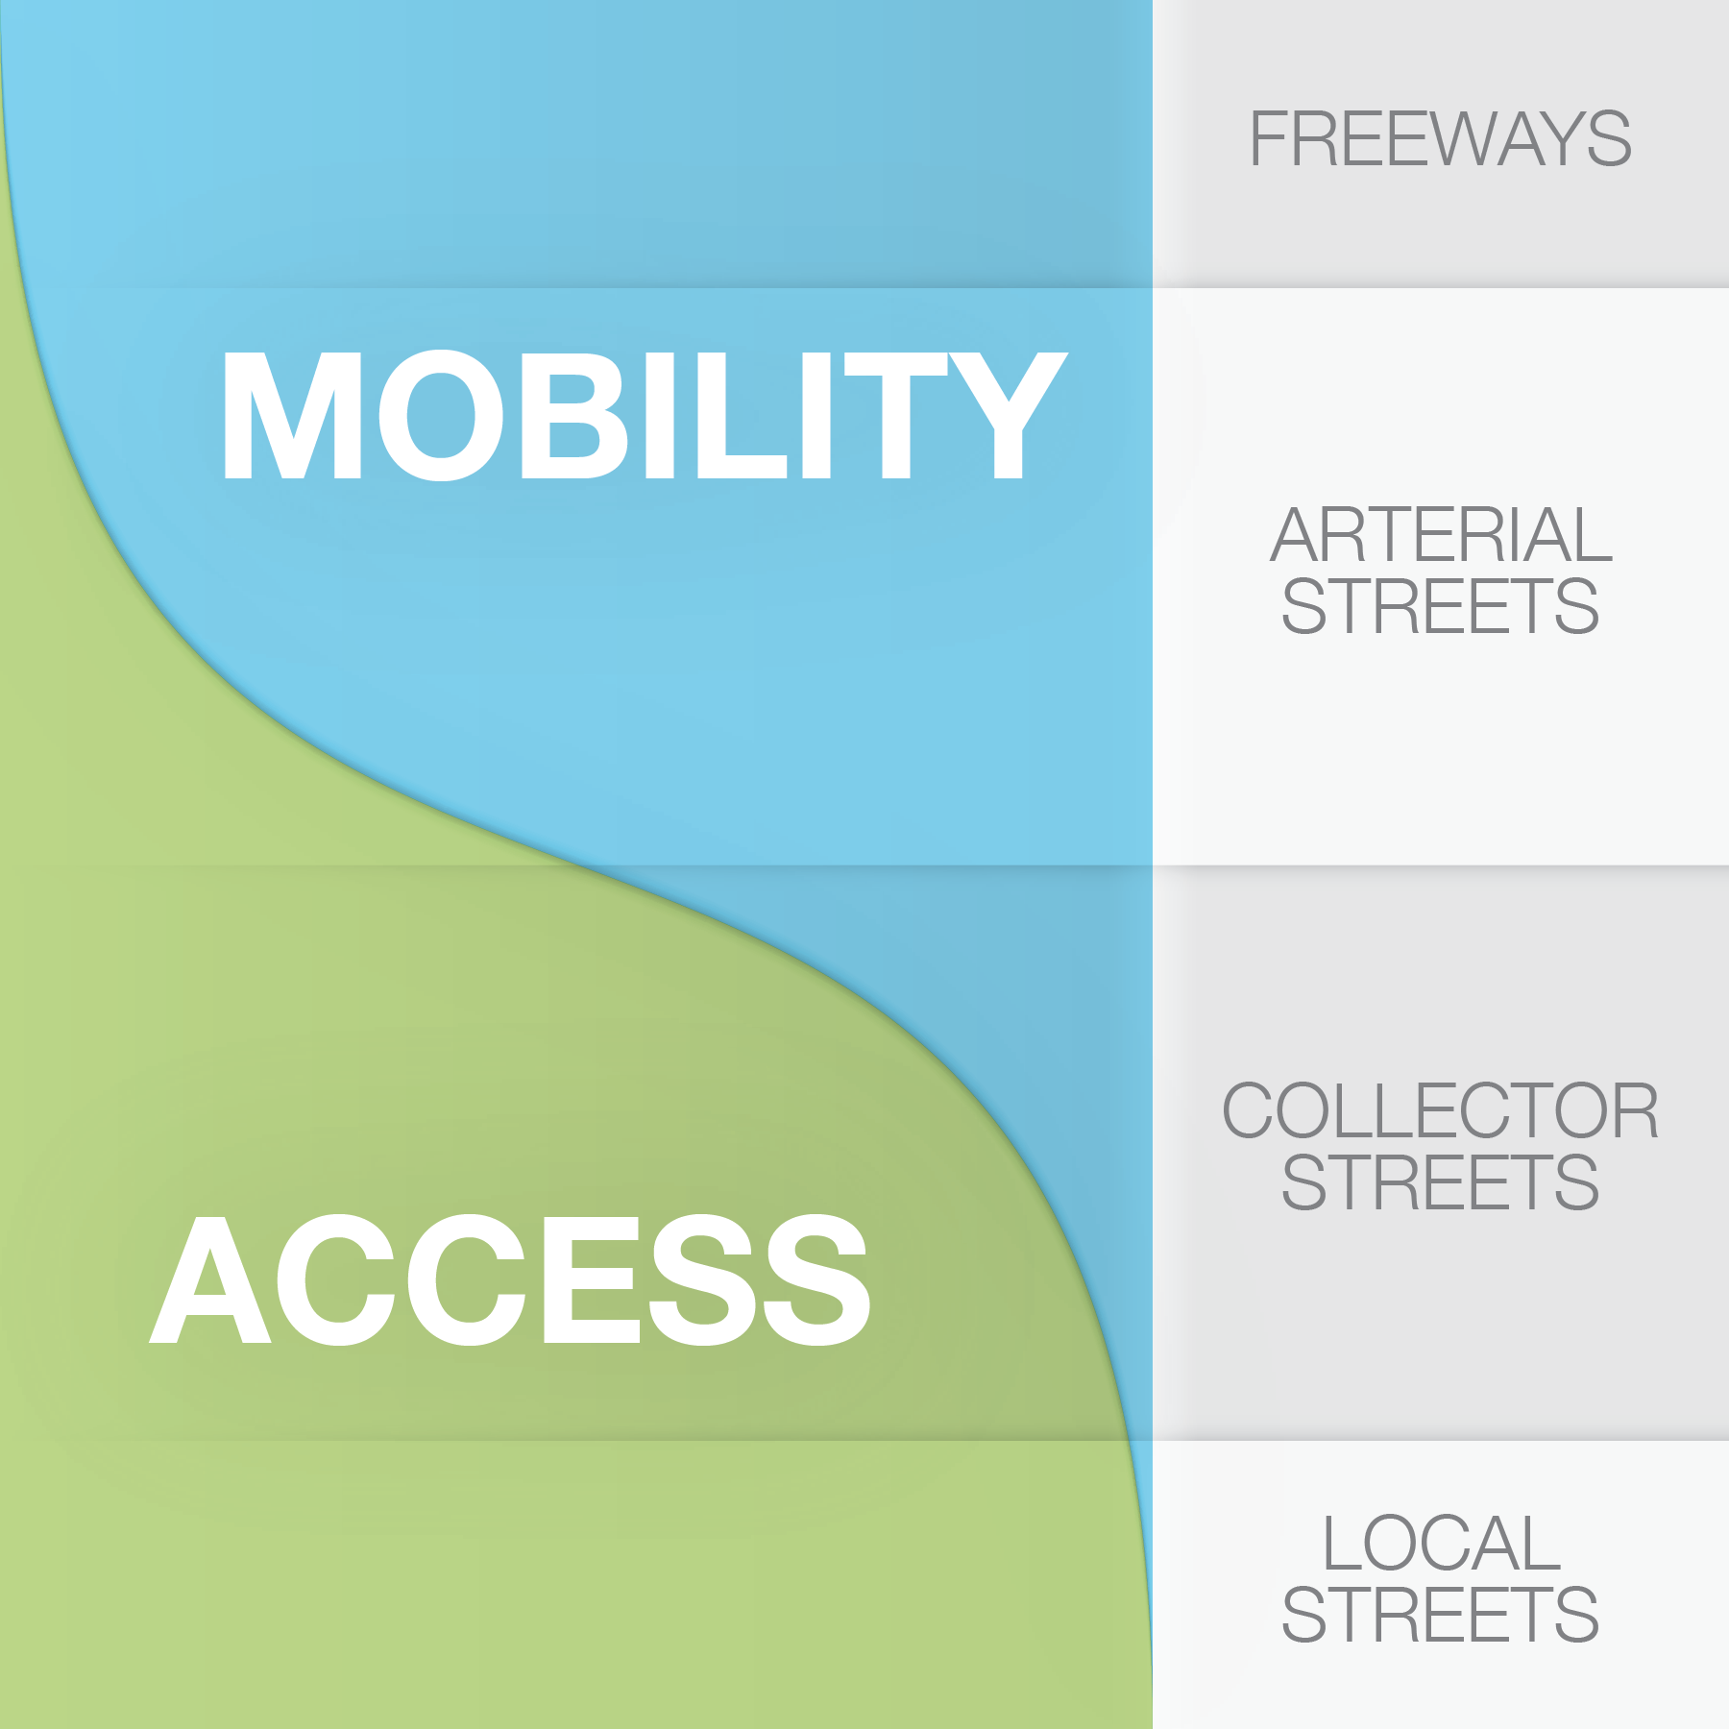
Exhibit 5-21. Roadway Functional Classification
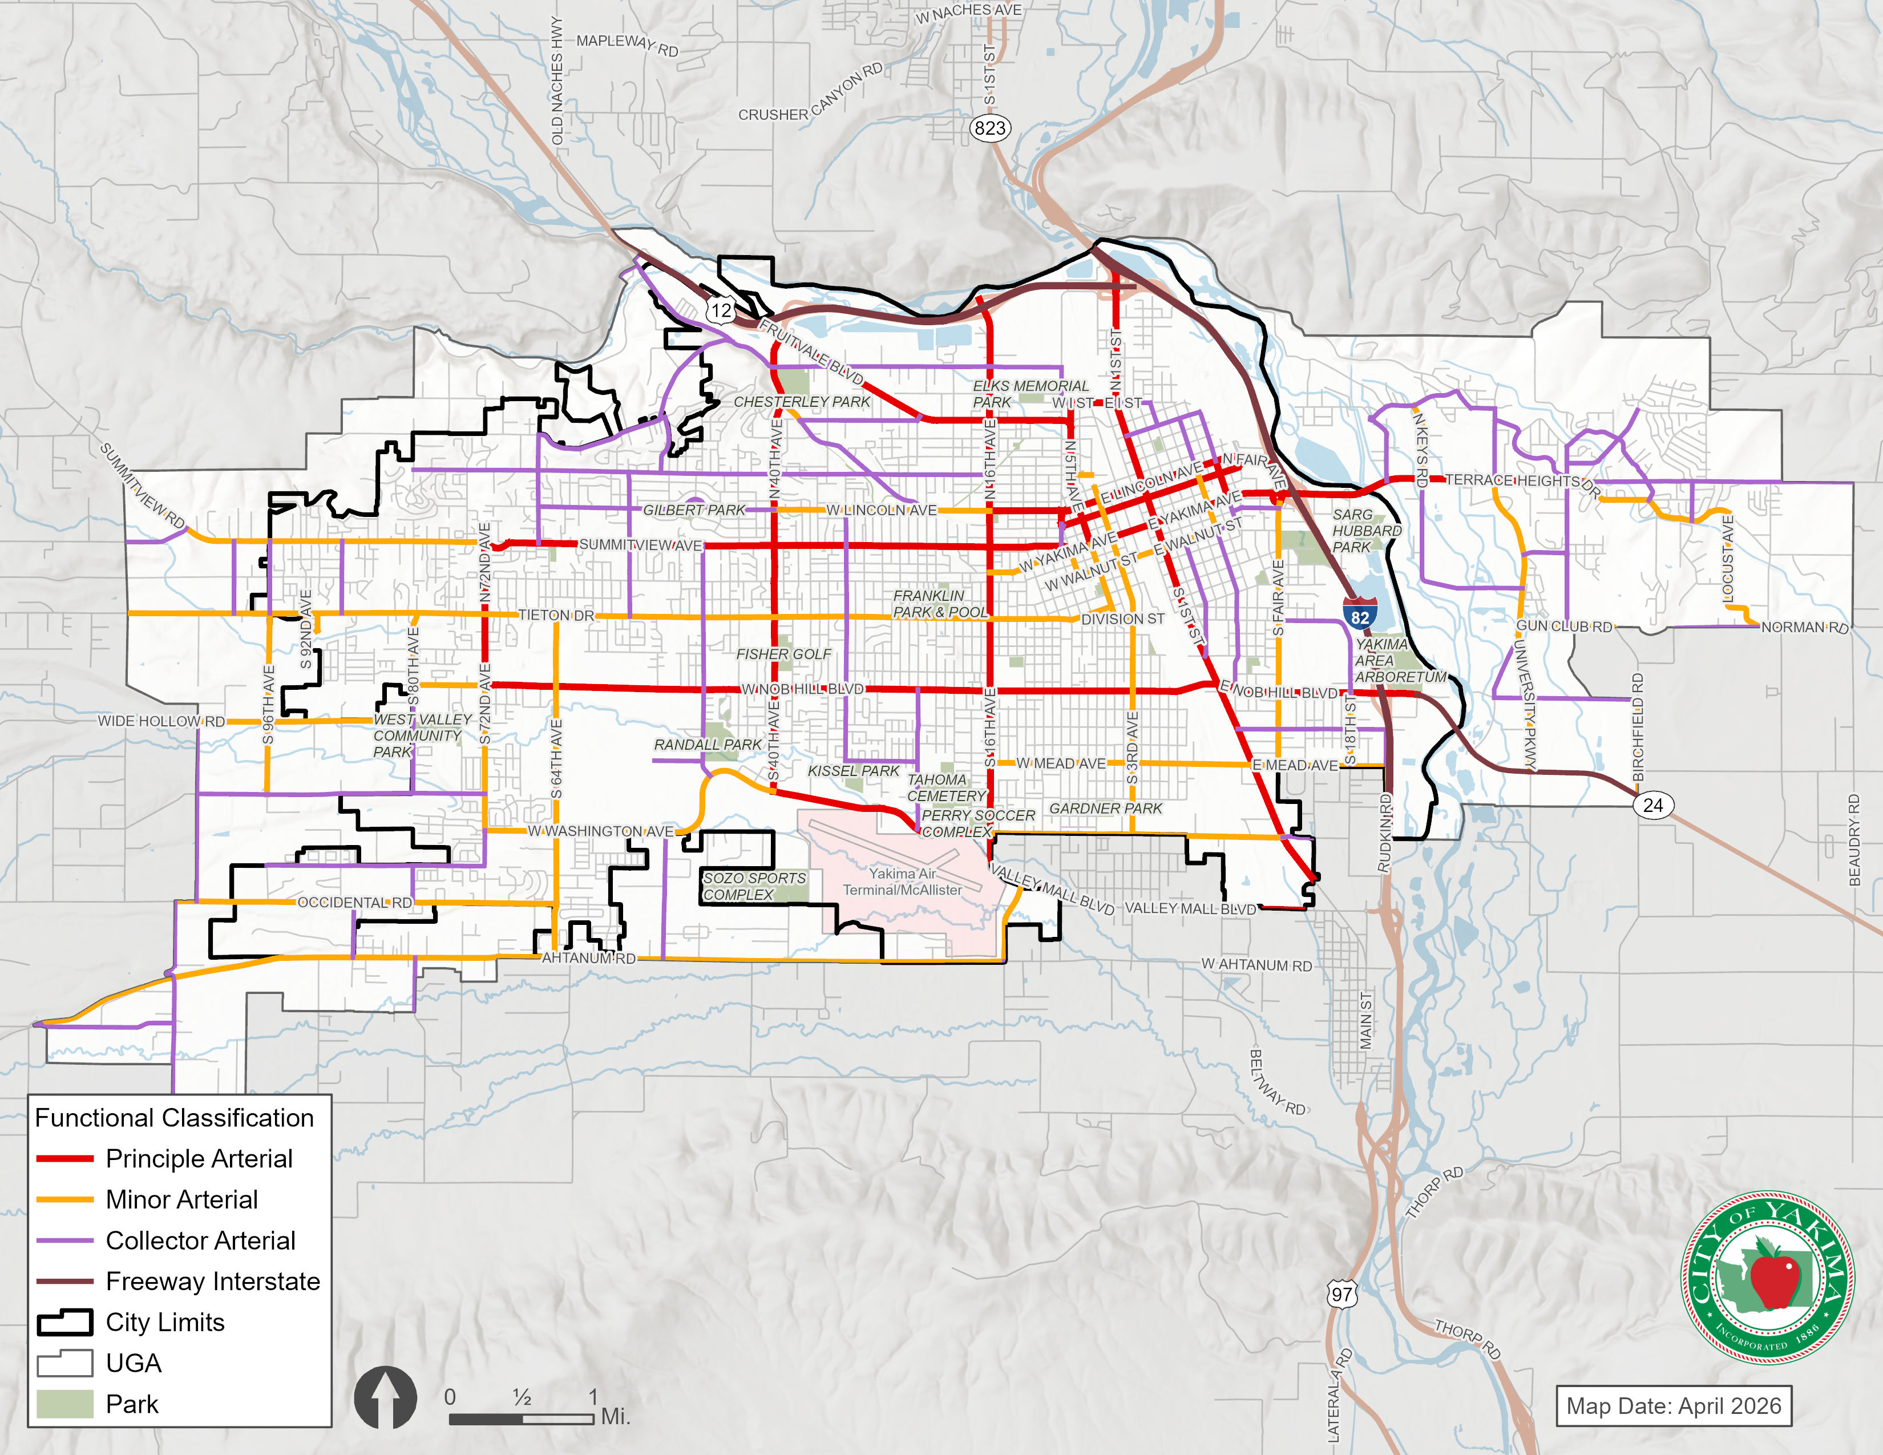

Exhibit 5-22. City of Yakima Functional Classification Definitions
Classification | Description
State  Highways | State Highways connect major regions with one another, and WSDOT classifies certain State highways as Highways of Statewide Significance.
Principal Arterials | Principal Arterials serve both local and through traffic entering and leaving the City and provide access to major activity centers within Yakima. The Principal Arterials also connect the minor arterial and collector street system to the freeways.
Minor  Arterials | Minor Arterial Streets support moderate-length trips and provide connections between neighborhoods and community/regional activity centers. There is a higher degree of access and lower vehicular travel speed than on major arterials.
Major  Collectors | Major Collectors are the intermediate street classification. They provide a link between local roadways and the arterial system providing a balance between access and mobility.
Local Streets | Local streets provide direct access to adjoining properties, commercial businesses, and similar traffic destinations. These roadways also provide traffic circulation within or through neighborhoods. Local streets typically carry low volumes of traffic, at relatively low speeds. Through traffic is generally discouraged through appropriate geometric design and/or traffic control devices.

Streets and state highways are the backbone of the transportation system serving the City of Yakima and surrounding communities. They provide for the overall movement of people and goods, for a wide range of travel modes. Streets and highways serve automobile trips, trucks, transit, vanpools, carpools, and the majority of bicycle and pedestrian travel. Therefore, the streets and highways establish the framework for the overall transportation system for the City.
Exhibit 5-23 highlights the highway and street system envisioned for the City of Yakima based on the size (number of lanes) and connectivity of City arterials and collectors. Most Principal Arterials are anticipated to be 4 to 5 lanes to best facilitate vehicular travel throughout the City. Existing Principal arterials limited to 4 lanes would be widened to 5 lanes where possible. Where widening Principal Arterials is impractical, then greater Access Management would be anticipated over time. Example corridors include 40th Street, 16th Street, 1st Street, Fruitvale Boulevard, Summitview Boulevard, Nob Hill Boulevard, and Valley Mall Boulevard.
Minor Arterials would be 3 to 5 lanes wide depending on anticipated traffic volumes in the area. Major Collectors would be limited to 2 to 3 lanes, with possible exceptions in commercial areas. Existing Major Collectors with 4 lanes would likely be reduced to 3 lanes in the future. Local streets are mostly 2 lanes with possible exceptions in commercial areas.

Exhibit 5-23. Highway and Street System Plan (2050 Planned Network)
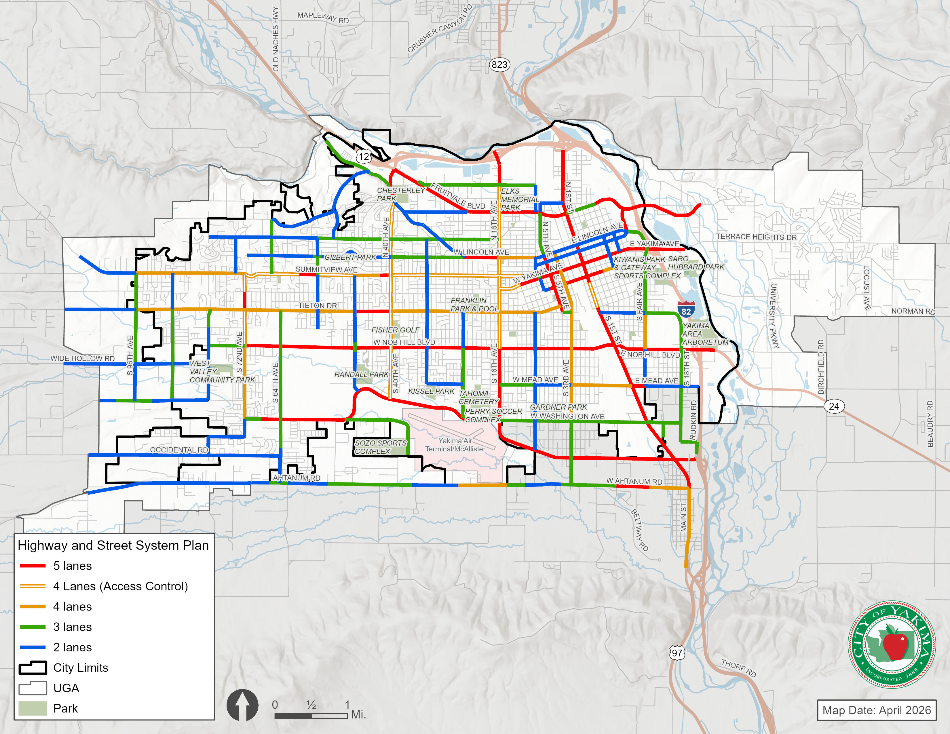
Other Street Classifications
The following classifications are included as reference. Federal and state classification systems serve different purposes from the City classifications, particularly as it relates to funding.
Federal Functional Classification
The Federal Functional Classification system provides a hierarchy of roadways as defined by the Federal Highway Administration (FHWA). This classification system defines the role of travel through a network of roadways, rather than focusing on individual roadways. As a result, the Federal Functional Classification differs in several ways from the City’s Functional Classification.
Changes to the Federal Functional Classification may be submitted through the Washington State Department of Transportation (WSDOT).
National Highway System
The National Highway System (NHS) includes the Interstate Highway System as well as other roads important to the nation’s economy, defense, and mobility as defined by the Federal Highway Administration (FHWA). Both I-82 and US 12 and are classified as NHS facilities.
Highways of Statewide Significance
WSDOT designates interstate highways and other principal arterials that are needed to connect major communities in the state as Highways of Statewide Significance (HSS). This designation assists with the allocation of some state and federal funding. These roadways typically serve corridor movements having travel characteristics indicative of substantial statewide and interstate travel. I-82 and SR 12 are HSS facilities.
Rail Crossings
Rail crossings are an important consideration when developing the Highway and Street System Plan. For safety and mobility reasons, Principal Arterials ideally would have grade-separated rail crossings. Fortunately, most of Yakima’s Principal Arterials cross rail lines with grade-separated structures (Lincoln Avenue, Martin Luther King Boulevard, Nob Hill Boulevard, and Valley Mall Boulevard). In addition, US 12 provides a major grade-separated crossing of the railroad corridor. In the long-term plan, an additional grade-separated crossing is anticipated between 5th Avenue and 1st Street north of downtown. This will reduce the crossing conflicts at nearby ‘I’ Street.
The Highway and Street System plan anticipates that the rail crossings at Yakima Avenue and 16th Avenue (both Principal Arterials) would remain at-grade.
Minor Arterials also have major rail crossings. Walnut Street is the only grade-separated crossing for a Yakima Minor Arterial. At-grade crossings are present at ‘I’ Street, Mead Avenue, and Washington Avenue. Changes to these routes or parallel routes are anticipated to reduce vehicle-rail conflicts in the future.
Pedestrian System Plan
Sidewalks, walkways, and multiuse trails are integral to the City’s overall transportation system. The City generally desires to have sidewalks or comparable pedestrian facilities on both sides of streets, unless special circumstances make it physically or cost prohibitive. In addition, safe crossings are desired at regular intervals along a corridor to discourage unsafe pedestrian and cyclist crossings of arterial roadways.
The City requires that new developments construct sidewalks on their internal streets and adjacent frontages. This process has helped the City convert the rural roadways developed under Yakima County road standards into the urban facilities needed to support the additional growth and higher traffic volumes within the City. Developer improvements will continue to provide for a large portion of the ultimate pedestrian system; however, even with those improvements some significant gaps would remain in sidewalks along arterial and collector corridors.
Exhibit 5-24 illustrates the priority pedestrian system plan for the City.
Most of the additional pedestrian facilities will be constructed as part of associated roadway projects or through sidewalk infill projects. These may be constructed as part of developer frontage requirements or as part of a capital project by the City of Yakima or another agency. In some corridors, pedestrian facilities will be provided through development of multi-use trails separated from the travel lanes.
Exhibit 5-24. Pedestrian System Plan

Bicycle System Plan
Exhibit 5-25 shows the planned bicycle system plan for Yakima and the surrounding areas. The bicycle system plan, provides comprehensive network of attractive bicycle facilities between the City’s residential neighborhoods, the transit system, employment areas, schools, and parks.
Exhibit 5-25. Bicycle System Plan

The bicycle facilities will include multiuse trails, protected bike lanes, buffered bike lanes, bike lanes, bike routes, and bicycle boulevards on lower volume roadways (see Exhibit 5-26). The 2017 bicycle master plan identified a skeleton network that, once built, would make connections with existing facilities and provide connections through downtown Yakima and to the Yakima Greenway. Many of these projects have yet to be completed, and these routes are considered part of the primary network. The primary bicycle routes indicate those corridors that have the highest priority for establishing a completely connected bicycle facility network. The secondary network indicates the arterials and collector streets that also should have basic bicycle facilities. Wide shoulders on higher speed roads and shared lane markings on low speed, low volume roads are appropriate bike facilities in the adjacent rural areas. Specific improvements for each corridor are identified, however project level planning and engineering studies are still required to determine feasibility on a project by project basis.
Exhibit 5-26. Examples of Bicycle Facilities
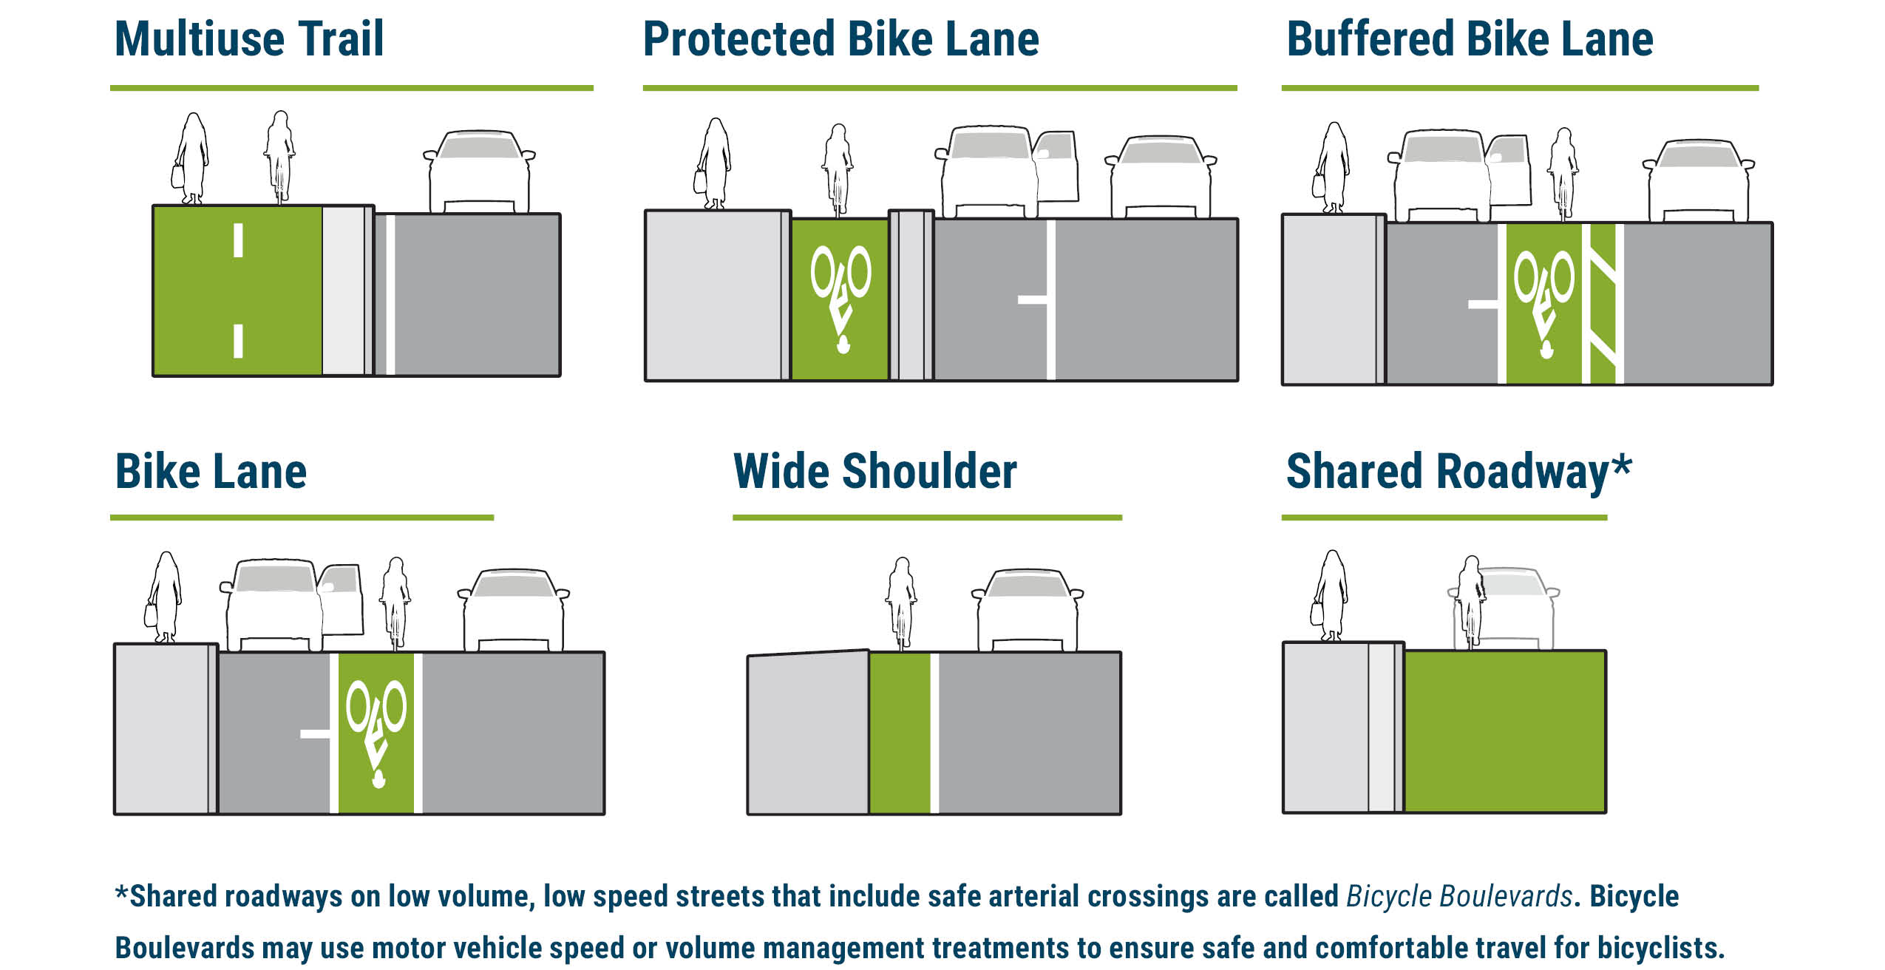

Bicycle facilities would be added along most key arterials and collectors, excluding most Principal Arterials due to high vehicle and truck volumes and limited right-of-way. Where routes parallel to busy arterials exist, neighborhood streets converted to shared bicycle boulevards will provide low stress connections between neighborhoods. The main east west corridors will be Chestnut Avenue in western Yakima and Walnut Street in eastern Yakima, Englewood Avenue in the North and Washington Avenue in the south. Major north-south bicycle corridors would be 64th Avenue, 44th Avenue, 32nd Avenue, 24th Avenue, 11th/10th Avenue (south of Walnut Street), and 5th Avenue (north of Walnut Street). Direct connections to the Yakima Greenway and Cowiche Canyon trails are also provided.
Key investment priorities include completion of short gaps in the existing bike lane system, construction of continuous bike lanes and bicycle boulevards which provide alternatives to bicycling on arterials, and connecting neighborhoods to destinations like schools and parks.
Freight System Plan
The City of Yakima has a significant level of truck activity. With increased commercial and employment growth forecast through 2040, the level of truck activity will also increase. To systematically address the needs of future truck travel, the City has adopted a defined system of truck routes.
As shown in Exhibit 5-31, the Truck Route system generally connects freight generating areas with I-82 and US 12. In northwest Yakima, Summitview Avenue and 40th Avenue are the major routes. In northeast Yakima, 16th Avenue and 1st Avenue connect Fruitvale Boulevard and Downtown areas to US 12. Yakima Avenue, Lincoln Avenue, and Martin Luther King Boulevard connect downtown areas to I-82. In southeast and southwest Yakima, Nob Hill Boulevard, Washington Avenue, Valley Mall Boulevard, and Ahtanum Road connect areas to I-82.
Exhibit 5-27. Truck Route Classification
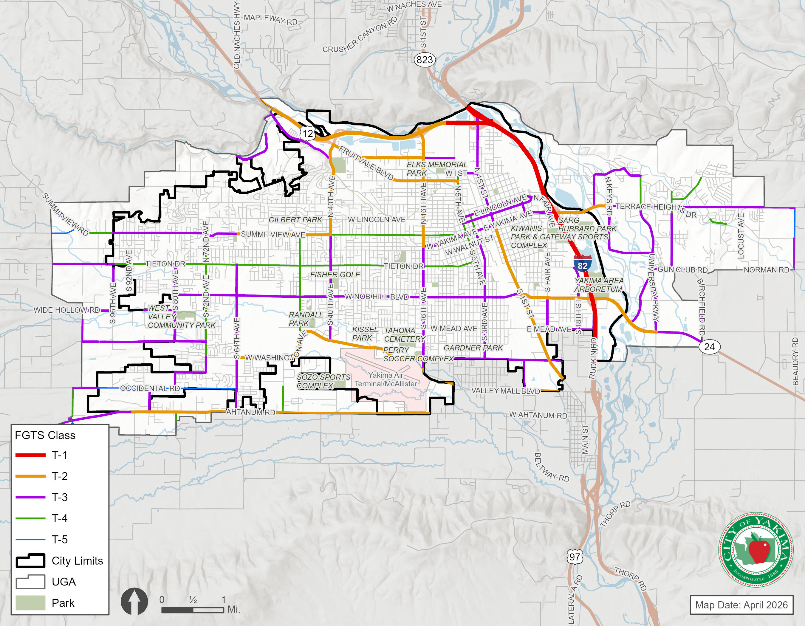
No significant changes to the freight network as planned as part of the 2050 systems plan.

Street Design Guidelines
The Street Design Guidelines are an integral part of implementing the Transportation System Plan. The Functional Classification and Travel Context Classification work together to inform City staff on the type of cross-section that would be anticipated for each roadway segment.
Exhibit 5-28 shows the Street Design Guidelines for the City of Yakima. For Principal Arterials, only the Auto Priority and Shared Priority classifications are relevant. For Minor Arterials and Collectors, all three Travel Context Classifications are provided. The following are general observations about each design element.
- Posted Speeds. Vehicle speeds would be 30 mph or less where bicyclist are anticipated. Otherwise arterial speeds could be 35 to 40 mph.
- Number of Travel Lanes. Number of lanes would be dictated by the Highway and Street System Plan.
- Center Median. For safety and mobility reasons, a center median is always recommended on arterials and collectors.
- Travel Lane Widths. Auto priority areas would have wider lanes (12 feet), otherwise narrower lanes are recommended. This does not include any width for shoulders or buffers.
- Shoulder/Buffer. Buffers would always be recommended, especially adjacent to bike facilities.
- Bike Facilities. Facilities would not be recommended on higher speed facilities. Elsewhere they would be recommended or required.
- On-Street Parking. Parking would only be provided on lower speed minor arterials and collectors.
Exhibit 5-28. Street Design Guidelines

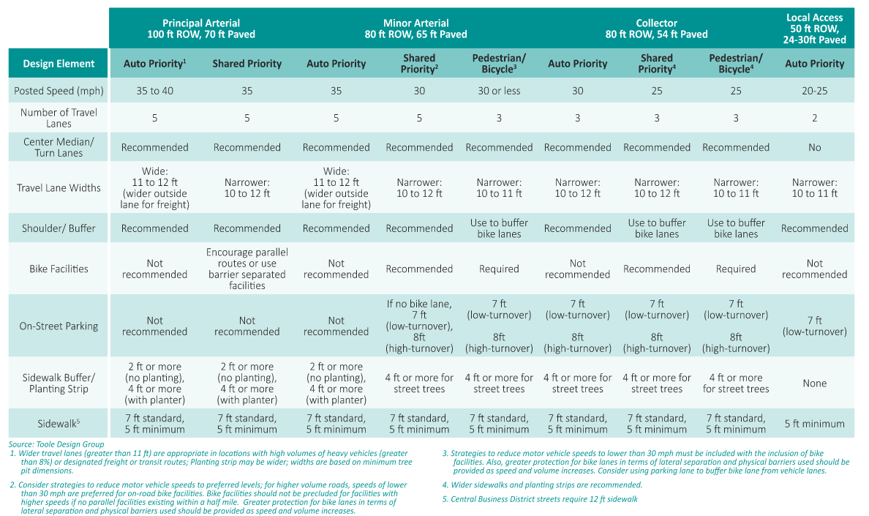
Transit and Transportation Demand Management
To provide a comprehensive transportation system, the City of Yakima recognizes the importance of transit and transportation demand management (TDM) programs. In general, these programs build on regional programs with some refinements to reflect the specific needs of the City.

Transit System
Transit service in the Yakima area is provided by Yakima Transit. Yakima Transit has submitted to WSDOT a six-year Transit Development Plan (TDP) for the period 2025 to 2030. The TDP provides a framework to guide Yakima Transit’s service delivery through the next six years. The City should continue to work with Yakima Transit to improve transit services and develop a convenient, integrated and efficient transit system that supports future growth.
Yakima Transit’s 6-year TDP identifies a variety of investments targeted at bringing back service. Besides capital investments in vehicle replacements and equipment upgrades, Yakima Transit also plans to have a new “Base of Operations” property as well as a new westside Transfer Station by the end of 2030.

TDM Programs
The expansion of existing TDM programs are recommended to reduce the overall amount of travel by single-occupancy vehicles within the City. TDM programs are coordinated with regional agencies such as Yakima County, Yakima Transit and Yakima Valley Conference of Governments (YVCOG).
The City of Yakima identifies Commute Trip Reduction (CTR) policies in the City’s Bicycle Master Plan, which includes policies found in the Yakima Valley Regional Transportation Plan (RTP) (see Chapter 1 of the Bicycle Master Plan). The YVCOG discusses components of the CTR program including:

- Ridesharing - Employers can develop and maintain a database of home addresses to facilitate carpool and vanpool matching between employees working on the same site. Employers can also provide financial incentives or reserved parking spaces for carpool and vanpool vehicles.
- Flexible and Alternative Work Schedules – Flexible work hour schedules allow employees to adjust start/end times to accommodate carpools, vanpools, or transit options. Alternative work schedules can also be used to reduce the number of days an employee commutes during peak travel periods. These programs help reduce the need for adding capacity to highways and arterials, and reduce the levels of peak hour congestion.
- Telecommuting – The use of telecommunications technology can allow some employees to work from home, reducing the need for travel to and from a work site for some work days.
- Secured Bicycle Parking and Showers – Secured bicycle parking could be provided near major employment centers, preferably in a covered, weather-protected area. Shower facilities at work sites are also desirable to encourage commuting by bicycle.

Transportation Projects and Programs
The City has identified a comprehensive list of multimodal transportation system improvement projects and programs. The multimodal improvement projects address transportation needs within the existing City limits. It also identifies improvement projects within the City’s unincorporated UGA needed to serve future growth within the area as it is annexed. Improvements under other jurisdictions include previously identified projects as well as potential improvements identified by the City of Yakima. The City will continue to coordinate with the other agencies in their transportation planning efforts to facilitate development of a comprehensive transportation system for the City and surrounding communities.
Each of the projects have been assigned a likely timing horizon of short-range (2027-2032), mid-range (2033-2040), and long-range (2040-2050). The timing blends the relative priority of each project with the likely timing to be able to fund, design, and construct an improvement project. The timing horizon also takes into consideration the availability of funding, which is presented in Chapter 5.
Planning level cost estimates were prepared for each project under the jurisdiction of the City of Yakima. The planning level cost estimates are based on typical unit costs for different project types. The cost estimates also account for potential right-of-way acquisition, and engineering design Costs of specific needs such as a bridge or major power lines are also incorporated, at a planning level. All cost estimates are reported in 2026 dollars.
The projects were categorized as follows:
- Intersection Improvements include upgrading intersections through added turn lanes or modifications to traffic controls. Where applicable, improvements may also include upgrading traffic signals and implementing Intelligent Transportation Systems (ITS), which could encompass modifications to vehicle detection and coordinated signal timing.
- Active Transportation improvements add pedestrian and bicycle facilities to roadways or construct off-street multiuse pathways to complete gaps in the existing non-motorized network.
- Study includes further analysis and evaluation to develop more detailed improvement projects and cost estimates.
- Roadway Improvements include modifying roadways to current City design standards and incorporating multimodal improvements to serve higher traffic volumes and non-motorized travel.
- New Roadway includes constructing new arterials or collector roads, including non-motorized facilities.

Roadway and intersection improvement projects are shown in Exhibit 5-29 and described in Exhibit 5-30, while active transportation projects are shown in Exhibit 5-31 and described in Exhibit 5-32.
Exhibit 5-29. Roadway and Intersection Improvement Projects
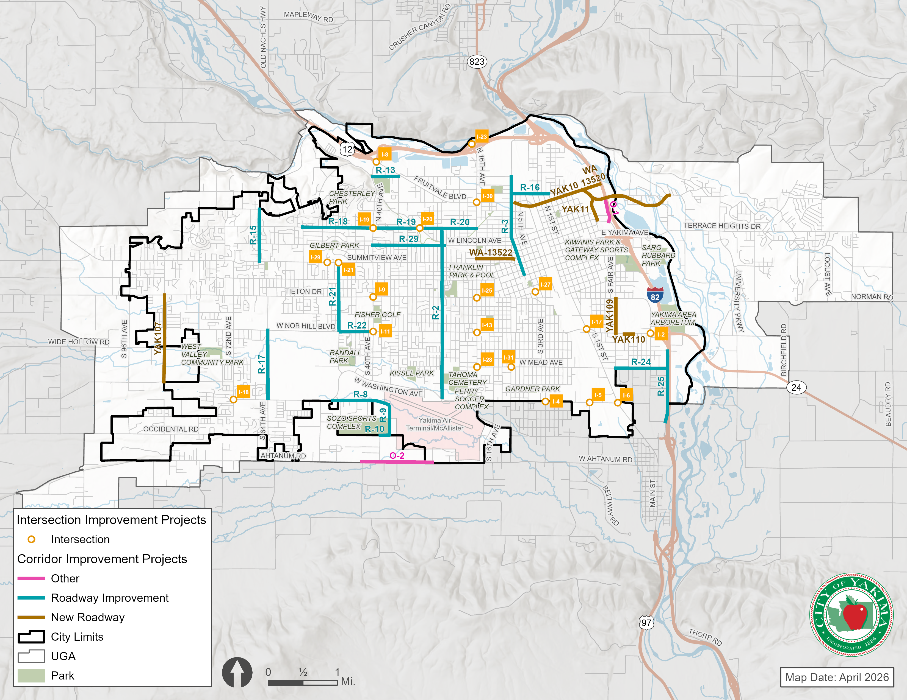
Exhibit 5-30. Roadway and Intersection Improvement Projects and Recommended Studies
ProjectID | Project Name | Location | Description | Time Frame | Cost
YAK84 | 16th Avenue Improvements |  | Reconstruct and widen 16th Avenue and Tieton drive by adding left-turn lanes for all movments at the in tersection. Upgrade the traffic signal | Short | $ 4,037,700
WA-14955 | Coolidge Rd - Roadway Improvements | 72nd Avenue to 84th Avenue | Rehabilitate existing pavement and update roadway to current city standards | Short | $ 1,500,000
YAK102 | N 1st Street & R Street Signal | Intersection | Install Traffic signal at the intersection | Short | $ 468,889
WA-15735 | Nob Hill Blvd 28th Ave to 40th Ave Paving | 28th Avenue to 40th Avenue | This project will rehabilitate the pavement on Nob Hill Blvd by milling and paving,  ADA curb ramp replacement, adjust utilities, restripe the road, and other work as  needed to rehabilitate the pavement. | Short | $ 1,414,000
WA-15881 | Nob Hill RR #2 and 72nd Ave S #87 Bridges - Joint Replacement | Nob Hill Blvd to 72nd Avenue | Replace expansion joints on the Nob Hill RR #2 bridge and expansion joints and girder grout channels on the 72nd Ave S #87 bridge. | Short | $ 1,172,552
YAK104 | Tieton Drive Resurfacing | S. 48th Ave. to S. 72nd Ave. | Grind and overlay, and ADA curb ramp replacement. | Short | $ 1,386,000
WA-15913 | Yakima Valley Trolley Bridge Rehabilitation | Naches River to Naches River | The project will complete repairs to the Yakima Valley Trolley Bridge over the Naches River. Repairs include removing and replacing decayed timber elements, regrading and compacting approach fills, replacements of the timber sill footings and the timber backwall, and scour protection of a bridge pier | Short | $ 653,000
I-2 | Nob Hill Blvd / 18th St Intersection Improvements | Intersection | Provide dual southbound left-turn lanes. Add westbound right-turn lane. Install curb, gutter, sidewalk, upgrade traffic signal system. Coordinate with Project I-13 (trail connection). | Medium | $ 910,000
I-4 | 3rd Ave / Washington Ave Intersection Improvements | Intersection | Upgrade the traffic signalization system | Medium | $ 400,000
YAK14 | Washington Ave / Longfiber Rd Intersection Improvements | Intersection | Improve the Washington Avenue and Longfiber Road intersection by constructing an eastboung left-turn lane on Washington and a northbound left-turn lane on Longfiber, install or replace curb, gutter, sidewalk, street lighting, storm drainage and safety flashing signal. Project may be removed or changed based on Washington Avenue study findings. | Short | $ 1,000,000
YAK108 | 1st St / Washington Ave Intersection Improvements | Intersection | Realign intersection, widen E. Washington Avenue to accommodate an additional lane, replace curb, gutter and sidewalk, and install a new traffic signalization system. Project may be removed based on Washington Avenue study findings. | Long | $ 2,710,000
I-7 | 72nd Ave / Tieton Dr Intersection Improvements | Intersection | Set standard at LOS E. Add dual left-turn lanes when needed. | Long | $ 10,530,000
I-9 | 40th Ave / Tieton Dr Intersection Improvements | Intersection | Set standard at LOS E. Add dual left-turn lanes when needed. Project may change based on 40th Avenue Access Management Plan | Long | $ 10,530,000
I-10 | 40th Ave / Summitview Ave Intersection Improvements | Intersection | Improve the intersection by constructing larger corner radii, lengthening the turn lanes, and upgrading the traffic signal system. Project may be modified based on 40th Avenue Access Management Corridor Study findings. | Medium | $ 1,920,000
I-11 | 40th Ave / Nob Hill Blvd Intersection Improvements | Intersection | Set standard at LOS E. Add dual left-turn lanes when needed. Project may change based on 40th Avenue Access Management Plan | Long | $ 10,530,000
I-12 | 16th Ave / Lincoln Ave Intersection Improvements | Intersection | Set standard at LOS E. Add dual left-turn lanes when needed. Project may change based on 16th Avenue Access Management Plan and Lincoln Ave/MLK Bvd Realignment Study. | Long | $ 10,530,000
I-13 | 16th Ave / Nob Hill Blvd Intersection Improvements | Intersection | Set standard at LOS E. Add dual left-turn lanes when needed. Project may change based on 16th Avenue Access Management Plan | Long | $ 10,530,000
I-15 | 1st St / I St Intersection Improvements | Intersection | Set standard at LOS E. Add dual left-turn lanes when needed. | Long | $ 10,530,000
I-16 | 3rd Ave / Nob Hill Blvd Intersection Improvements | Intersection | Set standard at LOS E. Add dual left-turn lanes on northbound and southbound approaches when needed. | Long | $ 5,260,000
I-17 | Nob Hill Blvd / 1st St Intersection Improvements | Intersection | Set standard at LOS E. Add dual left-turn lanes when needed. | Long | $ 12,280,000
YAK98 | 72nd Ave / Washington Ave Intersection Improvements | Intersection | Improve intersection by installing a traffic signal system or roundabout. | Medium | $ 2,000,000
I-19 | 40th Ave / Englewood Ave Intersection Improvements | Intersection | Replace traffic signal poles and upgrade controller. | Medium | $ 610,000
I-20 | Powerhouse Rd / Englewood Ave Intersection Improvements | Intersection | Construct single-lane roundabout. If not possible, realign intersection, install curb, gutter, sidewalk and safety flashing signal. | Short | $ 1,014,431
I-21 | 48th Ave / Summitview Ave Intersection Improvements | Intersection | Install traffic signal at the intersection of Summitview Avenue and 48th Avenue. | Medium | $ 1,220,000
I-22 | Washington Ave / 40th Ave Intersection Improvements | Intersection | Convert one northbound lane to a southbound left-turn lane to provide dual left-turn lanes. Update signal and lane markings at intersection to match. | Medium | $ 350,000
I-23 | SR 12 / 16th Ave Interchange Improvements | Interchange: SR 12 Ramps / 16th Avenue | Construct a roundabout where the westbound ramps intersect with N. 16th Avenue. Coordinate with I-13 project. | Medium | $ 2,630,000
I-24 | 16th Ave / Fruitvale Blvd Intersection Improvements | Intersection | Improve the intersection by constructing larger curb radii, installing ADA ramps, and upgrading the traffic signal system. | Medium | $ 1,410,000
I-26 | 16th Ave / Washington Blvd Intersection Improvements | Intersection | Widen south leg to provide exclusive dual left-turn lanes. Project may change based on Washington Ave corridor study. | Medium | $ 490,000
I-27 | Tieton Dr / 5th Ave Intersection Improvements | Intersection | Remove existing traffic signal and construct a roundabout, remove and replace curb, gutter, sidewalk, street lighting and drainage | Medium | $ 2,110,000
I-28 | 16th & Mead Intersection Improvements | Intersection | Add pedestrian signal or full traffic signal pending MUTCD signal warrant | Short | $ 750,000
I-29 | Summitview & 50th Intersection Improvements | Intersection | Add traffic signal at Summitview & 50th intersection | Long | $ 750,000
I-30 | 16th & Fruitvale | Intersection | Add Traffic Signal or Roundabout at 16th & Fruitvale Intersection | Short | $ 2,285,100
I-31 | Mead Ave and 10th Ave | Intersection | Mead Avenue Pedestrian Signal at 10th Avenue | Short | $ 250,000
S-1 | 40th Ave Access Management Plan (SR 12-Washington) | 40th Ave: SR 12 to Washington Ave | Study to determine plan for access management and spot intersection improvements to improve vehicle capacity and safety for all travel modes in corridor. | Medium | $ 880,000
S-2 | 16th Ave Access Management Plan (SR 12-Washington) | 16th Ave: SR 12 to Washington Ave | Study to determine plan for access management and spot intersection improvements to improve vehicle capacity and safety for all travel modes in corridor. | Medium | $ 880,000
S-3 | Lincoln Ave & MLK Blvd Realignment Study (Auto and Bike Mobility) | Lincoln Avenue: 16th Ave to 5th Ave; Pierce Ave: Lincoln Ave to Summitview Ave | Study the option of orienting the west end of the Lincoln/MLK couplet south to Summitview, and converting Lincoln Ave (16th to Pierce) to 3 lanes with bike lanes. Pierce Ave would be widened (to the east) to 5 lanes between Summitview Ave and MLK Blvd. Intersection of Summitview Ave/Pierce Ave would have dual eastbound left-turns and dual southbound right turns. Need to improve both auto and bike east-west mobility in area. | Medium | $ 440,000
S-4 | Washington Ave Corridor Study | Washington Ave: 16th Ave to 1st St | Study feasibility of converting corridor from 4 lanes to 3 lanes. Could reduce or eliminate need for improvements at 16th St, Longfiber Rd, and 1st St. Increases safety along corridor and reduces conflicts at the at-grade railroad crossing. | Medium | $ 260,000
S-5 | West Valley North/South Corridor (Ahtanum-Summitview) | North-South Corridor West of 80th Ave: Ahtanum Rd to Summitview Ave | Corridor study to determine the best location for a north/south limited access vehicle corridor in West Valley. City and County joint project. | Long | $ 880,000
S-6 | Citywide Speed Limit Study | Citywide | Conduct a comprehensive speed limit study to determine appropriate speed limits for all roadways across the city. | Short | $ 150,000
YAK10 | H St Extension, Phase 1 (1st-10th) | 'H' St: 1st St to 10th St | Construct new 3-lane roadway including water, sewer, curb, gutter, sidewalk, street lighting and storm drainage system. | Short | $ 7,470,000
R-2 | 24th Avenue Bike Corridor (Inglewood-Washington) | 24th Ave: Inglewood Ave to Washington Ave | Convert 4-lane street to 3-lane street with bike lanes between Washington and Nob Hill. Wayfinding throughout corridor. | Medium | $ 350,000
R-3 | 6th Avenue Rehabilitation (Walnut-River) | 6th Avenue, Walnut St to River Rd | Reconstruct the existing trolley rail and impacted roadway, grind and overlay the remaining width of 6th Avenue. | Medium | $ 7,720,000
R-5 | Linclon/MLK Bike Corridor | Along Lincoln Ave, 5th Ave to 10th St; Along MLK Blvd, 5th Ave to 10th St; Along Fair Ave, 10th St to Yakima Ave | Along Lincoln Ave and MLK Blvd, reduce vehicle lanes to 2 and add buffered/protected bike lanes. Add signage/markings to completed full corridor. | Medium | $ 880,000
R-6 | Yakima Downtown Future Initiatives, Phase 5 | Yakima Ave Corridor Area: 1st St to 9th St | Install historic lighting, sidewalk modifications and other improvements. Exact improvement area(s) to be determined. | Medium | $ 10,530,000
R-7 | Yakima Ave Bridge Replacement (18th St) | Yakima Ave / 18th Street Crossing | Replace the bridge on E. Yakima Avenue that crosses over 18th Street. Consider lowering 18th Street to accommodate larger vehicles. | Medium | $ 5,540,000
R-8 | Spring Creek Rd Widening (Washington-36th) | Spring Creek Rd: Washington Ave to 36th Ave | Widen roadway to 3 lanes, install curb, gutter, sidewalk and street lights. | Short | $ 3,370,000
R-9 | 36th Ave Widening (Spring Creek-Sorenson) | 36th Ave: Spring Creek Rd to Sorenson Rd | Widen roadway to 3 lanes, install curb, gutter, sidewalk and street lights. | Short | $ 1,590,000
R-10 | Sorenson Rd Widening (36th-38th) | Sorenson Rd: 36th Ave to 38th Ave | Widen roadway, install curb, gutter, sidewalk and street lights. | Short | $ 560,000
R-11 | 80th Ave Bridge Widening (Wide Hollow Creek) | 80th Ave: Wide Hollow Rd to Plath Ave | Replace existing two-lane bridge over Wide Hollow Creek with three-lane bridge. The City's involvement is only to pass through of an Ecology grant in conjunction with the County's flood plain management project. | Short | $ 180,000
R-12 | Wide Hollow Rd Bridge Widening (Wide Hollow Creek) | Wide Hollow Rd: 89th Ave to 88th Ave | Replace existing two-lane bridge over Wide Hollow Creek with three-lane bridge. The City's involvement is only to pass through of an Ecology grant in conjunction with the County's flood plain management project. | Short | $ 180,000
R-13 | River Rd Improvements (40th-36th) | River Rd: 40th Ave to 36th Ave | Upgrade road to urban standards and add bike facilities. | Short | $ 2,630,000
R-15 | 66th Ave Widening (Summitview-Scenic) | 66th Ave: Summitview Ave to Scenic Dr | Reconstruct and widen roadway to three lanes, install curb, gutter, sidewalk, storm drainage system and utilities. | Medium | $ 2,740,000
R-16 | I Street (6th Ave-3rd St) | Along I St, 6th Ave to 3rd St | Upgrade street to urban standards by constructing curb, gutter, sidewalk, and bike lanes. Keep at two vehicle lanes, no center vehicle median. | Medium | $ 7,260,000
R-17 | 64th Ave Widening (Washington-Nob Hill) | 64th Ave: Washington Ave to Nob Hill Blvd | Widen roadway to three lanes, install curb, gutter, sidewalk, street lighting and storm drainage system. | Medium | $ 3,650,000
R-18 | Englewood Ave Widening (40th-56th) | Englewood Ave: 40th Ave to 56th Ave | Widen roadway to three lanes, install curb, gutter, sidewalk, street lighting and storm drainage system. | Medium | $ 2,990,000
R-19 | Englewood Ave Widening (24th-40th) and Bike Corridor Connection | Englewood Ave: 24th Ave to 40th Ave | Reconstruct and widen roadway to three lanes, install curb, gutter, sidewalk, street lighting and storm drainage system. Install sewer and water lines. Add bike lanes to corridor. | Medium | $ 6,760,000
R-20 | Englewood Ave Widening (16th-24th) | Englewood Ave: 16th Ave to 24th Ave | Widen roadway to three lanes, install curb, gutter, sidewalk, street lighting and storm drainage system, water and sewer lines. Add bike lanes to corridor. | Medium | $ 5,980,000
R-21 | 48th Avenue Widening (Summitview-Nob Hill) | 48th Ave: Summitview Ave to Nob Hill Blvd | Reconstruct and widen 48th Avenue, install curb, gutter, sidewalk, street lighting and drainage system. | Medium | $ 4,520,000
R-22 | Nob Hill Widening (40th-48th) | Nob Hill Blvd: 40th Ave to 48th Ave | Widen corridor to 5 lanes | Medium | $ 2,910,000
R-24 | Mead Ave Reconstruction (Rudkin-Fair) | Mead Ave: Rudkin Rd to Fair Ave | Partner with Union Gap to reconstruct E. Mead Avenue, install curb, gutter, sidewalk and storm drainage system. | Medium | $ 3,790,000
R-25 | Rudkin Rd Reconstruction (Viola-Rainier) | Rudkin Rd: Viola Ave to Rainier Pl | Reconstruct roadway, install curb, gutter, sidewalk and storm drainage. Partner with Union Gap to install additional sewer force main. | Medium | $ 3,740,000
R-26 | 1st St Revitalization, Phase 1 (N St-SR 12) | 1st St: 'N' St to SR 12 | Improve North 1st Street by rehabilitating the pavement and lane markings, removing on- street parking, enhancing street and pedestrian lighting, constructing median islands and installing various pedestrian and decorative elements. | Short | $ 5,510,000
R-29 | Lincoln Ave Safety Improvements (40th-Powerhouse) | Lincoln Ave: 40th Ave to Powerhouse Rd | Convert 4-lane street to 3-lane street with bike lanes. | Medium | $ 740,000
YAK11 | Bravo Company Blvd Extension (H-Lincoln) | 10th St: 'H' St to Lincoln Ave | Construct new 5-lane roadway including water, sewer, curb, gutter, sidewalk, street lighting and storm drainage system. Connects new East-West corridor in Mill Site to Lincoln/MLK corridor. | Short | $ 6,000,000
WA-13520 | H St Extension, Phase 2 (10th-I 82) | H' St: 10th St to I-82 | Construct 5-lane new roadway including water, sewer, curb, gutter, sidewalk, street lighting and storm drainage system. Creates Mill Site east-west roadway. | Short | $ 6,500,000
N-4 | Fruitvale Blvd to H Street Connection (5th-1st) | New arterial roadway between Fruitvale Blvd/5th Ave intersection and 1st St/H St intersection. | Contruction new arterial roadway to connect the Fruitvale Blvd and H St corridors to provide a continuous east-west corridor. RR crossing would be grade separated. | Long | $ 43,850,000
N-5 | H St Extension, Phase 3 (I 82-Butterfield) | H' St: I-82 to Butterfield Rd | Complete new east-west corridor across the Yakima River to Butterfield Road | Medium | $ 87,710,000
O-1 | I-82 / Yakima Ave Interchange Improvements | I-82 Corridor: SR 12 to Nob Hill | Reconstruct/extend off-ramp from existing I-82 offramp for Lincoln Avenue (Fair Avenue) to vicinity of 'G' Street (the new east-west corridor). Construct Collector-Distributer (CD) roads and auxilary lanes along I-82. Construct new diamond interchange with 'H' Street extension. Connect 'H' Street ramps and Yakima Avenue interchange ramps to CD roads. Fair Ave Loop connector converted to limited access one-way road (right-in from Yakima, right-out to Fair Ave). | Medium | $ 131,560,000
O-2 | Ahtanum Road | Ahtanum Road from 26th Avenue to 42nd Avenue | Reconstructing and widening roadway to three lanes, with a separated bike/pedestrian pathway. | Short | $ 11,510,000

Exhibit 5-31. Active Transportation Improvement Projects
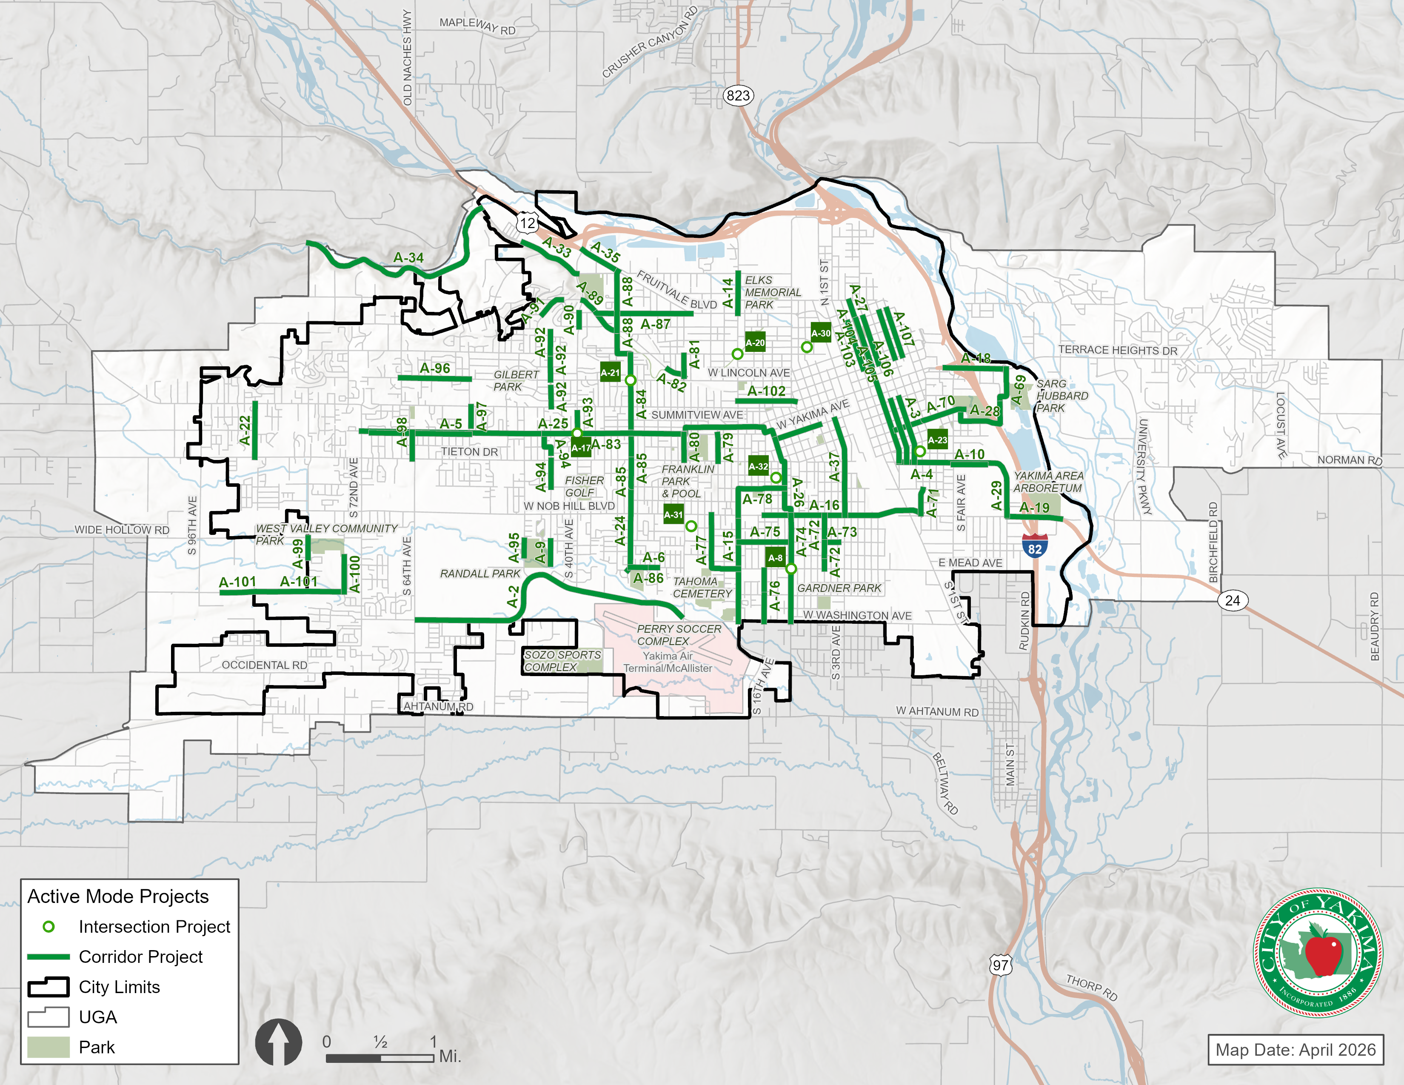
Exhibit 5-32. Active Transportation Improvement Projects
ProjectID | Project Name | Location (Extents) | Description | Time Frame | Cost
WA-15117 | Fred Meyer Active Transportation Pathway - Fruitvale Blvd & 40th Ave Roundabout | Intersection | Roundabout, Rectangular Rapid Flashing Beacons (RRFB), New Marked Crosswalk, Green Pavement/Bicycle Intersection Crossing Markings, ADA Curb Ramps, Audible Pedestrian Signal, Bicycle Wayfinding Signs/Markings, Shared-use Path/Trail | Short | $ 1,330,904
YAK114 | N 16th Avenue Sidewalk | River Road to US 12 Off Ramp | Contstruct sidewalk on west side of roadway | Short | $ 446,219
YAK103 | Nob Hill Elementary School Safety Improvements | various locations to various locations | This project will make various pedestrian safety improvements in the vicinity of Nob Hill Elementary School, such as new sidewalk and constructing ADA ramps | Short | $ 674,520
WA-15118 | Prasch Avenue Sidewalk Improvements | S 20th Avenue to S 16th Avenue | Construct sidewalks against existing curbing on Prasch Avenue from S. 16th Avenue to S. 20th Avenue, and along S 16th Ave from Prasch Avenue to Nob Hill Blvd. | Short | $ 185,000
YAK116 | Zier Road Sidewalk Improvements | 75th Avenue to West Valley High School | Add sidewalk. | Short | $ 980,000
A-2 | Washington Ave Bike Corridor (64th-24th) | Washington Ave: 64th St to 24th St | Add low stress bike trail on north side of corridor | Medium | $ 4,470,000
A-3 | Naches Avenue Sidewalk | Pacific Ave. to Walnut Ave. | Remove the existing sidewalk on both sides of the road and install new sidewalk | Medium | $ 580,000
A-4 | 4th Street Sidewalk | Pacific Ave. to Walnut Ave. | Remove the existing sidewalk on both sides of the road and install new sidewalk | Medium | $ 550,000
A-5 | Chestnut Avenue Sidewalk | 56th Ave. to 70th Ave. | Construct curb, gutter and sidewalk on the north side of the road | Medium | $ 790,000
A-6 | Mead Avenue Sidewalk | 27th Ave. to 28th Ave. | Construct curb, gutter and sidewalk on the south side of the road | Medium | $ 30,000
WA-13522 | Browne Avenue Sidewalk | 7th Ave. to 16th Ave. | Remove the existing sidewalk on both sides of the road and install new sidewalk | Medium | $ 440,000
YAK113 | Mead Avenue Pedestrian Signal | 10th Ave to 10th Ave. | Install pedestrian signal across Mead Avenue north of 10th Avenue | Short | $ 400,000
A-9 | 44th Avenue Sidewalk | Viola to Randall Park | Construct sidewalk on the west side of the road. | Medium | $ 480,000
A-10 | Pacific Avenue Sidewalk | Fair Avenue to Jail Property | Construct sidewalk on both sides of the road where needed. | Medium | $ 530,000
YAK-109 | Fair Avenue Sidewalk | Pacific Ave. to Nob Hill Blvd. | Construct sidewalk on the west side of the road. | Medium | $ 490,000
YAK110 | Nob Hill Blvd. Sidewalk | 12th Street to 14th Street | Construct sidewalk on the south side of the road. | Medium | $ 170,000
A-15 | 16th Ave Sidewalk Improvements (Washington-Nob Hill) | 16th Ave: Washington Ave to Nob Hill Blvd. | Install 7-foot sidewalk on the west side of 16th Avenue. | Medium | $ 1,280,000
A-16 | Nob Hill Blvd Sidewalk Improvements (16th-6th) | Nob Hill Blvd: 16th Ave to 6th St | Construct sidewalk in locations where it doesn’t exist on the south side of Nob Hill. | Medium | $ 2,630,000
A-17 | Chestnut Ave/40th Ave Crossing | Intersection (crossing east-west) | Add intersection treatment to create lower stress bicycle connection | Medium | $ 70,000
A-18 | Yakima Greenway Trail Access (Yakima Ave) | Along Yakima Ave, 10th St to 18th St | Reduce turn radii at major intersections and improve trail pavement markings; complete trail connection on east end of corridor. Coordinate with future interchange improvements (Project R-37). | Medium | $ 2,350,000
A-19 | Yakima Greenway Trail Access (Nob Hill Blvd) | Along Nob Hill Blvd, 18th St to I-82 NB Ramps | Reduce turn radii at major intersections and improve trail pavement markings; complete trail connection on west end of corridor | Medium | $ 1,210,000
A-20 | Powerhouse Trail Connection (16th Ave) | Intersection of 16th Ave/ Englewood Ave | Add lower stress bike connection between existing Powerhouse Trail endpoints, across intersection. | Medium | $ 390,000
A-21 | 32nd Ave/Lincoln Ave Bike Crossing | Intersection | Add RRFB for north-south bike crossing | Medium | $ 70,000
YAK107 | 88th Ave Reconstruction (Tieton-Summitview) | 88th Ave: Tieton Dr to Summitview Ave | Construct curb, gutter, sidewalk and storm drainage system on the east side of 88th Avenue. | Medium | $ 591,000
A-23 | Adams ES & Washington MS Safety Improvements | Various Streets | This project will make various pedestrian safety improvements in the vicinity of Adams Elementary School and Washington Middle School, such as, constructing sidewalks, improving roadway crossings, installing flashers and installing fencing. | Short | $ 490,000
A-24 | 32nd Ave/34th Ave Bike Corridor | Along 32nd Ave, from Mead Ave to Englewood Ave; Along 34th Ave, Englewood Ave to Fruitvale Blvd | Add bike boulevard treatments and wayfinding to corridor with a two lane bike lane | Medium | $ 1,470,000
A-25 | Chestnut Ave Bike Corridor | Along Chestnut Ave, 72nd Ave to 24th; Jog north along 24th, then along Yakima Ave, 24th to 14th; Jog along Terrace St, 12th Ave, Chestnut Ave, 11th Ave to Walnute Ave; Along Walnut Ave, 11th Ave to 5th Ave | Add bike boulevard treatments (or bike lanes in wider sections) and wayfinding to corridor | Medium | $ 2,140,000
A-26 | 10th/11th Ave Bike Corridor | Along 11th Ave, Walnut St to Steward St; Jog along Steward St; Along 10th Ave, Steward St to Washington St | Add bike lanes or bike boulevard elements along corridor to lower stress | Medium | $ 1,120,000
A-27 | 3rd Street Bike Corridor | Along 3rd St, I St to Pacific Ave | Add bike lanes, buffered bike lanes, or widen buffered bike lanes to lower stress | Medium | $ 1,420,000
A-28 | Maple St/Parks Bike Corridor | Along Maple St, 3rd St to 13th St; Along 13th St, Maple St to Beech St; Along Beech St, 13th St to Chalmers Rd; Along Chalmers Rd, Beech St to Riverside St; Along Riversidr St, Chalmers Rd to 18th St; Along 18th St, Riverside St to Bike Trail Connection | Intersection crossing improvement at 6th St; Add bike lanes and wayfinding; Along Beech St remove yellow centerline and add fog lines to indicate low volume roadway | Medium | $ 910,000
A-29 | Pacific/18th St Bike Corridor | Along Pacific Ave, 3rd St to 18th St; Along 18th St, Pacific Ave to Nob Hill Blvd | Add bike lanes by removing parking or removing center median | Medium | $ 1,030,000
A-30 | Garfield ES Safety Improvements | Various Streets | This project will make various pedestrian safety improvements in the vicinity of Garfield Elementary School, such as, constructing sidewalk, improving roadway crossings, installing flashers. | Short | $ 250,000
A-31 | McClure ES Safety Improvements | Various Streets | This project will make various pedestrian safety improvements in the vicinity of McClure Elementary School, such as, constructing sidewalk, ADA ramps and improving crosswalks. | Short | $ 470,000
A-32 | McKinley ES Safety Improvements | Various Streets | This project will make various pedestrian safety improvements in the vicinity of McKinley Elementary School, such as, replacing dilapidated sidewalk, constructing ADA ramps, and installing a HAWK pedestrian crossing system. | Short | $ 840,000
A-34 | Cowiche Canyon Trail Improvements | Cowiche Canyon: Powerhouse Rd to Trailhead | Construct a 10-foot wide pathway, including two bridges over Cowiche Creek. | Short | $ 3,510,000
A-35 | 34th Ave to Greenway Trail Connection | Along Fruitvale Blvd: 34th Ave to 40th Ave | Provide cycle track or trail on north side of Fruitvale Blvd to provide low stress bike connection between two primary bike corridors. | Medium | $ 330,000
A-36 | Yakima Ave Bike Corridor Connection (16th-Terrace) | Yakima Ave: 16th Ave to Terrace St | Add short section of cycle track on south side of Yakima (300 feet east of 16th Avenue to Terrace St) by removing one eastbound vehicle lane. | Medium | $ 140,000
A-37 | 3rd Avenue Sidewalk | Nob Hill Blvd to Walnut Ave. | Remove the existing sidewalk on both sides of the road and install new sidewalk | Medium | $ 840,000
A-38 | E G St / N 6th St Bike Lane | Along E G St / N 6th St: N 3rd St To E Martin Luther King Jr Blvd | Add 3630ft of Bike Lane | Long | $ 40,000
A-39 | S Fair Ave Bike Lane | Along S Fair Ave: E Nob Hill Blvd To E MLK JR Blvd/E Lincoln Ave | Add 9410ft of Bike Lane | Long | $ 110,000
A-40 | W Mead Ave Bike Lane | Along W Mead Ave: S 16th Ave To S Fair Ave | Add 10600ft of Bike Lane | Long | $ 130,000
A-41 | W Walnut St Bike Lane | Along W Walnut St: S 6th St To S 8th St | Add 760ft of Bike Lane | Long | $ 10,000
A-42 | N Front St Bike Lane and Sidewalk improvements | Along N Front St: E Walnut St To E I St | Add 5760ft of Bike Lane, add sidewalk on one side from MLK to I Street | Long | $ 3,120,000
A-43 | Randall Dog Park Shared Use Trail | Along Randall Dog Park: S 48th Ave To S 44th Ave | Add 1350ft of Shared Use Trail | Long | $ 540,000
A-44 | S 48th Ave Protected Bike Lane | Along S 48th Ave: W Washington Ave To 200ft north of Randal Dog Park South Lot | Add 870ft of Protected Bike Lane | Long | $ 50,000
A-41 | W Walnut St Buffered Bike Lane | Along W Walnut St: N 5th Ave To S 6th St | Add 4550ft of Buffered Bike Lane | Long | $ 20,000
A-45 | S 5th Ave Protected Bike Lane | Along S 5th Ave: Tieton Dr To W Lincoln Ave | Add 3850ft of Protected Bike Lane | Long | $ 230,000
A-46 | W MLK/Pierce Ave/W Lincoln Ave Buffered Bike Lane | Along W MLK/Pierce Ave/W Lincoln Ave: N 6th Ave To N 6th Ave | Add 1130ft of Buffered Bike Lane | Long | $ 30,000
A-47 | N 5th Ave Bike Lane | Along N 5th Ave: W Lincoln Ave To 270ft south of Cherry Ave | Add 970ft of Bike Lane | Long | $ 10,000
A-48 | N 5th Ave Protected Bike Lane | Along N 5th Ave: 270ft South of Cherry Ave To W I St | Add 2970ft of Protected Bike Lane | Long | $ 170,000
A-49 | Occidental/S 80th Ave/Coolidge Rd/S 72nd Ave Shared Roadway | Along Occidental/S 80th Ave/Coolidge Rd/S 72nd Ave: Western City Limits To Sali Rd | Add 20060ft of Shared Roadway | Long | $ 60,000
A-50 | Cherry Ave Buffered Bike Lane | Along Cherry Ave: N 16th Ave To N 5th Ave | Add 3000ft of Buffered Bike Lane | Long | $ 80,000
A-51 | W Lincoln Ave Bike Lane and sidewalk improvements | Along W Lincoln Ave: N 56th Ave To N 32nd Ave | Add 8230ft of Bike Lane, add sidewalk on one side of W Lincoln b/t N 40th Ave and N 56th Ave | Long | $ 4,460,000
A-52 | N 16th Ave Shared Use Trail | Along N 16th Ave: River Rd To US 12 | Add 1490ft of Shared Use Trail | Long | $ 600,000
A-53 | Tieton Drive Bike Lane | Along Tieton Drive: S 72nd Ave To S 5th Ave | Add 23150ft of Bike Lane | Long | $ 270,000
A-54 | Englewood Ave Bike Lane and Sidewalk improvements | Along Englewood Ave: N 66th Ave To N 56th Ave | Add 3350ft of Bike Lane and sidewalk on one side of street | Long | $ 1,810,000
A-55 | N 74th Ave and Englewood Ave Climbing Lane & Shared Roadway | Along N 74th Ave and Englewood Ave: W Lincoln Ave To N 66th Ave | Add 3930ft of Climbing Lane & Shared Roadway | Long | $ 30,000
A-56 | S 80th Ave Bike Lane | Along S 80th Ave: W Nob Hill Blvd To Tieton Drive | Add 2650ft of Bike Lane | Long | $ 30,000
A-57 | W Nob Hill Blvd Bike Lane | Along W Nob Hill Blvd: S 80th Ave To S 72nd Ave | Add 1960ft of Bike Lane | Long | $ 20,000
A-58 | S 64th Ave Buffered Bike Lane | Along S 64th Ave: Occidental Rd To Tieton Dr | Add 10630ft of Buffered Bike Lane | Long | $ 280,000
A-59 | S 75th Ave/ City Owned Property Shared Use Trail | Along S 75th Ave/ City Owned Property: West Valley Commuity Park Lot Entrance To W Viola Ave | Add 910ft of Shared Use Trail | Long | $ 360,000
A-60 | S 72nd Ave Bike Lane | Along S 72nd Ave: Sali Rd To Spokane St | Add 1000ft of Bike Lane | Long | $ 10,000
A-61 | W Lincoln Ave Shared Use Trail | Along W Lincoln Ave: N 24th Ave/Powerhouse Rd To N 20th Ave | Add 1300ft of Shared Use Trail | Long | $ 520,000
A-62 | Yakima Valley Canal Shared Use Trail | Along Yakima Valley Canal: N 44th Ave To Castlevale/Fechter Road | Add 2610ft of Shared Use Trail | Long | $ 1,040,000
A-63 | E Martin Luther King Jr Blvd/ E Lincoln Ave Buffered Bike Lane | Along E Martin Luther King Jr Blvd/ E Lincoln Ave: N Front St To N 8th Street via E Lincoln Ave | Add 5210ft of Buffered Bike Lane | Long | $ 140,000
A-64 | S 56th Ave Bike Lane | Along S 56th Ave: Tieton Drive To W Lincoln Ave | Add 3960ft of Bike Lane | Long | $ 50,000
A-65 | N 16th Ave Buffered Bike Lane | Along N 16th Ave: W Lincoln Ave To Englewood Ave/Cherry Ave | Add 1310ft of Buffered Bike Lane | Long | $ 30,000
A-66 | W Nob Hill Blvd Buffered Bike Lane | Along W Nob Hill Blvd: S 72nd Ave To S 64th Ave | Add 2600ft of Buffered Bike Lane | Long | $ 70,000
A-67 | S 18th St Bike Lane | Along S 18th St: E Mead Ave To E Nob Hill Blvd | Add 2720ft of Bike Lane | Long | $ 30,000
A-68 | W Lincoln Ave Buffered Bike Lane | Along W Lincoln Ave: N 16th Ave To N 20th Ave | Add 1320ft of Buffered Bike Lane | Long | $ 30,000
A-69 | S 18th St Sidewalk Project | Along S 18th St: Chalmers St to E Yakima Ave | Add sidewalks to both sides of S 18th Street and Riverside St. 3,400ft | Long | $ 1,760,000
A-70 | E Maple St Sidewalk Project | Along E Maple St: S 8th St to S Fair Ave | Add sidewalks to north side of E Maple between S 8th and S Fair Ave. 2100ft | Long | $ 1,100,000
A-71 | S 6th St Sidewalk Project | Along S 6th St: E Nob Hill Blvd to E Arlington St | Fill sidewalk gaps on east side of S 6th St. approx 780 linear feet | Long | $ 650,000
A-72 | S 6th Ave Sidewalk Project | Along S 6th Ave: W Mead Ave to W Nob Hill Blvd | Add sidewalks to west side of 6th ave b/t W Mead Ave and W Nob Hill Blvd ave, include sidewalks on both sides for section of 6th b/t Logan and Viola. 3270ft | Long | $ 330,000
A-73 | W Viola Ave Sidewalk Project | Along W Viola Ave: S 6th Ave to S 4th Ave | Add sidewalks to north side of W Viola Ave. 700ft | Long | $ 370,000
A-74 | S 10th Ave Sidewalk Project | Along S 10th Ave: W Washington Ave to W Nob Hill Blvd | Add sidewalk to west side of S 10th. 5,200ft | Long | $ 2,780,000
A-75 | W Viola Ave Sidewalk Project | Along W Viola Ave: S 16th Ave to S 10th Ave | Add sidewalks to south side of Viola Ave to connect to existing south side sidewalk at Viola and 10th. 2600ft | Long | $ 1,370,000
A-76 | S 12th Ave Sidewalk Project | Along S 12th Ave: W Washington Ave to W Mead Ave | Add sidewalks to S 12th Ave on both sides between W Washington and W Pierce St, Add sidewalks to east side of 12th between Pierce and Mead. 3130ft | Long | $ 1,230,000
A-77 | S 20th Ave / W Mead Ave Sidewalk Project | Along S 20th Ave / W Mead Ave: W Nob Hill Blvd to S 16th Ave | Add sidewalks to north side of W Mead b/t S 20th and S 16th, and along S 20th On the east side between Mead and Nob Hill Blvd. 4000ft | Long | $ 2,100,000
A-78 | S 16th Ave / W Arlington St Sidewalk Project | Along S 16th Ave / W Arlington St: W Nob Hill to S 11th Ave | Add sidewalk to fill gaps on S 16th Ave and W Arlington St from W Nob Hill to S 11th Ave | Long | $ 2,200,000
A-79 | S 19th Ave Sidewalk Project | Along S 19th Ave: Tieton Dr to W Yakima Ave | Add sidewalks on east side of S 19th between Tieton and Chestnut - not practical to extend sidewalk to Yakima. 1320ft | Long | $ 700,000
A-80 | S 24th Ave Sidewalk Project | Along S 24th Ave: Tieton Dr to W Chestnut Ave | Add sidewalks to west side of S 24th Ave. 1300ft | Long | $ 680,000
A-81 | N 24th Ave Sidewalk Project | Along N 24th Ave: Powerhouse Rd to Englewood Ave | Add sidewalks to east side of N 24th Ave. 1000ft | Long | $ 550,000
A-82 | Powerhouse Road Sidewalk Project | Along Powerhouse Road: 160 ft northwest of N 26th Ave to N 24th Ave | Add sidewalks to both sides of Powerhouse Road. 1800ft | Long | $ 890,000
A-83 | W Chestnut Ave Sidewalk Project | Along W Chestnut Ave: S 45th Ave to Henry Ave | Add sidewalks to one side of Chestnut - whichever is most practical. 6900ft | Long | $ 3,670,000
A-84 | N 32nd Ave Sidewalk Project | Along N 32nd Ave: W Chestnut Ave to Englewood Ave | Fill sidewalk gaps on east side of N 32nd Ave. 3500ft | Long | $ 1,880,000
A-85 | S 32nd Ave Sidewalk Project | Along S 32nd Ave: W Arlington St to Tieton Dr | Add sidewalk to the east side of S 32nd b/t Arlington and Webster, and to the west side between Arlington and Tieton 1300ft | Long | $ 690,000
A-86 | W Mead Ave Sidewalk Project | Along W Mead Ave: S 32nd Ave to S 29th Ave | Add sidewalk to the north side of W Mead Ave. 700ft | Long | $ 390,000
A-87 | Castlevale Rd Sidewalk Project | Along Castlevale Rd: Powerhouse Rd to Fruitvale Blvd | Add sidewalk to the south side of Castlevale Rd. 4700ft | Long | $ 2,470,000
A-88 | N 34th Ave Sidewalk Project | Along N 34th Ave: Powerhouse Rd to Fruitvale Blvd | Add sidewalk to west side of N 34th Ave. 2300ft | Long | $ 1,550,000
A-89 | Powerhouse Rd Sidewalk Project | Along Powerhouse Rd: N 40th Ave to N 34th Ave | Add sidewalk along Powerhouse Rd from N 40th Ave to N 34th Ave | Long | $ 1,240,000
A-90 | N 40th Ave Sidewalk Project | Along N 40th Ave: Kern Rd to Castelvale Rd | Add sidewalk to the west side of N 40th. 4000ft | Long | $ 420,000
A-91 | Conestoga Blvd/Fechter Rd Sidewalk Project | Along Conestoga Blvd/Fechter Rd: Surrey Ln to Congdon Canal | Add sidewalk to East side of Conestoga blvd, connecting with sidewalk on south side of Fechter Rd @Congdon Canal. 1200ft | Long | $ 660,000
A-92 | N 44th Ave Sidewalk Project | Along N 44th Ave: W Lincoln Ave to Northern Terminus of N 44th Ave | Between Summitview and Uplands, add sidewalk on one side of N 44th. 940ft. Between W Lincoln and Douglas, add sidewalk to east side of 44th 640ft. Between Douglas and Englewood, add sidewalk to both sides of 44th 635ft. between Englewood and Gardenpark way, add sidewalks on east side of 44th 1060ft. 3275ft total | Long | $ 1,740,000
A-93 | N 40th Ave Sidewalk Project | Along N 40th Ave: 620 north of W Chestnute Ave to Summit View Ave | Add sidewalk to east side of N 40th Ave 700ft | Long | $ 400,000
A-94 | S 44th Ave Sidewalk Project | Along S 44th Ave: W Arlington St to W Chestnut Ave | Between Arlington and Tieton, add sidewalks to west side of 44th 1300ft. Between Tieton and W Chestnut add sidewalks on one side of 44th/W Walnut/45th 1300ft. 2600ft total | Long | $ 1,380,000
A-95 | S 48th Ave Sidewalk Project | Along S 48th Ave: Randall Park West Lot to Signalized crossing @ MultiCare Cottage property | Add sidewalk to West side of S 48th Ave 2100ft | Long | $ 410,000
A-96 | W Lincoln Ave Sidewalk Project | Along W Lincoln Ave: N 66th Ave to Bitteroot Way | Add sidewalk to south side of W Lincoln Ave 3400ft | Long | $ 2,070,000
A-97 | N 56th Ave Sidewalk Project | Along N 56th Ave: 325ft north of W Chestnut Ave to Summitview Ave | Fill sidewalk gaps on West side of N 56th Ave 1000ft | Long | $ 510,000
A-98 | S 65th Ave Sidewalk Project | Along S 65th Ave: Tieton Dr to W Chestnut Ave | Add sidewalk to east side of S 65th Ave 1400ft | Long | $ 700,000
A-99 | S 80th Ave Sidewalk Project | Along S 80th Ave: W Plath Ave to Wide Hollow Rd | Add sidewalk to both sides of S 80th Ave 1000ft | Long | $ 1,000,000
A-100 | S 75th Ave Sidewalk Project | Along S 75th Ave: 570ft west of S 75th Ave to W Mead Ave | Add sidewalk to east side of S 75th Ave 2300ft | Long | $ 1,220,000
A-101 | Zier Road Sidewalk Improvements | Along Zier Rd: S 96th Ave to 570 ft west of S 75th Ave | Add sidewalk to both sides of Zier Rd OR add multiuse Path to South Side | Long | $ 6,050,000
A-102 | Browne Avenue Sidewalk Replacement | 7th Ave to 15th Ave | Replace Sidewalk | Short | $ 936,000
A-103 | 2nd Street Sidewalk Replacement | G Street to MLK Blvd | Replace Sidewalk | Short | $ 1,917,400
A-104 | 3rd Street Sidewalk Replacement | G Street to MLK Blvd | Replace Sidewalk | Short | $ 1,899,400
A-105 | 4th Street Sidewalk Replacement | G Street to MLK Blvd | Replace Sidewalk | Short | $ 1,783,200
A-106 | 6th Street Sidewalk Replacement | G Street to MLK Blvd | Replace Sidewalk | Short | $ 1,817,400
A-107 | 7th Street Sidewalk Replacement | G Street to MLK Blvd | Replace Sidewalk | Short | $ 1,869,700

Financing Program
The list of transportation improvement projects must be funded and implemented to meet existing and future travel demands in and around the City of Yakima. Estimated project costs and future revenues are presented and options to fund the projects are described in this section. Implementation strategies are discussed and include items such as coordination with WSDOT, Yakima County, and Yakima Valley Conference of Governments (YVCOG) to prioritize and fund regional improvements. The implementation plan sets up the framework for the City to prioritize and fund the improvements identified in the transportation plan.
The GMA requires the Transportation Element of the Comprehensive Plan to include a multi-year financing plan based on the identified improvement needs in the transportation systems plan. The financing plan is to be the basis in developing the required six-year Transportation Improvement Program (TIP). If probable funding is less than the identified needs, then the transportation financing program must also include a discussion of how additional funding will be raised or how land use assumptions will be reassessed to assure that level of service standards will be met. Alternatively, the city can adjust its level of service standards.
A summary of costs for capital improvement projects and citywide maintenance and operation programs are presented in this chapter. The capital project and maintenance and operations program costs are compared to estimated revenues from existing sources used by the City to fund transportation improvements. Other potential funding sources to help reduce the projected shortfall are described. Lastly, a summary of a reassessment strategy for the city to use for reviewing transportation funding in the context of the overall Comprehensive Plan is also included.

Project and Program Cost Estimates
Exhibit 5-33 summarizes the costs of the recommended transportation improvement projects and programs. These cover City of Yakima capital improvements, maintenance and operations. The costs are summarized for the life of the Plan. Improvements under the responsibility of WSDOT, or Yakima County are not included in the summary table. However, the city may choose to include a share of the costs of WSDOT improvements in its transportation impact fee or other funding options.
Exhibit 5-33. Transportation Project and Program Costs (2027 – 2050)
Improvement Type |  | (2027-2050) Total Costs¹ | Percent of Total Costs
Transportation Capital Projects²
Intersection |  | $ 114,160,000 | 19.0%
Roadway Capital Projects (includes maintenance) |  | $ 91,590,000 | 15.2%
New Roadway |  | $ 144,060,000 | 23.9%
Active Transportation |  | $ 105,860,000 | 17.6%
Other (includes non-city led projects) |  | $ 143,070,000 | 23.8%
Studies |  | $ 3,490,000 | 0.6%
Total Costs |  | $602,230,000 | 100%
  - All costs in 2026 dollars, rounded to $1,000
  - Does not include other agency improvements
Planning-level cost estimates were developed for the capital improvements and presented in the Forecast and Evaluation Chapter. The planning estimates were prepared based upon average unit costs for transportation projects within the region. Planning-level costs were developed with the assumption that costs would include associated storm water development requirements, property acquisition, wetland mitigation, and utility extensions and/or upgrades, based upon historic costs for those items. More detailed cost estimates will need to be prepared as the projects are closer to design and construction. Future design studies will identify specific property impacts and options to reduce costs and impacts on properties.
The estimated capital cost of the Transportation Plan is approximately $602.3 million (in 2026 dollars). Approximately 17.6% percent of the capital costs are associated with completion of the active transportation network in the city. These costs cover upgrading roadways to provide expanded options for pedestrians and bicyclists, along with construction of urban features such as crosswalks and sidewalks. Approximately 24% of costs are for the construction of new planned roadways, while intersection improvements (like roundabouts and new signals) account for 19% of planned improvements. Roadway improvement projects (which includes roadway maintenance), account for 15.2% of total costs. The “other” project category includes a new interchange along I-82, a major capital project that would be led by WSDOT and would not be the responsibility of the City of Yakima to fund.
Maintenance and operations costs are included as part of the roadway capital projects – as they both use the same Street Fund. These projects include roadway resurfacing and often include sidewalk and bike lane enhancements as part of those projects (such as the recent improvements along N 1st
Street).

Funding Analysis with Existing Revenue Sources
The City has historically used city and state tax revenues, a transportation benefit district, and grants to construct and maintain their transportation facilities. In early 2026 the City of Yakima changed the method of collecting Transportation Benefit District revenues from $20 vehicle tab fees to a 0.1% tax increase. Funds from the 0.1% sales and use tax are used for resurfacing and rehabilitation on City streets, such as 1st Street Revitalization Phase 2, as allowed in RCW.82.14.0445. The description of this and other available funding sources and projected revenues are listed in Exhibit 5-34.
Exhibit 5-34. Estimated Transportation Revenues (2027 – 2050)
Capital Fund Type |  | Revenues Sources | Estimated Biennial Budget | Percent of Total Revenues
Streets & Traffic Fund |  | > Property Taxes (REET 2)  > State Gas Tax  > Intergovernmental Revenues (Stormwater/Street Sweeping)  > Charges for Goods & Services  > Miscellaneous Revenues (Insurance Reimbursements for Motorist Damage)  > Other Financing Sources (Uses) | $8,422,000 | 27.0%
Transportation Benefit District |  | 0.1% sales tax | $6,910,000 | 22.2%
Street Overlay & Reconstruction |  | > Federal Grants  > Capital Imp. Gas Tax  > TBD or Transfer from TBD  > Property Taxes  > Fed. Highway Admin.  > Dept. of Transp.  > TIB  > SEID Grant - Yakima County  > Street Assessments | $15,850,000 | 50.8%
Estimated Total Revenues  (biannual budget x 12) |  |  | $374,184,000
Revenue projections were estimated based upon the City’s 2024 budget, and 5-years of historical revenues. Based on recent historical data, it is estimated that revenues would be more than $374 million during the 24-year period.

Developer Transportation Funding
The city uses several programs to help offset the increased traffic impacts of new development or redevelopment. These include construction of frontage improvements such as curb, gutter, and sidewalks, with or without dedication of right-of-way, and new roadways needed to serve the development. The City is also required to review the potential transportation impacts of development and define appropriate mitigation under the State Environmental Policy Act (SEPA) and GMA concurrency requirements. In addition, the City previously adopted a Transportation Impact Fee program as allowed for by the GMA to help fund growth-related transportation system improvements.
Other Developer Mitigation and Requirements
The City has adopted specific development-related requirements which will help fund the identified improvements. These include requirements for frontage improvements, mitigation of transportation impacts under SEPA, and concurrency requirements. The City requires developments to fund and construct certain roadway improvements as part of their projects. These typically include reconstructing abutting streets to meet the City’s current design standards. These improvements can include widening of pavement, drainage improvements, and construction of curb, gutter, and sidewalks.
Several of the projects identified in the Transportation Plan could be partially funded and constructed as part of new developments.
The city also evaluates impacts of development projects under SEPA. The SEPA review may identify adverse transportation impacts that require mitigation. These could include impacts related to safety, traffic operations, active transportation, or other transportation issues. The needed improvements may or may not be identified as specific projects in the Plan.
The city also requires an evaluation of transportation concurrency for development projects. The concurrency evaluation is intended to identify project impacts that will cause City facilities to operate below the City’s level of service standard. To resolve such a deficiency, the applicant can propose to fund and/or construct improvements to provide an adequate level of service. Alternatively, the applicant can wait for the City, or another agency or developer to fund improvements to resolve the deficiency. According to the GMA, the City must deny any proposal that will cause the level of service for transportation facilities to decline below the adopted standard unless a financial commitment is in place to complete measures to achieve the LOS standard within six years. (RCW 36.70A.070(6)(b).
Grants
Over the past several years the city has had significant success in securing grants for transportation improvements. Grant funding is typically tied to specific improvement projects and distributed on a competitive basis, often with a local funding match.

Forecasted Revenue Shortfall
Exhibit 5-35 summarizes the City’s proposed transportation financing strategy plan’s program expenditures. The Plan results in a shortfall of approximately $228 million. This assumes that the level of grants and developer commitments will be generated as estimated in the Transportation Plan. The deficit could be greater if the level of development or the level of grant funding is less than forecast. The former would be offset by a reduced need for transportation improvements to accommodate growth. If the City is more successful in obtaining grants or other outside funding for projects, then the potential deficit could be reduced, as discussed in the next section.
Exhibit 5-35. Estimated Transportation Revenues (2027 – 2050)
Revenue Source¹ | Total (2027–2050)
Transportation Capital Revenues | $374,184,000
Total Capital Project Costs | $602,230,000
Total Estimated Shortfall | ($228,046,000)
  - All revenues in 2026 dollars

Revenue Shortfall
The approximately $228 million shortfall in funding would primarily affect the ability of the city to fund all the identified capital improvement projects during the planning period. As evidenced by the formation of the Transportation Benefit District, the City is committed to funding the existing maintenance and operations programs needed to preserve the integrity, safety, and efficiency of its existing transportation system. The maintenance and operations cost will expand with transportation system improvements and the future annexation of the City’s unincorporated UGA.

Potential Options to Balance the Plan
As noted above, projected existing revenue sources would allow the city to fund the majority of the identified transportation improvement projects and program costs. The City could address this shortfall through delaying lower priority projects or increasing revenue allocations from discretionary sources, primarily the General Fund.
Transportation Impact Fees
The GMA allows agencies to develop and implement a Transportation Impact Fee (TIF) program to help fund part of the costs of transportation facilities needed to accommodate growth. State law (RCW 82.02) requires that TIF programs are:
- Related to improvements to serve new growth and not existing deficiencies;
- Assessed proportional to the impact of new developments;
- Allocated for improvements that reasonably benefit new development, and;
- Spent on facilities identified in the adopted Capital Facilities Plan.
TIFs can only be used to help fund improvements that are needed to serve new growth. The cost of projects needed to resolve existing deficiencies cannot be included.
The TIF program must allow developers to receive credits if they are required to construct all or a portion of system improvements to the extent that the required improvements were included in the TIF calculation. The city is in the process of updating its existing program based on the updated Transportation Plan. The City of Yakima is one of the only cities across Washington State that does not collect Transportation Impact Fees.
Options for Reducing the Funding Shortfall for Capital Improvement Projects
The city can increase funding for capital street projects using a range of revenue options. These include partnering with other agencies or additional grants as available. Alternatively, the city could delay implementation of projects, especially lower priority improvements. Possible applications of these funding strategies are discussed below.
Delaying Improvement Projects
The City will not likely be able to, or may choose not to, fund lower priority projects within the 20-year horizon without additional funding sources. Some of these projects may be funded through impact fees and/or frontage improvement requirements as development (or re-development occurs). As developments occur in these areas the city may require project-specific facility improvements including SEPA mitigation measures, as appropriate. The city also may identify other programs or opportunities to partially or fully fund some of these improvements.
Additional Grants and Other Agency Funding
As discussed above, the transportation financing analysis estimates that the city may receive approximately $22 million in grant funding over the life of the Plan. If the City is able to pursue and receive grants at a higher rate, shortfalls may be less than projected.
Tax Increment Financing
Washington State allows cities to create “increment areas” that allows for the financing of public improvements, including transportation projects within the area by using increased future revenues from local property taxes generated within the area. The specific rules and requirements are noted in the Community Revitalization Financing (CRF) Act.
The Local Infrastructure Financing Tool (LIFT) program is a potential tool for the City to pursue. Under this concept the annual increases in local sales/use taxes and property taxes can be used to fund various public improvements.
The city may choose to further consider these types of funding programs in the future as part of its annual budget and six-year Transportation Improvement Program (TIP) processes.
Voter Approved Bond/Tax Package
Bonds do not result in additional revenue unless coupled with a revenue generating mechanism, such as a voter approved tax. The debt service on the bonds results in increased costs which can be paid with the additional tax revenues. Although the city does not anticipate issuing bonds in the near future, it remains an option for generating additional transportation revenues to fund some of the higher cost improvement projects.
Local Improvement Districts
A local improvement district (LID) is a special assessment area established by a jurisdiction to help fund specific improvements that would benefit properties within the district. LIDs could be formed to construct sidewalks, upgrade streets, improve drainage or other similar types of projects. A LID may be in residential, commercial, or industrial areas or combinations depending on the needs and benefits. LIDs can be proposed either by the city or by property owners. LIDs must be formed by a specific process which establishes the improvements, their costs, and assessments. The assessments are added to the property tax which helps to spread the costs over time.

Reassessment Strategy
Although the financing summary identifies the potential for a total revenue shortfall of approximately $228 million (in 2026 dollars) over the life of the Plan, the city is committed to reassessing transportation needs and funding sources each year as part of its six-year Transportation Improvement Program (TIP). This allows the city to match the financing program with the short-term improvement projects and funding. To implement the Transportation Plan, the city will consider the following principals in its transportation funding program:
- Balance improvement costs with available revenues as part of the annual six-year Transportation Improvement Program (TIP);
- Consider creation of a transportation impact fee (TIF) program
- Review project design standards to determine whether costs could be reduced through reasonable changes in scope or deviations from design standards;
- Fund improvements or require developer improvements as they become necessary to maintain LOS standards;
- Explore ways to obtain more developer contributions to fund improvements;
- Coordinate and partner with WSDOT, Yakima County, and others to implement improvements to I-82;
- Vigorously pursue grant funds from state and federal sources;
- Work with Yakima County to develop multiagency grant applications for projects that serve growth in the city and its UGA;
- Review and update the TIF program regularly to account for the updated capital improvement project list, revised project cost estimates, and annexations;
Some lower priority improvements may be deferred or removed from the Transportation Plan. The city will use the annual update of the six-year Transportation Improvement Program (TIP) to re-evaluate priorities and timing of projects and need for alternative funding programs. Throughout the planning period, projects will be completed, and priorities revised. This will be accomplished by annually reviewing traffic growth and the location and intensity of land use growth in the city and its UGA. The city will then be able to direct funding to areas that are most impacted by growth or to roadways that may be falling below the city’s level of service standards. The development of the TIP will be an ongoing process over the life of the Plan and will be reviewed and amended annually.

Capital Facilities

Overview

Inventory

Water

Wastewater

Stormwater

Other Facilities

Level of Service

Water

Wastewater

Stormwater

Other Facilities

Capital Facilities Details

Water

Irrigation water

Needs, planned projects and projected cost

Wastewater

Needs, planned projects and projected cost

Stormwater

Needs, planned projects and projected cost

Other Facilities

Needs, planned projects and projected cost

Utilities

Overview

Analysis

Natural Environment

Overview

Analysis

Glossary
This report uses some terminology, acronyms, or data sources that may be unfamiliar. Here are some definitions.
Affordable Housing
The United States Department of Housing and Urban Development (HUD) considers housing to be affordable if the household is spending no more than 30% of its income on housing costs. A healthy housing market includes a variety of housing types that are aﬀordable to a range of diﬀerent household income levels. However, the term “aﬀordable housing” is often used to describe income-restricted housing available only to qualifying low-income households. Income-restricted housing can be located in public, nonprofit, or for-profit housing developments. It can also include households using vouchers to help pay for market-rate housing (see “Vouchers” below for more details).

American Community Survey (ACS)
This is an ongoing nationwide survey conducted by the U.S. Census Bureau. It designed to provide communities with current data about how they are changing. The ACS collects information such as age, race, income, commute time to work, home value, veteran status, and other important data from U.S. households. We use data from the ACS throughout this needs assessment.

Area Median Income (AMI)
This is a term that commonly refers to the area-wide calculation provided by the HUD for a county or metropolitan region. Income limits to qualify for affordable housing are typically set relative to AMI. In this report, unless otherwise indicated, AMI refers to the HUD Area Median Family Income (HAMFI). In 2025, AMI for a 4-person household in Yakima County is $82,300.

Cost Burden
When a household pays more than 30% of their gross income on housing, including utilities, they are considered “cost-burdened.” When a household pays more than 50% of their gross income on housing, including utilities, they are considered “severely cost-burdened.” Cost-burdened households have less money available for other essentials, like food, transportation, and medical care.

Household
A household is a group of people living within the same housing unit. The people can be related, such as a family. A person living alone in a housing unit or a group of unrelated people sharing a housing unit are also counted as households. Group quarters population, such as those living in a college dormitory, military barrack, or nursing home, are not considered to be living in households.

Household Income
The US Census Bureau defines household income as the sum of the income of all people 15 years and older living together in a household.

Income-Restricted Housing
This term refers to housing units that are only available to households with incomes at or below a set income limit and are oﬀered for rent or sale at below-market rates. Some income-restricted rental housing is owned by a city or housing authority, while others may be privately owned. In the latter case the owners typically receive a subsidy in the form of a tax credit or property tax exemption. As a condition of their subsidy, these owners must oﬀer a set percentage of all units as income-restricted and aﬀordable to households at a designated income level.

Low-Income (HUD Income Limits)
Households that are designated as Low-Income may qualify for income-subsidized housing units. HUD categorizes families as Low-Income, Very Low-Income, or Extremely Low-Income relative to AMI, with adjustment for family size. Exhibit 10-1 shows the income thresholds as published by HUD. While these definitions are expressed as a percentage of AMI, HUD includes additional adjustments in Yakima County to increase the income thresholds.
Exhibit 9-1. HUD Income Limits by Household Size (Number of Persons in Household), 2025
Income Category | Household Income Level | 1 | 2 | 3 | 4 | 5 | 6
Extremely Low-Income | 30% of AMI | $19,950 | $22,800 | $26,650 | $32,150 | $37,650 | $43,150
Very Low-Income | 50% of AMI | $33,200 | $37,950 | $42,700 | $47,400 | $51,200 | $55,000
Low-Income | 80% of AMI | $53,100 | $60,700 | $68,300 | $75,850 | $81,950 | $88,000
Source: US HUD, 2020; BERK, 2025.

Median Family Income (MFI)
The median income of all family households in an area. Family households are those that have two or more members who are related. Median income of non-family households is typically lower than for family households, as family households are more likely to have more than one income-earner. Data about median family income comes from the Census American Community Survey (ACS). However, HUD publishes current year MFI estimates for counties and metropolitan regions. These HUD MFI estimates are also known as AMI. Analyses of housing aﬀordability typically group all households by income level relative to AMI.

Vouchers (Tenant-based and Project-based)
HUD provides housing vouchers to qualifying low-income households. These are typically distributed by local housing authorities. Vouchers can be “tenant-based”, meaning the household can use the vouchers to help pay for market-rate housing in the location of their choice. Or they can be “project-based”, meaning they are assigned to a specific building.

Universal Design
Universal design is “the design and composition of an environment so that it can be accessed, understood and used to the greatest extent possible by all people regardless of their age, size, or ability.” When integrated into the built environment, universal design principles ensure that residents who are aging or who have a disability are not blocked from accessing housing and services.

References
Commerce. (2024). Snapshot of Homelessness in Washington State for July 2024. Retrieved from https://deptofcommerce.app.box.com/s/xonalo6msygtcjt0hr7ci7qjg8lug7rc/file/1931344749310
Fann et al. (2016). Ch. 3: Air Quality Impacts. The Impacts of Climate Change on Human Health in the United States: A Scientific Assessment. U.S. Global Change Research Program.
Sen, S., Li, H., & Khazanovich, L. (2022). Effect of climate change and urban heat islands on the deterioration of concrete roads. University of Pittsburgh,, Department of Civil and Environmental Engineering,. Pittsburgh, PA, USA: Engineering. doi:https://doi.org/10.1016/j.rineng.2022.100736.
University of Washington Climate Impacts Group. (2025). Climate Mapping for a Resilient Washington. Retrieved from https://cig.uw.edu/resources/analysis-tools/climate-mapping-for-a-resilient-washington/
Washington State Housing Finance Commission. (2025, December). Annual Affordable Housing Cost Data: Report to the Washington State Legislature. Retrieved from https://wshfc.org/admin/20251219BlacklineWSHFCCostDataReportFY2024-25.pdf
Zhang, Y., & Wang, Y. (2016). Climate-driven ground-level ozone extreme in the fall over the Southeast United States.

While 10% is the high end of the participate rate range offered in the Commerce guidance, we think it is justified due to changes in Yakima’s ADU regulations required by state law. These changes require the City and County to allow for up to two ADUs on any residential parcel within a UGA and allow for the sale of the ADUs as independent units. These changes have potential to make ADU production more feasible in Yakima. Additionally, our methodology does not consider the potential for ADUs to be included in new housing development, which adds even more capacity.
Note that when grouping households by income level, HUD adjusts income thresholds based on household size to reflect the fact that the living expenses for a one-person household are significantly less than those of a family of four. These adjustments are based on HUD's published household Income Limits needed to qualify for income-restricted affordable housing that is set aside for households at a specified income level or below. Washington State Housing Finance Commission publishes an expanded version of these income limits for each county in Washington State.
Commerce extracted housing status data from ProviderOne, the Automated Client Eligibility System (ACES), and the Homeless Management Information System (HMIS). "Homeless or Unstably Housed" refers to all clients or households experiencing homelessness or housing instability (e.g., they are literally homeless/unsheltered, receiving housing services that indicate housing instability, residing in transitional housing, or couch surfing). (Commerce, 2024).
“Homeless Only" is a subset of the "Homeless or Unstably Housed" population and includes unsheltered clients/households who lack a fixed nighttime residence, are living outside or in a shelter not fit for human habitation, or are living in emergency shelter. (Commerce, 2024).
See Homelessness is a Housing Problem (Colburn and Aldern, 2022)
Source: American Community Survey 5-year Estimates, 2018-2022
Washington State Employment Security Department, Agricultural Workforce Statistics, 2023
Seasonal adjustment is a statistical technique that accounts for predictable seasonal patterns in agricultural employment. It is calculated by taking the average of monthly employment counts across the entire year.
Washington State Employment Security Department, Agricultural Workforce Statistics, 2023
Sources: WA Employment Security Department, Yakima County Profile, 2025; BERK, 2025.
Sources: U.S. Census Bureau, Center for Economic Studies, 2017 & 2022; BERK, 2025.
Source: Washington Department of Labor and Industries, 2025.
WA Employment Security Department, Occupations in Demand List, 2025.
Source: Redfin Monthly Housing Market Data, 2025.
Source: Redfin Monthly Housing Market Data, 2025.
Sources: US HUD Comprehensive Housing Affordability Strategy, 2018-2022; BERK, 2025.
See Commerce’s Racially Disparte Impacts guidance at https://www.commerce.wa.gov/serving-communities/growth-management/growth-management-topics/planning-for-housing/updating-gma-housing-elements/.
See Yakima County 2046 Housing Allocations, published 6/6/2025.
See Appendix B: Adequate Provisions Checklists for a list of all available tools and their use status in Yakima.
See Appendix B Adequate Provisions Checklists for the full checklist review of barriers. This section includes a summary of findings.
Note that HUD sometimes refers to HUD Area Median Family Income as just Median Family Income, or MFI. See https://www.huduser.gov/portal/datasets/il.html
The Census sometimes refers to "occupied housing units" and considers all persons living in an occupied housing unit to be a single household. So, Census estimates of occupied housing units and households should be equivalent.
See https://www.hud.gov/program_offices/public_indian_housing/programs/hcv/tenant and https://www.hud.gov/program_offices/public_indian_housing/programs/hcv/project for more details.
http://universaldesign.ie/What-is-Universal-Design/

