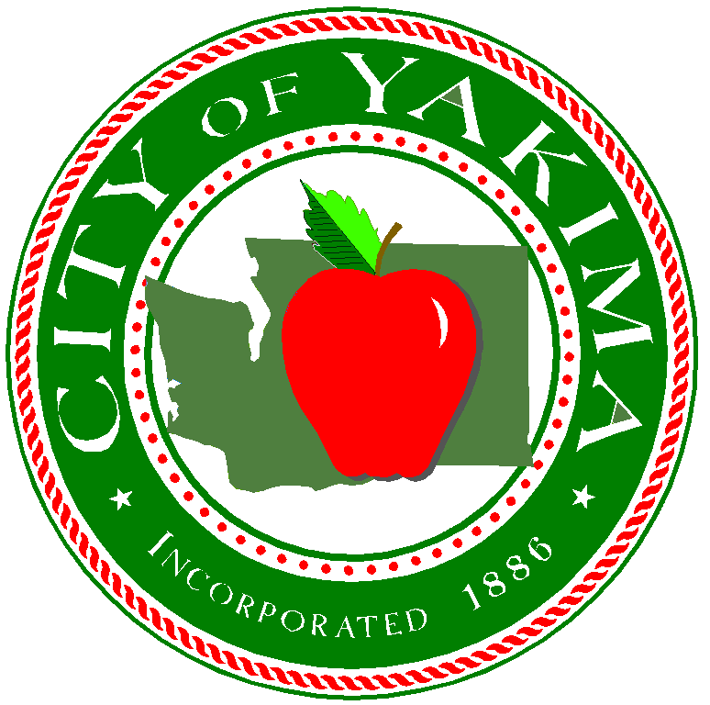

July 31, 2017

ATTENTION: All Respondents
SUBJECT: RFQ No. 11720Q – Architectural, Engineering, and Planning Consultant Services for Airport Grant Projects for Yakima Air Terminal – McAllister Field

Addendum No. I

Answers to the following changes are to be incorporated with the above RFQ:

- How many printed copies of the proposal would you like? Do you also want a pdf version (electronic copy on cd or USB drive?)
Answer: Please provide 5 copies of you proposal, as well as a PDF version submitted on a USB flash drive.

- Will there be a pre-proposal meeting? Will we be able to get a tour of the airfield?
Answer: There will be no pre-proposal meeting, however, an airfield tour has been scheduled for 10:00am on Friday, August 4, 2017. This is an informational meeting only and no detailed questions may be asked. Attendance is not mandatory.

- The RFQ notes that an SF330 Form “may be submitted” to satisfy SOQ… Will it be required?
Answer: An SF430 form IS REQUIRED and must be submitted with your response.

- A question was asked “If we submit for all Groups (A, B, and C); do you want separate proposals for each, or just submit one proposal for all three?
Answer: You may submit one proposal and highlight your qualifications for each group.

- A question was asked “One of the scoring items notes “Anticipated Sub-consultants”. What is meant by scoring of subconsultants? We so not anticipate utilizing very many subs unless it is viewed as a positive on the SOQ.”
Answer: If the firm believes they will not require sub-consultants and encompasses ample staff to accomplish work then submitting no sub-consultants will not impact the overall scoring of bid package.

- A question was asked “Can we get a copy of your most recent FAA CIP Project Letter?”
Answer: A CIP letter has not been provided by FAA.

- A question was asked “Are the Master Plan and ALP documents on your website the final versions? Is there an asbuilt ALP available?
Answer: The Master Plan and ALP on the airport website is the final version. There is little to no change to the ALP since adoption.

- Are AIP 39 (Acquire Snow Removal Equipment) and AIP 40 (Acquire Safety Equipment and/or Fencing) anticipated with this consulting contract?
Answer: No.

- Could you please clarify what affirmative action program you are looking for in our SOQ? Firms plan or plan where FAA is involved? Will it count toward the allowed pages in the SOQ?
Answer: Since FAA funds are involved, please include information for that program. It will not count against your page count.

Please acknowledge receipt of this Addendum No. 1 in the cover letter of your proposal.

NO OTHER CHANGES.

Sincerely,

Sue Ownby

Sue Ownby, CPPO
Purchasing Manager

