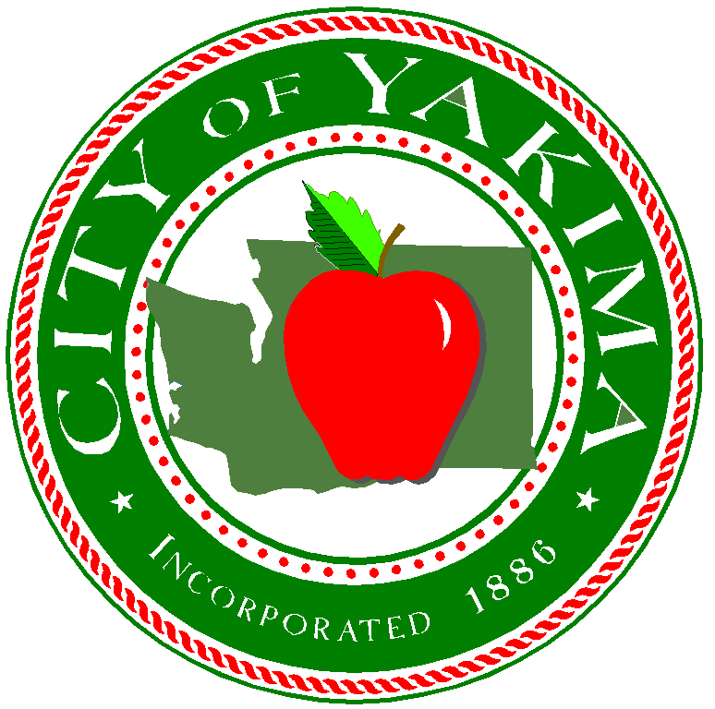

CITY OF YAKIMA

Packet for
Request for Qualifications
No. 11720Q

Architectural, Engineering, and Planning Consultant Services for Airport Grant Projects for
Yakima Air Terminal – McAllister Field

Responses due by 5:00 PM, Thursday, August 10, 2017

Yakima Air Terminal – McAllister Field
2406 West Washington Avenue, Suite B
Yakima, WA 98903

July 17, 2017
Notice to Consultants
Request for Qualifications No. 11720Q

Notice is hereby given by the undersigned that sealed Requests for Qualifications (hereby referred to as RFQ’s) will be accepted in the office of the Yakima City Clerk, Yakima City Hall, 129 N, 2nd Street, Yakima, WA 98901 until the hour of 5:00 P.M. Thursday, August 10, 2017 and Respondents names will be publicly read for:

Architectural, Engineering, and Planning Consultant Services for Airport Grant Projects for the Yakima Air Terminal-McAllister Field (herein after referred to as YKM)

Request for Qualification Packets that give submittal requirements are available on the web at:
www.yakimawa.gov/purchasing/services/specs. Contact Purchasing Manager Sue Ownby at 509-575-6093 if you have any questions about accessing the RFQ.

YKM will select services from firm(s) to provide professional engineering and construction management/inspection services, based upon any combination of the Groups listed in in the RFQ. All firms should be capable of FAA Airport Improvement Program (AIP) grant preparation and administration assistance, and should be knowledgeable and experienced with AIP requirements. The YKM reserves the right to retain the selected firm(s) for a term of up to five (5) years at the Airport’s discretion.

Resulting contracts will be subject to the provisions of Executive Order 11246 (affirmative Action to Ensure Equal Employment Opportunity) and to the provisions of Department of Transportation Regulation 49 CFR Part 26 (Disadvantaged Business Enterprise Participation) and 49 CFR Part 30 (Foreign Trade Restriction Clause). Disadvantaged Business Enterprise consultants/firms are encouraged to apply.

Further, YKM hereby notifies all proposers that it will affirmatively ensure that it will not discriminate on the grounds of race, creed, color, religion, national origin, sex, age, marital status, sexual orientation, pregnancy, veteran status, political affiliation or belief, or the presence of any sensory, mental or physical handicap in violation of the Washington State Law Against Discrimination (RCW chapter 49.60) or the Americans with Disabilities Act (42 USC 12101 et set.)

Following an evaluation of applications, firms considered to be the most highly qualified will be chosen by either qualification submitted in the RFQ and/or by interviews with the evaluation committee. YKM reserves the right to reject any and all RFQ’s.

Sue Ownby, CPPO
City of Yakima Purchasing Manager

Publish on July 17 & 18, 2017
Acct: 11293

Request for Qualifications No. 11720Q
Yakima Air terminal-Mcallister Field
&
City of Yakima
129 N. Second Street
Yakima, WA 98901

In accordance with Washington State RCW 39.80: Contracts for Architectural and Engineering Services, and Federal Aviation Administration Advisory Circular 150/5100-14E Architectural, Engineering and Planning Consultant Services for Airport Grant Projects, the Yakima Air Terminal-McAllister Field (hereinafter referred to as YKM) is requesting qualifications from engineering and consulting firms for the preparation of plans and specifications, providing project supervision and coordination, inspection and reports as requested for yet-to-be determined Airport construction, or other related projects that are currently under consideration at the YKM, located in Yakima, Washington. The Work will be performed on an “as-needed” basis through a professional services contract, and may be accomplished through multiple grants. This is a Qualification Based Selection process, as required by 2 CFR §200.320 utilizing full and open competition per 2 CFR §200.319.
Scope of Requested Services may include, but is not limited to:
Preliminary Engineering and Environmental Review
- Data Collection
- Preliminary Engineering
- Project Formulation and Pre-Design
Final Design
- Final Design
- Preparation of Bid Documents
- Engineer’s Estimate
- Grant Application and Administration
Permitting
- Permitting Coordination
- Agency Coordination
Construction Management
- Provide all services, after the award of the Construction Contract
- Inspection of work in progress
- Observing and reviewing all performance testing
- Final Inspection
- Review “Operation and Maintenance” Manuals
Project Closeout
- Final Inspection
- Recorded Drawings
- Final Engineering Report
- Project Closeout

Groups:
Firms may submit on ALL or ANY combination of Groups below. YKM reserves the right to select either one firm for all Groups, or separate firms for each Group. Projects under consideration may include, but is not limited to the following:

Group A
- Rehabilitation, reconstruction, construction of airfield pavement including but not limited to taxilanes, taxiways, runways, and/or aprons.
- Rehabilitation, reconstruction, construction of non-airfield pavement such as access roads, service roads, parking lots, and/or sidewalks.
- Rehabilitation, reconstruction, construction of airfield lighting including but not limited to Medium Intensity Taxiway Lights, Medium Intensity Runway Lights, High Intensity Runway Lights, and/or Signage.
- Rehabilitation and installation of airport visual navigation aids, including but not limited to Runway End Identification Lights, Precision Approach Path Indicators, Visual Approach Slope Indicators, segmented circle, compass rose, and wind cones.
- Construction of Airfield Markings.
- Update as-built Airport Layout Plan following completion of projects.

Group B
- Acquisition and installation of Automated Surface Observation System or Automated Weather Observation System.
- Rehabilitation, reconstruction, construction of buildings such as Snow Removal Equipment and Aircraft Rescue Firefighting buildings.
- Design and acquisition of airport equipment including but not limited to Aircraft Rescue and Firefighting equipment and Snow Removal Equipment.
- Design and construction of deice contamination facility.
- Rehabilitation, reconstruction, construction of security fence and security access systems.
- Update as-built Airport Layout Plan following completion of projects.

Group C
- Obstruction Removal.
- Update as-built Airport Layout Plan following completion of projects.
- Update Wildlife Hazard Assessment and Wildlife Hazard Management Plan.
- Land Acquisition.

Through mutual agreement between the airport and FAA, additional projects or work elements may be added after the original selection in accordance with the criteria under 150/5100-14E.

Term of Professional Services Agreement:
The term for Professional Services will commence from date of award for a period of one (1) year, with an option to extend contractual services for four (4), one (1) year periods, not to exceed five (5) years total. The work advertised may be accomplished over the course of multiple AIP grants. A project started within the first 5-years may continue beyond the duration of the initial contract; however once the 5-year duration has ended no new project will be initiated without a new procurement action.

Airport Projects may be considered for funding in part by an Airport Improvement Program (AIP) grant by the FAA, and will require compliance with all Federal, State and local requirements appropriate for this type of project.

Statement Requirements:
Statement of Qualifications (hereinafter referred to as SOQ’s) will be limited to fifteen (15) double sided pages (30 total), including cover letter, but not including resumes. Standard Federal Forms SF330, may be submitted to satisfy part or all of the Statement of Qualifications’ requirements. Statements shall include the following information:
- A cover letter that includes the consultant’s contact person for this service contract, including address, telephone, and e-mail address: description of project team, including any sub-consultants and the consultant’s offices(s) where the work will be performed.
- State which Group(s) your firm is submitting for.
- Project approach that describes each discipline and the project team member(s) responsibility for the task.
- Project team organization, including team member’s role and directly-related experience.
- Firm’s present workload and staffing with the ability to put key personnel on a project through completion.
- Firm’s experience with completing projects within original timeframe and cost estimates.
- Provide any additional information you feel uniquely that qualifies your firm to provide consulting services.
- Examples of similar projects completed with the last five (5) years.
- Provide a list of all current engineering design and construction management airport projects, as well as any which have been completed in the last three years. List the project manager you assigned to each project. Identify the starting dates for all projects, and the completion dates (where completed). List the project sponsor’s name and the name and telephone number of the sponsor’s contact person for each project identified.
- Experience and qualifications of your firm, and sub-consultants, on Airport Improvement Programs, with requirements similar to those of this project.
- Experience and qualification of your firm, and sub-consultants, on managing and administrating Aviation (FAA/AIP), WSDOT Aviation and Non-Aviation Grant and Loan Programs.
- The names and qualifications of persons in your firm, and sub-consultants, who would be assigned to key positions in the execution of this work.
- At least four (4) client references, including name and phone numbers from current or ongoing airport projects, or projects completed within the last three years, and
- A copy of your firm’s affirmative action program.

Consultant Selection and Evaluation Process
Firms shall be considered for selection based upon the following evaluation criteria:

1. Proposed project organization and approach to the work. | 25 Points
2. Directly related experience on similar projects complying with FAA requirements and a list of personnel that would be associated with the Project, including references. | 25 Points
3. Capability and availability of personnel and the team including specialized services. | 25 Points
4. Degree of interest and responsiveness shown in undertaking the projects. | 15 Points
5. Anticipated sub-consultants. | 10 Points
6. The ability of the firm to act as a Client Services Advisor that would provide unsolicited overviews, comments and suggestion on the use existing and future facilities and services, and offer recommendations for improvements, cost savings, planned scheduled maintenance and etc. that will maximize the existing and future use and growth, of the airport and tenants. | 10 Points
7. Ability to demonstrate an understanding of the projects’ needs and special challenges, and the YKM’s special concerns. | 10 Points
8. Current workload and demonstrated ability to meet schedules or deadlines. | 25 Points
Total | 150 Points

Qualification Statement Scoring
An estimated three to five top scoring Qualification Statements may be short-listed based on an evaluation of the written Statements by the Evaluation Team on the stated criteria. A proposer may not contact any member of an Evaluation Team except at the Evaluation Team’s direction.

Should the Evaluation Team request any oral presentations or demonstrations from one or more of the short-listed proposers, the Evaluation Team will review the initial scoring and make adjustments based on the information obtained in the oral presentation or demonstration and site visits (if applicable) to determine final scoring.

YKM will rank qualified persons and firms in order of preference, and initiate negotiations with the highest ranking firm(s) based on the Groups it desires.

In the event that the YKM and the selected consultant negotiate but are unable to agree upon a detailed scope of work or cost of contract, YKM reserves the right to negotiate with and/or award a contract to other person or firm sequentially ranked next (by the YKM’s selection committee) behind the selected consultant.

The final selection of the firm with which to negotiate a contract will be based upon the qualifications criteria listed above, as well as:

1. Ability to demonstrate an understanding of the project’s needs and special challenges, and
the sponsor’s special concerns.

2. Degree of interest and responsiveness shown in undertaking the project.

3. Overall quality of the response.

4. Demonstration of ability to meet the Airport’s needs.

5. DBE participation may be noted but not part of the consultant selection rating system. YKM has established a DBE plan, if required by FAA regulations. The RFQ submittal should include the following information:

a. Description of the kind of work that can be subcontracted.

b. The estimated percentage of the kind of work identified as subcontractable.

c. Identification of those subcontractable work items which could be performed by DBE
Firms.

d. Name, address, and name of certifying agency of those DBE firms that are anticipated to
perform the work items identified in item number three.

ADDITIONAL INFORMATION
No cost or fee schedules for engineering design and construction management/inspection services shall be submitted. FAA grant guidelines require cost and fee information to be presented during contract negotiations for a specific Airport Improvement Program project work scope after the selection of the most qualified consultant with which to negotiate.

The consulting firm is responsible for all costs related to the submittal of their applications, preparation of documents or submittals needed for negotiations, and the costs incurred in traveling to and participating in any meetings associated with the YKMs consultant selection process and/or negotiating an agreement.

It is understood that all submittals shall become the property and a part of the public file of the City of Yakima, without obligation to the City of Yakima, and may thereafter be used by the City of Yakima and Yakima Air Terminal-McAllister Field, without compensation to the consultants.

PROPRIETARY INFORMATION
Any requested restrictions on the use of data contained within a proposal, must be clearly stated in the proposal itself. Proprietary information submitted in response to a request will be handled in accordance with applicable Owner procurement regulations and the Washington State Public Records Act (RCW 42.56 et seq.). Proprietary restrictions normally are not accepted. However, when accepted, it is the Proposer’s responsibility to defend the determination in the event of an appeal or litigation.

Unless otherwise noted, data contained in a proposal, all documentation provided therein, and innovations developed as a result of the contracted commodities or services cannot be copyrighted or patented. All data, documentation, and innovations become the property of the Owner.

PROPRIETARY OR CONFIDENTIAL DESIGN INFORMATION
Washington State Public Disclosure Act (RCW 42.56 et seq.) requires public agencies in Washington to promptly make public records available for inspection and copying unless they fall within the specified exemptions contained in the Act, or are otherwise privileged. Documents submitted under this Specification shall be considered public records and, with limited exceptions, will be made available for inspection and copying by the public. It is the intent of the Owner to post all RFQ responses online and available to the public after the contract is signed.

If the Proposer considers any submittal document to be protected from disclosure under the law, the Proposer shall clearly identify on the page(s) affected such words as “CONFIDENTIAL,” "PROPRIETARY” or BUSINESS SECRET.” The Proposer shall also submit an index with its submittal identifying the affected page number(s) and location(s) of all such identified material. Marking the entire submittal as “confidential” or “proprietary” is not acceptable and is grounds to reject such submittal. In addition, the required electronic copy shall have any perceived confidential materials segregated into a separate electronic file, as the main RFQ response may be automatically released upon contract signing without notification.

If a request is made for disclosure of such identified documents or portions thereof, the Owner will determine whether the material is exempt from public disclosure. If, in the Owner opinion, the material is subject to disclosure, the Owner will notify Proposer of the request and impending release and allow the Proposer 10 days to take whatever action it deems necessary to protect its interests. All expense of such action shall be borne solely by the Proposer, including any damages, attorney’s fees or costs awarded by reason of having opposed disclosure and Proposer shall indemnify Owner against same. If the Proposer fails or neglects to take such action within said period, the Owner will release all materials deemed subject to disclosure. Submission of materials in response to this solicitation shall constitute assent by the Proposer to the foregoing procedure and the Proposer shall have no claim against the Owner on account of actions taken pursuant to such procedure.

For more information or questions about projects please contact Robert K. Peterson, Airport Director, Rob.Peterson@yakimawa.gov or at 509-575-6149.

For questions about the RFQ, please contact Sue Ownby, Procurement Manager, at sue.ownby@yakimawa.gov (preferred) or 509-576-6695.

Submit SOQ’s by 5:00 PM, Thursday, August 10, 2017 to:

Sue Ownby, Procurement Manager
City of Yakima
129 North 2nd Street
Yakima, WA 98901

