July 31, 2018

ATTENTION: All Bidders
SUBJECT: Bid No. 11805, Snow Brooms - Yakima Air Terminal – McAllister Field

Clarification Memo No. I

The following question was received from a prospective bidder. This is not an addendum, rather, a Clarification Memo, as this does not change the project specifications. It does not need to be acknowledged in the vendor’s response:

Question: “I wanted to reach out to you concerning Manufacturers bidding direct, versus Manufacturers Bidding with a Dealer on this bid. Some of the manufacturers bid direct to save on dealer costs but at the end of the day do not have a dealer network to support the equipment after the sale. My company has around 16 to 18 mechanics with 14 to 15 service trucks between our two Washington state locations and offer excellent service and support. I wanted know if there will be additional weight given to a local company with service bidding on this bid.”

Answer: All Bidders are treated equally when evaluating bids regardless of their location within the US, consistent with federal requirements.

NO OTHER CHANGES.

Sincerely,

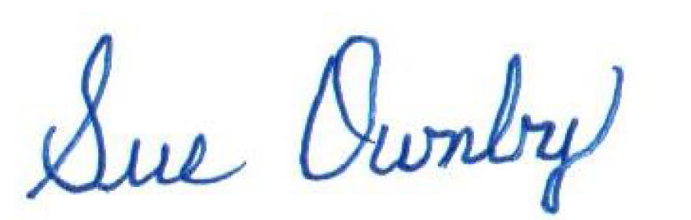
Sue Ownby, CPPO
Purchasing Manager

