August 7, 2018

Dear Interested Parties:

Subject: RFQ 11821Q Yakima Central Plaza Management
Additional Due Date Extension

The due date of the responses has been extended to 5:00PM, September 4, 2018.
If you have any questions please call me at (509) 576-6695.
Sincerely,
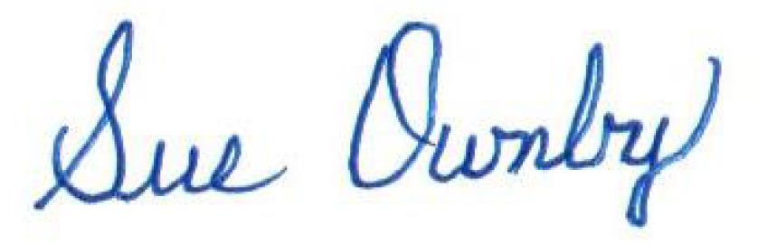
Sue Ownby, Purchasing Manager
City of Yakima

