August 8, 2018

Dear Interested Parties:

Subject: Addenda No. 3
RFQ 11821Q Yakima Central Plaza Management
Pre-Proposal Conference schedules

A Pre-Proposal Conference has been scheduled for 10:00 AM Friday, August 17, 2018 at Yakima City Hall, in the 2nd Floor Conference Room. The address is 129 No. 2nd Street, Yakima, WA 98901.
This will be your opportunity to ask any questions you may have, relating to the Yakima Central Plaza Management RFQ. This Pre-Proposal Conference is not mandatory, however prospective respondents are strongly urged to attend.
NO OTHER CHANGES.
If you have any questions please call me at (509) 576-6695.
Sincerely,
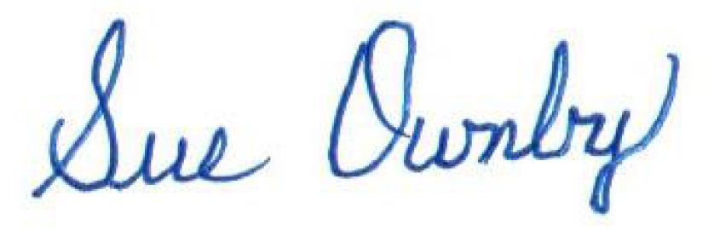
Sue Ownby, Purchasing Manager
City of Yakima

