February 1, 2016

Dear Sir or Madam:

Subject: Bid No. 11602 Fire Hydrants for Water/Irrigation
Addendum No. 1

Please see the following changes/additions to Bid specifications. The following changes have been made on the Bid Form, page 17 of the bid specifications. Please use the REVISED Bid Form when submitting your bid.

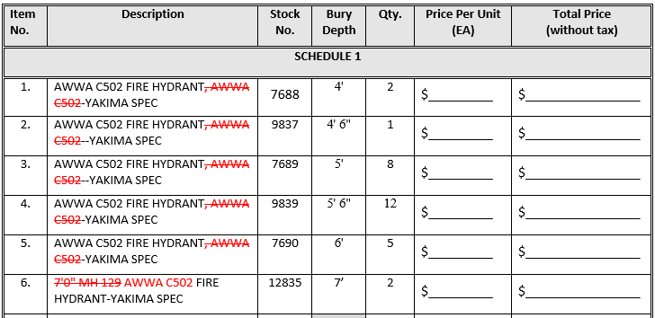

Please acknowledge receipt of this addendum on the signature page two (2) of the Bid document.

If you have any questions please do not hesitate to contact me at (509) 576-6696.

Sincerely,

Christina Payer, Buyer I

Item No. | Description | Stock No. | Bury Depth | Qty. | Price Per Unit (EA) | Total Price  (without tax)
SCHEDULE 1
1. | AWWA C502 FIRE HYDRANT, AWWA C502-YAKIMA SPEC | 7688 | 4' | 2 | $_________ | $________________
2. | AWWA C502 FIRE HYDRANT, AWWA C502--YAKIMA SPEC | 9837 | 4' 6" | 1 | $_________ | $________________
3. | AWWA C502 FIRE HYDRANT, AWWA C502--YAKIMA SPEC | 7689 | 5' | 8 | $_________ | $________________
4. | AWWA C502 FIRE HYDRANT, AWWA C502-YAKIMA SPEC | 9839 | 5' 6" | 12 | $_________ | $________________
5. | AWWA C502 FIRE HYDRANT, AWWA C502-YAKIMA SPEC | 7690 | 6' | 5 | $_________ | $________________
6. | 7'0" MH 129 AWWA C502 FIRE HYDRANT-YAKIMA SPEC | 12835 | 7’ | 2 | $_________ | $________________
7. | 6-INCH HYDRANT EXTENSTION KIT | 9983 |  | 5 | $_________ | $________________
8. | 6" EXTENSION FOR US PIPE M-03 HYDRANT 5-1/4" MVO ALSO FITS MUELLER CENTURION | 12829 |  | 2 | $_________ | $________________
9. | 12-INCH HYDRANT EXTENSION KIT | 7734 |  | 5 | $_________ | $________________
10. | 12" HYDRANT EXTENSION, M&H STYLE 929, 6 BOLTS AND LUGS | 9984 |  | 1 | $_________ | $________________
11. | 12" WATEROUS HYDRANT EXTENSION | 10459 |  | 1 | $_________ | $________________
12. | 12" EXTENSION FOR US PIPE M-03 HYDRANT, 5-1/4" MVO ALSO FITS MUELLER CENTURION | 12830 |  | 2 | $_________ | $________________
13. | 18-INCH HYDRANT EXTENSION KIT | 9985 |  | 5 | $_________ | $________________
14. | 18" HYDRANT EXTENSION KIT, M&H 929 | 9957 |  | 1 | $_________ | $________________
15. | HYDRANT REPAIR KIT FOR M&H MODEL 129. INCL. 1 BREAKAWAY COUPLING, 8 NUTS & BOLTS, 2 BREAKAWAY NUTS & BOLTS, 1 FLANGE GASKET | 10470 |  | 5 | $_________ | $________________
16. | HYDRANT REPAIR KIT FOR M&H 929, INCLUDES 1 STANDPIPE GASKET, TRAFFIC REPAIR KIT - COMPLETE | 9281 |  | 6 | $_________ | $________________
17. | A301-00, 5-1/4 MUELLER PRE 1972 SAFETY FLANGE REPAIR KIT (WITH BRASS SAFETY COUPLING) | 12493 |  | 2 | $_________ | $________________
18. | WATEROUS TRAFFICE REPAIR KIT NO.K528, BRKBL FLG ASSEMBLY | 10179 |  | 1 | $_________ | $________________
19. | UPPER STEM FOR M&H 929 FIRE HYDRANT OPEN LEFT 557000 FITS 1985 AND NEWER, 25 1/4" LONG | 12606 |  | 2 | $_________ | $________________
20. | UPPER STEM FOR M&H 129 FIRE HYDRANT, LENGTH | 12724 |  | 2 | $_________ | $________________
21. | 5” STORZ COUPLING NOZZLE X 4-1/2” NST CONNECTION WITH CAP & CABLE | 7528 |  | 25 | $_________ | $________________
22. | SEAT RING, 5 1/4" M&H 929/129 HYDRANT W/DRIVE LUGS | 13001 |  | 2 | $_________ | $________________
23. | MAIN VALVE RUBBER FOR M&H 929/129 HYDRANT | 13000 |  | 2 | $_________ | $________________
SUB TOTAL: |  |  |  |  |  | $________________
FREIGHT: |  |  |  |  |  | Must be Included
WA STATE SALES TAX - DESTINATION BASED @ 8.2%: |  |  |  |  |  | $________________
GRAND TOTAL: |  |  |  |  |  | $________________
List discount offered off list price for any other items not specifically listed: |  |  |  |  |  | _______________%
Price of fuel per gallon used to calculate trip rate: |  |  |  |  |  | $________________
List a cost breakdown to indicate what portion of service cost is attributed to fuel. (Attach a separate sheet if necessary):

